APPENDIX 1 C

DATA COLLECTION INSTRUMENTS and
electronic contact Record Form (ECRF)

REACTIVE SMOKING CESSATION Questions
(customer service and demographics questions)

Public Burden Statement

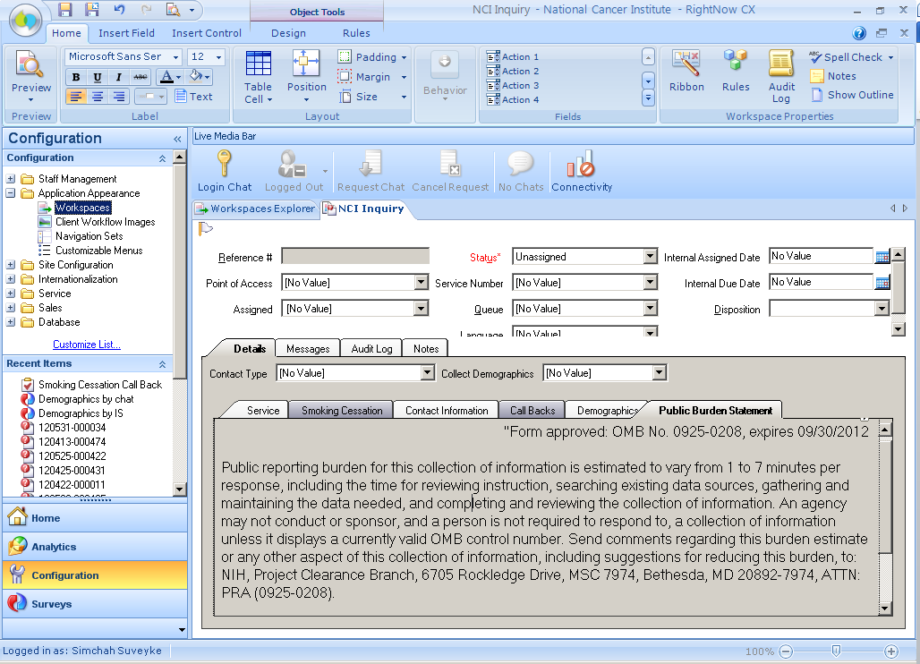

Smoking Cessation Intake Form (SCIF): Dependency Tab > Summary

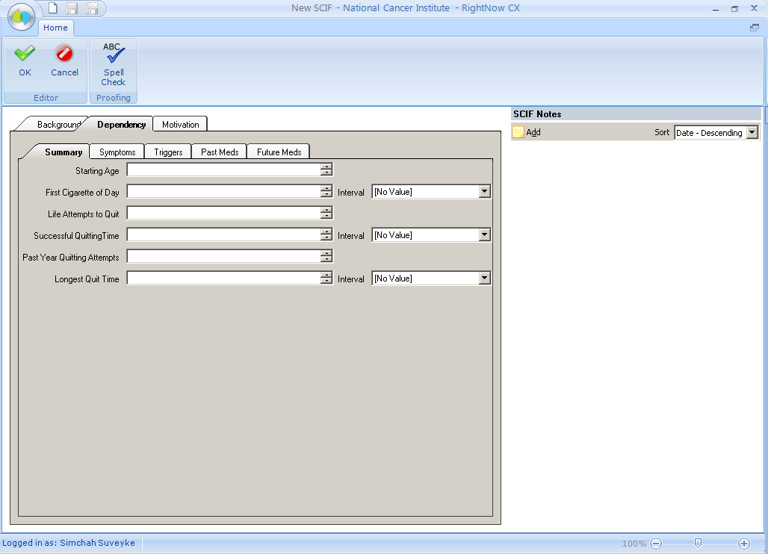

Smoking Cessation Intake Form (SCIF): Dependency Tab Symptoms

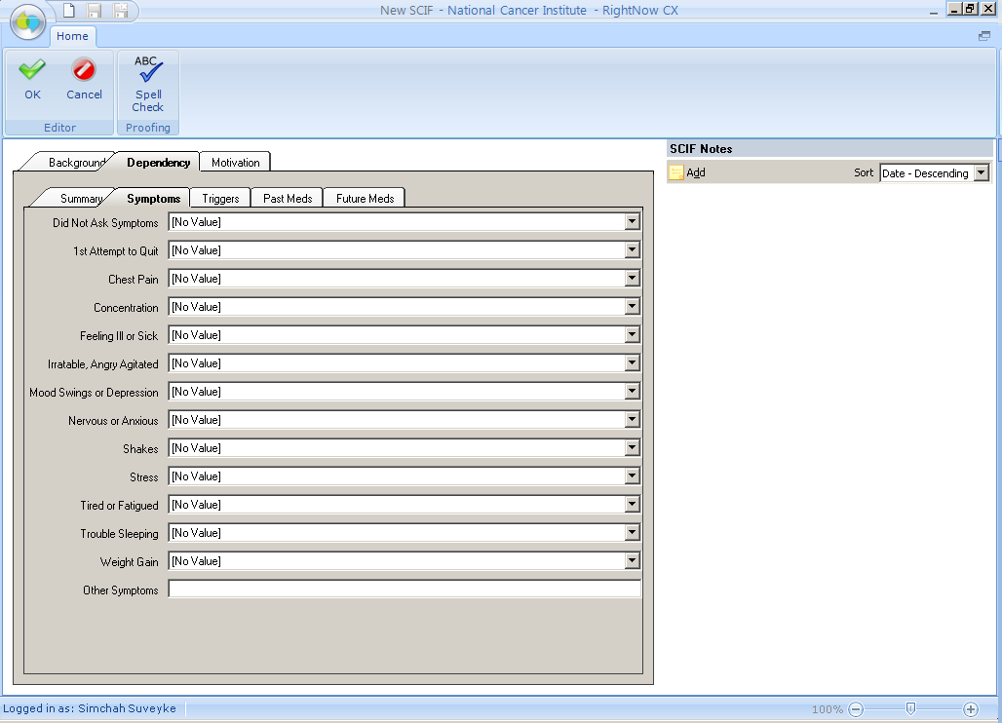

Smoking Cessation Intake Form (SCIF): Dependency Tab > Triggers

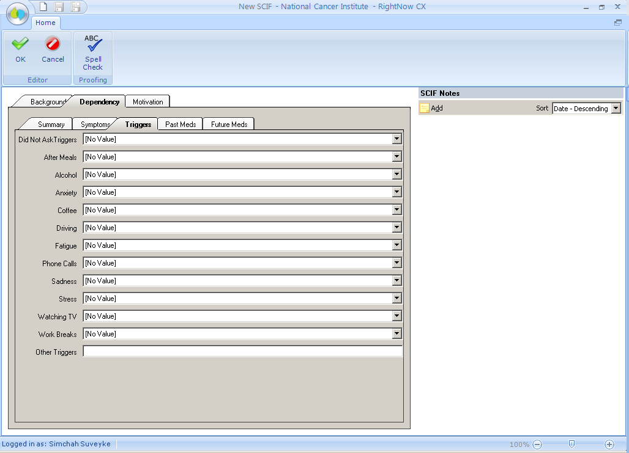

Smoking Cessation Intake Form (SCIF): Dependency Tab > Past Meds

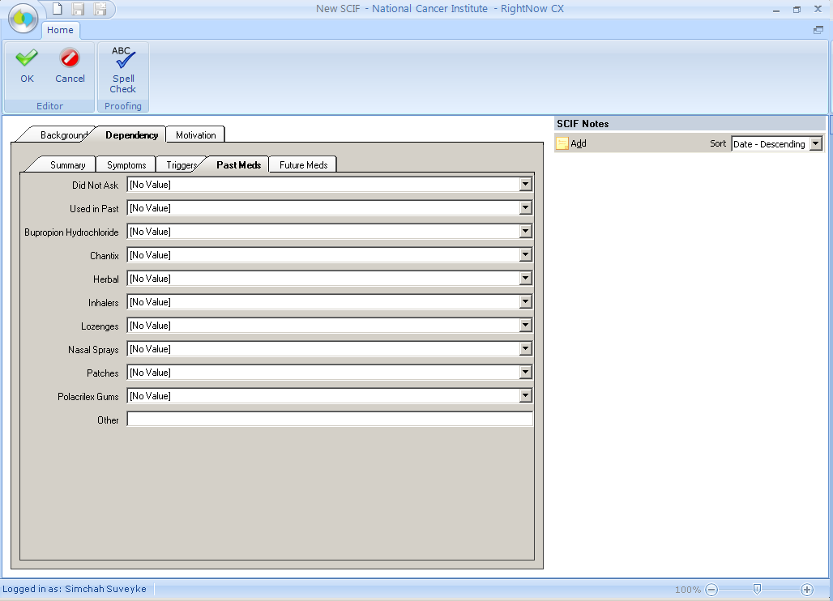

Smoking Cessation Intake Form (SCIF): Dependency Tab > Future Meds

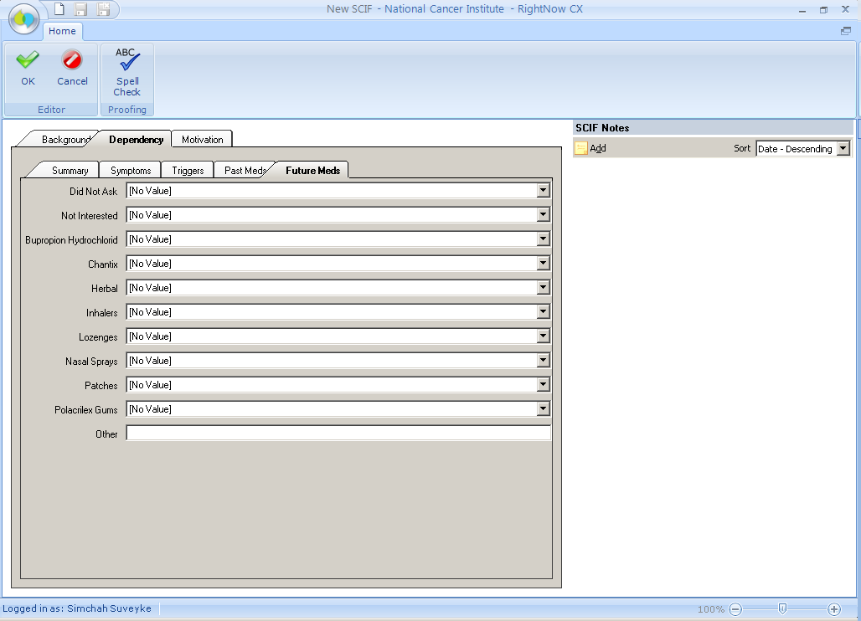

Smoking Cessation Intake Form (SCIF): Motivation Tab

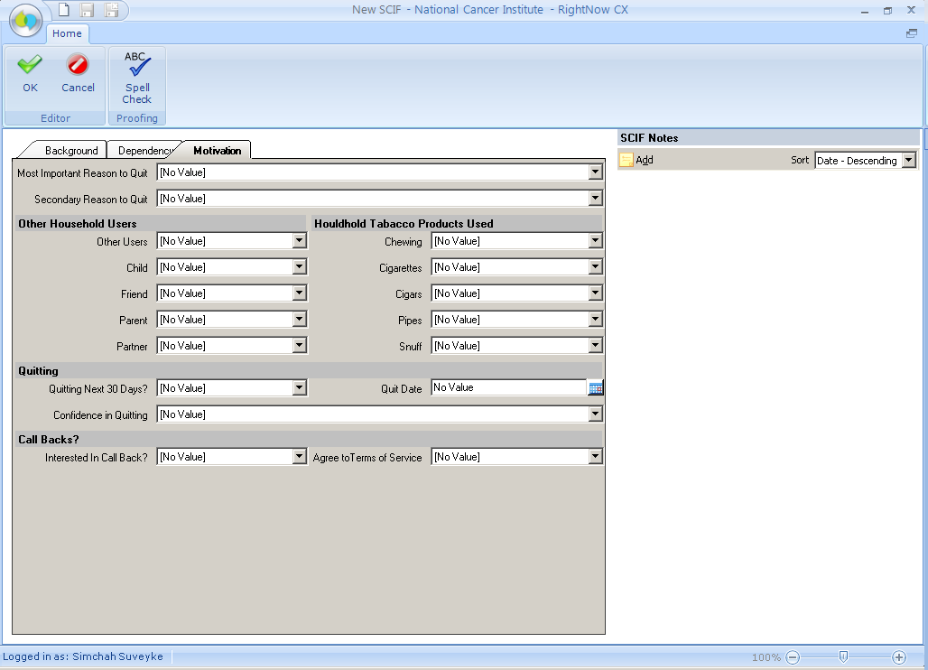

Electronic Coding Records Form (ECRF): seen within the Service Tab

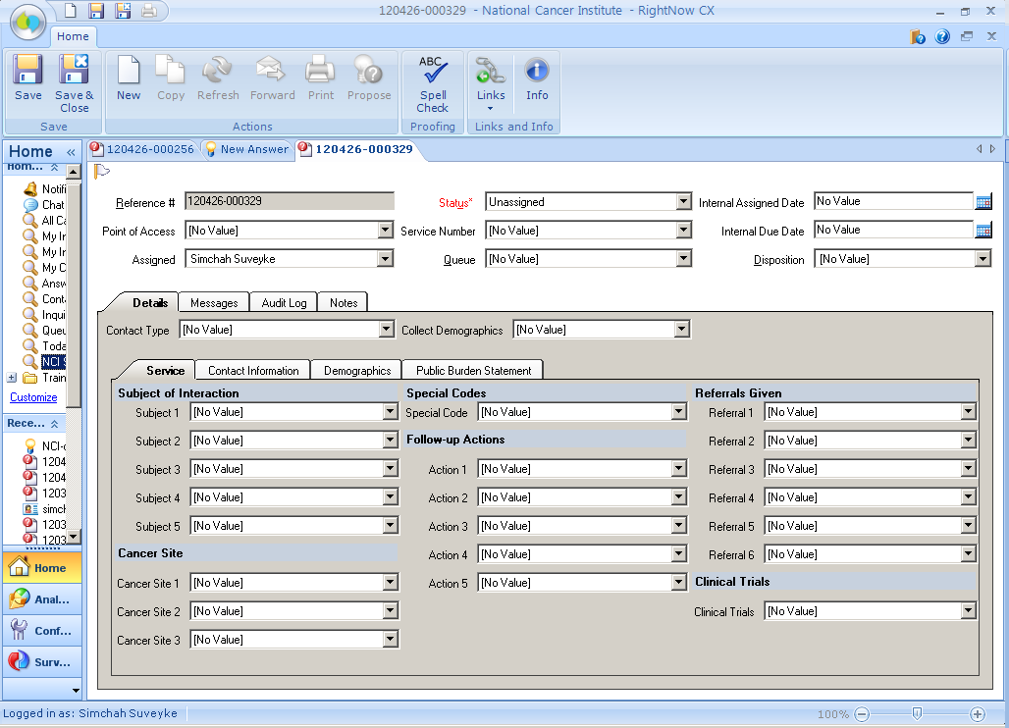

Spanish Version
Electronic Coding Records Form (ECRF): seen within the Service Tab

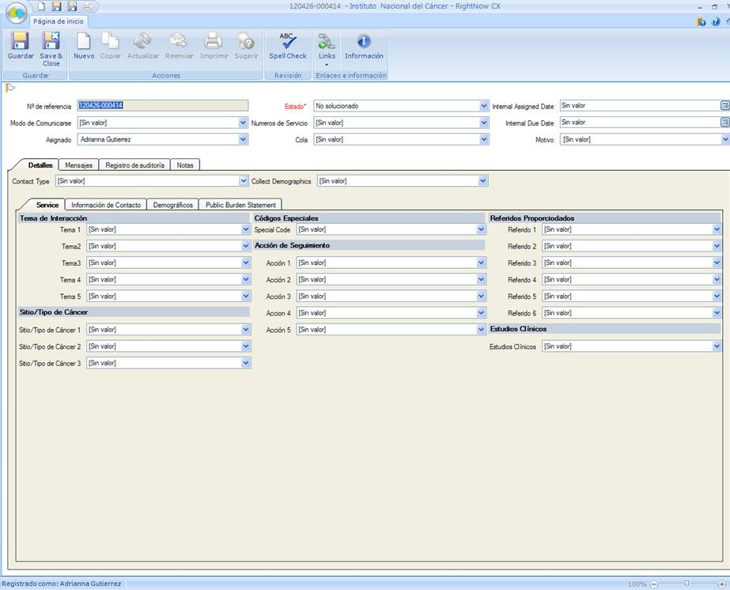

Customer Service Questions
