**APPENDIX 1 D**

**DATA COLLECTION INSTRUMENTS and**

**electronic contact Record Form (ECRF)**

**PROACTIVE SMOKING CESSATION Questions**

**Public Burden Statement**

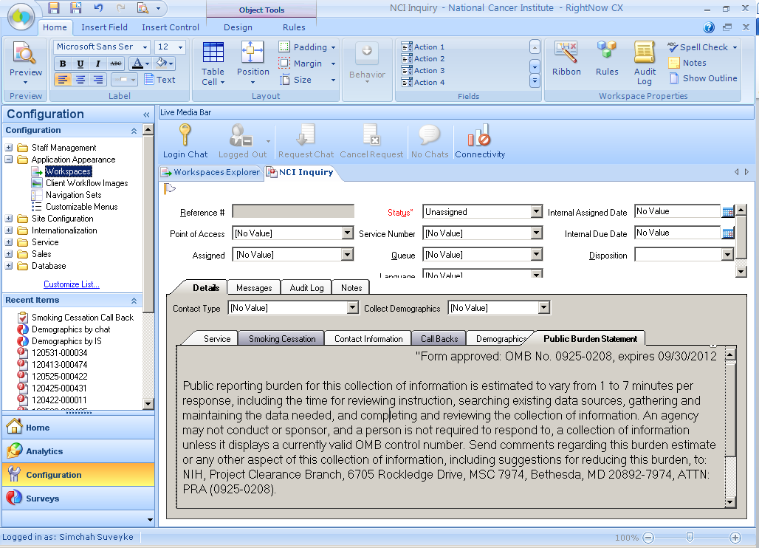

**Smoking Cessation Intake Form (SCIF): Dependency Tab > Summary**

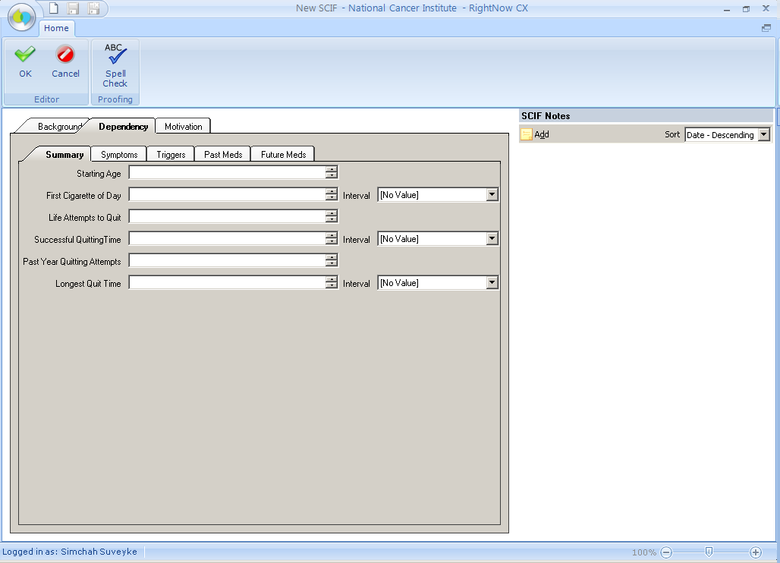

**Smoking Cessation Intake Form (SCIF): Dependency Tab Symptoms**

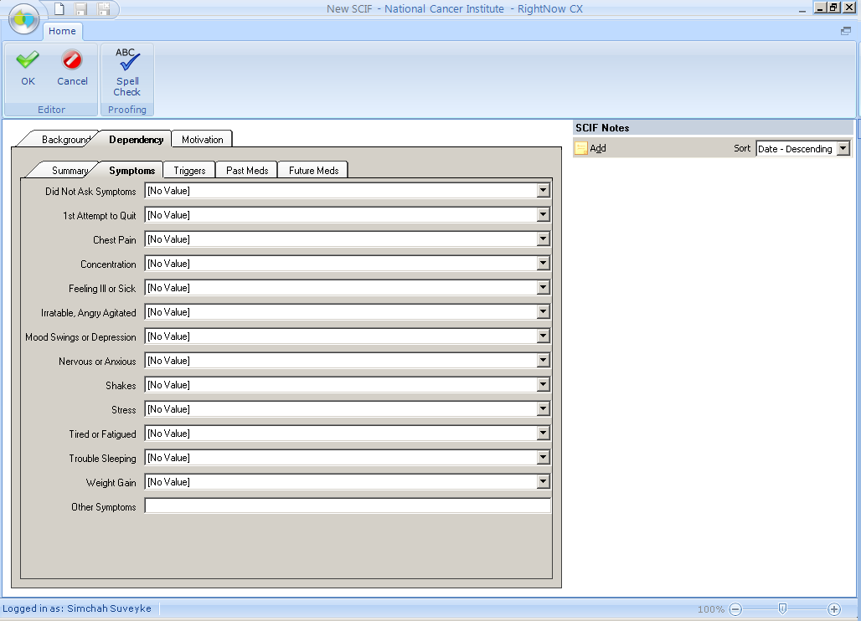

**Smoking Cessation Intake Form (SCIF): Dependency Tab > Triggers**

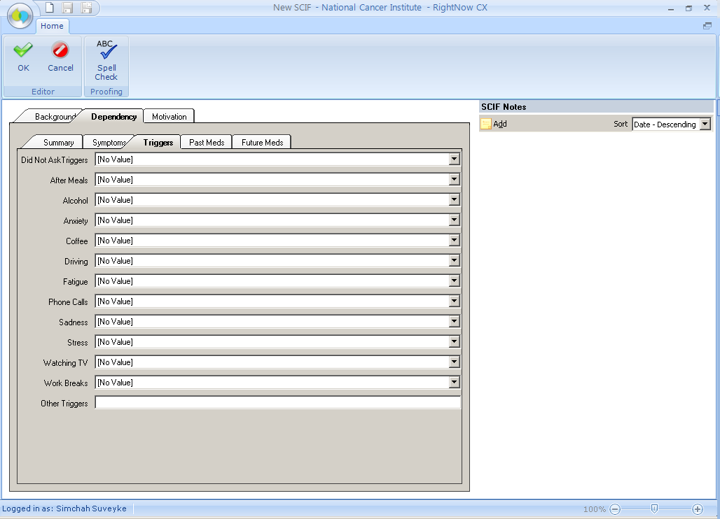

**Smoking Cessation Intake Form (SCIF): Dependency Tab > Past Meds**

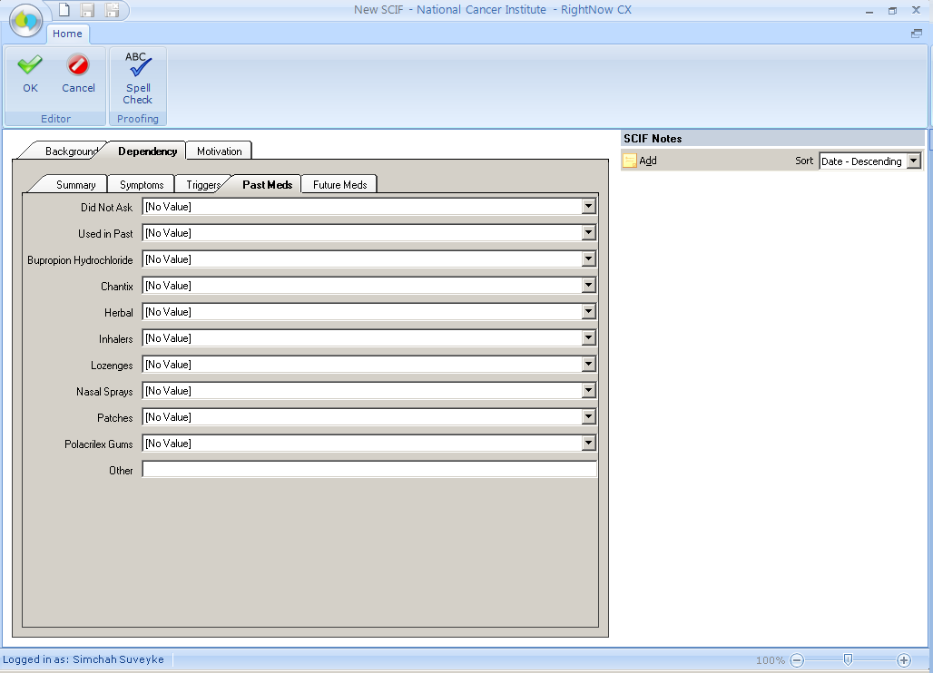

**Smoking Cessation Intake Form (SCIF): Dependency Tab > Future Meds**

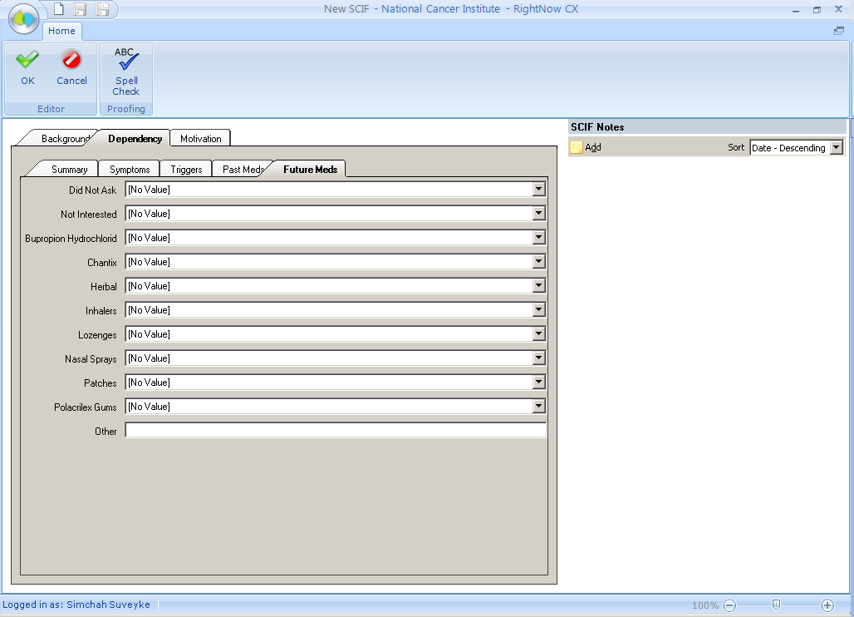

**Smoking Cessation Intake Form (SCIF): Motivation Tab**

