APPENDIX 1 D

DATA COLLECTION INSTRUMENTS and
electronic contact Record Form (ECRF)

PROACTIVE SMOKING CESSATION Questions

Public Burden Statement

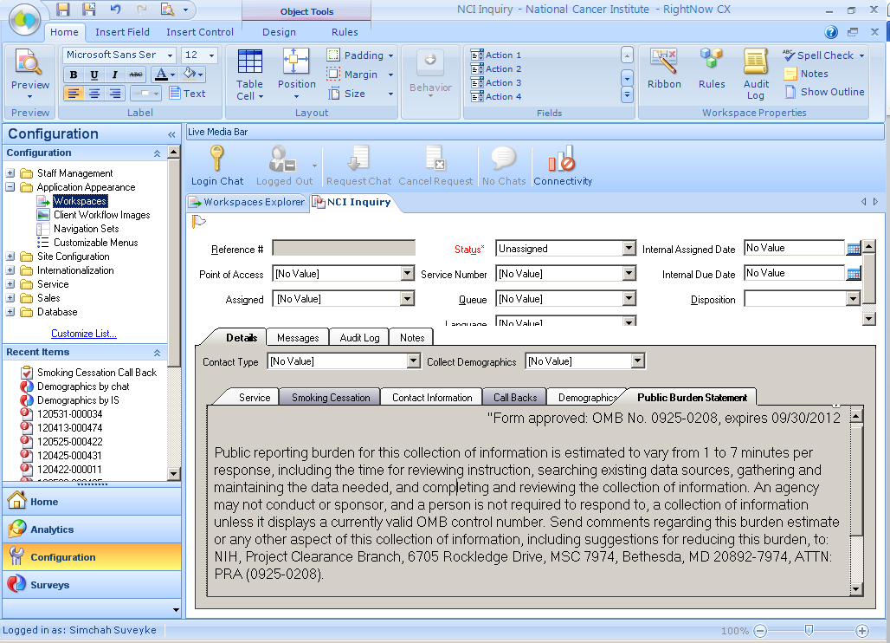
Smoking Cessation Intake Form (SCIF): Dependency Tab > Summary

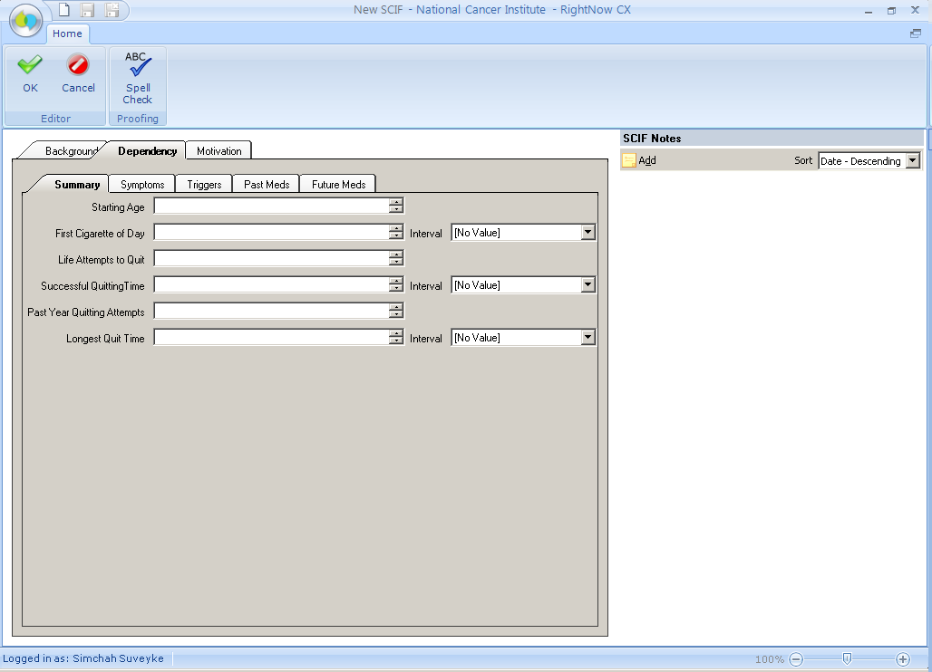

Smoking Cessation Intake Form (SCIF): Dependency Tab Symptoms

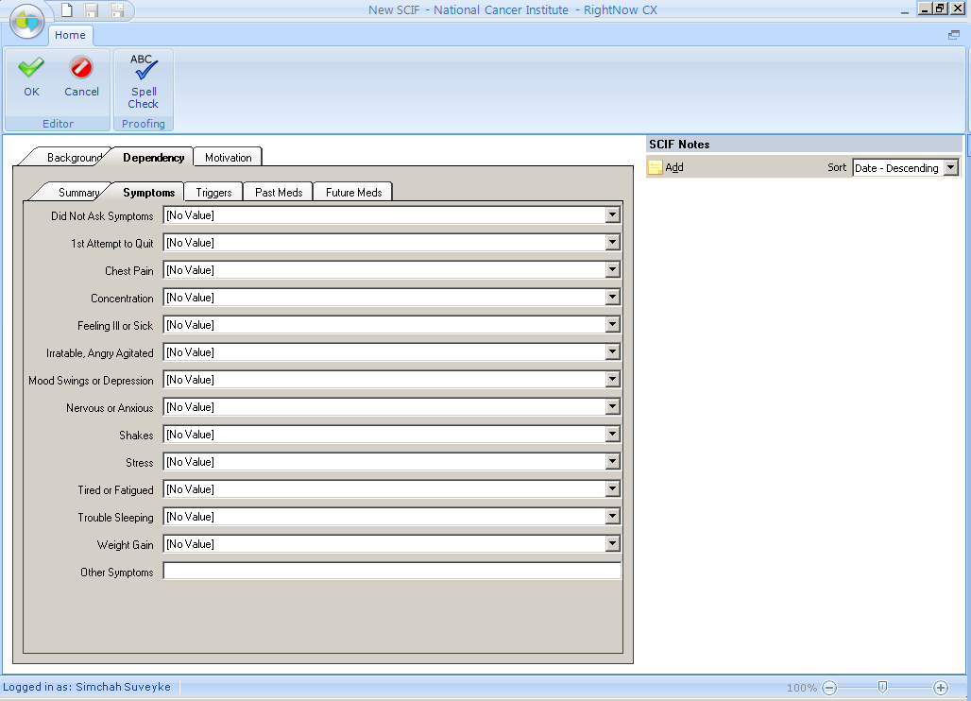

Smoking Cessation Intake Form (SCIF): Dependency Tab > Triggers

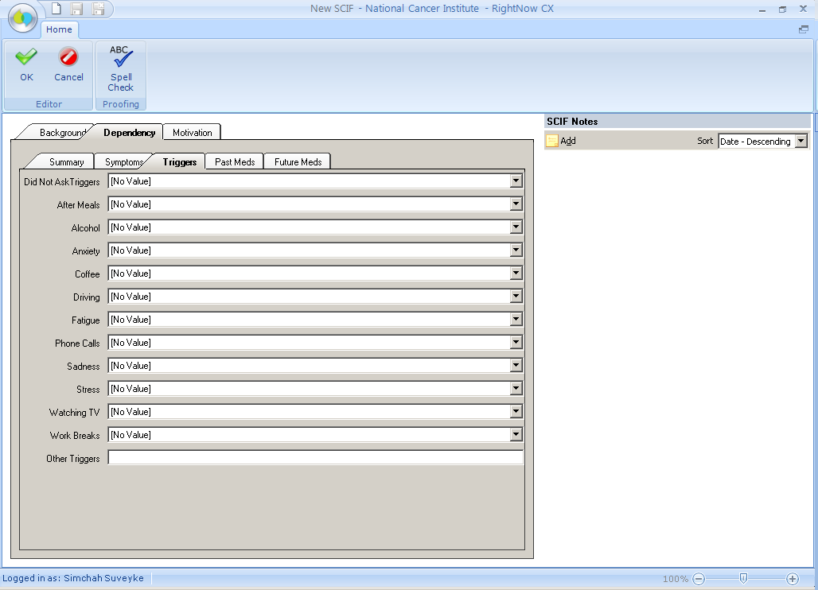

Smoking Cessation Intake Form (SCIF): Dependency Tab > Past Meds

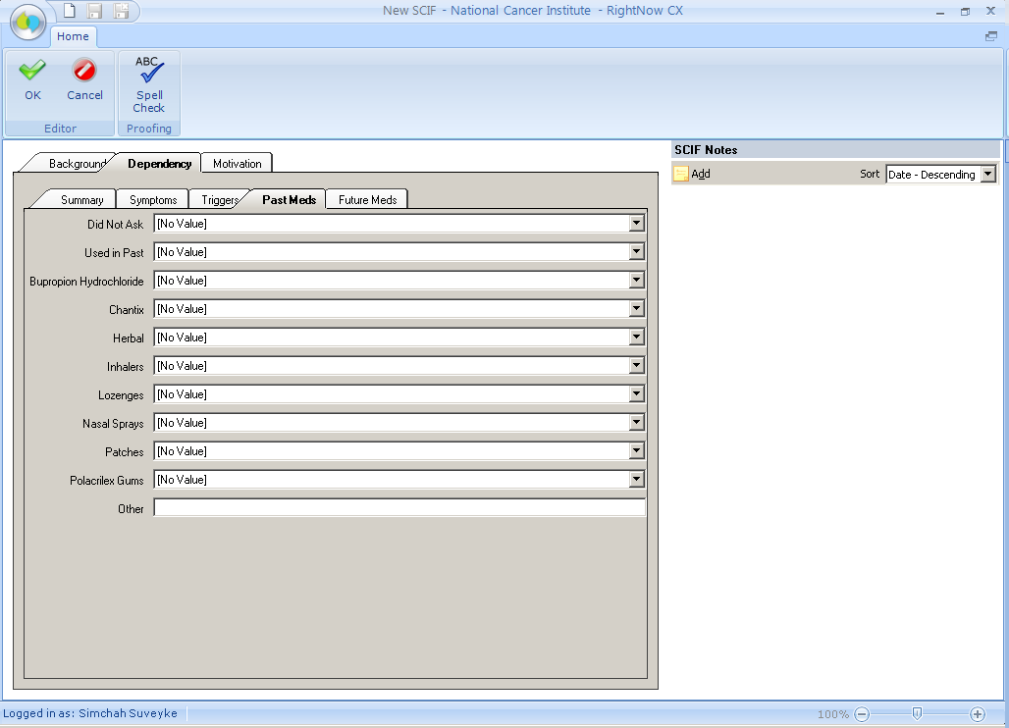

Smoking Cessation Intake Form (SCIF): Dependency Tab > Future Meds

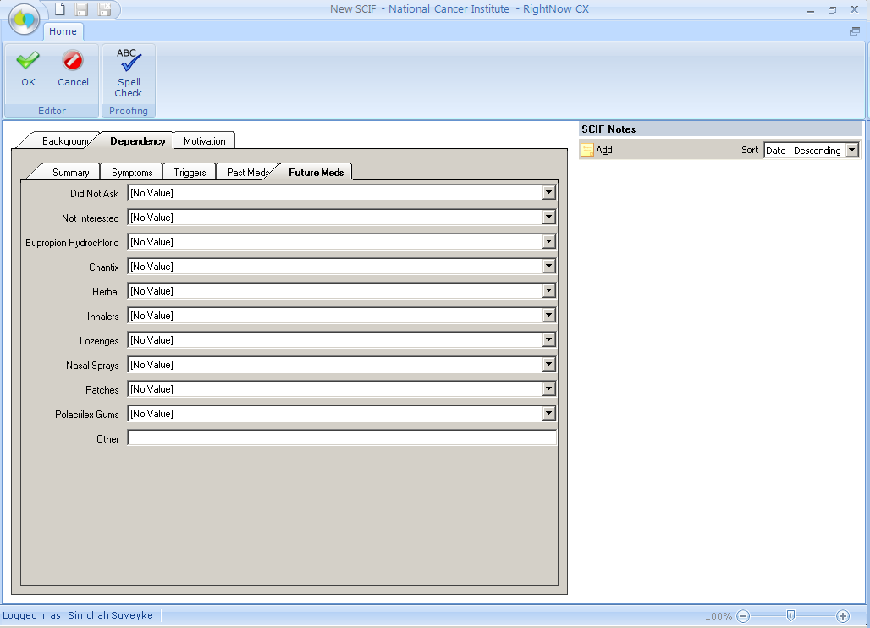

Smoking Cessation Intake Form (SCIF): Motivation Tab

