December 15, 2011

Dear Sir/Ma’am:

We want to learn from you.
HEALTHeLINK and the U.S. Department of Health and Human Services are working together on a study. We would like to help patients better understand the choices they may have about allowing providers to electronically share their medical information. In this survey, you can tell us what information you might need before deciding whether to allow doctors to electronically share your medical information.

What is HEALTHeLINK?
HEALTHeLINK is a non-profit organization. We are a health information exchange in Western New York .
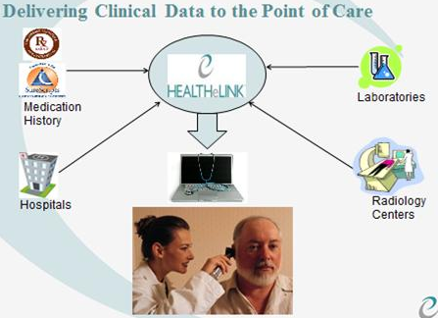
- What is a Health Information Exchange?
Through a health information exchange like HEALTHeLINK, health care providers who are treating you can electronically share your health information. (See the illustration on the right.) Other providers who need your health information can get it from HEALTHeLINK. Your information is always available, even if your doctor’s office is closed. Your doctor may ask your permission to electronically share your medical information through a health information exchange like HEALTHeLINK.

Tell us what is important to you.
This survey is not an agreement to share your health information. You are only telling us the information you would want before deciding whether providers may electronically share your medical information.

Please fill out the enclosed survey and mail it
in the stamped return envelope by DATE.

Thank you very much for your help.

Sincerely,

Dan Porreca, Executive Director
HEALTHeLINK

