OVC PPSR Sub 1- OVC Subgrants Administrative and Training Funds Screen

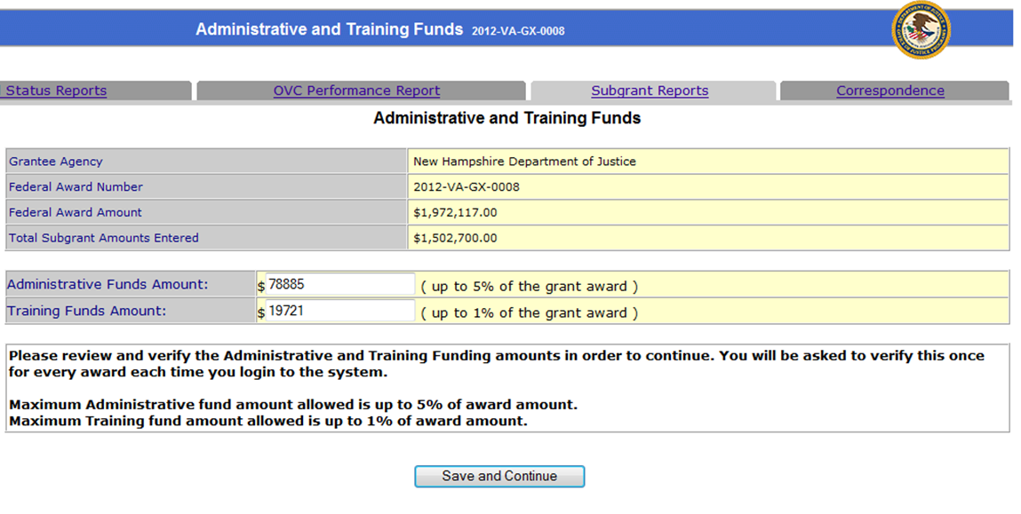

OVC PPSR Sub 2- OVC Subgrantee Agency Details Screen

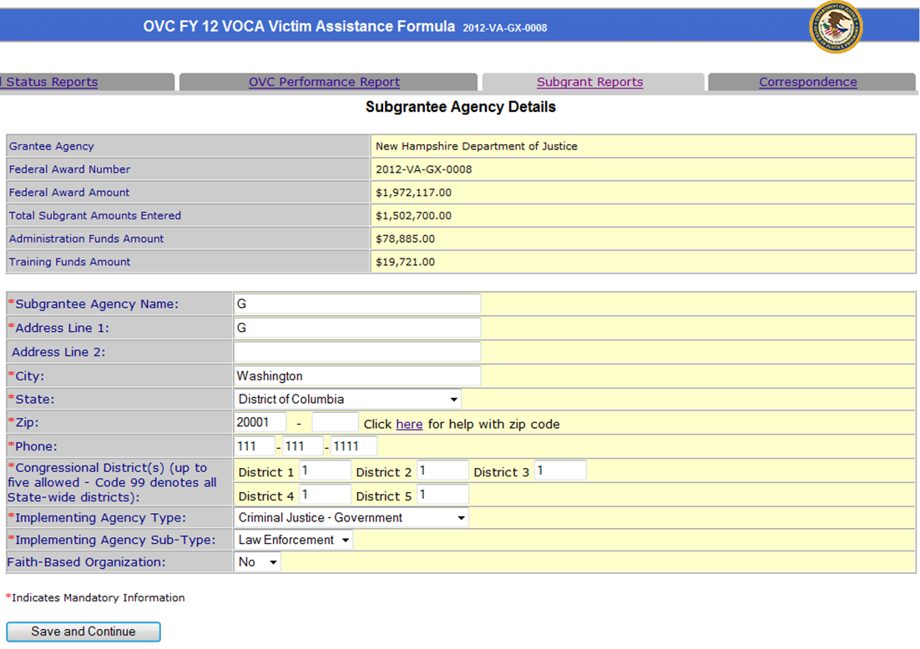

OVC PPSR Sub 3- OVC Subgrant Details Screen

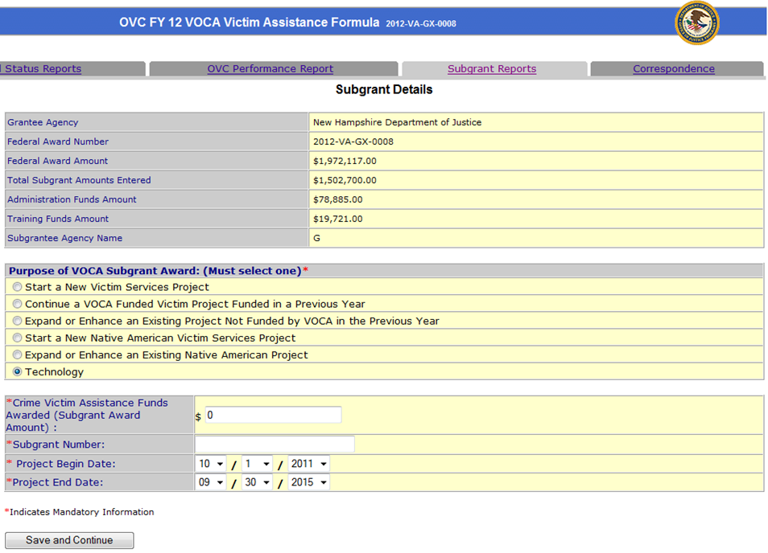

OVC PPSR Sub 4- OVC VOCA Fund Details Screen

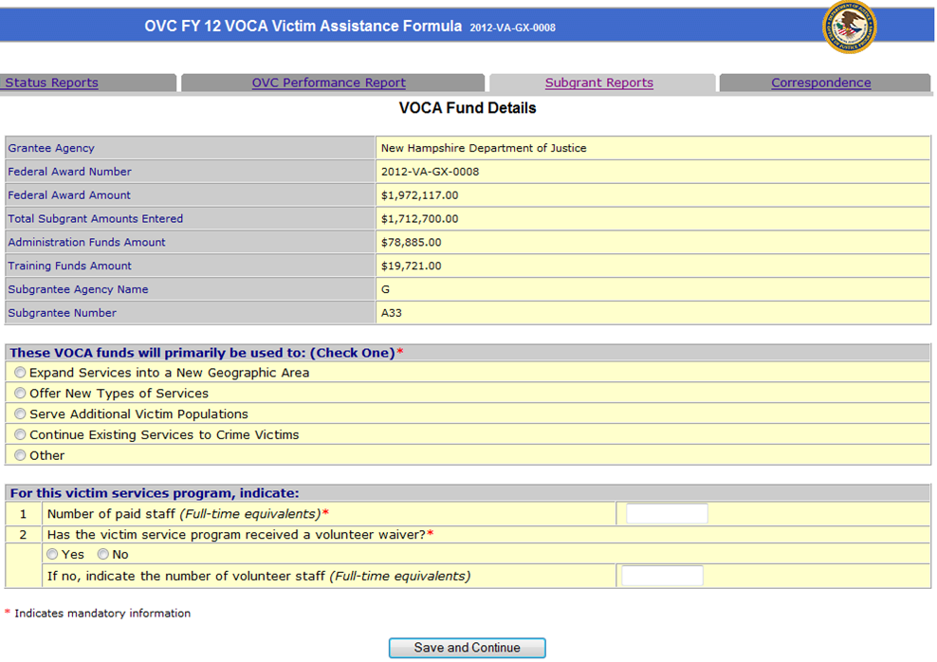

OVC PPSR Sub 5- OVC Subgrants Priority and Undeserved Requirements Screen

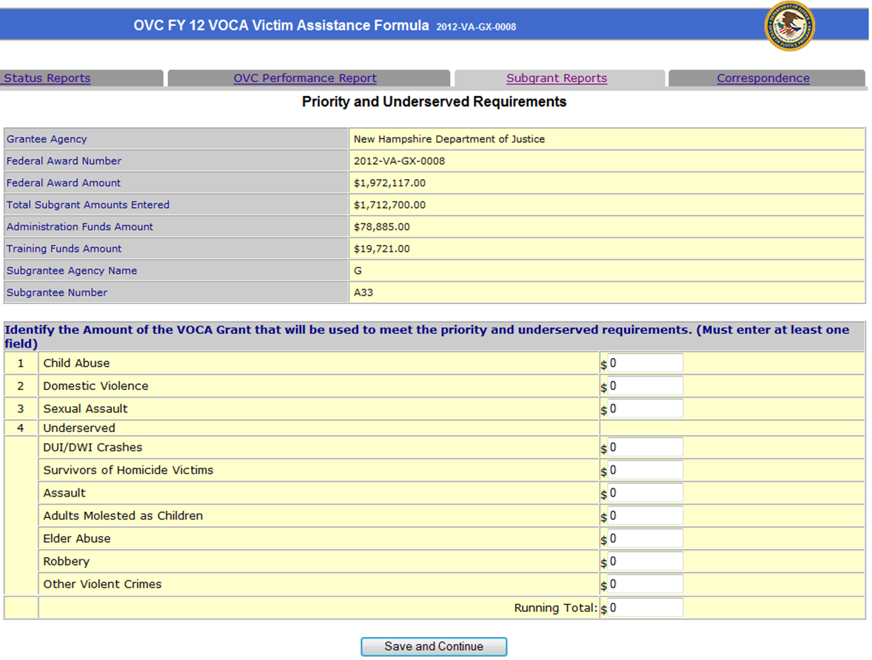

OVC PPSR Sub 6- OVC Subgrants Funding Summary Screen

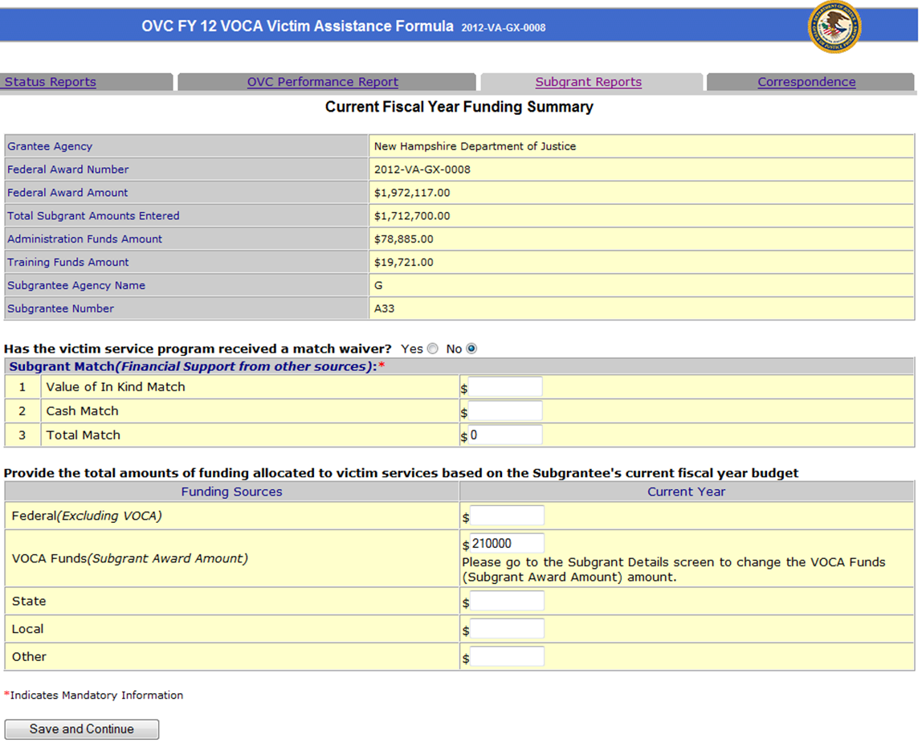

OVC PPSR Sub 7- OVC Subgrants Victims and Services Screen

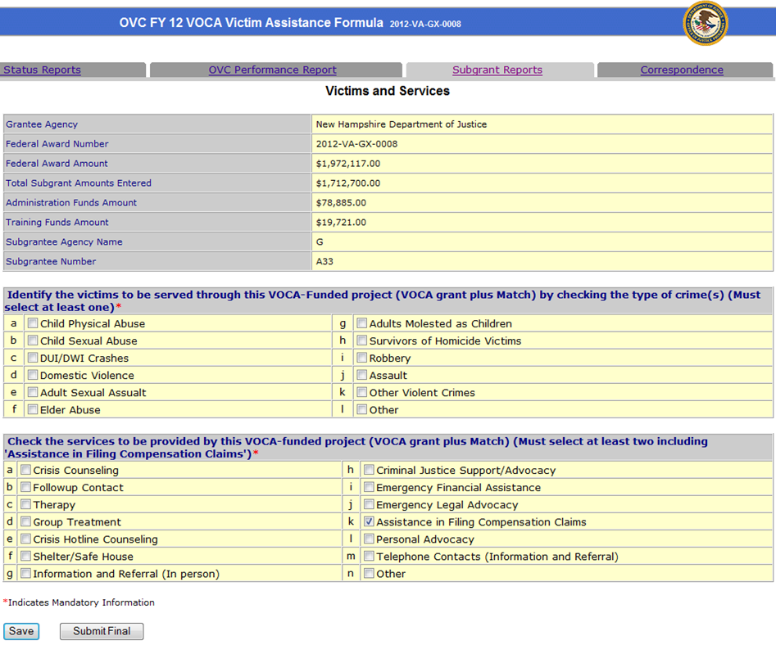

OJJDP PPSR JABG Sub 1- Subgrant Details Screen

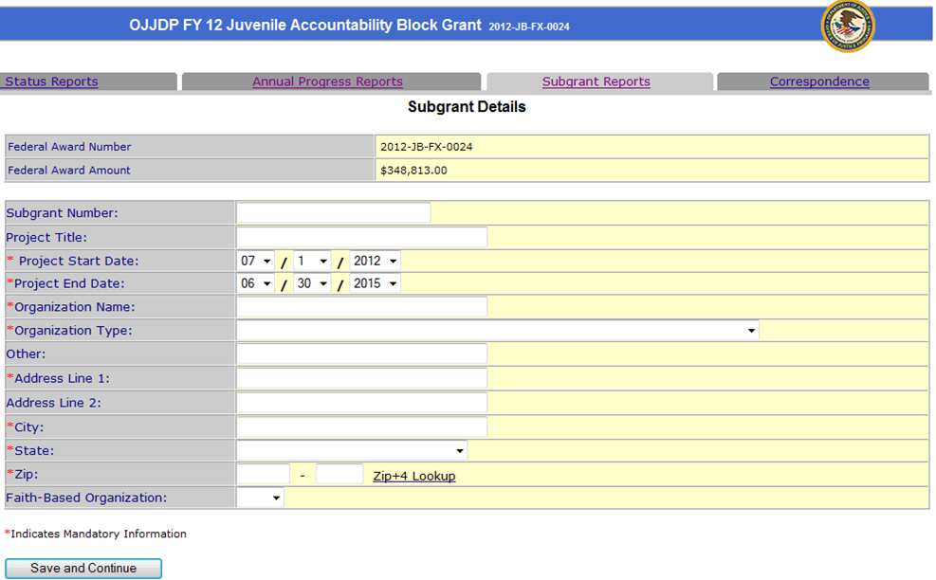

OJJDP PPSR JABG Sub 2- Subgrant Amount Screen

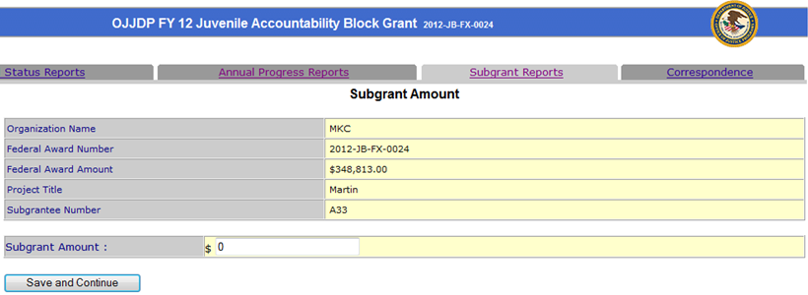

OJJDP PPSR JABG Sub 3- Purpose Area Screen

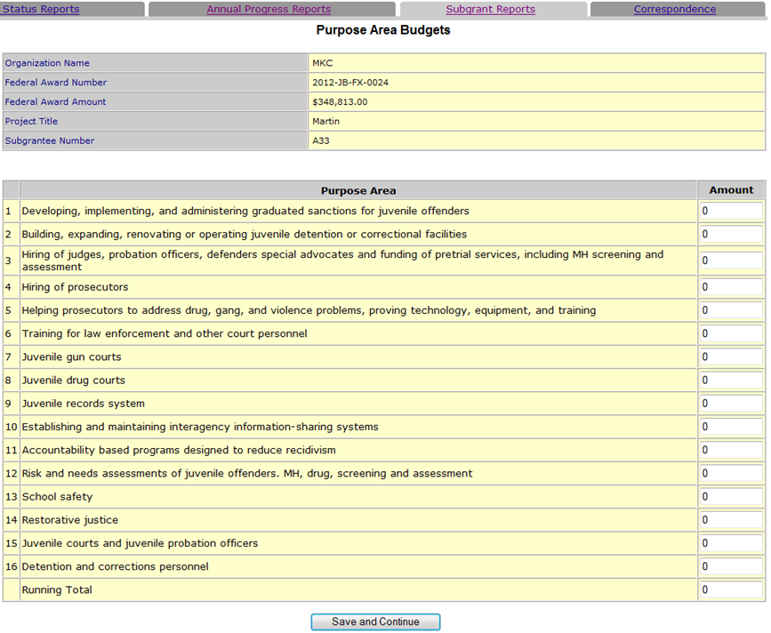

OJJDP PPSR JABG Sub 4- Juvenile Crime Enforcement Coalition Screen

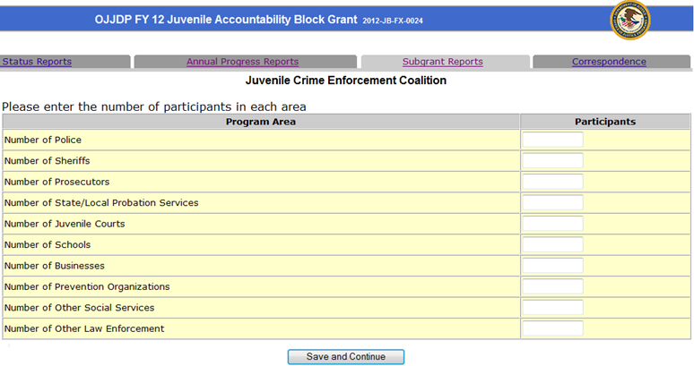

OJJDP PPSR JABG Sub 5- Subgrant Point of Contact Screen

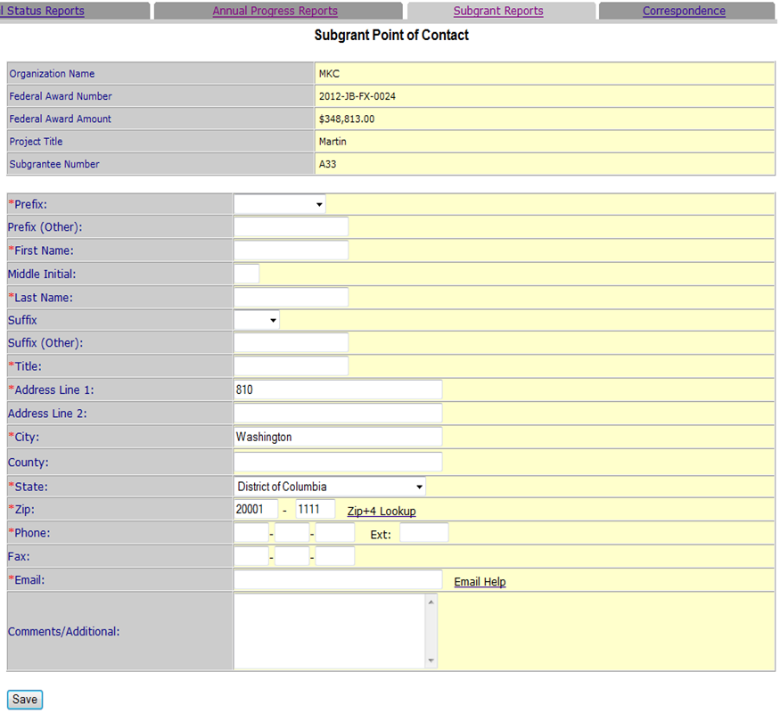

OJJDP PPSR Title II Sub 1- Subgrant Details Screen

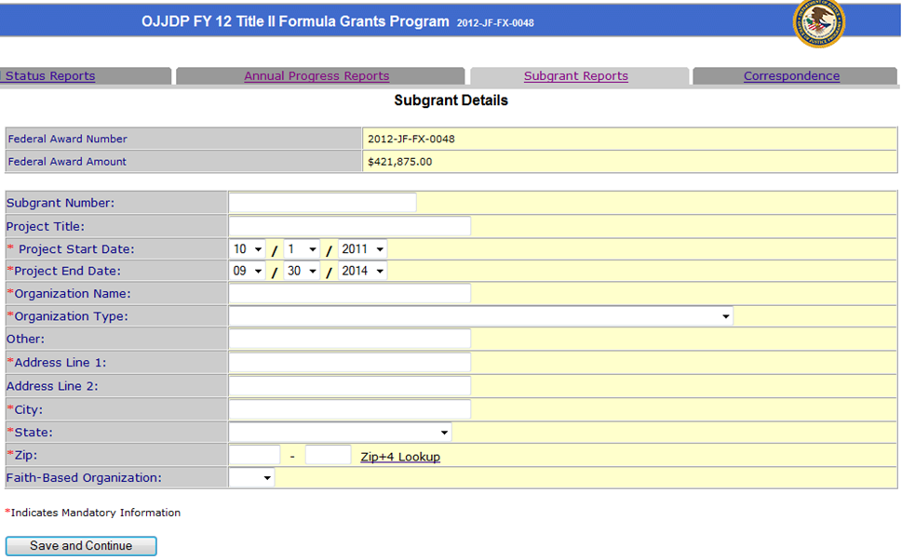

OJJDP PPSR Title II Sub 2- Subgrant Amount Screen

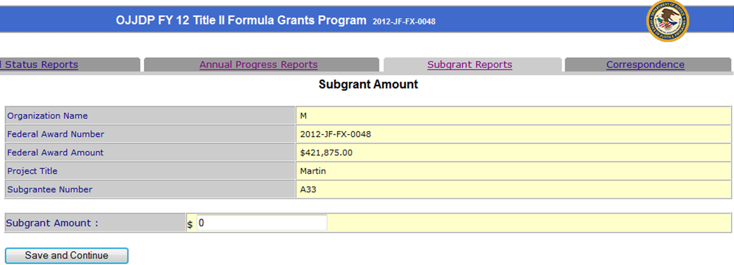

OJJDP PPSR Title II Sub 3- Standard Program Areas Screen

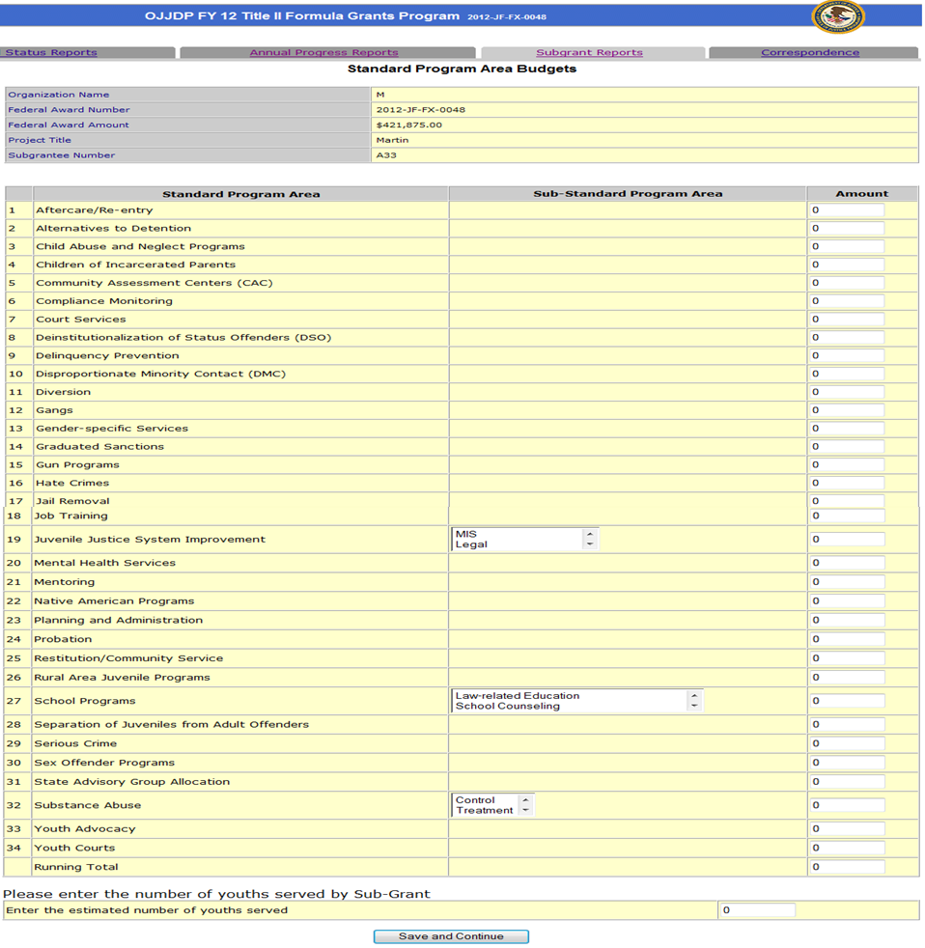

OJJDP PPSR Title II Sub 4- Point of Contact Screen

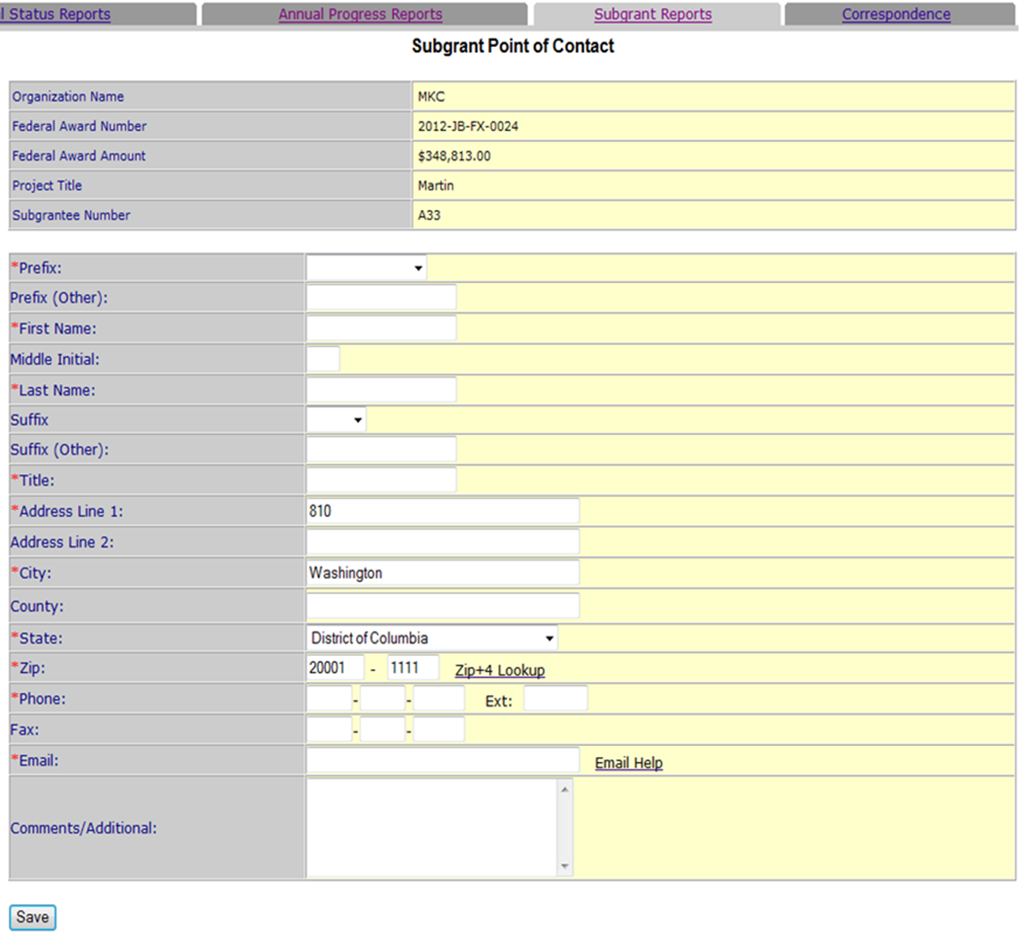

OJJDP PPSR Title V Sub 1- Subgrant Details Screen

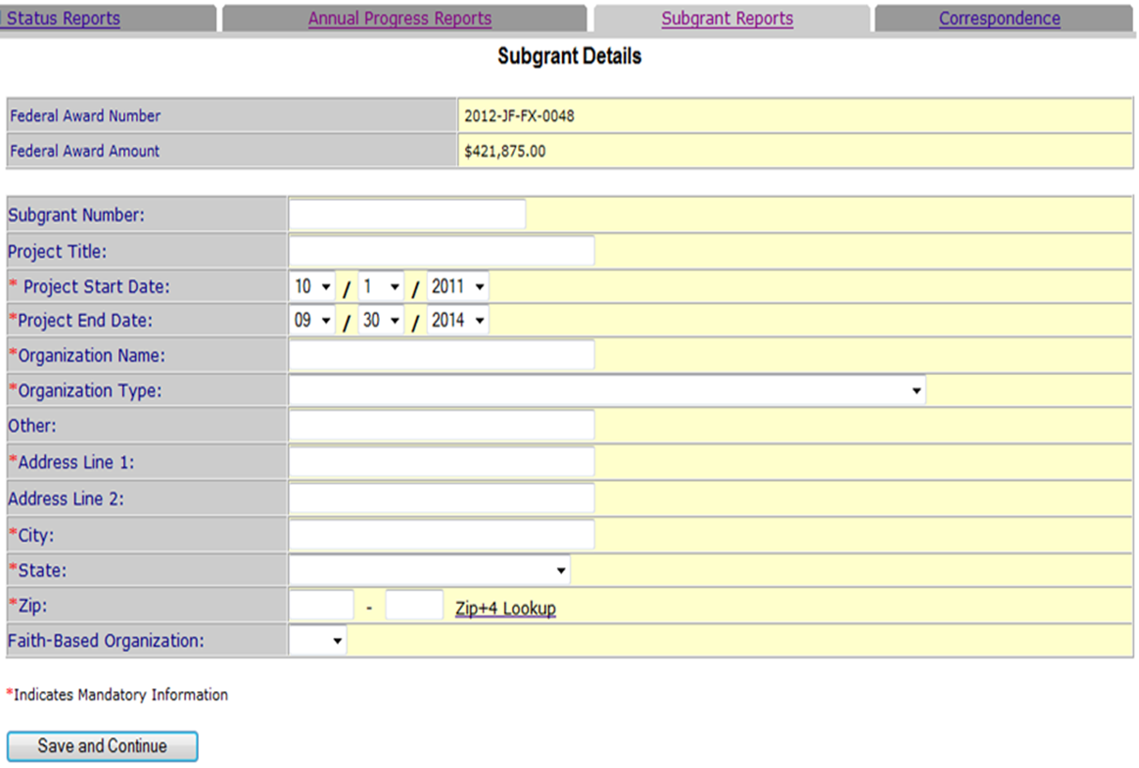

OJJDP PPSR Title V- Sub 2- Subgrant Amount Screen

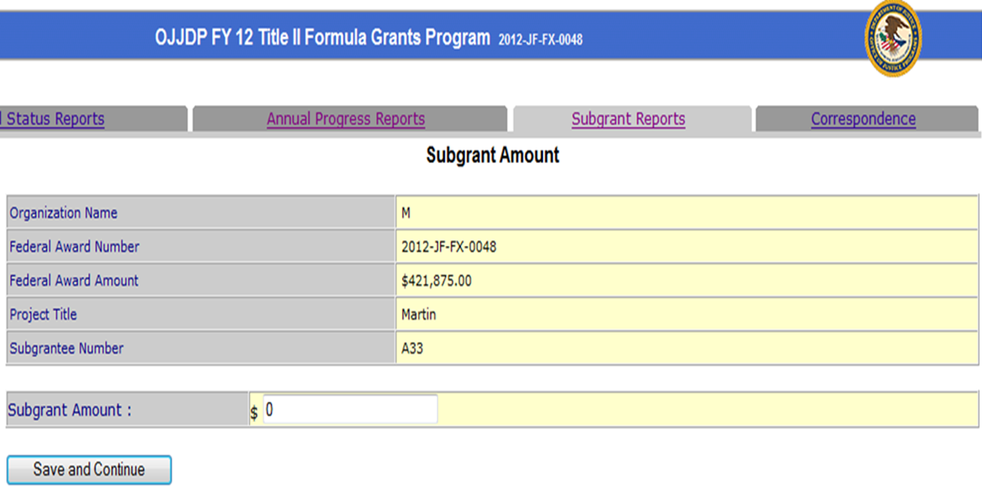

OJJDP PPSR Title V Sub 3- Project Area Screen
Unfortunately, this screen and the Policy Prevention Board Screen, which would be next, are not working correctly and are unable to be viewed. DCRs are necessary for this to be reported in GMS.

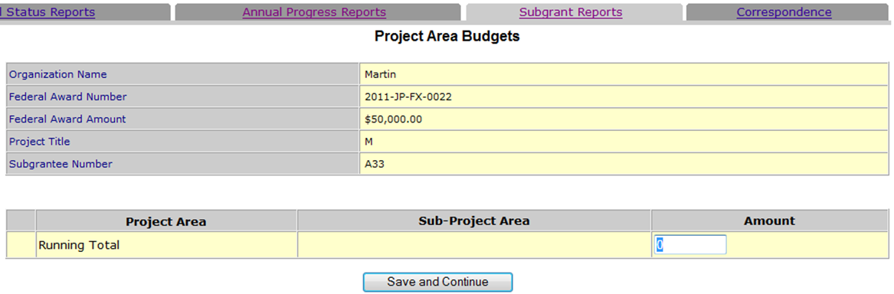

OJJDP PPSR Title V Sub 4- Point of Contact Screen

OJJDP PPSR EUDL Sub 1- Subgrant Details Screen

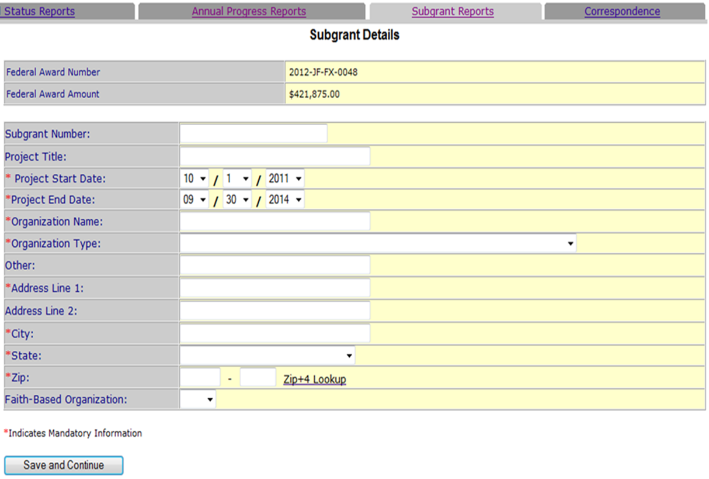

OJJDP PPSR EUDL Sub 2- Subgrant Amount Screen

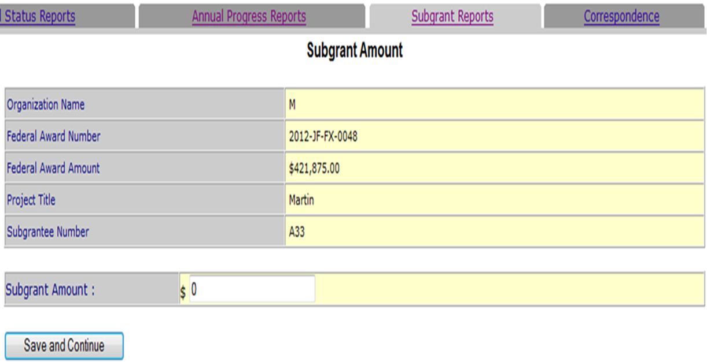

OJJDP PPSR EUDL Sub 3- Focus Areas Screen

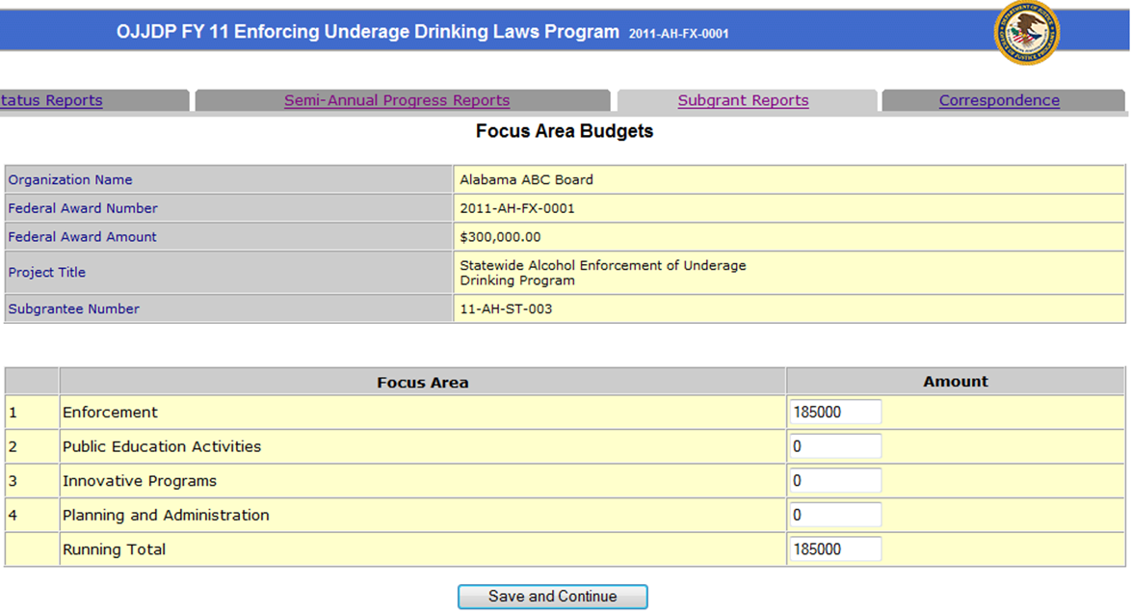

OJJDP PPSR EUDL Sub 4- Point of Contact Screen

