CO 1- Closeout Financial Reconciliation Screen

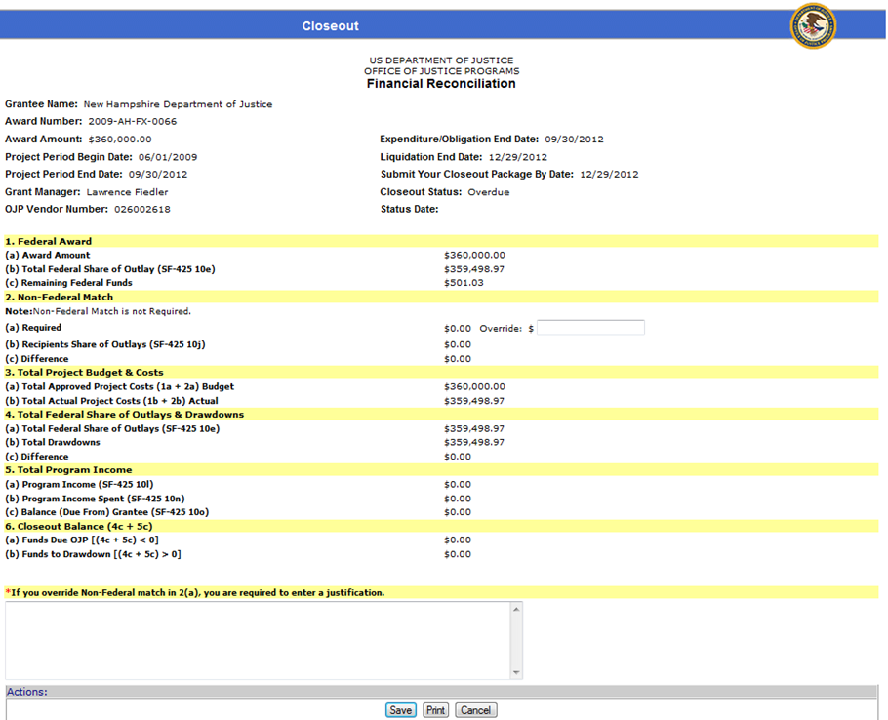

CO 2- Closeout Programmatic Requirements Certification Screen

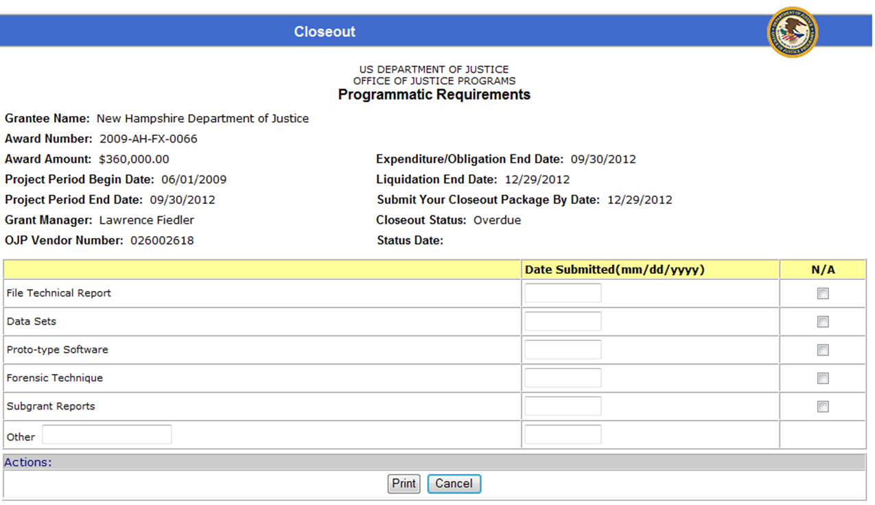

CO 3- Closeout Certification Screen

