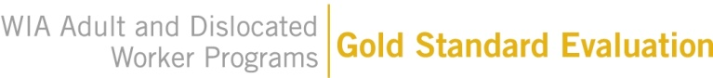
OMB Control No.: xxxx-xxxx
Expiration Date: xx/xx/20xx

WIA Gold Standard Evaluation
Resource Room Sign-In Sheet

Instructions

Please place the attached sign-in sheet near the entrance of your resource room; place it where customers can easily see it as they enter the room. Please ask customers to sign in before using the resource room for one week (Monday through Friday). If the resource room is unattended during some or all open hours, please post a sign asking customers to sign in upon entering.

The study team is primarily interested in knowing how many, rather that which customers use the room each day. For this reason, customers need only list their initials in the first column and not their full names. If a customer enters the resource room and does not list his or her initials on the sign-in sheet, the resource room attendant may simply write “Customer” in the first column.

Public reporting burden for this collection of information is estimated to average 0.5 minutes per respondent, including the time for reviewing instructions and recording the information requested. Send comments concerning this burden estimate or any other aspect of this collection of information to the Department of Labor, Employment and Training Administration, WIA Evaluation Room N-5641, 200 Constitution Ave. NW, Washington, DC, 20210. According to the Paperwork Reduction Act of 1995, an agency may not conduct or sponsor, and a person is not required to respond to, a collection of information unless it displays a valid OMB control number. The OMB control number for this information collection is xxxx-xxxx. Expiration Date xx/xx/20xx.
WIA Gold Standard Evaluation
Resource Room Sign In Sheet

Center Name: _________________________________
Start Date: ______________________________________

First and Last Initials | Date | Time In

