FedCASIC Web Survey
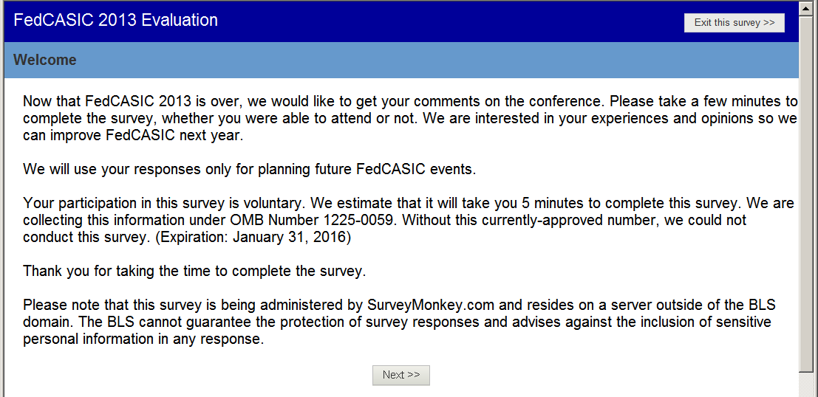
Welcome Screen

Question 1.

SKIP: If yes, go to Question 2. If no, skip to “Instructions for people who registered but didn’t attend” (after Question 15).
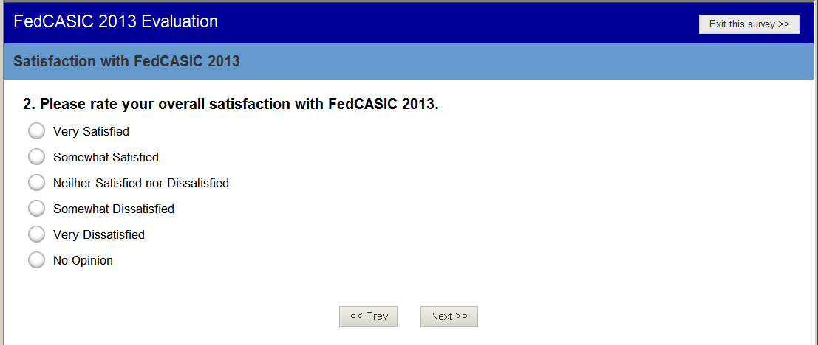
Question 2

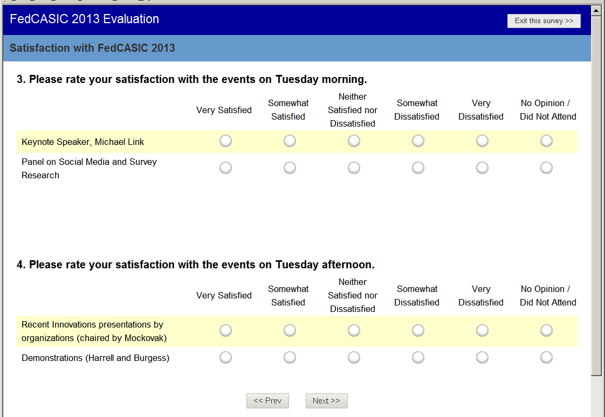
Questions 3 and 4
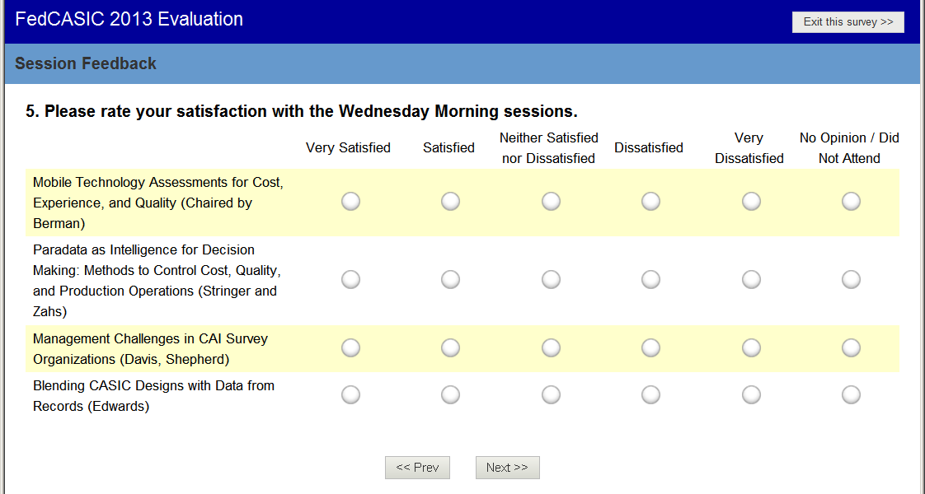
Question 5

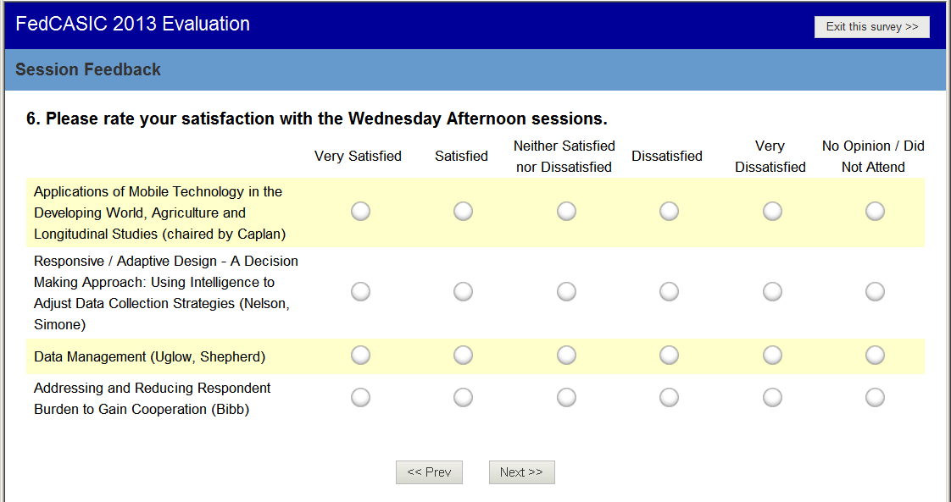
Question 6

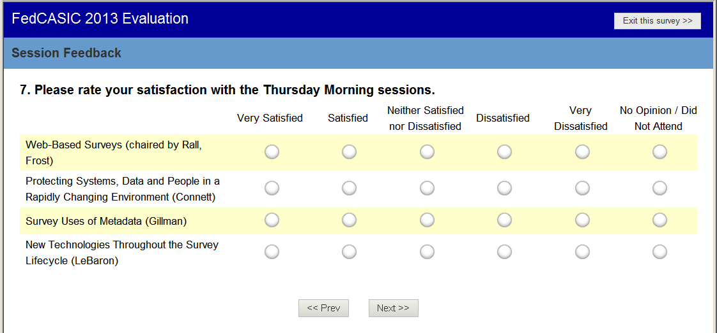
Question 7

Question 8

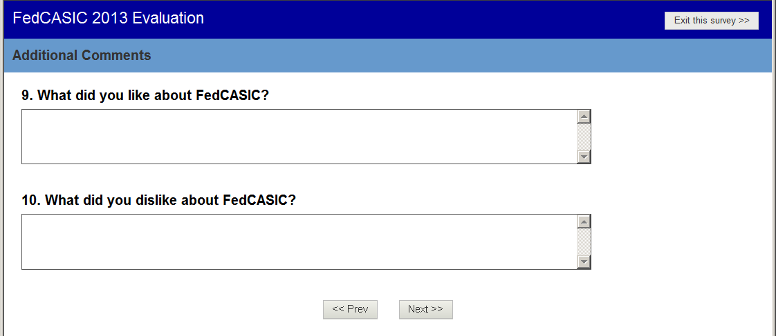
Questions 9 and 10

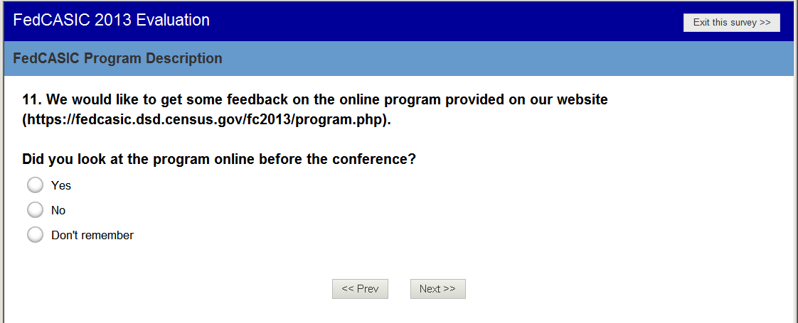
Question 11

SKIP: If yes, go to Question 12b. If no, go to 12a. If “Don’t Remember,” skip to Question 14.

Question 12a. SKIP to question 14.

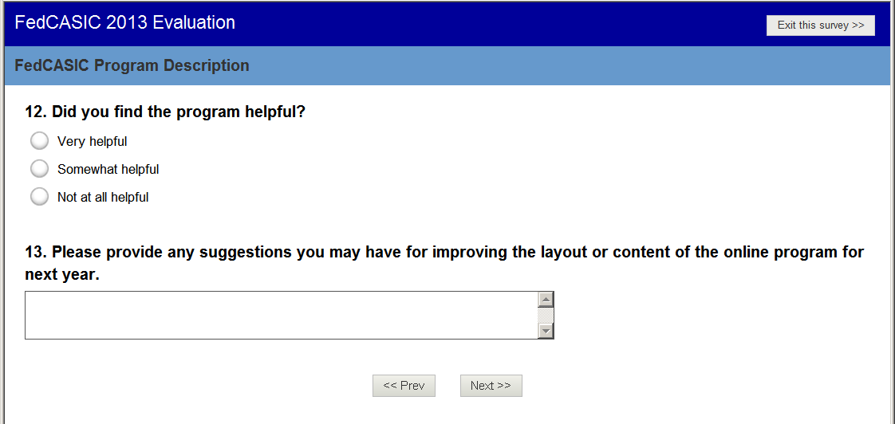
Questions 12b and 13

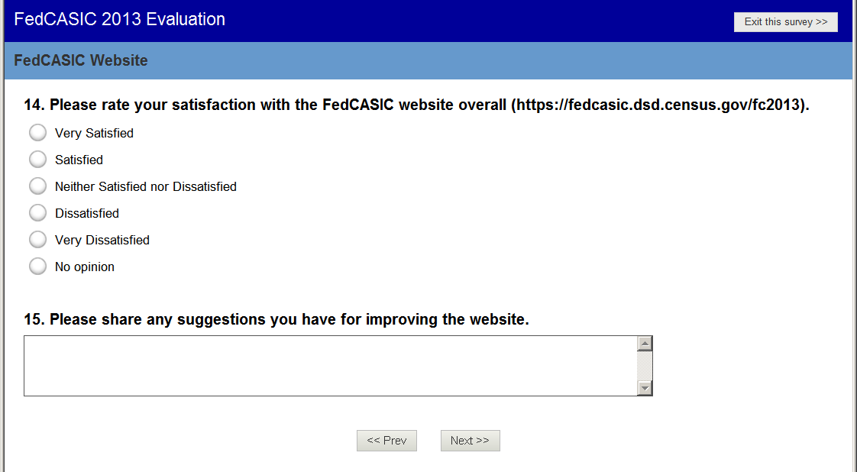
Questions 14 and 15. SKIP: Go to question 16.

Instructions for people who registered but didn’t attend. (Skipped to here if Q1 was No).

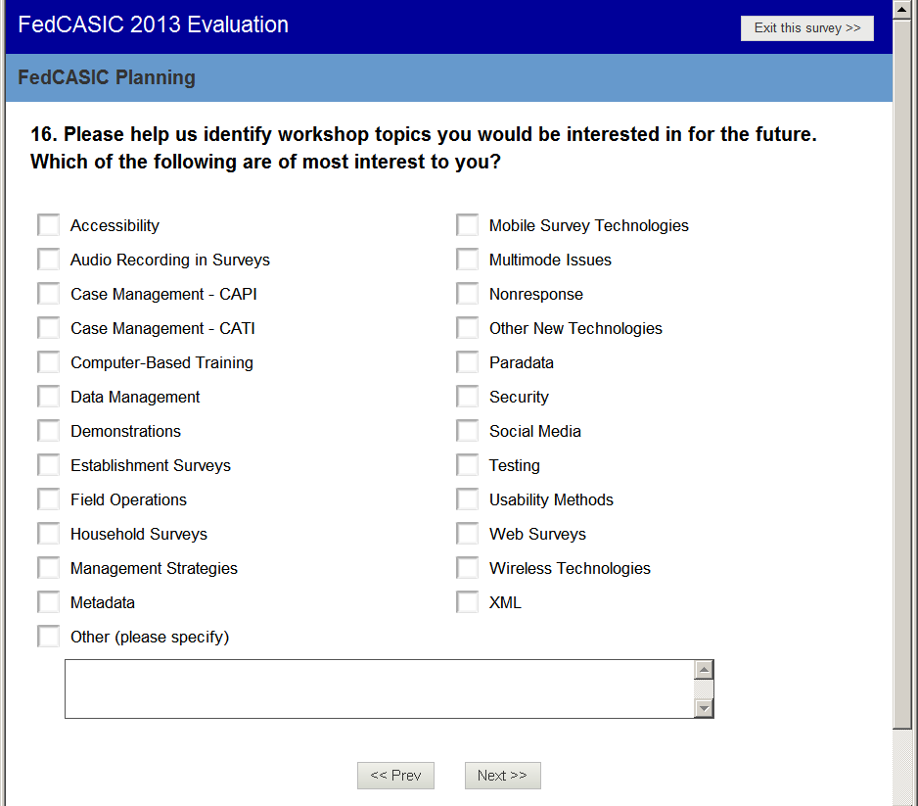
Question 16

Question 17

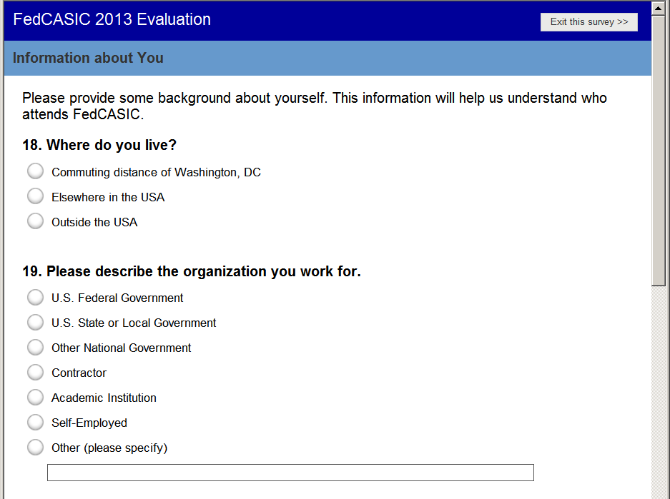
Questions 18 and 19

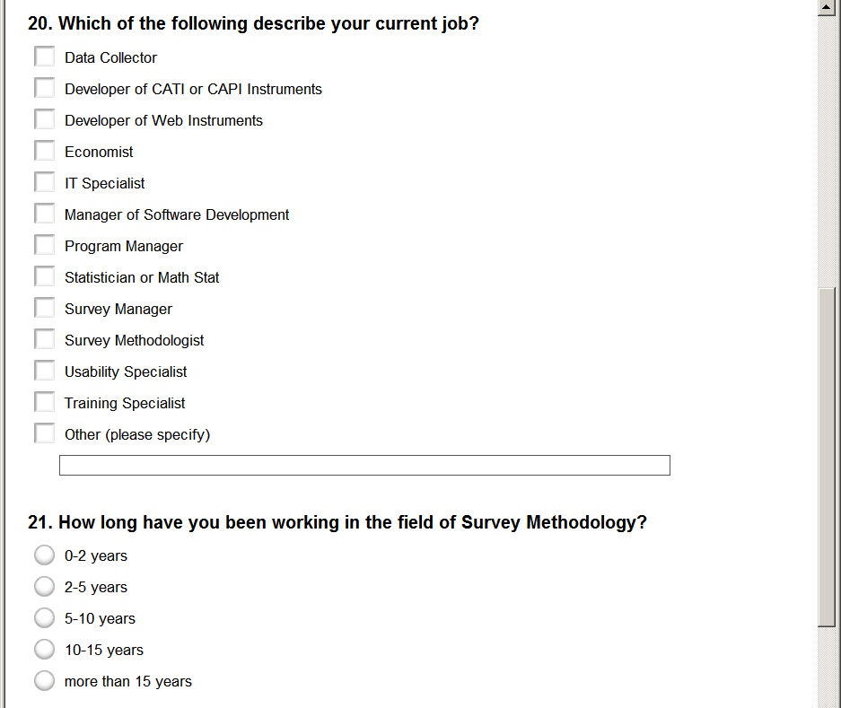
Questions 20 and 21

Question 22. SKIP: If Q22 = 0, then go to Question 23. Otherwise, go to Question 24

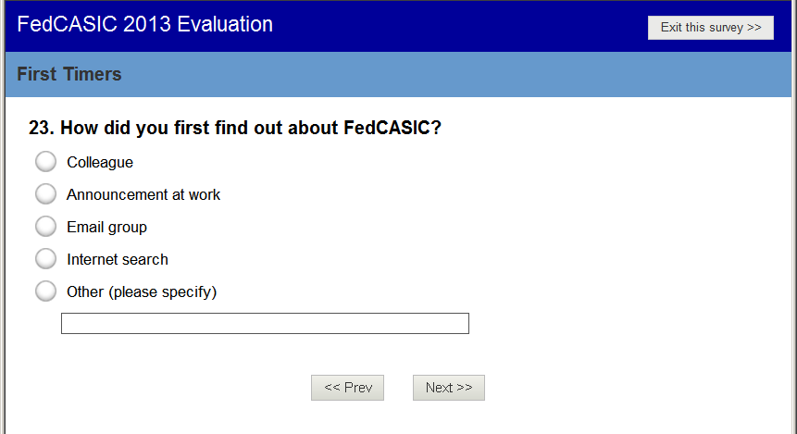
Question 23

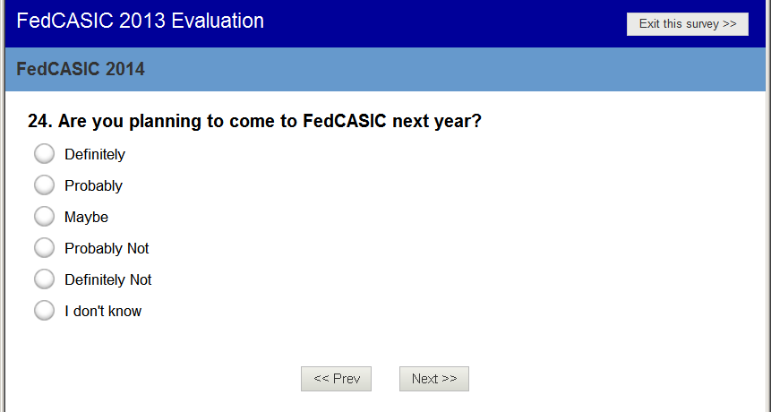
Question 24

Question 25

Thank you page

