Attachment D:
Principal Follow-up Survey (PFS) Questionnaires

Principal Follow-Up Surveys

PFS-1A | Principal Status Form for Public Schools
PFS-1B | Principal Status Form for Private Schools
PFS-1C | Principal Status Form for Public Principals
PFS-1D | Principal Status Form for Private Principals
PFS-1A(T) | Telephone Version of Principal Status Form for Public Schools
PFS-1B(T) | Telephone Version of Principal Status Form for Private Schools
PFS-1C(T) | Telephone Version of Principal Status Form for Public Principals
PFS-1D(T) | Telephone Version of Principal Status Form for Private Principals

PFS-1A

Principal Status Form for Public Schools

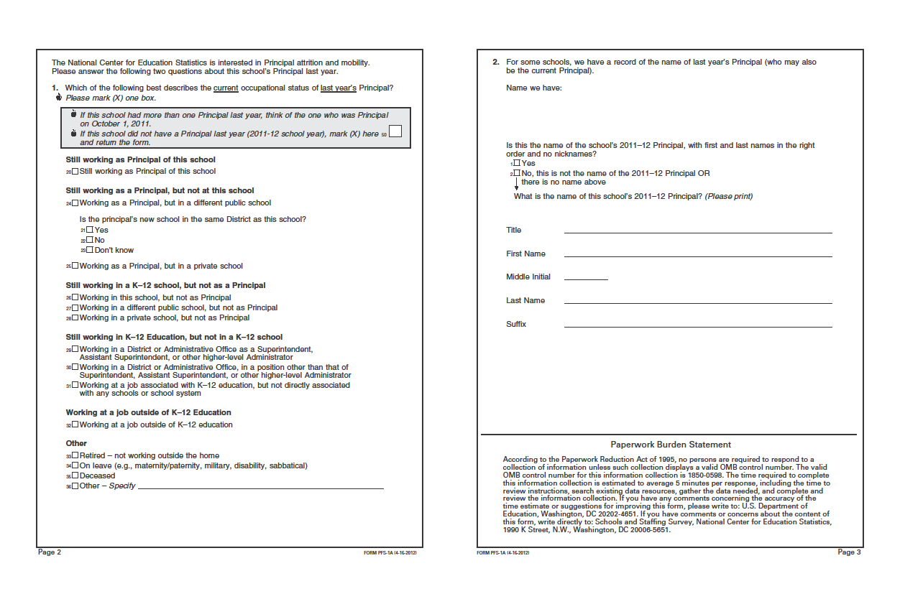

PFS-1B

Principal Status Form for Private Schools

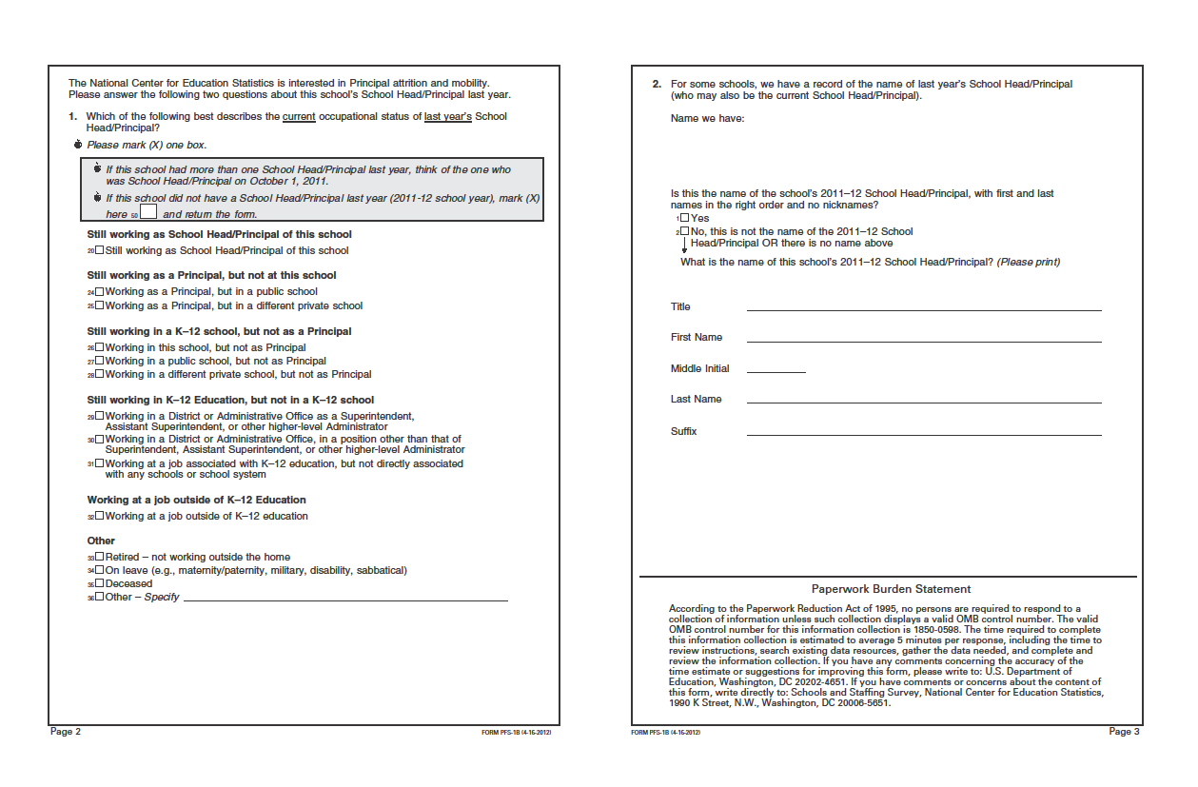

PFS-1C

Principal Status Form for Public Principals

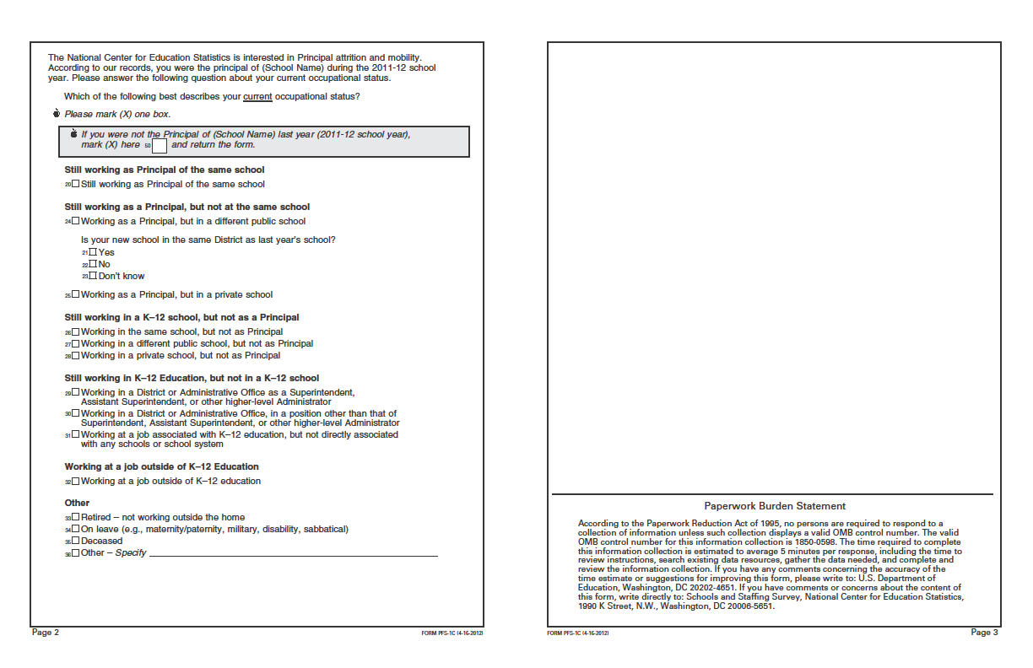

PFS-1D

Principal Status Form for Private Principals

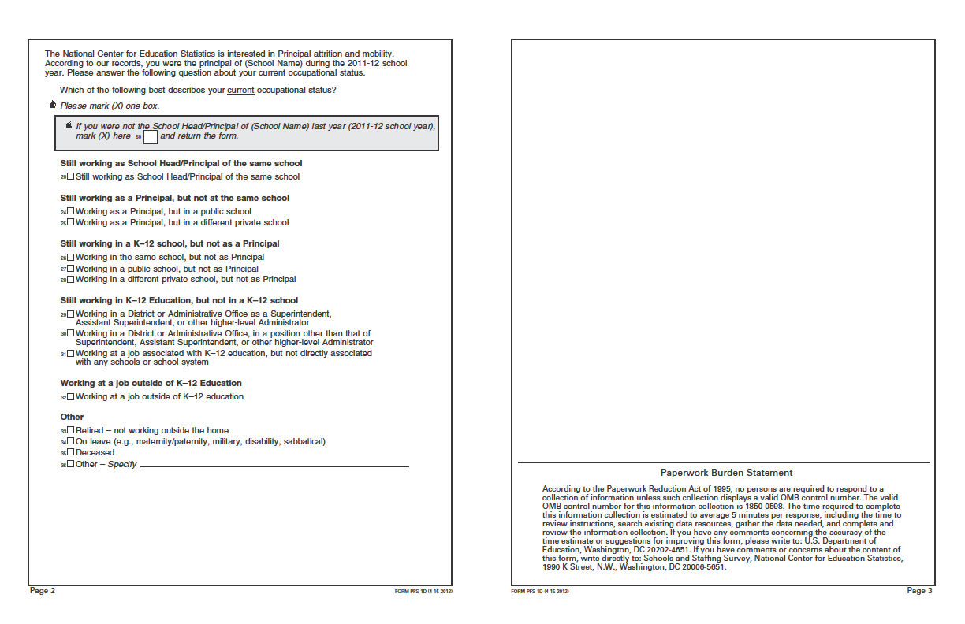

PFS-1A(T)

Telephone Version of Principal Status Form for Public Schools

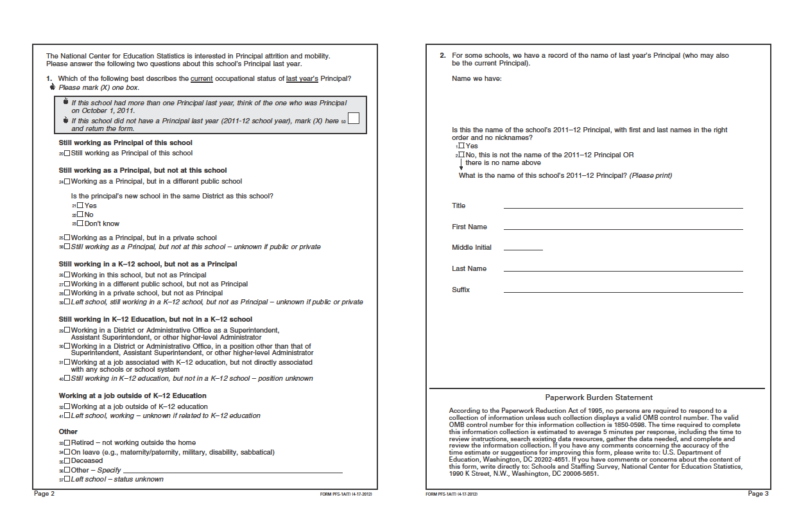

PFS-1B(T)

Telephone Version of Principal Status Form for Private Schools

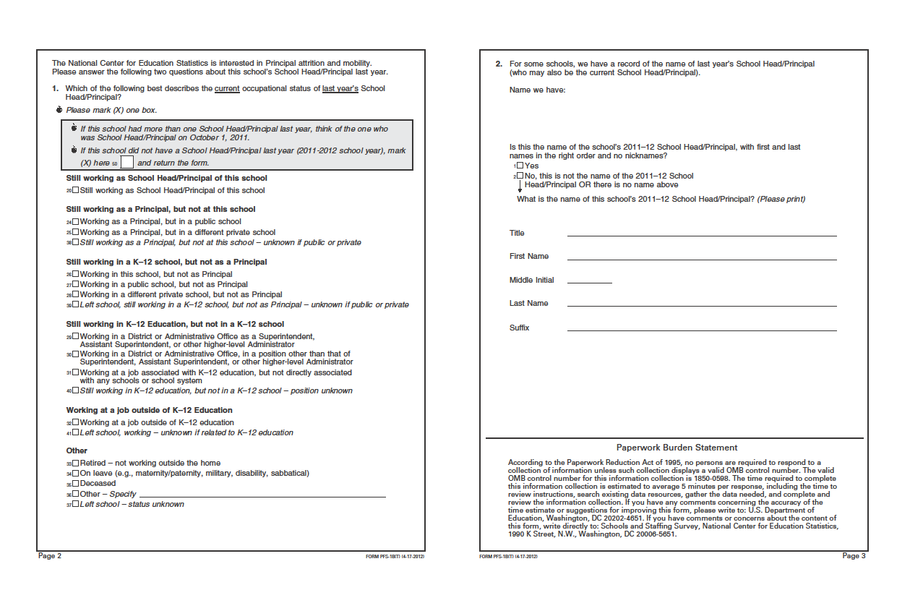

PFS-1C(T)

Telephone Version of Principal Status Form for Public Principals

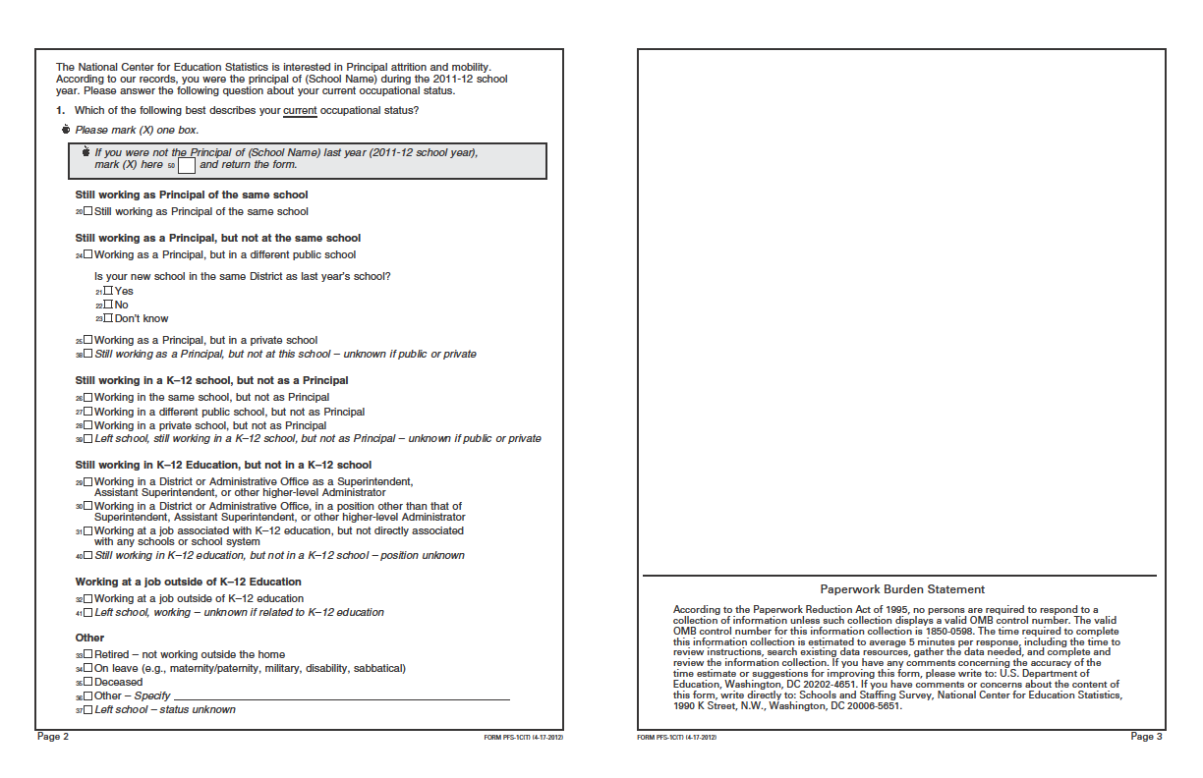

PFS-1D(T)

Telephone Version of Principal Status Form for Private Principals

