**EPIC IHP/APR Screen Views**

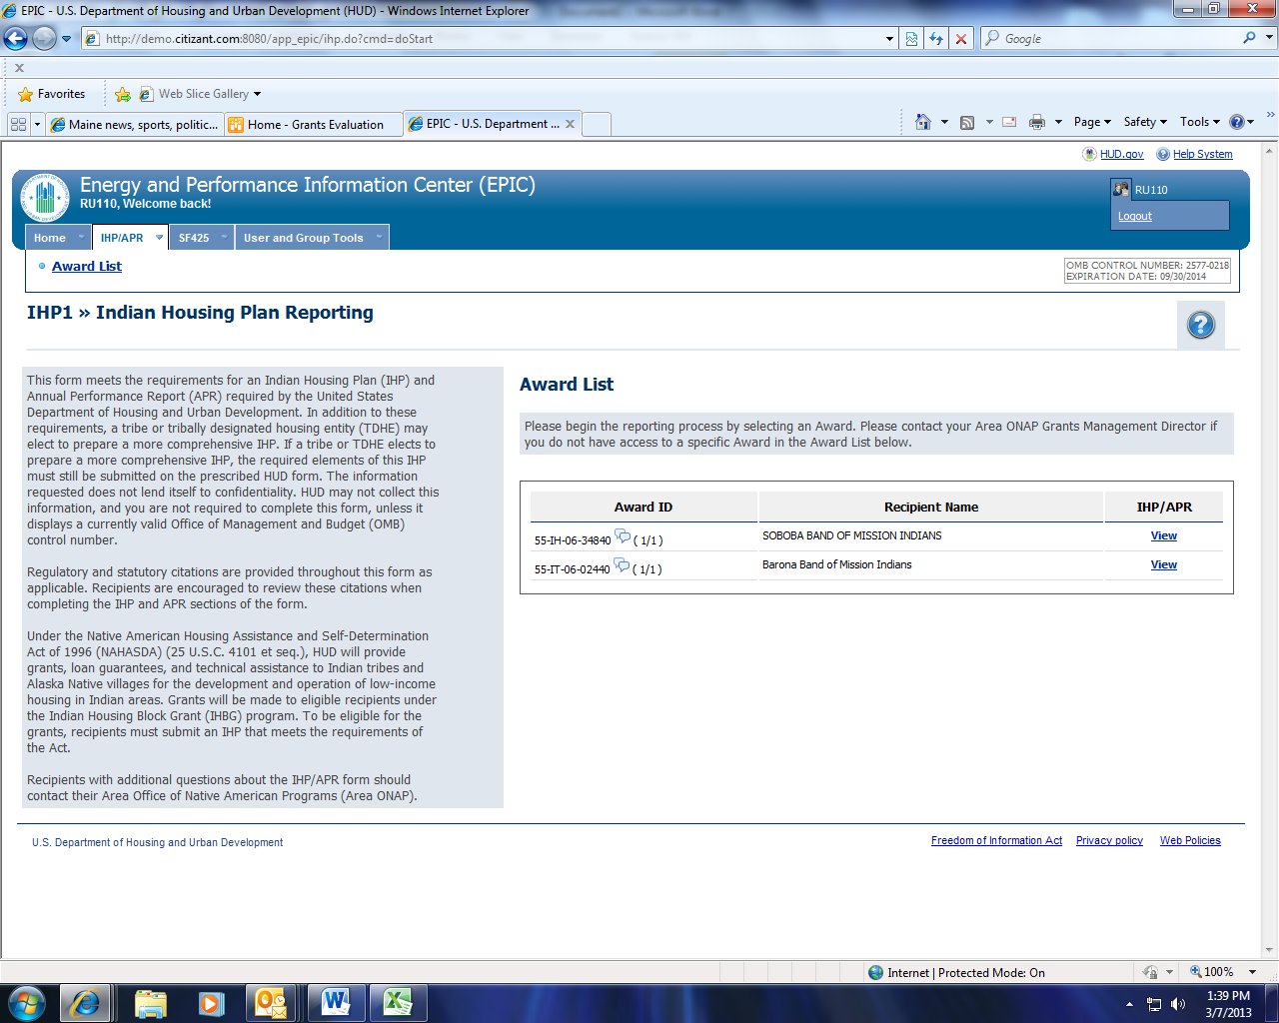

OMB Control Number, Expiation Date

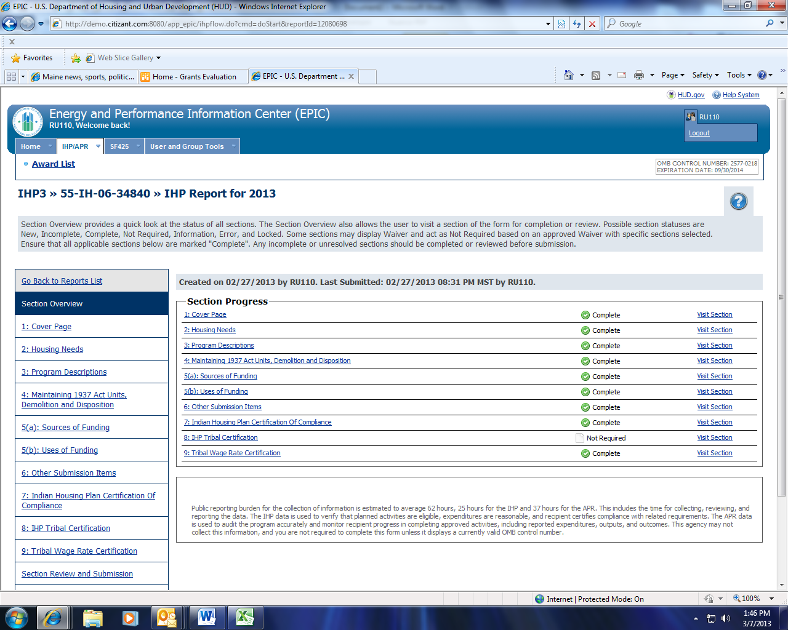

IHP Burden Statement

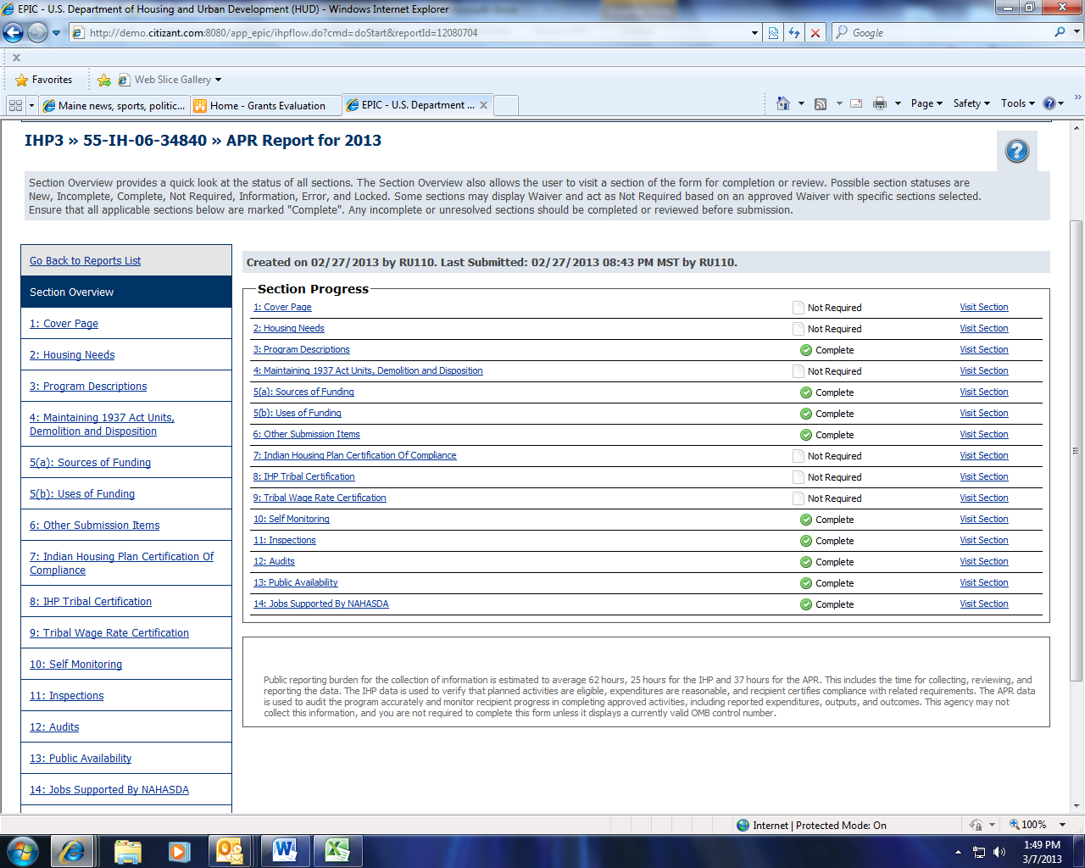

APR Burden Statement