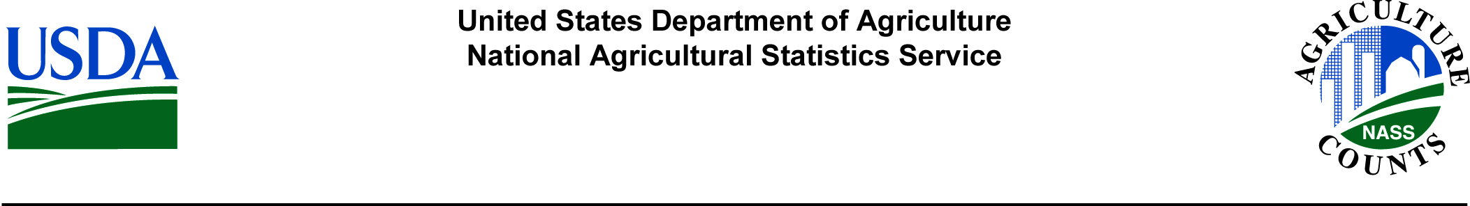

[Date]

Dear Mr./Ms. [Lastname]:

The National Agricultural Statistics Service (NASS) is testing the Hog Report form, and we need your help. NASS takes great care in developing agricultural questionnaires. The data we collect is critical to many sectors of the United States economy, including those people who develop agricultural policy. In order for the Hog Report to be thorough, at the same time making it as easy as possible for respondents to provide complete and accurate answers, NASS is looking for feedback on the questionnaire from farm operators such as yourself. You have been selected to take part in this important telephone test which will be conducted during the first full week of August.

The survey test will ask for information on market hog and breeding stock inventory, farrowing intentions, death loss, the latest pig crop and average pigs per litter. Your participation is important and will help provide a more efficient questionnaire.

Please be assured that your responses are completely confidential, as required by Federal law. The National Agricultural Statistics Service safeguards the privacy of all respondents, ensuring that no individual operation or producer can be identified.

Thank you for participating and for your support of our programs and [State] agriculture. If you have any questions or concerns, please do not hesitate to contact [Firstname Lastname] at (800) XXX-XXXX.

Sincerely,

[Director’s Name]

Director