**Generic Testing - Computer Assisted Personal Interview (CAPI)**

**In the June Area Survey and the Development**

**Of a Permanent Area Frame**

**OMB No. 0535-0248**

**Overview**

Propose research be conducted to modernize the June Area Survey (JAS) sampling frame and design. The project scope involves evaluating alternative processes for constructing an area frame and the impact of alternatives on sampling, data collection, and estimation for the JAS.

Current work is focusing on an area frame with permanent area segments. In permanent area frame segments, the tracts and fields may not be wholly contained within a segment boundary. In these cases, information must be collected about the entire field or tract, including the proportion of the field or tract that lies outside the segment. The most effective way to accomplish this is to delineate the field and/or tract utilizing (Geospatial Information Technology) GIS technology. Ideally, the entire tract or field would be delineated, including the part outside of the segment boundary, so that comparisons can be made with the operator self-report of field or tract size.

A computer-assisted personal interview survey instrument is needed to support a cost-effective data collection process for these delineations. The geospatial portion of the data collection instrument displays the aerial photography and provides tools to delineate fields and tracts at least partially within the area segment. A prototype instrument of this kind was used to collect delineations for 2011 NRI-CEAP (Conservation Effects and Assessment Program OMB # 0535-0245). This prototype was developed by Iowa State University (ISU) Center for Survey Statistics and Methodology (CSSM).

Even without the modernization of the JAS sampling frame, using Computer Assisted Personal Interviews (CAPI) to collect the data will bring about several improvements in efficiency and quality. CAPI would eliminate the need to key the data and allow error checks to be done during the interviews. In addition, adding a GIS interface to delineate the tracts and fields would eliminate the need to print the aerial photos reducing costs.

**Purpose of the Test**

1. To evaluate the feasibility of using permanent area segments and proposed protocols for working with such segments in the field.
2. To evaluate the use of CAPI for data collection of the June Area Survey, especially Section D.
3. Potential to save data entry costs, and the costs of aerial photos as well as improving data quality.

**Detailed Information**

The test would involve a sample of 90 segments; 40 segments in Pennsylvania, 40 segments in Indiana and 10 segments in Washington. The number of individuals who own land located inside these segments is estimated to be 30 or less per segment (see table below). The estimated number of these individuals who are classified as agricultural operators will be about 1,400 with an additional 1,000 classified as non-agricultural operators of land. The testing is expected to occur from late July through September.

The CAPI portion of the questionnaire will focus primarily on Section D of the 2012 June Area Survey (OMB # 0535-0213). The 2012 June Area Survey Pre-screener (OMB #0535-0213) will be conducted on paper unless a more streamlined approach is added to the CAPI instrument. The other sections of the June Area Survey will be conducted on paper.

The CAPI portion involves the field enumerators delineating the fields and tracts using the CAPI interface, which would calculate the proportion of area that is included in each field, and tract within the segment.

This is a new way of collecting data via CAPI. The projected time to collect the data will average around 30 minutes per agricultural interview. Interview length of non- agricultural operators is estimated to take 5 minutes per interview. Incorporating new technologies into the business process, there is a learning curve and CAPI is no exception, however, as the field enumerators become more accustomed in using CAPI, the length of the interview is predicted to decrease substantially.

The CAPI equipment used will be Apple iPADs (Version 3) with built in Verizon or AT&T service.

**Screen Shot of Section D on an iPAD:**

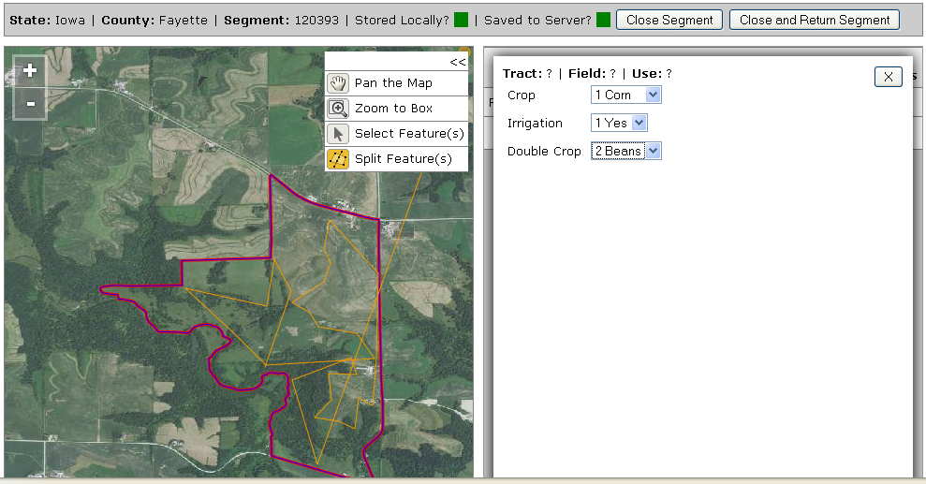

**Burden Calculations**

