**Generic Testing - Computer Assisted Personal Interview (CAPI)**

**In the June Area Survey and the Development**

**Of a Permanent Area Frame**

**OMB No. 0535-0248**

**Overview**

Propose research be conducted to modernize the June Area Survey (JAS) sampling frame and design. The project scope involves evaluating alternative processes for constructing an area frame and the impact of alternatives on sampling, data collection, and estimation for the JAS.

The current method for selecting segments for the June Area Survey is a two step process.  First, all land in a state is stratified using several GIS layers, such as satellite imagery, aerial photography, and the NASS Cropland Data Layer.  This is a manual process on the computer screen in which Primary Sampling Units (PSU) are digitized to meet the defined strata for a state.  The PSUs are typically eight square miles in the highly cultivated land strata.  This manual process for one state has been taking about 4-6 months for five people to complete.  The second step is to select segments in the sampled PSUs.  In this step segments are digitized in the selected PSU.  In highly cultivated strata the segments are typically one square mile.  For example, staff will be dividing an eight square mile PSU into eight one square mile segments.  Then one segment is randomly chosen.  Segment delineation is only necessary in the selected PSUs.  PSUs are really only a method to avoid drawing off all the segments to save resources.  About eight people are used each year to select the newly rotated in samples.

Current research is focusing on an area frame with permanent area segments. In permanent area frame segments, the tracts and fields may not be wholly contained within a segment boundary. In these cases, information must be collected about the entire field or tract, including the proportion of the field or tract that lies outside the segment. The most effective way to accomplish this is to delineate the field and/or tract utilizing (Geospatial Information Technology) GIS technology. Ideally, the entire tract or field would be delineated, including the part outside of the segment boundary, so that comparisons can be made with the operator self-report of field or tract size.

With the new methods we could have a permanent grid of segments.  If available the Public Land Survey System (PLSS) will be the basis for the grid, otherwise one will be created to layover the state.  The stratification of segments would be automated using primarily the Cropland Data Layer.  Afterwards the direct selection of segments would occur.  This has potential to greatly reduce the time needed to build and select the area frame segments.

A computer-assisted personal interview survey instrument is needed to support a cost-effective data collection process for these delineations. The geospatial portion of the data collection instrument displays the aerial photography and provides tools to delineate fields and tracts at least partially within the area segment. A prototype instrument of this kind was used to collect delineations for 2011 NRI-CEAP (Conservation Effects and Assessment Program OMB # 0535-0245). This prototype was developed by Iowa State University (ISU) Center for Survey Statistics and Methodology (CSSM).

Even without the modernization of the JAS sampling frame, using Computer Assisted Personal Interviews (CAPI) to collect the data will bring about several improvements in efficiency and quality. CAPI would eliminate the need to key the data and allow error checks to be done during the interviews. In addition, adding a GIS interface to delineate the tracts and fields would eliminate the need to print the aerial photos reducing costs.

**Purpose of the Test**

1. To evaluate the feasibility of using permanent area segments and proposed protocols for working with such segments in the field.
2. To evaluate the use of CAPI for data collection of the June Area Survey, especially Section D.
3. Potential to save data entry costs, and the costs of aerial photos as well as improving data quality.

**Detailed Information**

The test would involve a sample of 90 segments; 40 segments in Pennsylvania, 40 segments in Indiana and 10 segments in Washington. The number of individuals who own land located inside these segments is estimated to be 30 or less per segment (see table below). The estimated number of these individuals who are classified as agricultural operators will be about 1,400 with an additional 1,000 classified as non-agricultural operators of land. The testing is expected to occur from late July through September.

We chose PA, IN, and WA from a list of States where we have already constructed a permanent area frame for research.  The basis of the frame (Public Land Survey System or arbitrary grid), presence of CAPI hardware, experience of enumerators, staffing levels of field offices, and travel expenses were considered.  Within PA, the segments were randomly selected from counties near the field office to simplify travel.  These arbitrary grid segments will allow us to test the CAPI instrument in the absence of physically identifiable segment boundaries and with varying network connectivity.  They will also help us refine data collection protocols.  Indiana segments were randomly selected from counties with enumerators that will also be trained for NRI-CEAP.  These experienced enumerators and the PLSS segments in their counties will allow us to test the CAPI instrument under relatively simple conditions.  In WA, the segments were randomly drawn from counties where particularly savvy enumerators face more challenging situations.  Those are terrain in northwestern WA and intensive agriculture in south central WA.

The CAPI portion of the questionnaire will focus primarily on Section D of the 2012 June Area Survey (OMB # 0535-0213). The 2012 June Area Survey Pre-screener (OMB #0535-0213) will be conducted on paper unless a more streamlined approach is added to the CAPI instrument. The other sections of the June Area Survey (A-C and E-R) will not be done, which will help minimize respondent burden.

Only the Part D of the June Area Frame questionnaire and the GIS component are CAPI based. The GIS portion involves the field enumerators delineating the fields and tracts using the CAPI interface, which would calculate the proportion of area that is included in each field, and tract within the segment.

This is a new way of collecting data via CAPI. The projected time to collect the data will average around 30 minutes per agricultural interview. Interview length of non- agricultural operators is estimated to take 5 minutes per interview. Incorporating new technologies into the business process, there is a learning curve and CAPI is no exception, however, as the field enumerators become more accustomed in using CAPI, the length of the interview is predicted to decrease substantially.

The CAPI equipment used will be Apple iPADs (Version 3) with built in Verizon or AT&T service.

Before beginning an interview, NASS will provide the respondents with a paper letter describing the purpose of the interview, asking for their assistance, and informing them of its voluntary nature.  This letter will include the OMB Burden statement, estimated time, and clearance number.

**Screen Shot of Section D on an iPAD:**

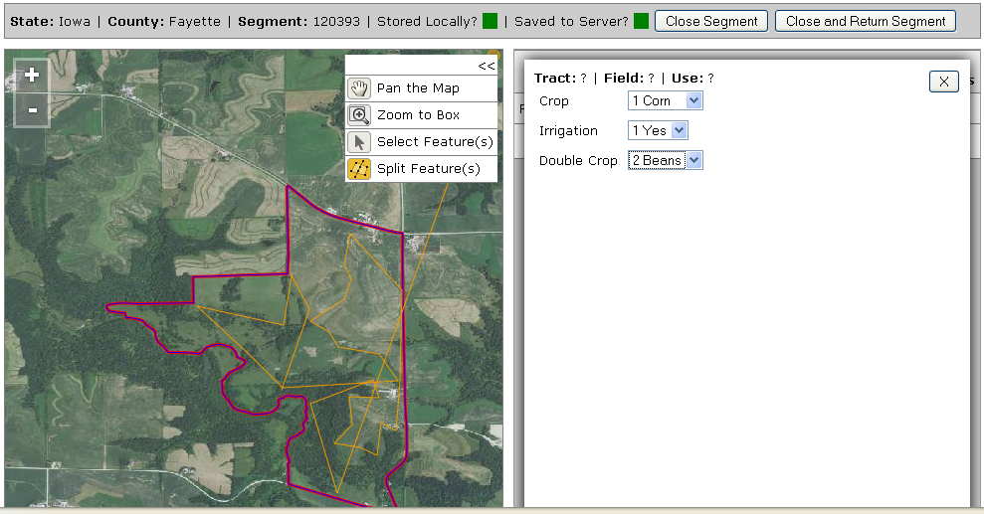

**Burden Calculations**

