OMB Control No. 0648-0594
Expires 9/30/2012

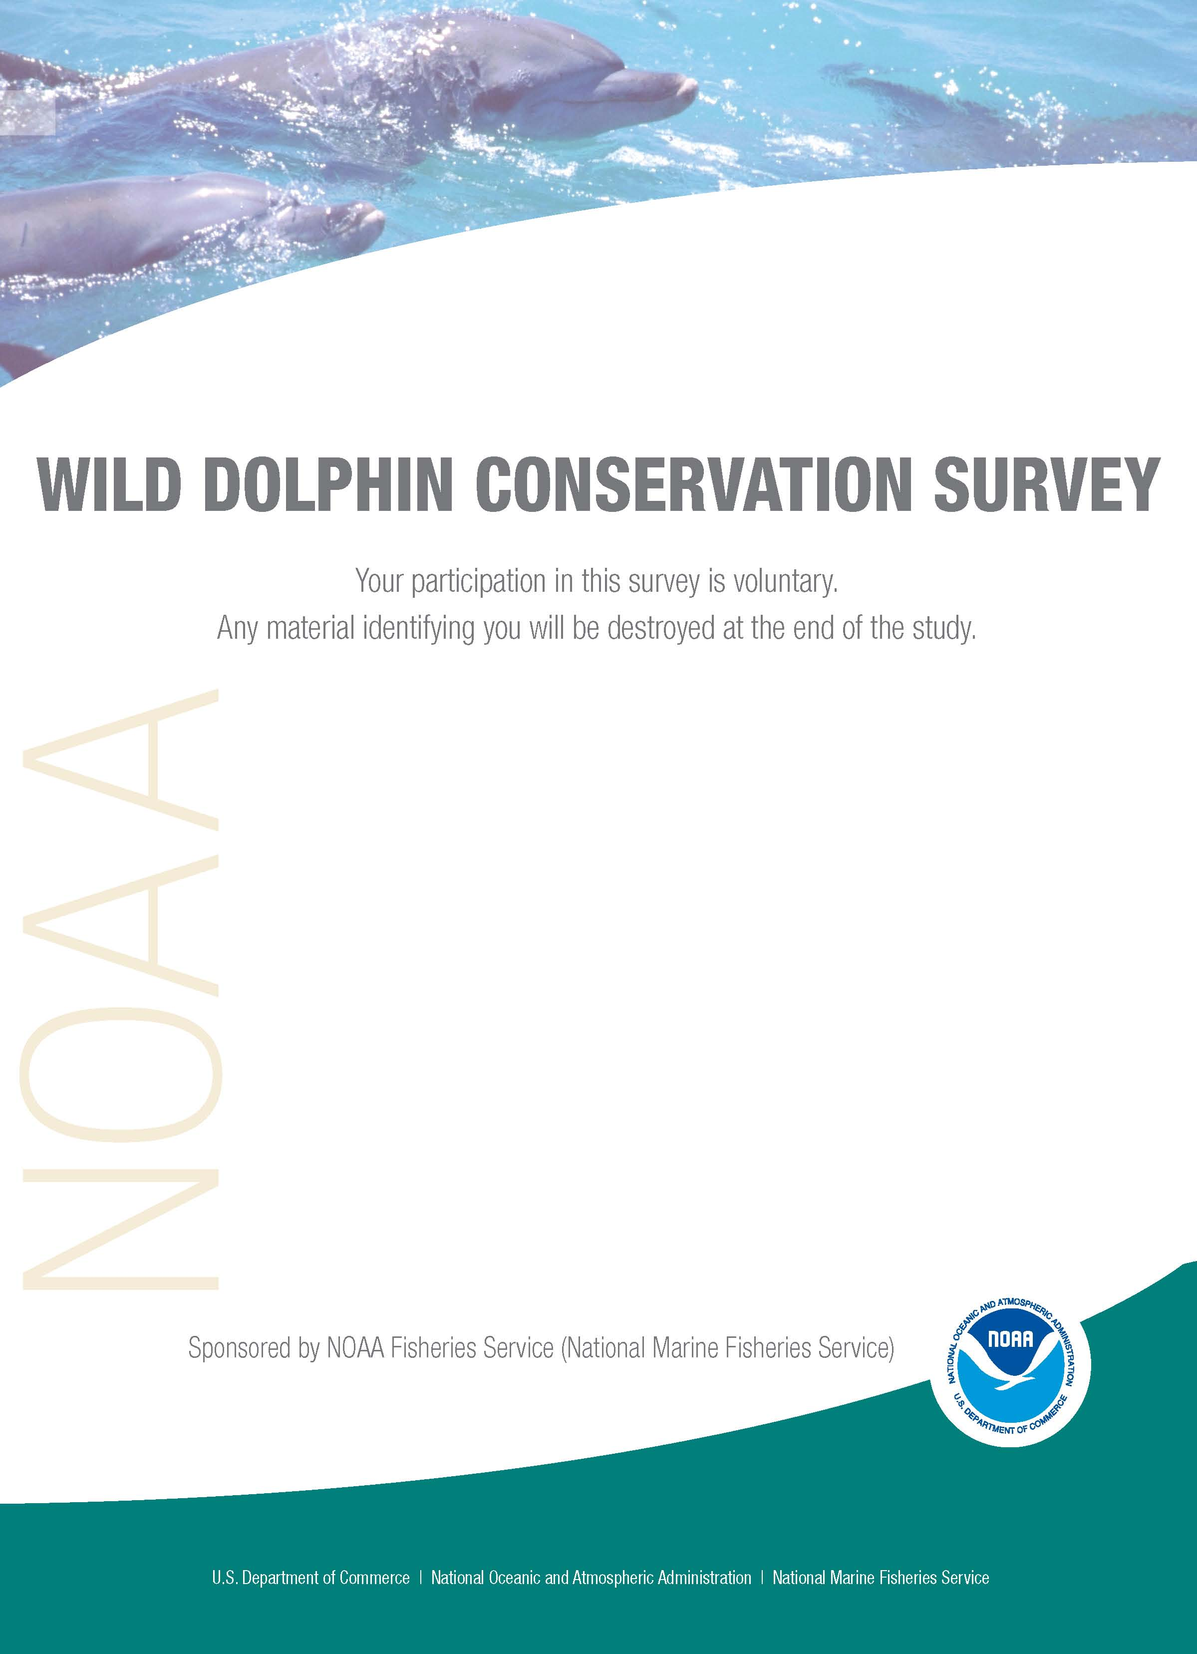
RESIDENTS/TOURISTS SURVEY

NOAA Fisheries Service (NMFS) is conducting a survey for more information on the public’s awareness and knowledge about wild dolphin conservation. The questions in this survey are about dolphins in the wild rather than dolphins in public display facilities (i.e., zoos and aquaria); therefore, any reference to the word “dolphin” means dolphins in the wild. The results of the survey will be used to help determine the effectiveness of NMFS’ public outreach efforts for wild dolphin conservation and guide future outreach activities.

Q1 How concerned are you, if at all, about protecting dolphins? (Please check one box)

❑ Very concerned
❑ Somewhat concerned
❑ Not very concerned
❑ Not at all concerned
❑ Neutral

Q2 To the best of your knowledge, which statement is true? (Please check one box)

❑ It is illegal but not harmful to feed dolphins in the wild → please go to Q3
❑ It is not illegal but harmful to feed dolphins in the wild → please go to Q3
- It is illegal and harmful to feed dolphins in the wild → please go to Q3
- It is not illegal nor harmful to feed dolphins in the wild → please go to Q4

Q3 Please tell us where you heard or read the information about feeding dolphins in the wild. (Please check all that apply)

A. Posted signs on or at:
❑ Docks or marinas
- Fishing Piers
- Visitor centers
- Other (please describe)__________________

B. Brochure from:
❑ Visitor centers
- Hotel
- Boat rental company
- Zoo or aquarium
- Federal, state, or local government
- Other (please describe)__________________
C. Public Service Announcement (PSA) through:
- Animal related television channel/show
- Non-wildlife related television channel
- Radio station
- Newspaper
- Magazine

D. Zoological or nature center:
- Zoo, aquarium, or a wildlife theme park such as Gulf World or Sea World
- City, county, or state park
- Other (please describe)__________________

E Internet:
❑ Florida Visitor Bureau or local tourism website
- Environmental conservation or non-profit organization website
- Federal, state, or local government website
- News related website
- Other (please describe)__________________

F. Television news:
❑ Local
❑ National
- Other (please describe)__________________
G. Newspaper article:
❑ Local
❑ National
- Other (please describe)__________________
H. Other:
❑ Educational workshops
❑ Nature/wildlife tour
- Word of mouth (i.e., friends and family)
- Billboard
- Other (please describe)__________________
- Cannot recall

Q4 Have you ever heard or read that it is all right to feed, pet, touch, or swim with dolphins in the wild? (Please check one box)

❑ Yes → please go to Q5
❑ No → please go to Q6
❑ Don’t know → please go to Q6

Q5 If you answered “Yes” to Q4, please tell us where you heard or read the information. (Please check all that apply)

- Television
- Newspaper

❑ Magazines
- Radio
- Movies
- Advertisements
- Aquarium
- Zoos or wildlife parks
- Commercial tour operations
- Word of mouth (i.e., friends and family)
- Other (please describe)__________________
- Cannot recall

Q6 To the best of your knowledge, which statement is true? (Please check one box)

❑ Swimming with, touching, or petting dolphins is potentially illegal but not harmful to you or dolphins → please go to Q7
- Swimming with, touching, or petting dolphins is not illegal but harmful to both dolphins and you → please go to Q7
- Swimming with, touching, or petting dolphins is potentially illegal and harmful to both you and dolphins → please go to Q7
- Swimming with, touching, or petting dolphins is not illegal nor harmful to you or dolphins → please go to Q8

Q7 Please tell us where you heard or read the information about swimming with, touching, or petting dolphins. (Please check all that apply)

A. Posted signs on or at:
❑ Docks or marinas
- Fishing Piers
- Visitor centers
- Other (please describe)__________________

B. Brochure from:
❑ Visitor centers
- Hotel
- Boat rental company
- Zoo or aquarium
- Federal, state, or local government
- Other (please describe)__________________
C. Public Service Announcement (PSA) through:
- Animal related television channel/show
- Non-wildlife related television channel
- Radio station
- Newspaper
- Magazine

D. Zoological or nature center:
- Zoo, aquarium, or a wildlife theme park such as Gulf World or Sea World
- City, county, or state park
- Other (please describe)__________________

E Internet:
❑ Florida Visitor Bureau or local tourism website
- Environmental conservation or non-profit organization website
- Federal, state, or local government website
- News related website
- Other (please describe)__________________

F. Television news:
❑ Local
❑ National
- Other (please describe)__________________
G. Newspaper article:
❑ Local
❑ National
- Other (please describe)__________________
H. Other:
❑ Educational workshops
❑ Nature/wildlife tour
- Word of mouth (i.e., friends and family)
- Billboard
- Other (please describe)__________________
- Cannot Recall

Q8 In your opinion, what are the best outreach methods for educating the public on safely viewing dolphins. (Please check one box for each category)

 | Very  effective | Somewhat effective | Not very effective | Not at all effective
Educational brochures and pamphlets………… | ❑ | ❑ | ❑ | ❑
TV Public Service Announcements | ❑ | ❑ | ❑ | ❑
Radio Public Service Announcements | ❑ | ❑ | ❑ | ❑
Print Public Service Announcement | ❑ | ❑ | ❑ | ❑
Internet…………… | ❑ | ❑ | ❑ | ❑
Signs………….….. | ❑ | ❑ | ❑ | ❑
Billboards………… | ❑ | ❑ | ❑ | ❑
Local newspaper articles…………… | ❑ | ❑ | ❑ | ❑
National magazine articles…………… | ❑ | ❑ | ❑ | ❑
Local television stories……………. | ❑ | ❑ | ❑ | ❑
National television stories……………. | ❑ | ❑ | ❑ | ❑
Boater training courses……………. | ❑ | ❑ | ❑ | ❑
Workshops or town hall meetings……… | ❑ | ❑ | ❑ | ❑
Podcasts………….. | ❑ | ❑ | ❑ | ❑
Other (please explain)

Q9 If feeding, petting, touching, and/or swimming with dolphins interests you, what do you think created this interest or desire (i.e, TV shows, aquaria/zoos, dolphins’ friendly appearance, etc)? (Please describe or else state if this does not interest you) _______________________________________________________________________

Q10 Which statement below best describes your living situation? (Please check one box).

❑ I live in the Panama City Beach metro area → please go to Q18
❑ I am a resident for part of the year in the Panama City Beach metro area → please go to 18)
❑ I am a first-time visitor to the Panama City Beach metro area → please go to Q11
❑ I am a repeat visitor to the Panama City Beach metro area → please go to Q11

Q11 How many total days will you be in the Panama City Beach metro area for your current trip? _________ day(s)

Q12 Which of the following best describes the purpose of your current trip to the Panama City Beach metro area? (Please check one box)

- Work
- Vacation
- Visit family or friends
- Other (please describe)__________________

Q13 For your current trip, did you come to the Panama City Beach metro area specifically to view dolphins? (Please check one box)

❑ Yes
❑ No

Q14 By what means did you travel to the Panama City Beach metro area for your current trip? (Please check one box)

❑ Airline
❑ Car
❑ Bus
- Other (please specify)__________________

Q15 Where did you stay while in the Panama City Beach metro area during your current trip? (Please check one box)

❑ Hotel
❑ Motel
❑ Time-share/condo
❑ Resort
❑ Rented cottage
❑ Motor home
❑ Camp in state park
❑ Stayed with local friends/family
- Other (please describe)__________________

Q16 How many people, including yourself, are traveling with you to the Panama City Beach metro area _______ Adults? ______ Children under 18?

Q17 During your current trip, which of the following activities do you plan to participate in while you are in the Panama City Beach metro area? (Please check all that apply)

A. Fishing from:
❑ A boat belonging to you or someone in your group
❑ A rented boat
❑ A paid charter boat
❑ The beach
❑ Piers
B. Swimming from:
❑ Boats
❑ The beach
C. Viewing Dolphins from a:
❑ Boat belonging to you or someone in your group
❑ Rented boat
❑ Paid charter boat
❑ Paid jet skis tour
D. Other:

❑ Jet ski
❑ Snorkel
❑ Scuba Dive
❑ Kayak
❑ Swim-with dolphins excursion

Q18 How may times have you participated in dolphin viewing activities in the Panama City Beach metro area? (Please check one box)

❑ Never
❑ Once
❑ 2-3 times
❑ 4-7 times
❑ 8-10 times
❑ 11 or more times

Q19 Have you ever participated in dolphin viewing activities in other areas of Florida, the United States, or internationally?

❑ Yes → please go to Q20
❑ No → please go to Q21

Q20 If you checked “yes” in Q19 to participating in dolphin viewing activities in other areas of Florida, the United States, or internationally:

- In what location did you participate in these activities? (Please specify)
_____________________________________________________________________

- In these other areas, which of the following dolphin activities did you participate? (Please check all that apply)

- Viewing dolphins from a boat
- Viewing dolphins from jet-skis
- Viewing dolphins from kayaks
- Swimming with dolphins in the wild
- Scuba-diving with dolphins in the wild
- Other (please describe)__________________

Q21 Would you prefer to go on a dolphin viewing tour that: (Please check all that apply)

❑ Minimizes impacts on dolphins by viewing them at a safe distance? → please go to Q23
- Provides educational information on dolphins biology and research → please go to Q23
- Provides information on how to help with dolphin conservation → please go to
Q23
- No or None of the above → please go to Q22

Q22 If you answered “no” or “none of the above” to Q21, which reason(s) below best describes why? (Please check all that apply)

❑ It may cost more.
❑ I want to get as close to dolphins as possible.
❑ I don’t see the value in viewing dolphins from a safe distance.
❑ Dolphins don’t need conservation measures.
- Other (please describe)__________________

Q23 If you live in the Panama City Beach metro area year-round or for part of the year, do you own a boat or jet-skis? (Please check one box)

❑ Yes
❑ No
❑ I’m a visitor

Q24 Are you a member of any organizations or associations related to the activities listed below? (Please check all that apply)

❑ Boating
❑ Fishing
❑ Water-based recreational sports
❑ Athletics
❑ Conservation
- Other (please describe)__________________

Q25 What is your home zip code, or if you are from another country, where is your home country? (Please describe) _____________

Q26 Which of the following describes your employment status? (Please check one box)

❑ Employed full-time
❑ Employed part-time
❑ Homemaker
❑ Student
❑ Retired
❑ Currently unemployed
- Other (please describe) ___________________________________________

Q27 What was your total household income (before taxes) in 2008? (Please check one box)

❑ Less than $24,999
❑ $25,000-$49,999
❑ $50,000-$74,999
❑ $75,000-$99,999
❑ $100,000-$124,999  $125,000-$149,999
❑ $150,000-$199,999
❑ $200,000 or more

Q28 Are you Hispanic or Latino? (Please check “No” if not Hispanic or Latino)

❑ Yes
- No

Q29 What is your race? (Please select one or more)

❑ Asian
❑ American Indian or Alaska Native
❑ Black or African American
❑ Native Hawaiian or other Pacific Islander
❑ White

Q30 What language do you primarily speak at home? (Please check one box)

❑ English
❑ Spanish
- Other (please specify)__________________

Q31 Are you:

❑ Male
❑ Female

Q32 What is the highest level of education you have attained? (Please check one box)

❑ Less than 9th grade
❑ 9th grade to 12th grade, no diploma
❑ High school graduate (includes equivalency)
❑ Some college, no degree
❑ Two year college degree (AA, AS) or technical school
❑ Four year college graduate (BA, BS)
❑ Some graduate work, but did not receive a graduate degree
❑ Graduate degree (MA, MS, PhD, JD, MD, etc)

Thank you for taking the time to complete this survey. Your participation is greatly appreciated!

Public reporting burden for this information collection is estimated at 15 minutes, including time for reviewing instruction and completing and reviewing the collection of information. An additional 15 minutes is estimated for those respondents who choose to mail in their responses by the stamped and pre-addressed envelope provided. All responses will be handled as confidential in accordance with NOAA Administrative Order 216-100, Protection of Fishery Statistics. Notwithstanding any other provision of the law, no person is required to respond to, nor shall any person be subject to a penalty for failure to comply with, a collection of information subject to the requirements of the Paperwork Reduction Act, unless that collection of information displays a currently valid OMB Control Number.

