**Pre/Post Matching Code**

Assign students a unique code for matching pre- and post-tests.

**Demographics**

What grade are you in?

* Grade PreK, 1, 2, or 3
* Grade 4
* Grade 5
* Grade 6
* Grade 7
* Grade 8
* Grade 9, 10, 11, or 12

In science, do you usually get...

* Mostly A's?
* Mostly B's?
* Mostly C's?
* Mostly D's or below?
* Our school does not give this type of grades
* I prefer not to answer

Do you identify as (check all that apply):

* Hispanic or Latino
* American Indian or Alaska Native
* Asian
* Black or African American
* Native Hawaiian or other Pacific Islander
* White
* Other
* I prefer not to answer

Do you mostly speak English at home?

* No
* Yes
* I prefer not to answer

Are you ....

* Male
* Female
* I prefer not to answer

**Objective 1: Define the term “watershed”**

How sure are you that you know what a watershed is?

* Not at all sure
* A little sure
* Very sure
* I'm positive

Which of these is the best definition of a watershed?

* A building at a water treatment plant
* An area of land that drains into a specific body of water
* A significant pollution event
* Another name for a river or stream
* Don't know

How sure are you that you know what groundwater is?

* Not at all sure
* A little sure
* Very Sure
* I'm positive

Watersheds contain groundwater.

* No
* Yes
* Don't know

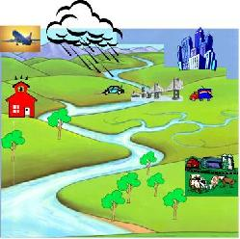

Look at the picture.  Which of the following is in this river’s watershed?

|  |  |  |  |
| --- | --- | --- | --- |
|  | No | Yes | Don't know |
| The red school building |  |  |  |
| The farm |  |  |  |
| The city |  |  |  |
| The small creek on the right |  |  |  |

**Objective 2: Identify their local watershed(s)**

Do you live in a watershed?

* No
* Yes
* Don't know

**Objective 3: Identify how watersheds are connected to the ocean via streams, rivers, and human-made structures**

Where does most of the water from the land eventually end up?

* Ocean
* River
* Sewer
* Lake
* Don't know

How sure are you that you know what a storm drain is?

* Not at all sure
* A little sure
* Very sure
* I'm positive

Ultimately, where does water end up after it enters a storm drain?

* Wastewater treatment plant
* A local body of water
* In the ground
* City sewer
* Don't know

**Objective 4: Identify the functions that occur in a watershed (transport, store, and cycle water)**

What are some of the functions that occur within a watershed?

|  |  |  |  |
| --- | --- | --- | --- |
|  | No | Yes | Don't know |
| The transport of water |  |  |  |
| The transport of materials, like soil through rivers |  |  |  |
| The storage of water in lakes, rivers, groundwater, etc. |  |  |  |
| The transformation of water from one state to another (liquid, ice, vapor, etc.) |  |  |  |

**Objective 5: Recognize that both natural processes and human activities affect water flow and water quality in watersheds**

Which of these statements is FALSE? Watershed boundaries …

* Hardly ever change; they are nearly permanent
* Can sometimes be changed by the actions of people
* Can sometimes be changed by natural processes
* Are constantly altered by both human activities and natural processes
* Don't know

Which of the following can change how water drains in a watershed?

|  |  |  |  |
| --- | --- | --- | --- |
|  | No | Yes | Don't know |
| A flood |  |  |  |
| A landslide |  |  |  |
| A dam |  |  |  |
| The construction of a storm drain |  |  |  |

How sure are you that you know what stormwater is?

* Not at all sure
* A little sure
* Very sure
* I'm positive

Stormwater pipes are similar to streams and creeks because they both:

* Usually have greater water flow when it storms
* Are natural habitats for plants and animals
* Are constructed by people
* Usually receive most of the water from drains and ditches
* Don't know

When trees in a watershed are cut down and replaced with pavement and buildings, …

|  |  |  |  |
| --- | --- | --- | --- |
|  | No | Yes | Don't know |
| More water will drain into local rivers and lakes |  |  |  |
| More water will drain into groundwater |  |  |  |
| Water will drain into local rivers and lakes faster |  |  |  |
| There will be a greater chance of flooding and erosion |  |  |  |

Vegetated buffers (that is, trees, shrubs, other plants along streams, rivers, and estuaries) …

* Increase flooding along streams and rivers
* Decrease erosion and filter water flowing to streams and rivers
* Increase erosion and filter run-off along streams and rivers
* Increase the nutrients that flow into water
* Don't know

Which human activities might increase water pollution?

|  |  |  |  |
| --- | --- | --- | --- |
|  | No | Yes | Don't know |
| Water running off people’s yards and farm fields |  |  |  |
| Water running off streets and parking lots |  |  |  |
| Putting chemicals down storm drains |  |  |  |
| Draining wetlands, such as marshes |  |  |  |
| Removing trees and other plants |  |  |  |

Nutrients (such as nitrogen and phosphorus) in a stream, river, lake, or ocean can be a form of pollution.

* No
* Yes
* Don't know

**Objective 6: Identify connections between human welfare and water flow and quality**

The quality of the water in rivers, lakes, and the ocean can affect the health of people living near them.

* No
* Yes
* Don't know

The water from bodies of water, such as rivers and creeks, is used ...

|  |  |  |  |
| --- | --- | --- | --- |
|  | No | Yes | Don't know |
| for drinking after it's cleaned |  |  |  |
| for farming |  |  |  |
| by wildlife |  |  |  |

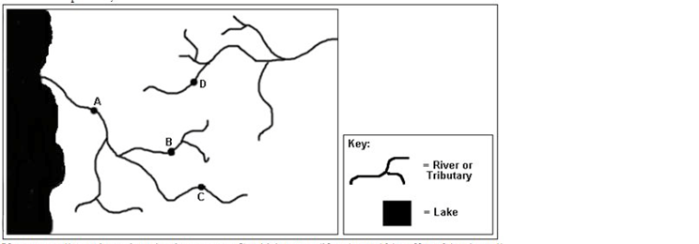

If a pollutant is put into the river at Town C, which town(s) (if any) would be directly affected by the pollution?  Check all that apply.

* A
* B
* C
* D

**Objective 7: Identify possible point and non-point sources of water pollution**

How sure are you that you know what non-point source pollution is?

* Not at all sure
* A little sure
* Very sure
* I'm positive

Which of these is a type of non-point source pollution?

|  |  |  |  |
| --- | --- | --- | --- |
|  | No | Yes | Don't know |
| Oil in the water running off of streets and parking lots |  |  |  |
| Soil in the water running off of farm fields |  |  |  |
| Fertilizer in the water running off of lawns |  |  |  |
| Chemicals in the water coming out of a factory pipe |  |  |  |

Rivers are the major ways through which non-point source pollution enters the ocean.

* No
* Yes
* Don't know

How sure are you that you know what point source pollution is?

* Not at all sure
* A little sure
* Very sure
* I'm positive

Controlling point source pollution is typically easier than controlling non-point source pollution.

* No
* Yes
* Don't know

**Objective 8: Identify actions individuals can engage in to protect/restore water quality in watersheds**

Which of the following would help keep water clean?

* Disposing of household chemicals down the drain
* Washing the car on the grass instead of on pavement
* Leaving the water running while brushing teeth
* Cutting down native trees in the woods
* Don't know

People can help protect the water in their local watershed by:

|  |  |  |  |
| --- | --- | --- | --- |
|  | No | Yes | Not sure |
| Conserve water at home or school |  |  |  |
| Help clean up or take care of a local stream, river, or beach |  |  |  |
| Participate in a restoration activity such as planting trees or removing invasive plants |  |  |  |