Population Assessment of Tobacco and Health (PATH) Study

English-Language Protocol

Please note that respondents will be randomly assigned a subset of the following modules. Modules that are restricted solely to adult or youth respondents are noted in the module name, (e.g., Adult Tobacco Use Module).
No single respondent will receive more than 7 modules and each interview will be limited to 56 minutes.
Table of Contents
Screening and Polyuse Module 4
Screening 4
Polyuse 5
Electronic Products 7
E-cigarettes 17
E-cigarette Nicotine Dependence 40
Adult Hookah Module 50
Hookah 58
Hookah Nicotine Dependence 75
Adult Nicotine Dependence Module 85
Dependency items 85
Quitting 91
Withdrawal 91
Considered quitting 94
Youth Nicotine Dependence 95
Adult Tobacco Use Module 101
Cigarettes 101
Cigars 108
Use of Non-tobacco Products 132
Pipes 135
Smokeless Tobacco 141
Dissolvable Tobacco 154
Youth Tobacco Use Module 156
Cigarettes 156
Electronic Products 170
E-cigarette 173
Cigars 195
Pipes 225
Hookah 232
Smokeless Tobacco 256
Dissolvable Tobacco 272
Harm Module 274
Relative Harm 274
Advertising Claims about Relative Harm 276

Media Module 285
Internet Use 285
General Use, Games, and Videos 285
Social Media 287
Apps 294
Health Promotion 296
Marketing and Promotion Items 297
Adult Demographics Module 303
Income 303
Residence 305
Ladder 306
Parents Income 307
Health Insurance 309
Youth Demographics Module 311
Allowance 311
Adult Pregnancy Module 312
Youth Health Module 318
Adult Barcode Scanning Module 322

Screening and Polyuse Module
adult and youth respondents

Screening
PATH ID: SCREENING
RESEARCH QUESTIONS
Determine respondent’s current use.
I have a set of cards here, each labeled with a type of tobacco product. On one side is the name and picture of the product. On the back is a description. Are you unfamiliar with any of these products? IF YES, Which ones?
Which of these products (YOUTH ONLY: , if any,) have you ever used, even just once?
FOR EACH PRODUCT EVER USED,
Did you try it just once or twice, or did you use it regularly?
Do you still use it?
MARK each product currently uses ON SKIP SHEET
NOTE ANY REACTIONS RESPONDENT HAS TO PICTURES OR DESCRIPTIONS, IF APPLICABLE.
Besides these products, are you aware of any other products that contain nicotine?
PROBE MORE ON ANY PRODUCT R MENTIONS (PARTICULARLY NICOTINE GEL OR OR NICOTINE WATER) THAT IS NOT A CESSATION AID
if not a polyuser (CURRENTLY USING 2 or more TOBACCO PRODUCTS) go to next module

Polyuse
PATH ID: Polyuse
Research questions
We want to explore dual use and why polyusers choose one product over another. The purpose is to get a portrait of respondents’ polyuse. We want to know about use patterns; when and why they use certain products; distinguish between what's used most; what's most important; what's considered to be primary versus secondary.
You said you use more than one tobacco product. I’d like to ask you a few questions about these products to get a better sense of when and why you use them.
IF ONLY TWO PRODUCTS:
Do you consider one product to be more important to you than the other?
IF YES, Which one? Why do you consider it most important?
Which one do you use most often? IF DIFFERENT FROM MOST IMPORTANT, PROBE TO FIND OUT WHY.
Tell me about when you use [PRIMARY PRODUCT] versus [SECONDARY PRODUCT]? How do you decide which one to use?
Are there certain places that you use [PRIMARY PRODUCT] instead of [SECONDARY PRODUCT] and vice versa? IF NEEDED, Where do you use each?

IF MORE THAN TWO PRODUCTS
Do you consider one product to be more important than the others? IF YES, Which one? Why do you consider it most important?
Which one do you use most often? IF DIFFERENT FROM MOST IMPORTANT, PROBE TO FIND OUT WHY.
Which one is next in importance? Why?
Which one is least important to you? Why?
Tell me more about how you decide which product to use at any given time.
Are there certain places that you use particular products? IF NEEDED, Where do you use each product?

Electronic Products

Screening
Research questions
The introduction and first few items are newly revised to ask about all electronic products. Testing is needed.
Additionally, how do the various users of different electronic device types report on daily use? What’s the best unit for these users to report on dosage – puffs versus volume (number of cartridges)?
BOX ID: R02_AOT01
The next questions are about electronic nicotine products, such as e-cigarettes, e-cigars, e-hookahs, e-pipes, vape pens, hookah pens and personal vaporizers. These products are battery-powered, use nicotine fluid rather than tobacco leaves, and produce vapor instead of smoke. Some common brands include Fin, NJOY, Blu, e-Go and Vuse.
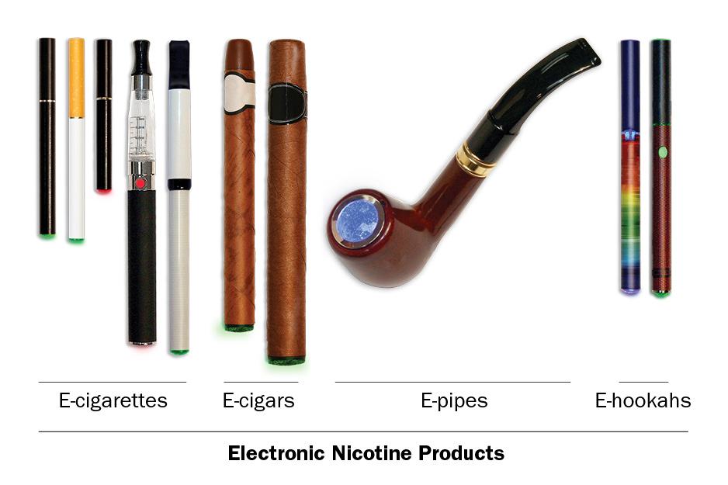
What reaction, if any, did you have to this description and the picture? In your own words, what is “vapor”?
Are you familiar with all of these products? IF NO, Which ones are new to you?
Are these the words you use, or do you call these products by different names?
All of these products together are called “electronic nicotine products.” What do you think of that name? Is there another word you use to refer to all of these products?
PATH ID: R02_AO9034
- Have you ever used an electronic nicotine product, even one or two times? (Electronic nicotine products include e-cigarettes, e-cigars, e-hookahs, e-pipes, vape pens, hookah pens and personal vaporizers.)
- Yes
- No go to next MODULE
- DON’T KNOW go to next MODULE
In your own words, what is this question asking?
In your own words, what is an “electronic nicotine product”?
PATH ID: R02_AO9035
- Which type of electronic nicotine product have you ever used? Choose all that apply.
- E-cigarette (including vape pens and personal vaporizers) MARK ON SKIP SHEET
- E-cigar MARK ON SKIP SHEET
- E-hookah (including hookah pens) MARK ON SKIP SHEET
- E-pipe MARK ON SKIP SHEET
- Something else SPECIFY:___________________
- DON’T KNOW
Tell me more about your answer. PROBE ON WHETHER RESPONDENT KNOWS THE DIFFERENCE BETWEEN THESE PRODUCTS. DETERMINE IF RESPONDENT IS MARKING MULTIPLE CATEGORIES FOR A SINGLE PRODUCT.Do you have your [E-cigarette/E-cigar/E-hookah/E-pipe] here with you? IF YES, Is it okay if I take a picture of it/them?
if do not use any electronic products go to next MODULE

E-cigarette
if do not use e-cigarettes go to Q11

Use
research question
Revised item. Testing inclusion of a fourth response category, “rarely.”
PATH ID: R02_AE1003_ECIG
- Do you now use e-cigarettes…
- Every day
- Some days
- Rarely go to Q7
- Not at all go to Q11
Tell me more about your answer. PROBE TO GET A BETTER SENSE OF FREQUENCY OF USE.
In the past 30 days, how many days did you use e-cigarettes?
How easy or difficult was it to choose your answer from this list of choices? In your own words, what is the difference between using e-cigarettes “some days” and using e-cigarettes “rarely”?
IF RESPONDENT SELECTS “RARELY,” If “rarely” hadn’t been an answer choice, how would you have answered this question? IF NEEDED, Would you have chosen “not at all” or “sometimes”? Why?

PATH ID: R02_AE0100_ECig
- When did you last use an e-cigarette?
- In the past hour go to Q6
- Sometime today
- Yesterday
- Day before yesterday
- Three or more days ago go to Q7

research question
Testing the new response options.
PATH ID: R02_AE0102_E-CIG
- When you last used an e-cigarette, was it…
- Midnight to 6 AM
- After 6 AM but before noon
- Noon to 6 PM
- After 6 PM but before midnight
When exactly did you last use an e-cigarette?
How easy or difficult was it for you to answer this question? What made it easy or difficult?
PATH ID: R02_AE0103_ECIG
- On the day you last used e-cigarette, how many puffs did you take?
______________________

- DON’T KNOW
Tell me more about your answer. How did you decide on your answer? What do you consider to be a “puff”? PROBE TO SEE IF RESPONDENTS ARE REPORTING PUFFS OR TIMES OR ACTUAL E-CIGARETTES.
How easy or difficult was it to answer this question?

Flavor
Research questions
Previous testing showed some recall issues and difficulties assigning categories to flavors. Test if respondents can identify flavors and whether the list is exhaustive.
Additionally, try to tease out if respondents consider non-flavored products to be unflavored, regular, tobacco flavored, traditional, etc.
Some youth previously showed confusion on the meaning of “menthol.” Test further.
PATH ID: R02_AE1130_ECIGFLAVOR
- In the past 30 days, were any of the e-cigarettes you used flavored to taste like menthol, mint, clove, spice, fruit, chocolate, alcoholic drinks, candy or other sweets?
- Yes
- No go to Q9
- I don’t know go to Q9
IF NO, Are you familiar with these flavors? Which ones have you heard of?
IF NO, Was it flavored at all? Would you call it “unflavored” or “regular” or something else?

PATH ID: R02_AE1131_ECIGFLAVOR_Past30
- Which flavors have you used in the past 30 days? Choose all that apply.
- Menthol or mint
- Clove or spice
- Fruit
- Chocolate
- An alcoholic drink (such as wine, cognac, margarita or other cocktails)
- Candy or other sweets
- Some other flavor
- DON'T KNOW
IF CANDY, FRUIT, OR SWEETS, PROBE FOR EXACT FLAVOR.
IF CHECK MULTIPLE FLAVORS, Was each flavor a different e-cigarette, or did a single e-cigarette have multiple flavors?
How easy/difficult was it for you to answer this question?
How confident are you in your response(s)?
Are there any flavors we left out?

PATH ID: R02_YE1146
- Some e-cigarettes come in flavors like menthol, mint, clove, spice, fruit, chocolate, alcoholic drinks, candy or other sweets.
Are flavored e-cigarettes easier to use, about the same, or harder to use than unflavored e-cigarettes?
- Easier to use
- About the same
- Harder to use
How did you decide on your answer?
What does “harder to smoke” mean? What does “easier to smoke” mean?
Have you heard of menthol or mint flavored e-cigarettes? What have you heard? In your own words, what is “menthol”?
What does “unflavored” e-cigarettes mean to you? Would it make more sense if we asked about “regular” e-cigarettes?

Switching
Research question
Earlier testing revealed that “switching” may not be a meaningful concept for all tobacco products (e.g., hookah users). Test further.
Test whether asking “Have you thought about…” works better than “Have you considered…” for respondents.
PATH ID: R02_AX0307_REVISED_ECIG
- Have you thought about switching from e-cigarettes to any of the following products? Choose all that apply.
- I have not thought about switching to another product
- Cigarettes
- Traditional cigars
- Cigarillos
- Filtered cigars
- Pipes
- Hookahs
- Snus pouches
- Smokeless tobacco such as loose snus, moist snuff, dip, spit, or chewing tobacco
- Dissolvable tobacco
What reaction, if any, did you have to this question?
NOTE IF RESPONDENT FINDS CONCEPT OF “SWITCHING” TO BE INAPPROPRIATE FOR A PARTICULAR PRODUCT
In your own words, what does it mean to “switch” to another product?
PROBE IF RESPONDENT INTERPRETS IT AS GIVING THE FIRST PRODUCT UP COMPLETELY
Tell me more about your answer.
IF SELECTED PRODUCTS, Why have you thought about switching from X to X?
IF HAVE NOT THOUGHT ABOUT SWITCHING, Tell me more about why you haven’t thought about switching to these other products?
If this question asked “Have you considered switching…” instead of “Have you thought about switching…”, would that have changed your answer? Why or why not?
Which do you prefer? Why?

Other Electronic Nicotine Devices
if do not use e-cigars, E-HOOKAHS, OR E-PIPES go to NEXT SECTION
Box ID: R02_AOT01
The following questions ask about electronic nicotine products other than e-cigarettes. This includes e-cigars, e-hookahs, e-pipes, vape pens, hookah pens and personal vaporizers. We will ask about e-cigarettes later.
PATH ID: R02_AO1005
- How many times have you used other electronic nicotine products in your entire life?
- 1 or more puffs but never a whole one
- 1 to 10
- 11 to 20
- 21 to 50
- 51 to 99
- 100 or more
Tell me more about your answer.
What do you consider to be a “puff”? Do you typically call them “puffs” or is there another term you use?
IF NEEDED, Which products were you including in your answer? DETERMINE IF RESPONDENT WAS INCLUDING E-CIGARETTES.

PATH ID: R02_AO9010
- Do the electronic nicotine products you usually use contain nicotine?
- Yes
- No
Tell me more about your answer. How did you know whether or not it contained nicotine?
PATH ID: R02_AO9029
- About how long has it been since you last took a puff from an electronic nicotine product?
______________________________
PATH ID: R02_AO1008
- When you first started using electronic nicotine products, were they flavored to taste like menthol, mint, clove, spice, fruit, chocolate, alcoholic drinks, candy or other sweets?
- Yes
- No go to Q6
- I don’t know go to Q6
IF NO, Are you familiar with these flavors? Which ones have you heard of?
IF NO, Was it flavored at all? Would you call it “unflavored” or “regular” or something else?

PATH ID: R02_AO1011
- Which flavor did you first start using? If multiple flavors were mixed together, choose all that apply.
- Menthol or mint
- Clove or spice
- Fruit
- Chocolate
- An alcoholic drink (such as wine, cognac, margarita or other cocktails)
- Candy or other sweets
- Some other flavor
IF CANDY, FRUIT, OR SWEETS, PROBE FOR EXACT FLAVOR.
IF CHECK MULTIPLE FLAVORS, Was each flavor a different e-cigarette, or did a single e-cigarette have multiple flavors?
How easy/difficult was it for you to answer this question?
How confident are you in your response(s)?
Are there any flavors we left out?
PATH ID: R02_AO1100
- Have you ever used electronic nicotine products fairly regularly?
- Yes
- No
In your own words, what is this question asking? IF NEEDED, What does it mean to say someone is using electronic nicotine products “fairly regularly”?

E-cigarettes

Description and Image
Research question
Test the revised introduction and images, which now includes the term “vaping” and a picture of a vaporizer. Determine if respondents properly distinguish between e-cigarettes and other electronic products.
Box ID: R02_AET02
The next questions are about e-cigarettes.

Some e-cigarettes can be bought as one-time, disposable products, while others can be bought as re-usable kits with a cartridge or tank system. Some people refill their own e-cigarettes with nicotine fluid, sometimes called “e-liquid”.

Disposable e-cigarettes, e-cigarette cartridges and e-liquid come in many different flavors and nicotine concentrations. Some common brands include Fin, NJOY, Blu, e-Go and Vuse.
Please think only about e-cigarettes as you answer these questions.
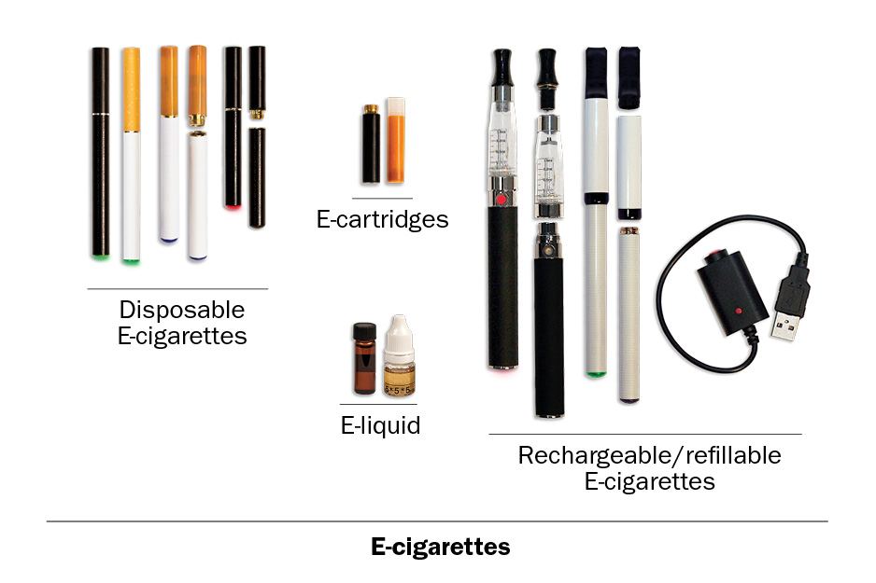

What reaction, if any, did you have to this description of e-cigarettes?
What did you think of the pictures?
Is there anything that you found confusing?
Is there anything that we left out that we should add?
Are you familiar with the different types of e-cigarettes? What type do you usually use?
Do you call the fluid “e-juice,” “e-liquid,” or something else?
Does e-liquid always have nicotine in it?

Determining Type
Research question
Determine if this series of items correctly identifies respondent e-cigarette types and appropriate fills for subsequent items.
PATH ID: R02_AE9005
Please think about the e-cigarette you use most of the time.
- Is your e-cigarette rechargeable?
- Yes MARK ON SKIP SHEET AS RECHARGEABLE
- No go to Q4
Do you call them rechargeable e-cigarettes or do you call them something else?
PATH ID: R02_AE9008
- Does your e-cigarette use cartridges?
- Yes go to Q4
- No
Do you call them cartridges or do you call them something else?

PATH ID: R02_AE9038
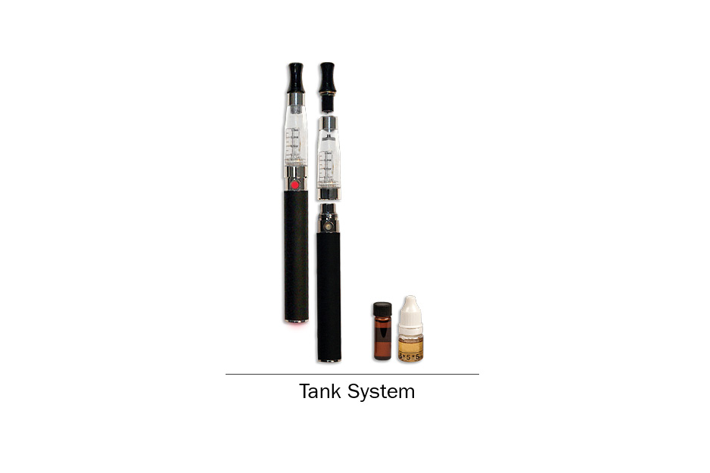
- Does your e-cigarette use a tank system?
- Yes
- No
- Not sure
What is a tank system? Are you familiar with the term “tank system”? Is there another term that you use?
What reaction, if any, did you have to the picture? Was the picture helpful? Why or why not?
What reaction, if any, did you have to these questions?
How easy or difficult was it to answer these questions?
What brand of e-cigarette do you have? What type or version of [BRAND] is it?
PATH ID: R02_AE9009
- Can you refill your e-cigarette or e-cigarette cartridges with “e-liquid”?
- Yes MARK ON SKIP SHEET as refillable
- No go to NEXT SECTION
ASK: Respondents who have used an e-cigarette (AO9035[1]=1)

PATH ID: R02_AE9036
- Who refills your e-cigarette or e-cigarette cartridge with “e-liquid”?
- I refill it myself
- I get it refilled at a vape shop or vapor lounge
- I buy it already filled
- I get it refilled some other way
Are you familiar with the term “vape shop” or “vapor lounge”? Is there another term that you use?

Disposable E-cigarettes

Dosage
Research question
Testing has shown that asking respondents about the number of “puffs” taken in a given time period can be tricky, particularly for respondents who use refillable e-cigarettes, who may be able to more accurately report the volume of e-fluid. These new items attempt to give respondents more flexibility in reporting. Test effectiveness of new items.
PATH ID: R02_AE1021_DISPOSABLE
- On average, about how many e-cigarettes do you now use each day?
- Less than 1 each day
- _______________________

Tell me more about your answer. How did you come up with a number?
How easy or difficult was it to answer?
Is there a better way we could ask this question?

PATH ID: R02_AE1022_Disposable_Past30
- On how many of the past 30 days did you use an e-cigarette?
_______________________
- 0 go to Q9
PATH ID: R02_AE9029_Disposable_Lastpuff
- About how long has it been since you last took a puff from an e-cigarette?
_______________________
Do you typically call them “puffs” or is there another term you use?
PATH ID: R02_AE9010_DisposableNicotine
- Does the e-cigarette you usually use contain nicotine?
- Yes
- No go to Q11

Tell me more about your answer. How did you know whether or not it contained nicotine?

PATH ID: R02_AE9006_DisposableConcentration
- What concentration of nicotine do you usually use?
- I don’t know the concentration
- 0 mg or 0%
- 1-12 mg or 0.1-0.6%
- 13-17 mg or 0.7-1.2%
- 18-24 mg or 1.3-1.8%
- 25+ mg or 1.9+%
IF ABLE TO SPECIFY CONCENTRATION:
How did you decide your answer? How certain are you that you know the exact concentration?
Is concentration something you normally notice when you’re buying e-cigarettes or e-liquid?
Do you usually know the mg or the % or both?
This question asks you about the number of milligrams or the percentage of nicotine. Are there other ways you know how much nicotine is in an e-cigarette that you use? IF NEEDED: Have you ever heard people describing the nicotine as “strong” or “full flavored”?

Modification
Research question
New item added for Wave 2. Test whether respondents can correctly answer this item. Also probe on ways in which respondents modify e-cigarettes, including modifications to the battery or voltage.
PATH ID: R02_AE9032_Disposable_Mod
- Have you modified your e-cigarette at all?
- Yes go to Q28
- No go to Q28
In your own questions, what is this question asking?
IF YES, How have you modified it? Why did you modify it?
PROBE HOW AND WHY RESPONDENTS MODIFY THEIR E-CIGARETTES (E.G., TO IMPROVE BATTERY LIFE, CHANGE AMOUNTS OF E-LIQUID VAPORIZED, ETC.)
Where did you learn how to modify your e-cigarette?
IF NO, Have you ever heard of modifying e-cigarettes? Where did you hear about it? What types of modifications have you heard of?

Non-refillable Cartridges

Dosage
Research question
Testing has shown that asking respondents about the number of “puffs” taken in a given time period can be tricky, particularly for respondents who use refillable e-cigarettes, who may be able to more accurately report the volume of e-fluid. These new items attempt to give respondents more flexibility in reporting. Test effectiveness of new items.
PATH ID: R02_AE1021_NOn-Refillable
- On average, about how many e-cigarette cartridges do you now use each day?
- Less than 1 each day
- _______________________

Tell me more about your answer. How did you come up with a number?
How easy or difficult was it to answer?
Is there a better way we could ask this question?

PATH ID: R02_AE1022-Non-Refillable_Past30
- On how many of the past 30 days did you use an e-cigarette?
_______________________
- 0 go to Q15
PATH ID: R02_AE9029_Non-Refillable_Lastpuff
- About how long has it been since you last took a puff from an e-cigarette?
_______________________
Do you typically call them “puffs” or is there another term you use?
PATH ID: R02_AE9010_Non-RefillableNicotine
- Does the e-cigarette cartridge you usually use contain nicotine?
- Yes
- No go to Q17

Tell me more about your answer. How did you know whether or not it contained nicotine?

PATH ID: R02_AE9006_Non-refillableconcentration
- What concentration of nicotine do you usually use?
- I don’t know the concentration
- 0 mg or 0%
- 1-12 mg or 0.1-0.6%
- 13-17 mg or 0.7-1.2%
- 18-24 mg or 1.3-1.8%
- 25+ mg or 1.9+%
IF ABLE TO SPECIFY CONCENTRATION:
How did you decide your answer? How certain are you that you know the exact concentration?
Is concentration something you normally notice when you’re buying e-cigarettes or e-liquid?
Do you usually know the mg or the % or both?

Modification
Research question
New item added for Wave 2. Test whether respondents can correctly answer this item. Also probe on ways in which respondents modify e-cigarettes, including modifications to the battery or voltage.
IF NOT RECHARGEABLE go to Q18
PATH ID: R02_AE9037_Disposable_Voltage
- Can you change the voltage on your e-cigarette?
- Yes
- No
- Not sure
In your own words, what is this question asking? IF NEEDED, What does it mean to change the voltage?
IF YES, Have you changed the unit’s voltage? Why or why not?
PATH ID: R02_AE9032_Non-refillable_Mod
- Have you modified your e-cigarette at all?
- Yes
- No
In your own words, what is this question asking?
IF YES, How have you modified it? Why did you modify it?
PROBE HOW AND WHY RESPONDENTS MODIFY THEIR E-CIGARETTES (E.G., TO IMPROVE BATTERY LIFE, CHANGE AMOUNTS OF E-LIQUID VAPORIZED, ETC.)
Where did you learn how to modify your e-cigarette?
IF NO, Have you ever heard of modifying e-cigarettes? Where did you hear about it? What types of modifications have you heard of?

Research question
Test new items that ask about customization of constituents in e-liquids, particularly flavoring choices and modification of nicotine content.
PATH ID: Non-Refillable E-Cig Modify NEW
- Do you customize or modify the e-liquid you use in your e-cigarette?
- Yes go to Q28
- No go to Q28
IF YES, Tell me more about how you customize or modify the e-liquid. Why do you customize or modify the e-liquid?
PROBE TO DETERMINE HOW AND WHY RESPONDENTS ARE MODIFYING E-LIQUID (E.G., CHANGE NICOTINE CONTENT, CHANGE FLAVOR)
In this question, do the words customize and modify mean the same thing to you or do they mean different things? IF NEEDED: Tell me more.
Where did you learn how to customize or modify your e-liquid?
IF NO, Have you ever heard of modifying e-liquid? Where did you hear about it? What types of modifications have you heard of?
Have you ever heard of the term “dripping”? IF YES, Can you tell me more about it?

Refillable Cartridges or Tank

Dosage
Research question
Testing has shown that asking respondents about the number of “puffs” taken in a given time period can be tricky, particularly for respondents who use refillable e-cigarettes, who may be able to more accurately report the volume of e-fluid. These new items attempt to give respondents more flexibility in reporting. Test effectiveness of new items.
PATH ID: R02_AE1021_REfillable
- On average, about how many milliliters of e-liquid do you now use each day?
- Less than 1 each day
- _______________________

Tell me more about your answer. How did you come up with a number?
How easy or difficult was it to answer? How confident are you in your answer?
Is there a better way we could ask this question?

PATH ID: R02_AE1022_REfillable_Past30
- On how many of the past 30 days did you use an e-cigarette?
_______________________
- 0 go to Q23
PATH ID: R02_AE9029_Refillable_Lastpuff
- About how long has it been since you last took a puff from an e-cigarette?
_______________________
Do you typically call them “puffs” or is there another term you use?
PATH ID: R02_AE9010_REfillableNicotine
- Does the e-liquid you usually use contain nicotine?
- Yes
- No go to Q25

Tell me more about your answer. How did you know whether or not it contained nicotine?

PATH ID: R02_AE9006_REfillableConcentration
- What concentration of nicotine do you usually use?
- I don’t know the concentration
- 0 mg or 0%
- 1-12 mg or 0.1-0.6%
- 13-17 mg or 0.7-1.2%
- 18-24 mg or 1.3-1.8%
- 25+ mg or 1.9+%
IF ABLE TO SPECIFY CONCENTRATION:
How did you decide your answer? How certain are you that you know the exact concentration?
Is concentration something you normally notice when you’re buying e-cigarettes or e-liquid?
Do you usually know the mg or the % or both?

Modification
Research question
New item added for Wave 2. Test whether respondents can correctly answer this item. Also probe on ways in which respondents modify e-cigarettes, including modifications to the battery or voltage.
IF NOT RECHARGEABLE go to Q26
PATH ID: R02_AE9037_Refillable_Voltage
- Can you change the voltage on your e-cigarette?
- Yes
- No
- Not sure
In your own words, what is this question asking? IF NEEDED, What does it mean to change the voltage?
IF YES, Have you changed the unit’s voltage? Why or why not?
PATH ID: R02_AE9032_Refillable_Mod
- Have you modified your e-cigarette at all?
- Yes
- No
In your own words, what is this question asking?
IF YES, How have you modified it? Why did you modify it?
PROBE HOW AND WHY RESPONDENTS MODIFY THEIR E-CIGARETTES (E.G., TO IMPROVE BATTERY LIFE, CHANGE AMOUNTS OF E-LIQUID VAPORIZED, ETC.)
Where did you learn how to modify your e-cigarette?
IF NO, Have you ever heard of modifying e-cigarettes? Where did you hear about it? What types of modifications have you heard of?
Research question
Test new items that ask about customization of constituents in e-liquids, particularly flavoring choices and modification of nicotine content.
PATH ID: Refillable e-Cig Modify NEW
- Do you customize or modify the e-liquid you use in your e-cigarette?
- Yes
- No
IF YES, Tell me more about how you customize or modify the e-liquid. Why do you customize or modify the e-liquid?
PROBE TO DETERMINE HOW AND WHY RESPONDENTS ARE MODIFYING E-LIQUID (E.G., CHANGE NICOTINE CONTENT, CHANGE FLAVOR)
Where did you learn how to customize or modify your e-liquid?
IF NO, Have you ever heard of modifying e-liquid? Where did you hear about it? What types of modifications have you heard of?
Have you ever heard of the term “dripping”? IF YES, Can you tell me more about it?

Use of Non-tobacco Products
Research question
Develop and test new items about smoking something other than tobacco in e-cigarette. Previous testing revealed confusion with the concepts of smoking marijuana in an e-cigarette vs. using e-liquid flavored to taste like marijuana vs. using e-liquid made from marijuana.
PATH ID: E-Liquid Non-Tobacco
- Have you ever used an e-liquid made from something other than tobacco?
- Yes
- No
- Don’t know
ALL RESPONDENTS, Can you give me examples of what, other than tobacco, an e-liquid might be made from?
IF YES, What was it made from?
IF RESPONDENT SAYS MARIJUANA, Was it flavored like marijuana, or did it contain actual marijuana?
IF NEEDED, Could it get you high?
Have you ever heard of an e-liquid made from marijuana concentrates, waxes or hash oils? What do you know about it?
Does it contain actual marijuana?
IF NEEDED, Could it get you high?
PATH ID: E-cigarette with Pot
- Have you ever smoked pot or hash from an e-cigarette?
- Yes
- No
- Don’t know
IF YES, Tell me more about your answer. How do you smoke pot from an e-cigarette?

E-cigarette Nicotine Dependence
adult CURRENT e-cigarette users
research questions
Test applicability of the items on dependency, quitting and withdrawal for users of less standard tobacco products such as hookah, e-cigarette, and smokeless tobacco. Do they seem inappropriate or difficult to answer for users of these products?
Additionally, do respondents who are using e-cigarettes as cessation devices find any of these questions confusing and/or difficult to answer?

Dependency items
R02_ANT01_ECIG
The next questions ask about your experience with e-cigarettes.
PATH ID: R02_AN0010_ECIGDEPENDENCY
- Do you consider yourself addicted to e-cigarettes?
- No, not at all
- Yes, somewhat addicted
- Yes, very addicted
In your own words, what does it mean to be “addicted” to e-cigarettes?
IF NO, NOT AT ALL, Tell me more about your answer.
How easy or difficult was it to answer this question? What made it easy/difficult?
PATH ID: R02_AN0015_Ecig_Cravings
- Do you ever have strong cravings to use e-cigarettes?
- Yes
- No
PATH ID: R02_AN0020_Ecig_REallyNeed
- Have you ever felt like you really needed to use e-cigarettes?
- Yes
- No
What does it mean to “really need” to smoke/use a [ND FILL 1]?
PATH ID: R02_AN0055_Ecig_Agreement
Please rate your level of agreement for each statement using the following scale:
1= not true of me at all to 5=extremely true of me.
- I find myself reaching for e-cigarettes without thinking about it.
- 1 Not true of me at all
- 2
- 3
- 4
- 5 Extremely true of me
PATH ID: R02_AN0025_Ecig_Craving
- I frequently crave e-cigarettes.
- 1 Not true of me at all
- 2
- 3
- 4
- 5 Extremely true of me
PATH ID: R02_AN0030_Ecig_urges
- My urges keep getting stronger if I don’t use e-cigarettes.
- 1 Not true of me at all
- 2
- 3
- 4
- 5 Extremely true of me

PATH ID: R02_AN0035_Ecig_Control
- E-cigarettes control me.
- 1 Not true of me at all
- 2
- 3
- 4
- 5 Extremely true of me
PATH ID: R02_AN0045_Ecig_outofControl
- My e-cigarette use is out of control.
- 1 Not true of me at all
- 2
- 3
- 4
- 5 Extremely true of me
PATH ID: R02_AN0060_Ecig_WAkeup
- I usually want to use e-cigarettes right after I wake up.
- 1 Not true of me at all
- 2
- 3
- 4
- 5 Extremely true of me
PATH ID: R02_AN0065_Ecig_Fewhours
- I can only go a couple of hours without using e-cigarettes.
- 1 Not true of me at all
- 2
- 3
- 4
- 5 Extremely true of me

PATH ID: R02_AN0050_Ecig_Nothought
- I frequently use e-cigarettes without thinking about it.
- 1 Not true of me at all
- 2
- 3
- 4
- 5 Extremely true of me
PATH ID: R02_AN0070_Ecig_FeelBetter
- Using e-cigarettes really helps me feel better if I’ve been feeling down.
- 1 Not true of me at all
- 2
- 3
- 4
- 5 Extremely true of me
PATH ID: R02_AN0075_ECIG_Thinkbetter
- Using e-cigarettes helps me think better.
- 1 Not true of me at all
- 2
- 3
- 4
- 5 Extremely true of me
PATH ID: R02_AN0332
- Most of the people I spend time with use e-cigarettes.
- 1 Not true of me at all
- 2
- 3
- 4
- 5 Extremely true of me

PATH ID: R02_AN0255
- Most of the people I spend time with use tobacco.
- 1 Not true of me at all
- 2
- 3
- 4
- 5 Extremely true of me
PATH ID: R02_AN0080_Ecig_Alone
- I would feel alone without my e-cigarettes.
- 1 Not true of me at all
- 2
- 3
- 4
- 5 Extremely true of me
PATH ID: R02_AN0085_Ecig_HardToStop
- I would find it really hard to stop using e-cigarettes.
- 1 Not true of me at all
- 2
- 3
- 4
- 5 Extremely true of me
PATH ID: R02_AN0090_Ecig_1week
- I would find it hard to stop using e-cigarettes for a week.
- 1 Not true of me at all
- 2
- 3
- 4
- 5 Extremely true of me

PATH ID: R02_AN0095_Ecig_Irritable
- After not using e-cigarettes for a while, I need to use e-cigarettes in order to feel less restless and irritable.
- 1 Not true of me at all
- 2
- 3
- 4
- 5 Extremely true of me
PATH ID: R02_AN0100_Ecig_Discomfort
- After not using e-cigarettes for a while, I need to use e-cigarettes in order to keep myself from experiencing any discomfort.
- 1 Not true of me at all
- 2
- 3
- 4
- 5 Extremely true of me
PATH ID: R02_AN0813_ECIG_Permitted
- In the past 12 months, did you find it difficult to keep from using e-cigarettes in places where it was not permitted?
- Yes
- No
PATH ID: R02_AN0812_Ecig_Activities
- In the past 12 months, did you give up or cut down on activities that were enjoyable or important to you because e-cigarette use was not permitted at the activity?
- Yes
- No
What reaction, if any, do you have to this last set of questions about your experiences with e-cigarettes?
How easy or difficult was it to answer these questions? What did you think of the answer choices?
What did you think of being asked these questions? IF NEEDED, Do you think it makes sense to ask these questions of people who use e-cigarettes?
Were you thinking just about e-cigarettes when you were answering, or were you also including other electronic products, such as e-hookahs, e-cigars, etc.?

Quitting
research question
Explore what respondents used to quit, especially for pipe, cigar, dissolvable tobacco, and hookah users. Do respondents use other things like an “app” or a “doctor” to help them quit?
PATH ID: R02_AN0105_Ecig_Triedtoquit
- In the past 12 months, have you tried to quit using e-cigarettes? Choose all that apply.
- Yes, I have tried to quit completely
- Yes, I have tried to quit by reducing or cutting back
- No, I have reduced or cut back instead of trying to quit
- No, I have not tried to quit at all go to Q31
Tell me more about your answer. How did you decide which answer choice to choose?
In your own words, what is the difference between trying to quit completely and trying to quit by reducing or cutting back?
IF YES, Can you tell me how you tried to quit? What did you use to quit?
IF NEEDED: Did you rely on the support of friends and family to help you quit?
Did you use counseling, a telephone help line or quit line, books, pamphlets, videos, a quit tobacco clinic, class, or support group, or an internet or web-based program?
Did you use an app?
Did you use any different tobacco product to help you quit?
Did you use a nicotine patch, gum, inhaler, nasal spray, lozenge or pill?
Did a doctor help you?
Did you use a prescription drug like Chantix, varenicline, Wellbutrin, Zyban, or bupropion?
Is there anything else that you used to help you quit?

Withdrawal
research questions
Test applicability of these items for users of less standard tobacco products such as hookah, e-cigarette, and smokeless tobacco. Do they seem inappropriate or difficult to answer for users of these products?
PATH ID: R02_AN0804_Eicg_Withdrawal
The next questions ask about how you felt within days after the last time you tried to quit using e-cigarettes in the past 12 months.
Within days after stopping or cutting down on your e-cigarette use in the past 12 months, did you….
- Feel depressed?
- Yes
- No
PATH ID: R02_AN0805_Ecig_DifficultSleeP
Within days after stopping or cutting down on your e-cigarette use in the past 12 months, did you….
- Have difficulty falling asleep or staying asleep?
- Yes
- No
PATH ID: R02_AN0806_Ecig_Concentration
Within days after stopping or cutting down on your e-cigarette use in the past 12 months, did you….
- Have difficulty concentrating?
- Yes
- No
PATH ID: R02_AN0807_Ecig_Weight
Within days after stopping or cutting down on your e-cigarette use in the past 12 months, did you….
- Eat more than usual or gain weight?
- Yes
- No
PATH ID: R02_AN0808_Ecig_Angry
Within days after stopping or cutting down on your e-cigarette use in the past 12 months, did you….
- Become easily irritated, angry, or frustrated?
- Yes
- No
PATH ID: R02_AN0809_Ecig_Anxious
Within days after stopping or cutting down on your e-cigarette use in the past 12 months, did you….
- Feel anxious or nervous?
- Yes
- No
PATH ID: R02_AN0810_Ecig_Restless
Within days after stopping or cutting down on your e-cigarette use in the past 12 months, did you….
- Feel more restless than usual?
- Yes
- No
What reaction, if any, do you have to these last few questions about your experiences with quitting?
How easy or difficult was it to answer these questions?
IF NEEDED, Do you think it makes sense to ask these questions of people who use e-cigarettes?

Considered quitting
research questions
Test applicability of this item for users of less standard tobacco products such as Hookah, e-cigarette, and smokeless tobacco. Does this item make sense for current users of these products?
PATH ID: R02_AN0230_Ecig_Interestinquitting
- Overall, on a scale from 1 to 10 where 1 is not at all interested and 10 is extremely interested, how interested are you in quitting e-cigarette use? Please enter a number from 1 to 10.
- Not at all interested
- 2
- 3
- 4
- 5
- 6
- 7
- 8
- 9
- Extremely Interested
What reaction, if any, do you have to this question?
IF NEEDED, Do you think it makes sense to ask these questions of people who use e-cigarettes?

Adult Hookah Module
ALL CURRENT Hookah users
research questioNS
Due to constraints in earlier testing, the hookah module was only tested with a small number of hookah users. Test with a larger number of respondents.

Screening
PATH ID: R02_AHT01
We next ask about smoking tobacco in a hookah, which is a type of water pipe. It is sometimes also called a “narghile” pipe. From now on, we will use “hookah” to refer to a water pipe or narghile pipe that is often used to smoke tobacco.
There are many types of hookahs. People often smoke tobacco in hookahs in groups at cafes or in hookah bars. The picture below shows a typical hookah.

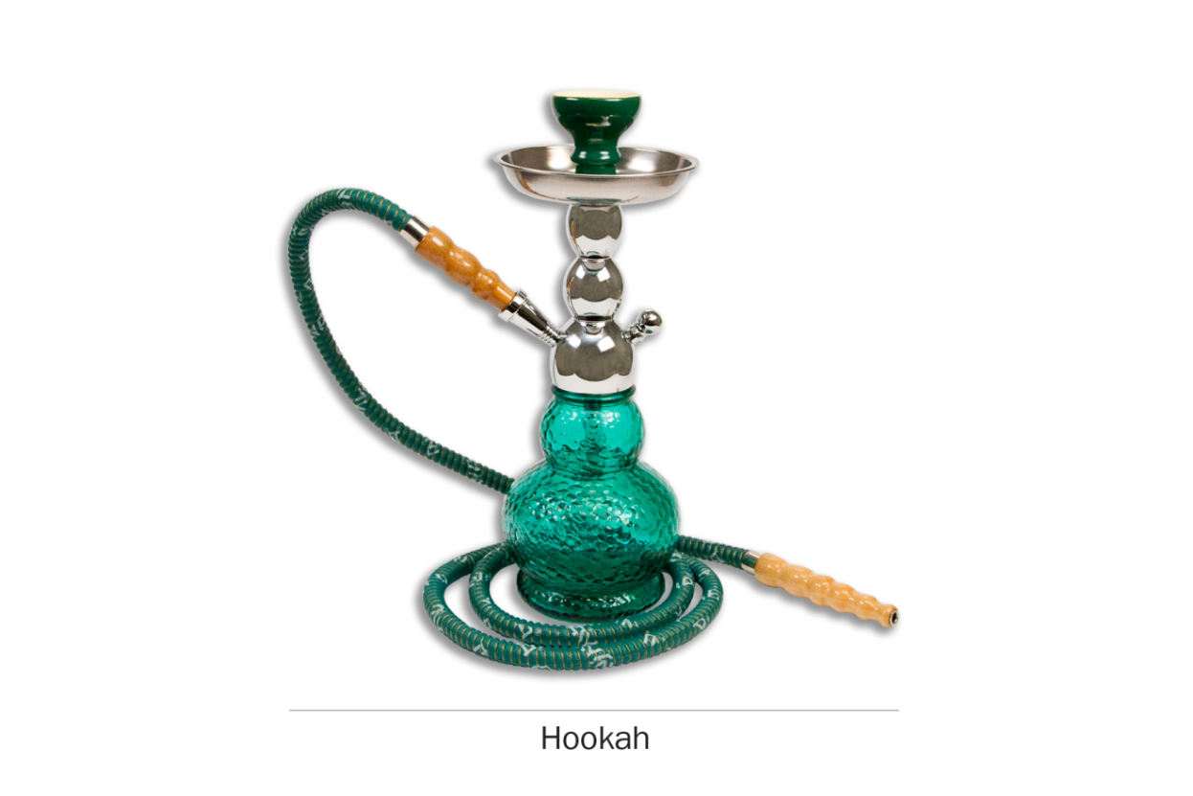

What reaction, if any, did you have to this description and pictures of hookah?
PATH ID: YH1002
- Have you ever smoked tobacco in a hookah, even one or two puffs?
- Yes go to next module
- No
Was this a regular hookah, or an electronic hookah (e-hookah)?
research question
Revised item. Testing inclusion of a fourth response category, “rarely.”
PATH ID: R02_AH1003
- Do you now smoke hookah…
- Every day
- Some days
- Rarely go to Q6
- Not at all go to next module
Tell me more about your answer. PROBE TO GET A BETTER SENSE OF SMOKING FREQUENCY.
In the past 30 days, how many days did you smoke hookah?
How easy or difficult was it to choose your answer from this list of choices? In your own words, what is the difference between smoking “some days” and smoking “rarely”?
IF RESPONDENT SELECTS “RARELY,” If “rarely” hadn’t been an answer choice, how would you have answered this question? IF NEEDED, Would you have chosen “not at all” or “sometimes”? Why?

PATH ID: R02_AH0100
- When did you last smoke hookah?
- In the past hour go to Q5
- Sometime today
- Yesterday
- Day before yesterday
- Three or more days ago go to Q6

research question
Testing the new response options.
PATH ID: R02_AH0102
- When you last smoked hookah, was it…
- Midnight to 6 AM
- After 6 AM but before noon
- Noon to 6 PM
- After 6 PM but before midnight
When exactly did you last smoke hookah?
How easy or difficult was it for you to answer this question? What made it easy or difficult?
PATH ID: R02_AH0103
- On the day you last smoked hookah, how many puffs did you take?
___________________________________

- DON'T KNOW

Flavor
Research questions
Previous testing showed some recall issues and difficulties assigning categories to flavors. Test if respondents can identify flavors and whether the list is exhaustive.
Additionally, try to tease out if respondents consider non-flavored products to be unflavored, regular, tobacco flavored, traditional, etc.
PATH ID: R02_AH1130
- In the past 30 days, was any of the shisha or hookah tobacco you smoked flavored to taste like menthol, mint, clove, spice, fruit, chocolate, alcoholic drinks, candy or other sweets?
- Yes
- No go to Q8
- I don’t know go to Q8
IF NO, Are you familiar with these flavors? Which ones have you heard of?
IF NO, Was it flavored at all? Would you call it “unflavored” or “regular” or something else?

PATH ID: R02_AH1131
- Which flavors have you smoked in the past 30 days? Choose all that apply.
- Menthol or mint
- Clove or spice
- Fruit
- Chocolate
- An alcoholic drink (such as wine, cognac, margarita or other cocktails)
- Candy or other sweets
- Some other flavor
- DON'T KNOW
IF CANDY, FRUIT, OR SWEETS, PROBE FOR EXACT FLAVOR.
IF CHECK MULTIPLE FLAVORS, Was each flavor a different package of shisha, or did a single package of shisha have multiple flavors?
How easy/difficult was it for you to answer this question?
How confident are you in your response(s)?
Are there any flavors we left out?

PATH ID: R02_YH1146
- Some shisha or hookah tobacco comes in flavors like menthol, mint, clove, spice, fruit, chocolate, alcoholic drinks, candy or other sweets.
Is flavored shisha or hookah tobacco easier to smoke, about the same, or harder to smoke than unflavored shisha or hookah tobacco?
- Easier to smoke
- About the same
- Harder to smoke
How did you decide on your answer?
What does “harder to smoke” mean? What does “easier to smoke” mean?
Have you heard of menthol or mint flavored shisha or hookah tobacco? What have you heard? In your own words, what is “menthol”?
What does “unflavored” shisha or hookah tobacco mean to you? Would it make more sense if we asked about “regular” shisha or hookah tobacco?

Switching
Research question
Earlier testing revealed that “switching” may not be a meaningful concept for all tobacco products (e.g., hookah users). Test further.
Test whether asking “Have you thought about…” works better than “Have you considered…” for respondents.
PATH ID: R02_AX0307_REVISED_Hookah
- Have you thought about switching from hookahs to any of the following products? Choose all that apply.
- I have not thought about switching to another product
- Cigarettes
- E-cigarettes
- Traditional cigars
- Cigarillos
- Filtered cigars
- Pipes
- Snus pouches
- Smokeless tobacco such as loose snus, moist snuff, dip, spit, or chewing tobacco
- Dissolvable tobacco
What reaction, if any, did you have to this question?
NOTE IF RESPONDENT FINDS CONCEPT OF “SWITCHING” TO BE INAPPROPRIATE FOR A PARTICULAR PRODUCT
In your own words, what does it mean to “switch” to another product?
PROBE IF RESPONDENT INTERPRETS IT AS GIVING THE FIRST PRODUCT UP COMPLETELY
Tell me more about your answer.
IF SELECTED PRODUCTS, Why have you thought about switching from X to X?
IF HAVE NOT THOUGHT ABOUT SWITCHING, Tell me more about why you haven’t thought about switching to these other products?
If this question asked “Have you considered switching…” instead of “Have you thought about switching…”, would that have changed your answer? Why or why not?
Which do you prefer? Why?

Hookah
PATH ID: Hookah Intro
The next few questions are about smoking tobacco in a hookah. A hookah pipe is a type of water pipe that is sometimes also called a narghile pipe. From now on, we will use hookah to refer to a water pipe or narghile pipe that is often used to smoke tobacco.
There are many types of hookahs. People often smoke tobacco in hookahs in groups at cafes or in hookah bars.
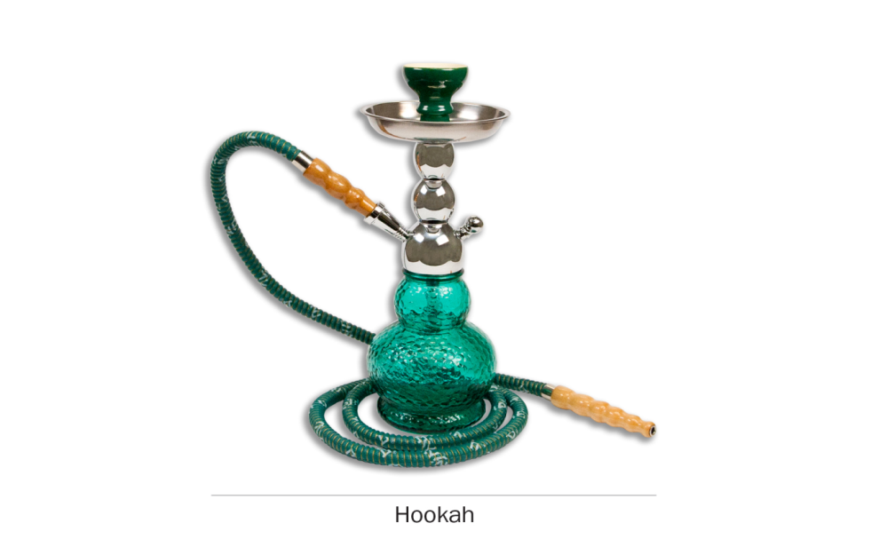
People smoke shisha or hookah tobacco in a hookah. Some shisha contains tobacco and some does not. Shisha comes in many flavors.
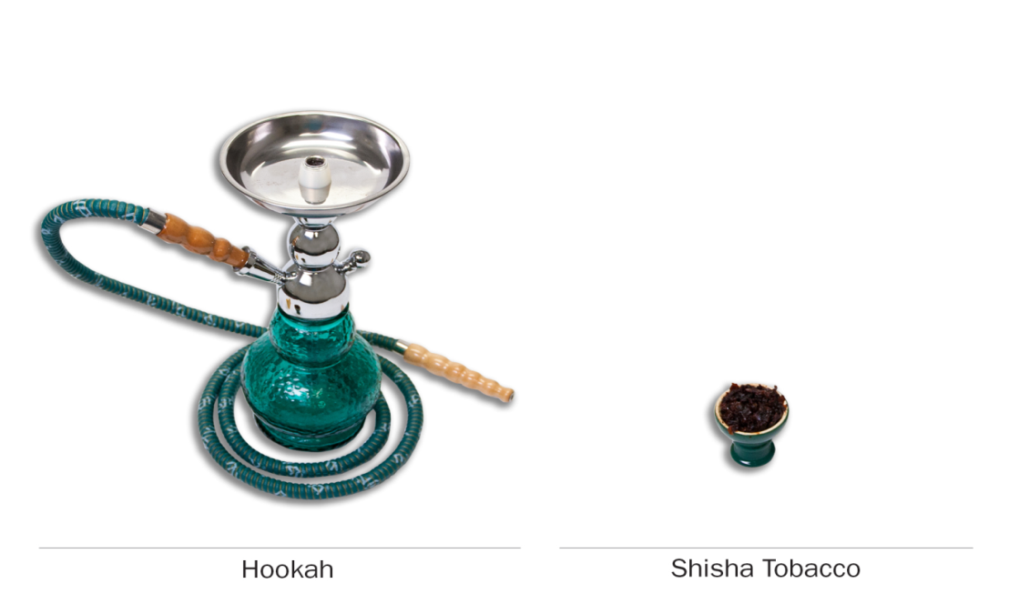
What reaction, if any, did you have to this description and pictures of shisha?
Do you usually refer to it as shisha, or is there another term you use?

Frequency of Use
PATH ID: R02_AH1005
- How many times have you smoked hookah in your entire life? Count each sitting or session where you smoked tobacco in a hookah, whether alone or with others.
- 1 to 10
- 11 to 20
- 21 to 50
- 51 to 99
- 100 or more
Tell me more about how you came up with your answer.
How easy or difficult was it for you to answer this question? What made it easy/difficult?
RESEARCH QUESTION
Given the atypical nature of hookah use, how do respondents interpret the phrase “fairly regularly”?
PATH ID: R02_AH1100
- Have you ever smoked hookah fairly regularly?
- Yes
- No go to Q4
What does it mean to smoke hookah ‘fairly regularly’?
PATH ID: R02_AH1007
- How old were you when you first started smoking hookah fairly regularly?
___________________________________
How did you remember how old you were when you first started smooking hookah fairly regularly?
PATH ID: R02_AH9003
- Which of the following choices best describes your hookah smoking? Usually I smoke hookah…
- Every day go to Q7
- Weekly go to Q6
- Monthly
- Every couple of months go to Q9
- About once a year go to Q9
How did you decide to answer [ANSWER]? How easy or difficult was it to answer this question?
When do you smoke hookah?
PROBE TO SEE IF HOOKAH USE IS REGULAR (VERSUS SPORADIC).
IF ANSWER COUPLE OF MONTHS OR ABOUT ONCE A YEAR, Over a year, about how often do you smoke hookah? Count each sitting or session where you smoked tobacco in a hookah, whether alone or with others.

PATH ID: R02_AH9004
- On average, about how many times do you smoke hookah in a month? Count each sitting or session where you smoked tobacco in a hookah, whether alone or with others.
___________________________________ go to Q8
How did you come up with your answer? How confident are you in your answer?
IF NEEDED, Do you smoke hookah about the same amount every month, or do you smoke less or more in some months?
Do you call it a “sitting” or “session,” or do you use another word?
PATH ID: R02_AH9005
- On average, about how many times do you smoke hookah in a week? Count each sitting or session where you smoked tobacco in a hookah, whether alone or with others.
___________________________________ go to Q8
How did you come up with your answer? How confident are you in your answer?
IF NEEDED, Do you smoke hookah about the same amount every week, or do you smoke less or more in some weeks?
Do you call it a “sitting” or “session,” or do you use another word?
PATH ID: R02_AH9006
- On average, about how many times do you smoke hookah each day? Count each sitting or session where you smoked tobacco in a hookah, whether alone or with others.
___________________________________
How did you come up with your answer? How confident are you in your answer?
IF NEEDED, Do you smoke hookah about the same amount every day, or do you smoke less or more in some days?
Do you call it a “sitting” or “session,” or do you use another word?
PATH ID: R02_AH1024
- On the days that you smoke hookah, how soon after you wake up do you typically take your first puff from a hookah?

___________________________________
How easy or difficult was it for you to answer this question?
Do you usally call it a “puff,” or is there another word you use?
IF NEEDED, Do you ever use the word “drag”?
PATH ID: R02_AH1009
- About how long has it been since you last smoked hookah?
___________________________________
How easy or difficult was it for you to answer this question?

Ownership and How/Where to use
PATH ID: R02_AH1090
- Do you own a hookah?
- Yes
- No
PATH ID: R02_AH9041
- Does anyone else living in your home own a hookah?
- Yes
- No
PATH ID: R02_AH9011
- Where do you usually smoke hookah? Choose all that apply.
- At home
- In a hookah bar or cafe
- At a friend’s house
- Somewhere else (SPECIFY:__________)
PATH ID: R02_AH9012
- Do you usually share the same hookah with others when you smoke?
- Yes
- No go to Q15
PATH ID: R02_AH9013
- How many people do you usually share hookah with?
- 1 other person
- 2 other people
- 3 other people
- 4 or more other people
Do you usually smoke hookah with the same number of people, or does it change? IF CHANGES, How did you decide on your answer?

PATH ID: R02_AH9014
- On average, how long is one hookah session for you (and the people you share it with)? A session is one sitting in which you smoke hookah, whether alone or with others.
- Less than 30 minutes
- More than 30 minutes up to 1 hour
- 1 to 2 hours
- More than 2 hours
PATH ID: R02_AH9015
- On average, when you smoke hookah, how many times do you refill it with tobacco?
- 0 times
- 1 time
- 2 to 3 times
- 4 or more times
Are you usually the one who refills it? IF NOT, Who usually refills it?
PATH ID: R02_AH9016
- How often do you personally set up the hookah?
- Every time
- Most of the time
- Some of the time
- Rarely
- Never, someone else always sets it up for me
Tell me more about your answer. IF NEEDED, what does it mean to ‘set up the hookah’?

Purchasing
PATH ID: R02_AH1097
The next questions ask about your experience buying shisha or hookah tobacco.
- In the past 30 days, have you used a coupon when buying shisha or hookah tobacco?
- Yes
- No go to Q20
IF YES, Where did you use the coupon? Was it at a restaurant, café, a tobacco store, etc.? IF NEEDED, Was the coupon just for the shisha, or did it include other things, such as the use of a hookah pipe?
IF YES, Where do you usually get your coupons? Have you ever used “Groupon” or something similar?
IF NO, Have you ever seen a coupon when buying shisha or hookah tobacco? Have you ever used one?
Do you usually buy the shisha or hookah tobacco? IF NO, How did you decide on your answer?
Have you ever bought shisha online? IF YES, If you did buy it online, and you used a discount code, how would you answer this question?
DETERMINE IF RESPONDENT INCLUDES A DISCOUNT CODE AS A COUPON.

PATH ID: R02_AH1098
- In the past 30 days, how many times have you used a coupon when buying shisha or hookah tobacco?
___________________________________
PATH ID: R02_AH1030
- How do you usually buy shisha or hookah tobacco for yourself? Is it…
- In person (such as at a store or hookah bar)
- From the internet go to Q23
- By telephone go to Q23
- I do not buy my own shisha or hookah tobacco go to Q23
PATH ID: R02_AH1032
- Do you usually buy shisha or hookah tobacco...?
- In your own state
- In another state
- Outside the US

PATH ID: R02_AH1033
- Where do you buy your shisha or hookah tobacco most of the time?
- A hookah bar or cafe
- A convenience store or gas station
- A supermarket, grocery store, or drug store
- A warehouse club, such as Sam’s or Costco
- A smoke shop, tobacco specialty store or tobacco outlet store
- A duty free shop or military commissary
- A bar, pub, restaurant or casino
- A friend or relative
- A swap meet or flea market
- A liquor store
- Or from somewhere else SPECIFY: ____________________________
IF ANSWERS HOOKAH BAR OR CAFÉ, Do you usually call it a hookah bar or café, or is there another term you use?
Are there any places missing from this list?
Is there anything here you haven’t heard of?

Regular Brand
PATH ID: R02_AH1047
- Do you have a regular brand of shisha or hookah tobacco that you usually smoke?
- Yes
- No
How did you come up with your answer?
In your own words, what is a “regular” brand?
PATH ID: R02_AH1048
- What brand of shisha or hookah tobacco did you last smoke?
SHOW RESPONDENT BRAND LIBRARY
___________________________________ go to Q26
- Something else
PATH ID: R02_AH1049
- You said that your brand was not pictured. What is it?

___________________________________
PATH ID: R02_AH1070
- You selected [BRANDFILL] as your brand. What kind of [BRANDFILL] did you last smoke?
SHOW RESPONDENT BRAND LIBRARY
___________________________________ go to Q28
- Something else
PATH ID: R02_AH1071
- You said that the type of [BRANDFILL]s that you smoke is not pictured. What type is it?
___________________________________
PATH ID: R02_AH9108
- Does this brand of shisha contain tobacco?
- Yes
- No
How confident are you in your answer? How do you know whether or not your shisha contains tobacco?
Are you familiar with shisha that doesn’t have tobacco?
PATH ID: R02_AH1051
- About how long have you been smoking your regular brand of shisha or hookah tobacco?
___________________________________
- I don’t have a regular brand
Tell me more about how you came up with your answer. IF NEEDED, how do you remember when you first started smoking your regular brand of shisha or hookah tobacco?

Reasons to Use
BEFORE RESPONDENT SEES QUESTIONS, PROBE GENERALLY,
Tell me more about why you smoke hookah.
PATH ID: R02_AH1060
The next questions are about the reasons people smoke hookah. Please select which reasons apply to you.
I smoke hookah because…
- It is affordable.
- Yes
- No
PATH ID: R02_AH1061
- People in the media or other public figures smoke hookah.
- Yes
- No
PATH ID: R02_AH1085
- I can smoke hookah at times when or in places where smoking cigarettes isn’t allowed.
- Yes
- No
PATH ID: R02_AH1062
- It might be less harmful than smoking cigarettes.
- Yes
- No
PATH ID: R02_AH1063
- Shisha or hookah tobacco comes in flavors I like.
- Yes
- No

PATH ID: R02_AH1064
- Smoking hookah helps people to quit smoking cigarettes.
- Yes
- No
PATH ID: R02_AH1068
- People who are important to me smoke hookah.
- Yes
- No
PATH ID: R02_AH1069
- I like socializing while smoking hookah.
- Yes
- No
PATH ID: R02_AH1072
- The advertising for hookah appeals to me.
- Yes
- No
PATH ID: R02_AH1073
- Smoking hookah is part of my cultural tradition.
- Yes
- No
How easy or difficult was it to answer this series of questions?
What did you think of these possible reasons to smoke hookah? Are there any that seemed strange or out of place? Are there other reasons someone might have for choosing a particular brand that are missing?

Use of Non-tobacco Products
research question
Developing new items to capture misuse of tobacco products, particularly the use of herbal substances which users think do not contain tobacco (but which might) and the use of liquid other than water in hookahs (e.g., alcohol, milk, Kool-Aid).
The next questions are about things other than shisha or hookah tobacco that someone might smoke in a hookah.
PATH ID: NEW_ HOOKAH MARIJUANA MISUSE
- Have you ever smoked marijuana from a hookah?
- Yes
- No
Tell me more about how you came up with your answer.
IF YES, How do you smoke marijuana from a hookah?
IF NEEDED, Is it just marijuana, or do you mix it with tobacco?
IF NO, Have you heard of people smoking marijuana from a hookah? What have you heard about it?

PATH ID: NEW_ HOOKAH OTHER SUBSTANCES MISUSE
- Have you ever smoked anything else in a hookah?
- Yes
- No

In your own words, what is this question asking?
If YES, What else have you smoked in a hookah? Where did you learn that was something you could smoke from a hookah?
IF NO, Have you ever heard of people smoking something other than marijuana, shisha or hookah tobacco in a hookah? What have you heard? Where did you hear about it?
PATH ID: NEW_ HOOKAH LIQUID MISUSE
- Have you ever used another liquid besides water in the bowl of the hookah?
- Yes
- No
IF YES, What type of liquid did you use? Where did you first hear about using liquid other than water in a hookah?
IF NO, Have you ever heard of using a liquid other than water in the bowl of the hookah? What kinds of liquids? Where did you hear about them?

PATH ID: NEW_ SHISHA WITH TOBACCO CLARIFICATION
- Do you usually smoke shisha with tobacco when you smoke a hookah?
- Yes
- No
How do you know if shisha contains tobacco or not?
What kind of shisha do you usually smoke?

Hookah Nicotine Dependence
adult CURRENT Hookah tobacco users
research questions
Test applicability of the items on dependency, quitting and withdrawal for users of less standard tobacco products such as hookah, e-cigarette, and smokeless tobacco. Do they seem inappropriate or difficult to answer for users of these products?

Dependency items
PATH ID: R02_ANT01_Hookah
Now we would like to ask about your experience with hookah. Please think only about hookah as you answer these questions.
PATH ID: R02_AN0010_HookahDependency
- Do you consider yourself addicted to hookah?
- No, not at all
- Yes, somewhat addicted
- Yes, very addicted
In your own words, what does it mean to be “addicted” to hookah?
IF NO, NOT AT ALL, Tell me more about your answer.
How easy or difficult was it to answer this question? What made it easy/difficult?
PATH ID: R02_AN0015_Hookah_Cravings
- Do you ever have strong cravings to smoke hookah?
- Yes
- No

PATH ID: R02_AN0020_Hookah_Reallyneed
- Have you ever felt like you really needed to smoke hookah?
- Yes
- No
What does it mean to “really need” to smoke a hookah?
PATH ID: R02_AN0055_Hookah_Agreement
Please rate your level of agreement for each statement using the following scale: 1= not true of me at all to 5=extremely true of me.
- I find myself reaching for hookah without thinking about it.
- 1 Not true of me at all
- 2
- 3
- 4
- 5 Extremely true of me
PATH ID: R02_AN0025_Hookah_Craving
- I frequently crave hookah.
- 1 Not true of me at all
- 2
- 3
- 4
- 5 Extremely true of me
PATH ID: R02_AN0030_Hookah_urges
- My urges keep getting stronger if I don’t smoke hookah.
- 1 Not true of me at all
- 2
- 3
- 4
- 5 Extremely true of me

PATH ID: R02_AN0035_Hookah_Control
- Hookah smoking controls me.
- 1 Not true of me at all
- 2
- 3
- 4
- 5 Extremely true of me
PATH ID: R02_AN0045_Hookah_Outofcontrol
- My hookah smoking is out of control.
- 1 Not true of me at all
- 2
- 3
- 4
- 5 Extremely true of me
PATH ID: R02_AN0060_Hookah_wakeup
- I usually want to smoke hookah right after I wake up.
- 1 Not true of me at all
- 2
- 3
- 4
- 5 Extremely true of me
PATH ID: R02_AN0065_Hookah_Fewhours
- I can only go a couple of hours without smoking hookah.
- 1 Not true of me at all
- 2
- 3
- 4
- 5 Extremely true of me

PATH ID: R02_AN0050_Hookah_nothought
- I frequently smoke hookah without thinking about it.
- 1 Not true of me at all
- 2
- 3
- 4
- 5 Extremely true of me
PATH ID: R02_AN0070_Hookah_feelbetter
- Smoking hookah really helps me feel better if I’ve been feeling down.
- 1 Not true of me at all
- 2
- 3
- 4
- 5 Extremely true of me
PATH ID: R02_AN0075_Hookah_ThinkBetter
- Smoking hookah helps me think better.
- 1 Not true of me at all
- 2
- 3
- 4
- 5 Extremely true of me
PATH ID: R02_AN0255
- Most of the people I spend time with are tobacco users.
- 1 Not true of me at all
- 2
- 3
- 4
- 5 Extremely true of me

PATH ID: R02_AN0080_Hookah_Alone
- I would feel alone without my hookah.
- 1 Not true of me at all
- 2
- 3
- 4
- 5 Extremely true of me
PATH ID: R02_AN0085_Hookah_hardtostop
- I would find it really hard to stop smoking hookah.
- 1 Not true of me at all
- 2
- 3
- 4
- 5 Extremely true of me
PATH ID: R02_AN0090_Hookah_1week
- I would find it hard to stop smoking hookah for a week.
- 1 Not true of me at all
- 2
- 3
- 4
- 5 Extremely true of me
PATH ID: R02_AN0095_Hookah_Irritable
- After not smoking hookah for a while, I need to smoke hookah in order to feel less restless and irritable.
- 1 Not true of me at all
- 2
- 3
- 4
- 5 Extremely true of me

PATH ID: R02_AN0100_hookah_Discomfort
- After not smoking hookah for a while, I need to smoke hookah in order to keep myself from experiencing any discomfort.
- 1 Not true of me at all
- 2
- 3
- 4
- 5 Extremely true of me
PATH ID: R02_AN0813_Hookah_Permitted
- In the past 12 months, did you find it difficult to keep from smoking hookah in places where it was not permitted?
- Yes
- No
PATH ID: R02_AN0812_Hookah_Activities
- In the past 12 months, did you give up or cut down on activities that were enjoyable or important to you because hookah smoking was not permitted at the activity?
- Yes
- No
What reaction, if any, do you have to this last set of questions about your experiences with hookah?
How easy or difficult was it to answer these questions? What did you think of the answer choices?
What did you think of being asked these questions? IF NEEDED, Do you think it makes sense to ask these questions of people who smoke hookah?

Quitting
research question
Explore what respondents used to quit, especially for pipe, cigar, dissolvable tobacco, and hookah users. Do respondents use other things like an “app” or a “doctor” to help them quit?
PATH ID: R02_AN0105_Hookah_Triedtoquit
- In the past 12 months, have you tried to quit smoking hookah? Choose all that apply.
- Yes, I have tried to quit completely
- Yes, I have tried to quit by reducing or cutting back
- No, I have reduced or cut back instead of trying to quit
- No, I have not tried to quit at all go to Q30
Tell me more about your answer. How did you decide which answer choice to choose?
In your own words, what is the difference between tyring to quit completely and trying to quit by reducing or cutting back?
IF YES, Can you tell me how you tried to quit? What did you use to quit?
IF NEEDED: Did you rely on the support of friends and family to help you quit?
Did you use counseling, a telephone help line or quit line, books, pamphlets, videos, a quit tobacco clinic, class, or support group, or an internet or web-based program?
Did you use an app?
Did you use any different tobacco product to help you quit?
Did you use a nicotine patch, gum, inhaler, nasal spray, lozenge or pill?
Did a doctor help you?
Did you use a prescription drug like Chantix, varenicline, Wellbutrin, Zyban, or bupropion?
Is there anything else that you used to help you quit?

Withdrawal
research questions
Test applicability of these items for users of less standard tobacco products such as hookah, e-cigarette, and smokeless tobacco. Do they seem inappropriate or difficult to answer for users of these products?
PATH ID: R02_AN0804_Hookah_Withdrawal
The next questions ask about how you felt within days after the last time you tried to quit smoking hookah in the past 12 months.
Within days after stopping or cutting down on your hookah smoking in the past 12 months, did you….
- Feel depressed?
- Yes
- No
PATH ID: R02_AN0805_Hookah_DifficultSleep
Within days after stopping or cutting down on your hookah smoking in the past 12 months, did you….
- Have difficulty falling asleep or staying asleep?
- Yes
- No
PATH ID: R02_AN0806_Hookah_Concentration
Within days after stopping or cutting down on your hookah smoking in the past 12 months, did you….
- Have difficulty concentrating?
- Yes
- No
PATH ID: R02_AN0807_Hookah_Weight
Within days after stopping or cutting down on your hookah smoking in the past 12 months, did you….
- Eat more than usual or gain weight?
- Yes
- No
PATH ID: R02_AN0808_Hookah_angry
Within days after stopping or cutting down on your hookah smoking in the past 12 months, did you….
- Become easily irritated, angry, or frustrated?
- Yes
- No
PATH ID: R02_AN0809_Hookah_Anxious
Within days after stopping or cutting down on your hookah smoking in the past 12 months, did you….
- Feel anxious or nervous?
- Yes
- No
PATH ID: R02_AN0810_Hookah_Restless
Within days after stopping or cutting down on your hookah smoking in the past 12 months, did you….
- Feel more restless than usual?
- Yes
- No
What reaction, if any, do you have to these last few questions about your experiences with quitting?
How easy or difficult was it to answer these questions?
IF NEEDED, Do you think it makes sense to ask these questions of people who smoke hookah?

Considered quitting
research questions
Test applicability of this item for users of less standard tobacco products such as Hookah, e-cigarette, and smokeless tobacco. Does this item make sense for current users of these products?
PATH ID: R02_AN0230_Hookah_Interestinquitting
- Overall, on a scale from 1 to 10 where 1 is not at all interested and 10 is extremely interested, how interested are you in quitting smoking hookah? Please enter a number from 1 to 10.
- Not at all interested
- 2
- 3
- 4
- 5
- 6
- 7
- 8
- 9
- Extremely Interested
What reaction, if any, do you have to this question?
IF NEEDED, Do you think it makes sense to ask these questions of people who smoke hookah?

Adult Nicotine Dependence Module
adult CURRENT smokeless tobacco users
research questions
Test applicability of the items on dependency, quitting and withdrawal for users of smokeless tobacco. Do they seem inappropriate or difficult to answer for users of smokeless tobacco?

Dependency items
PATH ID: R02_ANT01_Smokeless

Now we would like to ask about your experience with smokeless tobacco. Please think only about smokeless tobacco as you answer these questions.
PATH ID: R02_AN0010_SmokelessTobaccoDEPENDENCY
- Do you consider yourself addicted to smokeless tobacco?
- No, not at all
- Yes, somewhat addicted
- Yes, very addicted
In your own words, what does it mean to be “addicted” to smokeless tobacco?
IF NO, NOT AT ALL, Tell me more about your answer.
How easy or difficult was it to answer this question? What made it easy/difficult?

PATH ID: R02_AN0015_Smokeless_Cravings
- Do you ever have strong cravings to use smokeless tobacco?
- Yes
- No
PATH ID: R02_AN0020_Smokeless_Reallyneed
- Have you ever felt like you really needed to use smokeless tobacco?
- Yes
- No
What does it mean to “really need” to use smokeless tobacco?
PATH ID: R02_AN0055_Smokeless_Agreement
Please rate your level of agreement for each statement using the following scale: 1= not true of me at all to 5=extremely true of me.
- I find myself reaching for smokeless tobacco without thinking about it.
- 1 Not true of me at all
- 2
- 3
- 4
- 5 Extremely true of me
PATH ID: R02_AN0025_Smokeless_Craving
- I frequently crave smokeless tobacco.
- 1 Not true of me at all
- 2
- 3
- 4
- 5 Extremely true of me
PATH ID: R02_AN0030_Smokeless_Urges
- My urges keep getting stronger if I don’t use smokeless tobacco.
- 1 Not true of me at all
- 2
- 3
- 4
- 5 Extremely true of me
PATH ID: R02_AN0035_Smokeless_Control
- Smokeless tobacco controls me.
- 1 Not true of me at all
- 2
- 3
- 4
- 5 Extremely true of me
PATH ID: R02_AN0045_Smoekless_outofcontrol
- My smokeless tobacco use is out of control.
- 1 Not true of me at all
- 2
- 3
- 4
- 5 Extremely true of me
PATH ID: R02_AN0060_Smokeless_Wakeup
- I usually want to use smokeless tobacco right after I wake up.
- 1 Not true of me at all
- 2
- 3
- 4
- 5 Extremely true of me
PATH ID: R02_AN0065_Smokeless_Fewhours
- I can only go a couple of hours without using smokeless tobacco.
- 1 Not true of me at all
- 2
- 3
- 4
- 5 Extremely true of me
PATH ID: R02_AN0050_Smokeless_nothought
- I frequently use smokeless tobacco without thinking about it.
- 1 Not true of me at all
- 2
- 3
- 4
- 5 Extremely true of me
PATH ID: R02_AN0070_Smokeless_Feelbetter
- Using smokeless tobacco really helps me feel better if I’ve been feeling down.
- 1 Not true of me at all
- 2
- 3
- 4
- 5 Extremely true of me
PATH ID: R02_AN0075_Smokeless_ThinkBetter
- Using smokeless tobacco helps me think better.
- 1 Not true of me at all
- 2
- 3
- 4
- 5 Extremely true of me
PATH ID: R02_AN0332
- Most of the people I spend time with use e-cigarettes.
- 1 Not true of me at all
- 2
- 3
- 4
- 5 Extremely true of me
PATH ID: R02_AN0255_Tobacco
- Most of the people I spend time with use tobacco.
- 1 Not true of me at all
- 2
- 3
- 4
- 5 Extremely true of me

PATH ID: R02_AN0080_SmokelessTobacco_Alone
- I would feel alone without my smokeless tobacco.
- 1 Not true of me at all
- 2
- 3
- 4
- 5 Extremely true of me
PATH ID: R02_AN0085_Smokeless_hardtostop
- I would find it really hard to stop using smokeless tobacco.
- 1 Not true of me at all
- 2
- 3
- 4
- 5 Extremely true of me
PATH ID: R02_AN0090_Smokeless_1week
- I would find it hard to stop using smokeless tobacco for a week.
- 1 Not true of me at all
- 2
- 3
- 4
- 5 Extremely true of me
PATH ID: R02_AN0095_Smokeless_irritaBle
- After not using smokeless tobacco for a while, I need to use smokeless tobacco in order to feel less restless and irritable.
- 1 Not true of me at all
- 2
- 3
- 4
- 5 Extremely true of me

PATH ID: R02_AN0100_Smokeless_Discomfort
- After not using smokeless tobacco for a while, I need to use smokeless tobacco in order to keep myself from experiencing any discomfort.
- 1 Not true of me at all
- 2
- 3
- 4
- 5 Extremely true of me
PATH ID: R02_AN0813_Smokeless_Permitted
- In the past 12 months, did you find it difficult to keep from using smokeless tobacco in places where it was not permitted?
- Yes
- No
PATH ID: R02_AN0812_Smokeless_Activities
- In the past 12 months, did you give up or cut down on activities that were enjoyable or important to you because smokeless tobacco use was not permitted at the activity?
- Yes
- No
What reaction, if any, do you have to this set of questions about your experiences with smokeless tobacco?
How easy or difficult was it to answer these questions?
What did you think of the answer choices?
What did you think of being asked these questions? IF NEEDED, Do you think it makes sense to ask these questions of people who use smokeless tobacco?

Quitting
research question
Explore what respondents used to quit. Do respondents use other things like an “app” or a “doctor” to help them quit?
PATH ID: R02_AN0105_Smokeless_TriedToquit
- In the past 12 months, have you tried to quit using smokeless tobacco? Choose all that apply.
- Yes, I have tried to quit completely
- Yes, I have tried to quit by reducing or cutting back
- No, I have reduced or cut back instead of trying to quit
- No, I have not tried to quit at all go to Q31
Tell me more about your answer. How did you decide which answer choice to choose?
In your own words, what is the difference between tyring to quit completely and trying to quit by reducing or cutting back?
IF YES, Can you tell me how you tried to quit? What did you use to quit?
IF NEEDED: Did you rely on the support of friends and family to help you quit?
Did you use counseling, a telephone help line or quit line, books, pamphlets, videos, a quit tobacco clinic, class, or support group, or an internet or web-based program?
Did you use an app?
Did you use any different tobacco product to help you quit?
Did you use a nicotine patch, gum, inhaler, nasal spray, lozenge or pill?
Did a doctor help you?
Did you use a prescription drug like Chantix, varenicline, Wellbutrin, Zyban, or bupropion?
Is there anything else that you used to help you quit?

Withdrawal
research questions
Test applicability of these items for users of less standard tobacco products such as hookah, e-cigarette, and smokeless tobacco. Do they seem inappropriate or difficult to answer for users of these products?
PATH ID: R02_AN0804_Smokeless_Withdrawal
The next questions ask about how you felt within days after the last time you tried to quit using smokeless tobacco in the past 12 months.
Within days after stopping or cutting down on your smokeless tobacco use in the past 12 months, did you….
- Feel depressed?
- Yes
- No
PATH ID: R02_AN0805_Smokeless_DifficultSleep
Within days after stopping or cutting down on your smokeless tobacco use in the past 12 months, did you….
- Have difficulty falling asleep or staying asleep?
- Yes
- No
PATH ID: R02_AN0806_Smokeless_Concentration
Within days after stopping or cutting down on your smokeless tobacco use in the past 12 months, did you….
- Have difficulty concentrating?
- Yes
- No
PATH ID: R02_AN0807_Smokeless_Weight
Within days after stopping or cutting down on your smokeless tobacco use in the past 12 months, did you….
- Eat more than usual or gain weight?
- Yes
- No
PATH ID: R02_AN0808_Smokeless_Angry
Within days after stopping or cutting down on your smokeless tobacco use in the past 12 months, did you….
- Become easily irritated, angry, or frustrated?
- Yes
- No
PATH ID: R02_AN0809_Smokeless_Anxious
Within days after stopping or cutting down on your smokeless tobacco use in the past 12 months, did you….
- Feel anxious or nervous?
- Yes
- No
PATH ID: R02_AN0810_Smokeless_restless
Within days after stopping or cutting down on your smokeless tobacco use in the past 12 months, did you….
- Feel more restless than usual?
- Yes
- No
What reaction, if any, do you have to these last few questions about your experiences with quitting?
How easy or difficult was it to answer these questions?
IF NEEDED, Do you think it makes sense to ask these questions of people who use smokeless tobacco?

Considered quitting
research questions
Test applicability of this item for users of less standard tobacco products such as Hookah, e-cigarette, and smokeless tobacco. Does this item make sense for current users of these products?
PATH ID: R02_AN0230_Smokeless_Interestinquitting
- Overall, on a scale from 1 to 10 where 1 is not at all interested and 10 is extremely interested, how interested are you in quitting smokeless tobacco use? Please enter a number from 1 to 10.
- Not at all interested
- 2
- 3
- 4
- 5
- 6
- 7
- 8
- 9
- Extremely Interested
What reaction, if any, do you have to this question?
IF NEEDED, Do you think it makes sense to ask these questions of people who use smokeless tobacco?

Youth Nicotine Dependence
Youth tobacco users
research questions
Given limitations of earlier testing, we’d like to test these items with additional youth. We are primarily concerned whether these items are appropriate for youth respondents. Are youth able to answer these items - do they even think about things like having strong cravings?
We also want to know how these items work for users of less standard tobacco products such as hookah, e-cigarette, and smokeless tobacco. Do these items seem inappropriate or more difficult to answer for users of these products?
PATH ID: R02_YN0703
The next questions ask about your experience with tobacco products.
- How soon after you wake up do you want to use tobacco?
- Within 5 minutes
- From 6 to 30 minutes
- From more than 30 minutes to 1 hour
- After more than 1 hour but less than 24 hours
- I rarely want to use tobacco
- Don’t know

PATH ID: R02_YN0704
- Do you ever have strong cravings to use tobacco?
- Yes
- No
- Don’t know
In your own words, what does it mean to have ‘strong cravings’ to use tobacco products?
What kind(s) of tobacco product(s) were you thinking about when you answered this question?
IF YES, tell me more about your answer.
PATH ID: R02_YN0705
- Have you ever felt like you really needed to use tobacco?
- Yes
- No
- Don’t know

PATH ID: R02_YN0055
Please rate your level of agreement for each statement using the following scale: 1= not true of me at all to 5=extremely true of me.
- I find myself reaching for a tobacco product without thinking about it.
- 1 Not true of me at all
- 2
- 3
- 4
- 5 Extremely true of me
- Don’t know
PATH ID: R02_YN0025
- I frequently crave tobacco.
- 1 Not true of me at all
- 2
- 3
- 4
- 5 Extremely true of me
- Don’t know
PATH ID: R02_YN0045
- My tobacco use is out of control.
- 1 Not true of me at all
- 2
- 3
- 4
- 5 Extremely true of me
- Don’t know

PATH ID: R02_YN0070
- Using tobacco really helps me feel better if I’ve been feeling down.
- 1 Not true of me at all
- 2
- 3
- 4
- 5 Extremely true of me
- Don’t know
PATH ID: R02_YN0075
- Using tobacco helps me think better.
- 1 Not true of me at all
- 2
- 3
- 4
- 5 Extremely true of me
- Don’t know
PATH ID: R02_YN0080
- I would feel alone without my tobacco.
- 1 Not true of me at all
- 2
- 3
- 4
- 5 Extremely true of me
- Don’t know

PATH ID: R02_YN0060
- I usually want to use tobacco right after I wake up.
- 1 Not true of me at all
- 2
- 3
- 4
- 5 Extremely true of me
- Don’t know
PATH ID: R02_YN0332
- Most of the people I spend time with use e-cigarette.
- 1 Not true of me at all
- 2
- 3
- 4
- 5 Extremely true of me
- Don’t know

PATH ID: R02_YN0255
- Most of the people I spend time with use tobacco.
- 1 Not true of me at all
- 2
- 3
- 4
- 5 Extremely true of me
- Don’t know

What reaction, if any, do you have to this series of questions about your experiences with tobacco products?
What did you think of being asked these questions?
How easy or difficult was it to answer these questions? What did you think of the answer choices?
IF NEEDED, Do you think it makes sense to ask these questions of people who [smoke hookah/use e-cigarettes/use smokeless tobacco]?

Adult Tobacco Use Module

Cigarettes

Screening
PATH ID: YC1002
- Have you ever tried cigarette smoking, even one or two puffs?
- Yes
- No go to CIGARS

research question
Revised item. Testing inclusion of a fourth response category, “rarely.”
PATH ID: R02_AC1003
- Do you now smoke cigarettes…
- Every day
- Some days
- Rarely go to Q8
- Not at all go to CIGARS
Tell me more about your answer. PROBE TO GET A BETTER SENSE OF SMOKING FREQUENCY.
In the past 30 days, how many days did you smoke cigarettes?
How easy or difficult was it to choose your answer from this list of choices? In your own words, what is the difference between smoking “some days” and smoking “rarely”?
IF RESPONDENT SELECTS “RARELY,” If “rarely” hadn’t been an answer choice, how would you have answered this question? IF NEEDED, Would you have chosen “not at all” or “sometimes”? Why?
PATH ID: R02_AC0100
- When did you last smoke a cigarette?
- In the past hour go to Q5
- Sometime today
- Yesterday
- Day before yesterday
- Three or more days ago go to Q8
research question
Testing the new response options.
PATH ID: R02_AC0102
- When you last smoked a cigarette, was it…
- Midnight to 6 AM
- After 6 AM but before noon
- Noon to 6 PM
- After 6 PM but before midnight
When exactly did you last smoke a cigarette?
How easy or difficult was it for you to answer this question? What made it easy or difficult?
PATH ID: R02_AC0103
- On the day you last smoked, how many cigarettes did you smoke? A pack usually has 20 cigarettes in it.
___________________________________
PATH ID: R02_AC1022
- On how many of the past 30 days did you smoke cigarettes?
___________________________________

- DON'T KNOW

RESEARCH QUESTION
How well can respondents report quantities?
PATH ID: R02_AC1023
- On average, on those days you smoked, how many cigarettes did you usually smoke each day? A pack usually has 20 cigarettes in it.
Cigarettes per day
___________________________________ Packs per day
- DON'T KNOW
How did you come up with your answer? How confident are you in your answer?
IF NEEDED, How easy or difficult was it to answer this question?
Research questions
Questions about smokers self-perceptions (i.e., do they value it and consider it part of their identity versus feeling ambivalent) are being developed in order to allow for later analysis on the relationship between e-cigarette use and the value assigned to smoking by smokers.
PATH ID: R02_AC9022
- Do you consider yourself a smoker?
- Yes
- No
- DON'T KNOW
Tell me more about your answer. How did you decide yes/no?
IF NO, Tell me more about why you don’t consider yourself a smoker?
In your own words, what makes someone a “smoker”?

PATH ID: new smoker identity
- Do you consider being a smoker part of your identity?
- Yes
- No
- DON'T KNOW
Tell me more about your answer. How did you decide yes/no?
IF NO, Why don’t you consider smoking part of your identity?

Flavor
Research questions
Previous testing showed some recall issues and difficulties assigning categories to flavors. Test if respondents can identify flavors and whether the list is exhaustive.
Additionally, try to tease out if respondents consider non-flavored products to be unflavored, regular, tobacco flavored, traditional, etc.
PATH ID: R02_AC1130
- In the past 30 days, were any of the cigarettes you smoked flavored to taste like menthol, mint, clove, spice, fruit, chocolate, alcoholic drinks, candy or other sweets?
- Yes
- No go to Q12
- I don’t know go to Q12
IF NO, Are you familiar with these flavors? Which ones have you heard of?
IF NO, Was it flavored at all? Would you call it “unflavored” or “regular” or something else?

PATH ID: R02_AC1131
- Which flavors have you smoked in the past 30 days? Choose all that apply.
- Menthol or mint
- Clove or spice
- Fruit
- Chocolate
- An alcoholic drink (such as wine, cognac, margarita or other cocktails)
- Candy or other sweets
- Some other flavor
- DON'T KNOW
IF CANDY, FRUIT, OR SWEETS, PROBE FOR EXACT FLAVOR.
IF CHECK MULTIPLE FLAVORS, Was each flavor a different cigarette, or did a single cigarette have multiple flavors?
How easy/difficult was it for you to answer this question?
How confident are you in your response(s)?
Are there any flavors we left out?

Switching
Research question
Earlier testing revealed that “switching” may not be a meaningful concept for all tobacco products (e.g., hookah users). Test further.
Test whether asking “Have you thought about…” works better than “Have you considered…” for respondents.
PATH ID: R02_AX0307_REVISED_Cigarettes
- Have you thought about switching from cigarettes to any of the following products? Choose all that apply.
- I have not thought about switching to another product
- E-cigarettes
- Traditional cigars
- Cigarillos
- Filtered cigars
- Pipes
- Hookahs
- Snus pouches
- Smokeless tobacco such as loose snus, moist snuff, dip, spit, or chewing tobacco
- Dissolvable tobacco
What reaction, if any, did you have to this question?
NOTE IF RESPONDENT FINDS CONCEPT OF “SWITCHING” TO BE INAPPROPRIATE FOR A PARTICULAR PRODUCT
In your own words, what does it mean to “switch” to another product?
PROBE IF RESPONDENT INTERPRETS IT AS GIVING THE FIRST PRODUCT UP COMPLETELY
Tell me more about your answer.
IF SELECTED PRODUCTS, Why have you thought about switching from X to X?
IF HAVE NOT THOUGHT ABOUT SWITCHING, Tell me more about why you haven’t thought about switching to these other products?
If this question asked “Have you considered switching…” instead of “Have you thought about switching…”, would that have changed your answer? Why or why not?
Which do you prefer? Why?

Cigars

Screening
RESEARCH QUESTIONS
Need further testing with cigar items. We want to know if we are routing cigar users correctly.
PATH ID: R02_AGT01
The next questions are about traditional cigars, cigarillos, and filtered cigars. These products go by lots of different names, so please use these descriptions and photos to understand what they are.
Traditional cigars contain tightly rolled tobacco that is wrapped in a tobacco leaf. Some common brands of traditional cigars include Macanudo, Romeo y Julieta, and Arturo Fuente, but there are many others.
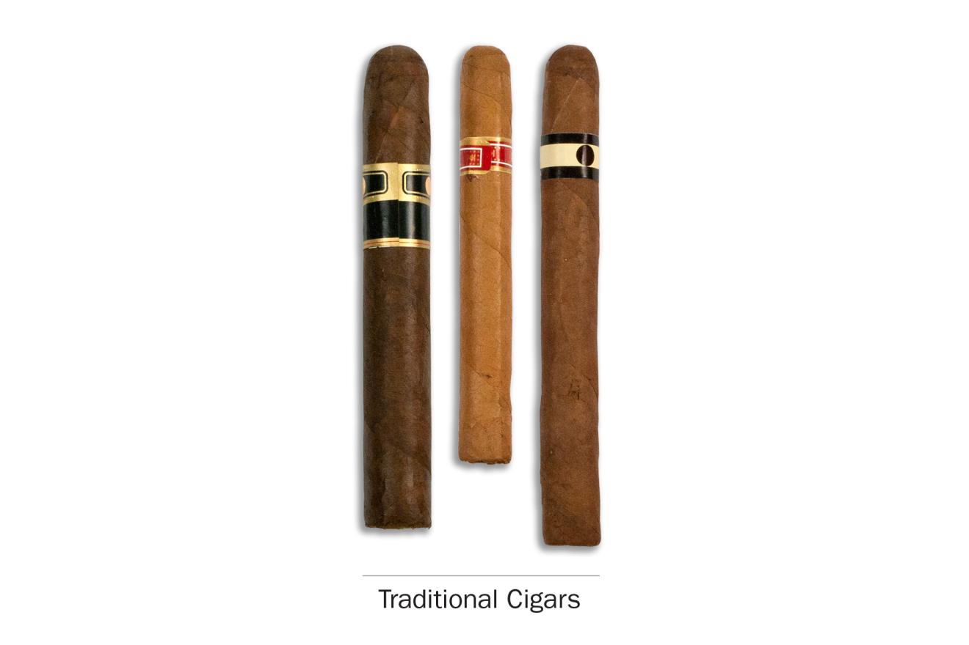

PATH ID: R02_AGT02
Cigarillos and filtered cigars are smaller than traditional cigars. They are usually brown. Some are the same size as cigarettes, and some come with filters or with plastic or wooden tips. Some common brands are Black & Mild, Swisher Sweets, Dutch Masters, Phillies Blunts, Prime Time, and Winchester.
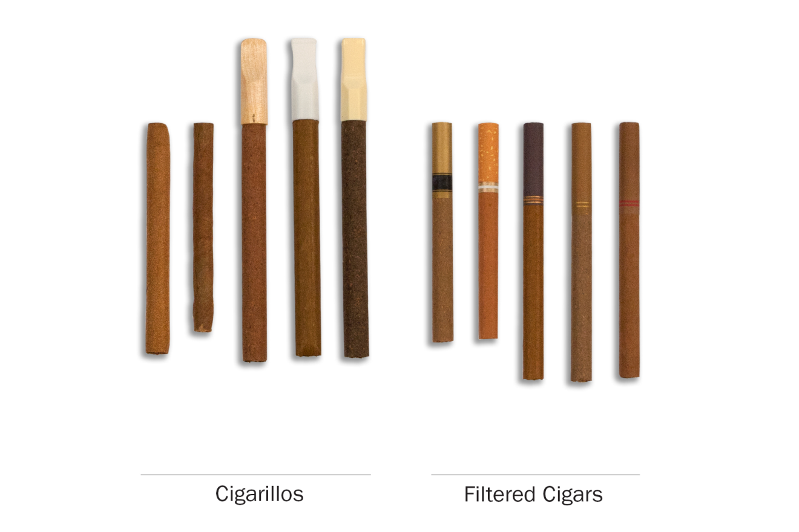PATH ID: R02_AGD01
PATH ID: YG1002
- Have you ever smoked a traditional cigar, cigarillo, or filtered cigar, even one or two puffs?
- Yes
- No GO TO NEXT SECTION
PATH ID: YG9104
- Which type of cigar have you ever smoked?
- Traditional cigars like Macanudo, Romeo y Julieta, Arturo Fuente, or others MARK ON SKIP SHEET as traditional cigar user GO TO Q4
- Cigarillos or filtered cigars like Black & Mild, Swisher Sweets, Dutch Masters, Phillies Blunts, Prime Time, Winchester, or others
PATH ID: R02_AG9009
- Which of the following kinds of cigarillos or filtered cigars have you smoked? Choose all that apply. The kind…
- With a plastic or wooden tip MARK ON SKIP SHEET as cigarillo
- With a filter (like a cigarette filter) MARK ON SKIP SHEET as little filtered cigar
- Without a tip or filter MARK ON SKIP SHEET as cigarillo
- DON'T KNOW
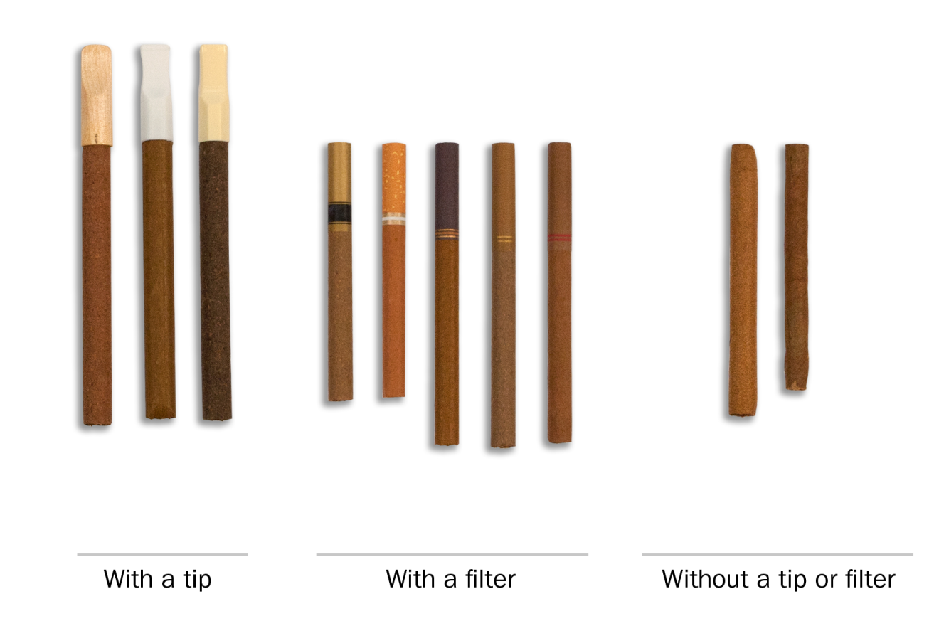

Did you bring a cigar with you? Can I take a picture of it?

Traditional cigars
if do not use traditional cigars go to Q11
PATH ID: R02_AGD02_CIGARSPic
The next questions are about traditional cigars, like those shown below. As you answer these questions, please think ONLY about your use of traditional cigars.

Use
research question
Revised item. Testing inclusion of a fourth response category, “rarely.”
PATH ID: R02_AG1003
- Do you now smoke traditional cigars…
- Every day
- Some days
- Rarely go to Q8
- Not at all go to Q11
Tell me more about your answer. PROBE TO GET A BETTER SENSE OF SMOKING FREQUENCY.
In the past 30 days, how many days did you smoke traditional cigars?
How easy or difficult was it to choose your answer from this list of choices? In your own words, what is the difference between smoking “some days” and smoking “rarely”?
IF RESPONDENT SELECTS “RARELY,” If “rarely” hadn’t been an answer choice, how would you have answered this question? IF NEEDED, Would you have chosen “not at all” or “sometimes”? Why?
PATH ID: R02_AG0100_Cigar_Last
- When did you last smoke a traditional cigar?
- In the past hour go to Q7
- Sometime today
- Yesterday
- Day before yesterday
- Three or more days ago go to Q8
research question
Testing the new response options.
PATH ID: R02_AG0102_Cigar_Timeofday
- When you last smoked a traditional cigar, was it…
- Midnight to 6 AM
- After 6 AM but before noon
- Noon to 6 PM
- After 6 PM but before midnight
When exactly did you last smoke a traditional cigar?
How easy or difficult was it for you to answer this question? What made it easy or difficult?
PATH ID: R02_AG0103_Cigars_howmany
- On the day you last smoked, how many traditional cigars did you smoke? (If less than 1, enter 1.)
______________________

- DON'T KNOW

Flavor
Research questions
Previous testing showed some recall issues and difficulties assigning categories to flavors. Test if respondents can identify flavors and whether the list is exhaustive.
Additionally, try to tease out if respondents consider non-flavored products to be unflavored, regular, tobacco flavored, traditional, etc.
Some youth previously showed confusion on the meaning of “menthol.” Test further.
PATH ID: R02_AG1130_Cigars_30dayFlavor
- In the past 30 days, were any of the traditional cigars that you smoked flavored to taste like menthol, mint, clove, spice, fruit, chocolate, alcoholic drinks, candy or other sweets?
- Yes
- No go to Q10
- I don’t know go to Q10
IF NO, Are you familiar with these flavors? Which ones have you heard of?
IF NO, Was it flavored at all? Would you call it “unflavored” or “regular” or something else?

PATH ID: R02_AG1131_Cigars_Whichflavors
- Which flavors have you smoked in the past 30 days? Choose all that apply.
- Menthol or mint
- Clove or spice
- Fruit
- Chocolate
- An alcoholic drink (such as wine, cognac, margarita or other cocktails)
- Candy or other sweets
- Some other flavor
- DON'T KNOW
IF CANDY, FRUIT, OR SWEETS, PROBE FOR EXACT FLAVOR.
IF CHECK MULTIPLE FLAVORS, Was each flavor a different cigar, or did a single cigar have multiple flavors?
How easy/difficult was it for you to answer this question?
How confident are you in your response(s)?
Are there any flavors we left out?

Switching
Research question
Earlier testing revealed that “switching” may not be a meaningful concept for all tobacco products (e.g., hookah users). Test further.
Test whether asking “Have you thought about…” works better than “Have you considered…” for respondents.
PATH ID: R02_AX0307_REVISED_CIGARS
- Have you thought about switching from traditional cigars to any of the following products? Choose all that apply.
- I have not thought about switching to another product
- Cigarettes
- E-cigarettes
- Cigarillos
- Filtered cigars
- Pipes
- Hookahs
- Snus pouches
- Smokeless tobacco such as loose snus, moist snuff, dip, spit, or chewing tobacco
- Dissolvable tobacco
What reaction, if any, did you have to this question?
NOTE IF RESPONDENT FINDS CONCEPT OF “SWITCHING” TO BE INAPPROPRIATE FOR A PARTICULAR PRODUCT
In your own words, what does it mean to “switch” to another product?
PROBE IF RESPONDENT INTERPRETS IT AS GIVING THE FIRST PRODUCT UP COMPLETELY
Tell me more about your answer.
IF SELECTED PRODUCTS, Why have you thought about switching from X to X?
IF HAVE NOT THOUGHT ABOUT SWITCHING, Tell me more about why you haven’t thought about switching to these other products?
If this question asked “Have you considered switching…” instead of “Have you thought about switching…”, would that have changed your answer? Why or why not?
Which do you prefer? Why?

Cigarillos
if do not smoke cigarillos go to Q18
PATH Id: R02_AGD02_CIGARILLOSPIC
The next questions are about cigarillos, like those shown below. As you answer these questions, please think ONLY about your use cigarillos.
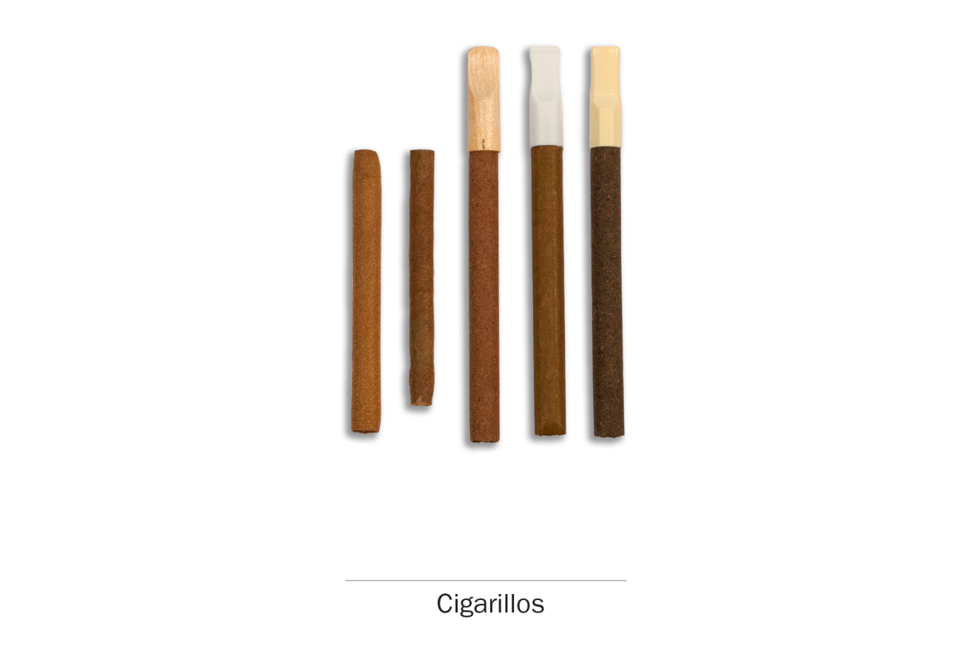

Use
research question
Revised item. Testing inclusion of a fourth response category, “rarely.”
PATH ID: R02_AG1003
- Do you now smoke cigarillos…
- Every day
- Some days
- Rarely go to Q15
- Not at all go to Q18
Tell me more about your answer. PROBE TO GET A BETTER SENSE OF SMOKING FREQUENCY.
In the past 30 days, how many days did you smoke cigarillos?
How easy or difficult was it to choose your answer from this list of choices? In your own words, what is the difference between smoking “some days” and smoking “rarely”?
IF RESPONDENT SELECTS “RARELY,” If “rarely” hadn’t been an answer choice, how would you have answered this question? IF NEEDED, Would you have chosen “not at all” or “sometimes”? Why?
PATH ID: R02_AG0100_Cigarillo_Last
- When did you last smoke a cigarillo?
- In the past hour go to Q14
- Sometime today
- Yesterday
- Day before yesterday
- Three or more days ago go to Q15

research question
Testing the new response options.
PATH ID: R02_AG0102_Cigarillo_TimeofDay
- When you last smoked a cigarillo, was it …
- Midnight to 6 AM
- After 6 AM but before noon
- Noon to 6 PM
- After 6 PM but before midnight
When exactly did you last smoke a cigarillo?
How easy or difficult was it for you to answer this question? What made it easy or difficult?
PATH ID: R02_AG0103_Cigarillos_howmany
- On the day you last smoked, how many cigarillos did you smoke? (If less than 1, enter 1.)
______________________

- DON'T KNOW

Flavor
Research questions
Previous testing showed some recall issues and difficulties assigning categories to flavors. Test if respondents can identify flavors and whether the list is exhaustive.
Additionally, try to tease out if respondents consider non-flavored products to be unflavored, regular, tobacco flavored, traditional, etc.
Some youth previously showed confusion on the meaning of “menthol.” Test further.
PATH ID: R02_AG1130_Cigarillos_30dayflavor
- In the past 30 days, were any of the cigarillos that you smoked flavored to taste like menthol, mint, clove, spice, fruit, chocolate, alcoholic drinks, candy or other sweets?
- Yes
- No go to Q17
- I don’t know go to Q17
IF NO, Are you familiar with these flavors? Which ones have you heard of?
IF NO, Was it flavored at all? Would you call it “unflavored” or “regular” or something else?

PATH ID: R02_AG1131_Cigarillos_Whichflavors
- Which flavors have you smoked in the past 30 days? Choose all that apply.
- Menthol or mint
- Clove or spice
- Fruit
- Chocolate
- An alcoholic drink (such as wine, cognac, margarita or other cocktails)
- Candy or other sweets
- Some other flavor
- DON'T KNOW
IF CANDY, FRUIT, OR SWEETS, PROBE FOR EXACT FLAVOR.
IF CHECK MULTIPLE FLAVORS, Was each flavor a different cigarillo, or did a single cigarillo have multiple flavors?
How easy/difficult was it for you to answer this question?
How confident are you in your response(s)?
Are there any flavors we left out?

Switching
Research question
Earlier testing revealed that “switching” may not be a meaningful concept for all tobacco products (e.g., hookah users). Test further.
Test whether asking “Have you thought about…” works better than “Have you considered…” for respondents.
PATH ID: R02_AX0307_REVISED_CIGARILLOS
- Have you thought about switching from cigarillos to any of the following products? Choose all that apply.
- I have not thought about switching to another product
- Cigarettes
- E-cigarettes
- Traditional cigars
- Filtered cigars
- Pipes
- Hookahs
- Snus pouches
- Smokeless tobacco such as loose snus, moist snuff, dip, spit, or chewing tobacco
- Dissolvable tobacco
What reaction, if any, did you have to this question?
NOTE IF RESPONDENT FINDS CONCEPT OF “SWITCHING” TO BE INAPPROPRIATE FOR A PARTICULAR PRODUCT
In your own words, what does it mean to “switch” to another product?
PROBE IF RESPONDENT INTERPRETS IT AS GIVING THE FIRST PRODUCT UP COMPLETELY
Tell me more about your answer.
IF SELECTED PRODUCTS, Why have you thought about switching from X to X?
IF HAVE NOT THOUGHT ABOUT SWITCHING, Tell me more about why you haven’t thought about switching to these other products?
If this question asked “Have you considered switching…” instead of “Have you thought about switching…”, would that have changed your answer? Why or why not?
Which do you prefer? Why?

Filtered cigars
if do not smoke little filtered cigars go to next Section
PATH ID: R02_AGD02_FilteredcigarsPic
The next questions are about filtered cigars, like those shown below. As you answer these questions, please think ONLY about your use of filtered cigars.
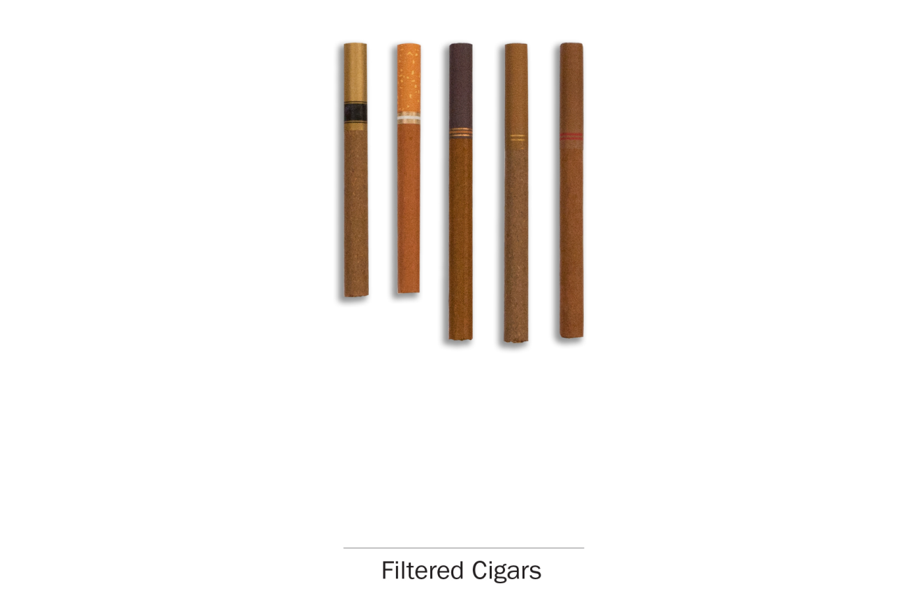

Use
research question
Revised item. Testing inclusion of a fourth response category, “rarely.”
PATH ID: R02_AG1003
- Do you now smoke filtered cigars…
- Every day
- Some days
- Rarely go to Q22
- Not at all go to next Section
Tell me more about your answer. PROBE TO GET A BETTER SENSE OF SMOKING FREQUENCY.
In the past 30 days, how many days did you smoke filtered cigars?How easy or difficult was it to choose your answer from this list of choices? In your own words, what is the difference between smoking “some days” and smoking “rarely”?
IF RESPONDENT SELECTS “RARELY,” If “rarely” hadn’t been an answer choice, how would you have answered this question? IF NEEDED, Would you have chosen “not at all” or “sometimes”? Why?

PATH ID: R02_AG0100_FilteredCigar_Last
- When did you last smoke a filtered cigar?
- In the past hour go to Q21
- Sometime today
- Yesterday
- Day before yesterday
- Three or more days ago go to Q22
research question
Testing the new response options.
PATH ID: R02_AG0102_FilteredCigar_TimeofDay
- When you last smoked a filtered cigar, was it…
- Midnight to 6 AM
- After 6 AM but before noon
- Noon to 6 PM
- After 6 PM but before midnight
When exactly did you last smoke a filtered cigar?
How easy or difficult was it for you to answer this question? What made it easy or difficult?
PATH ID: R02_AG0103_Filteredcigars_Howmany
- On the day you last smoked, how many filtered cigars did you smoke? (If less than 1, enter 1.)
______________________

- DON'T KNOW

Flavor
Research questions
Previous testing showed some recall issues and difficulties assigning categories to flavors. Test if respondents can identify flavors and whether the list is exhaustive.
Additionally, try to tease out if respondents consider non-flavored products to be unflavored, regular, tobacco flavored, traditional, etc.
Some youth previously showed confusion on the meaning of “menthol.” Test further.
PATH ID: R02_AG1130_FilteredCigar_30dayFlavor
- In the past 30 days, were any of the filtered cigars that you smoked flavored to taste like menthol, mint, clove, spice, fruit, chocolate, alcoholic drinks, candy or other sweets?
- Yes
- No go to Q24
- I don’t know go to Q24
IF NO, Are you familiar with these flavors? Which ones have you heard of?
IF NO, Was it flavored at all? Would you call it “unflavored” or “regular” or something else?

PATH ID: R02_AG1131_FilteredCigars_Whichflavors
- Which flavors have you smoked in the past 30 days? Choose all that apply.
- Menthol or mint
- Clove or spice
- Fruit
- Chocolate
- An alcoholic drink (such as wine, cognac, margarita or other cocktails)
- Candy or other sweets
- Some other flavor
- DON'T KNOW
IF CANDY, FRUIT, OR SWEETS, PROBE FOR EXACT FLAVOR.
IF CHECK MULTIPLE FLAVORS, Was each flavor a different filtered cigar, or did a single filtered cigar have multiple flavors?
How easy/difficult was it for you to answer this question?
How confident are you in your response(s)?
Are there any flavors we left out?

Switching
Research question
Earlier testing revealed that “switching” may not be a meaningful concept for all tobacco products (e.g., hookah users). Test further.
Test whether asking “Have you thought about…” works better than “Have you considered…” for respondents.
PATH ID: R02_AX0307_REVISED_FILTEREDCIGARS
- Have you thought about switching from filtered cigars to any of the following products? Choose all that apply.
- I have not thought about switching to another product
- Cigarettes
- E-cigarettes
- Traditional cigars
- Cigarillos
- Pipes
- Hookahs
- Snus pouches
- Smokeless tobacco such as loose snus, moist snuff, dip, spit, or chewing tobacco
- Dissolvable tobacco
What reaction, if any, did you have to this question?
NOTE IF RESPONDENT FINDS CONCEPT OF “SWITCHING” TO BE INAPPROPRIATE FOR A PARTICULAR PRODUCT
In your own words, what does it mean to “switch” to another product?
PROBE IF RESPONDENT INTERPRETS IT AS GIVING THE FIRST PRODUCT UP COMPLETELY
Tell me more about your answer.
IF SELECTED PRODUCTS, Why have you thought about switching from X to X?
IF HAVE NOT THOUGHT ABOUT SWITCHING, Tell me more about why you haven’t thought about switching to these other products?
If this question asked “Have you considered switching…” instead of “Have you thought about switching…”, would that have changed your answer? Why or why not?
Which do you prefer? Why?

Use of Non-tobacco Products
All Respondents
research question
Test items with larger sample size including different cigar usage types. Additionally, identify the appropriateness of the current items we are asking blunt users and whether we are defining blunt users appropriately. Lastly, seek out information about which cigar types are associated with blunt use.

Screening
PATH ID: R02_AG9107
- Sometimes people take tobacco out of a traditional cigar, cigarillo or filtered cigar and replace it with marijuana. This is sometimes called a “blunt”.
In the past 12 months, have you smoked part or all of a traditional cigar, cigarillo or filtered cigar with marijuana in it?
- Yes
- No go to next module
In your own words, what is this question asking?
Are you familiar with the term “blunt”? Is it one you use? Are there other terms you use?

PATH ID: R02_AG9106
- In the past 12 months, when you smoked a traditional cigar, cigarillo or filtered cigar, how often has tobacco been replaced with any marijuana?
- Every time
- Most of the time
- Sometimes
- Rarely
- Never
In your own words, what is this question asking?
How easy or difficult was it to answer?
When you smoke a blunt, do you remove all of the tobacco, or do you leave some in?
PATH ID: R02_AG1095
- Please look at this picture. Which group is most like the type of cigar you usually smoke as a blunt? Choose all that apply.
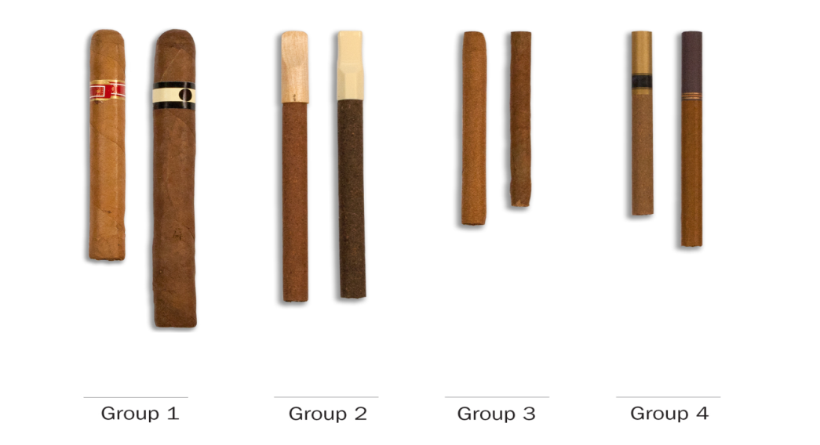
- Group 1
- Group 2
- Group 3
- Group 4
How easy or difficult was it for you to answer this question? What made it easy or difficult?
PROBE TO ENSURE RESPONDENT IS BEING CATEORIZED CORRECTLY

Pipes

Screening
PATH ID: R02_APT01
The next questions are about smoking tobacco in pipes.
Pipes come in many shapes and sizes. They all have a bowl that holds the tobacco and a stem. Pipe tobacco is often sold loose in packages or tins. In the following section, we are only asking about smoking pipes filled with tobacco. The picture below shows a typical pipe and some pipe tobacco.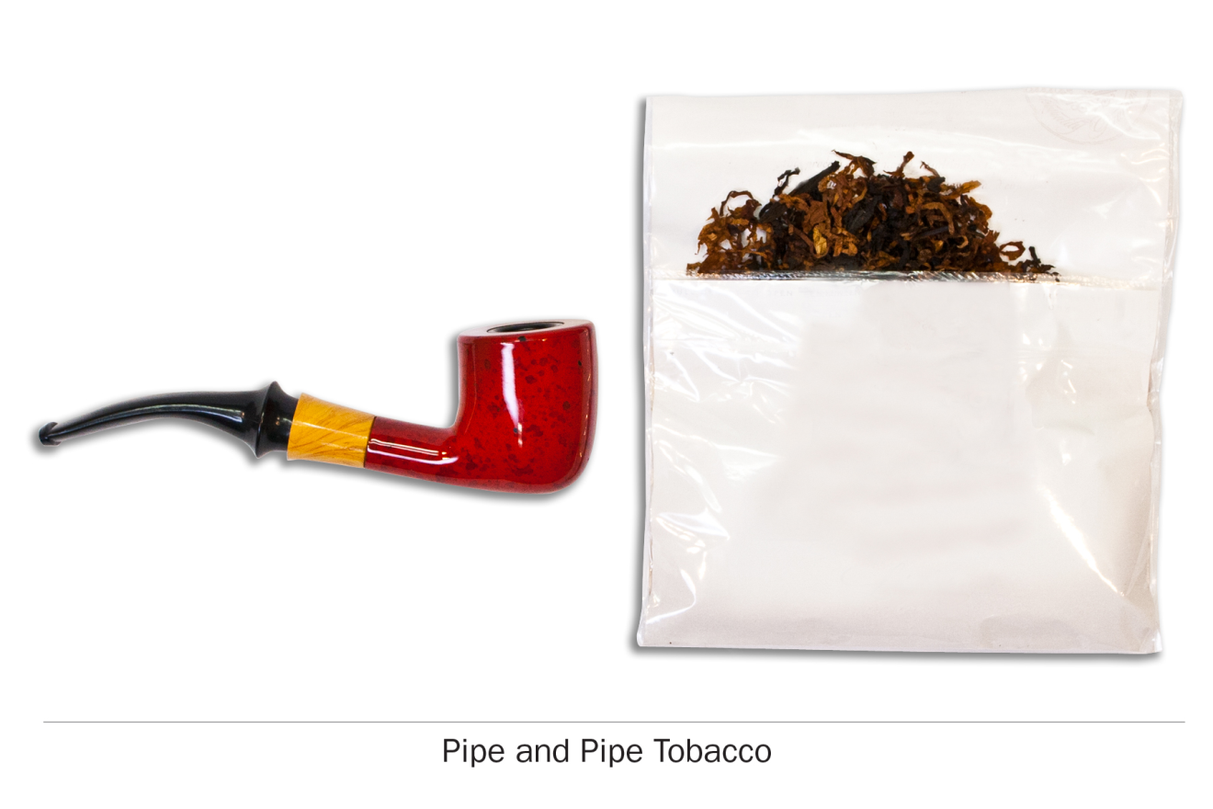
PATH ID: YP1002
- Have you ever smoked a pipe filled with tobacco, even one or two puffs?
- Yes
- No go to next section

research question
Revised item. Testing inclusion of a fourth response category, “rarely.”
PATH ID: R02_AP1003
- Do you now smoke a pipe filled with tobacco…
- Every day
- Some days
- Rarely go to Q6
- Not at all go to next Section
Tell me more about your answer. PROBE TO GET A BETTER SENSE OF SMOKING FREQUENCY.
In the past 30 days, how many days did you smoke a pipe filled with tobacco?
How easy or difficult was it to choose your answer from this list of choices? In your own words, what is the difference between smoking “some days” and smoking “rarely”?
IF RESPONDENT SELECTS “RARELY,” If “rarely” hadn’t been an answer choice, how would you have answered this question? IF NEEDED, Would you have chosen “not at all” or “sometimes”? Why?

PATH ID: R02_AP0100
- When did you last smoke a pipe filled with tobacco?
- In the past hour go to Q5
- Sometime today
- Yesterday
- Day before yesterday
- Three or more days ago go to Q6

research question
Testing the new response options.
PATH ID: R02_AP0102
- When you last smoked a pipe filled with tobacco, was it…
- Midnight to 6 AM
- After 6 AM but before noon
- Noon to 6 PM
- After 6 PM but before midnight
When exactly did you last smoke a pipe?
How easy or difficult was it for you to answer this question? What made it easy or difficult?
research question
Need further testing with pipe users.
PATH ID: R02_AP0103
- On the day you last smoked, how many bowls filled with pipe tobacco did you smoke? (If less than 1, enter 1.)
___________________________________
- DON'T KNOW
In your own words, what is a bowl? Do you usually talk about “bowls,” are do you call it something else?

Flavor
Research questions
Previous testing showed some recall issues and difficulties assigning categories to flavors. Test if respondents can identify flavors and whether the list is exhaustive.
Additionally, try to tease out if respondents consider non-flavored products to be unflavored, regular, tobacco flavored, traditional, etc.
PATH ID: R02_AP1130
- In the past 30 days, was any of the pipe tobacco you smoked flavored to taste like menthol, mint, clove, spice, fruit, chocolate, alcoholic drinks, candy or other sweets?
- Yes
- No go to Q8
- I don’t know go to Q8
IF NO, Are you familiar with these flavors? Which ones have you heard of?
IF NO, Was it flavored at all? Would you call it “unflavored” or “regular” or something else?

PATH ID: R02_AP1131
- Which flavors have you smoked in the past 30 days? Choose all that apply.
- Menthol or mint
- Clove or spice
- Fruit
- Chocolate
- An alcoholic drink (such as wine, cognac, margarita or other cocktails)
- Candy or other sweets
- Some other flavor
- DON'T KNOW
IF CANDY, FRUIT, OR SWEETS, PROBE FOR EXACT FLAVOR.
IF CHECK MULTIPLE FLAVORS, Was each flavor a different pipe tobacco, or did a single pipe tobacco have multiple flavors?
How easy/difficult was it for you to answer this question?
How confident are you in your response(s)?
Are there any flavors we left out?

Switching
Research question
Earlier testing revealed that “switching” may not be a meaningful concept for all tobacco products (e.g., hookah users). Test further.
Test whether asking “Have you thought about…” works better than “Have you considered…” for respondents.
PATH ID: R02_AX0307_REVISED_Pipe
- Have you thought about switching from pipes to any of the following products? Choose all that apply.
- I have not thought about switching to another product
- Cigarettes
- E-cigarettes
- Traditional cigars
- Cigarillos
- Filtered cigars
- Hookahs
- Snus pouches
- Smokeless tobacco such as loose snus, moist snuff, dip, spit, or chewing tobacco
- Dissolvable tobacco
What reaction, if any, did you have to this question?
NOTE IF RESPONDENT FINDS CONCEPT OF “SWITCHING” TO BE INAPPROPRIATE FOR A PARTICULAR PRODUCT
In your own words, what does it mean to “switch” to another product?
PROBE IF RESPONDENT INTERPRETS IT AS GIVING THE FIRST PRODUCT UP COMPLETELY
Tell me more about your answer.
IF SELECTED PRODUCTS, Why have you thought about switching from X to X?
IF HAVE NOT THOUGHT ABOUT SWITCHING, Tell me more about why you haven’t thought about switching to these other products?
If this question asked “Have you considered switching…” instead of “Have you thought about switching…”, would that have changed your answer? Why or why not?
Which do you prefer? Why?

Smokeless Tobacco

Screening
PATH ID: R02_AST01
The next questions ask about smokeless tobacco which you put in your mouth. Frequently you chew, suck or spit while using smokeless tobacco, although there is no need to do so for some types. Snus, for instance, is a type of smokeless tobacco that comes in a small pouch that you put inside your lip.
There are many kinds of smokeless tobacco, such as snus pouches, loose snus, moist snuff, dip, spit, and chewing tobacco. Common brands include Redman, Levi Garrett, Beechnut, Skoal, Grizzly, Nordic Ice and Copenhagen.
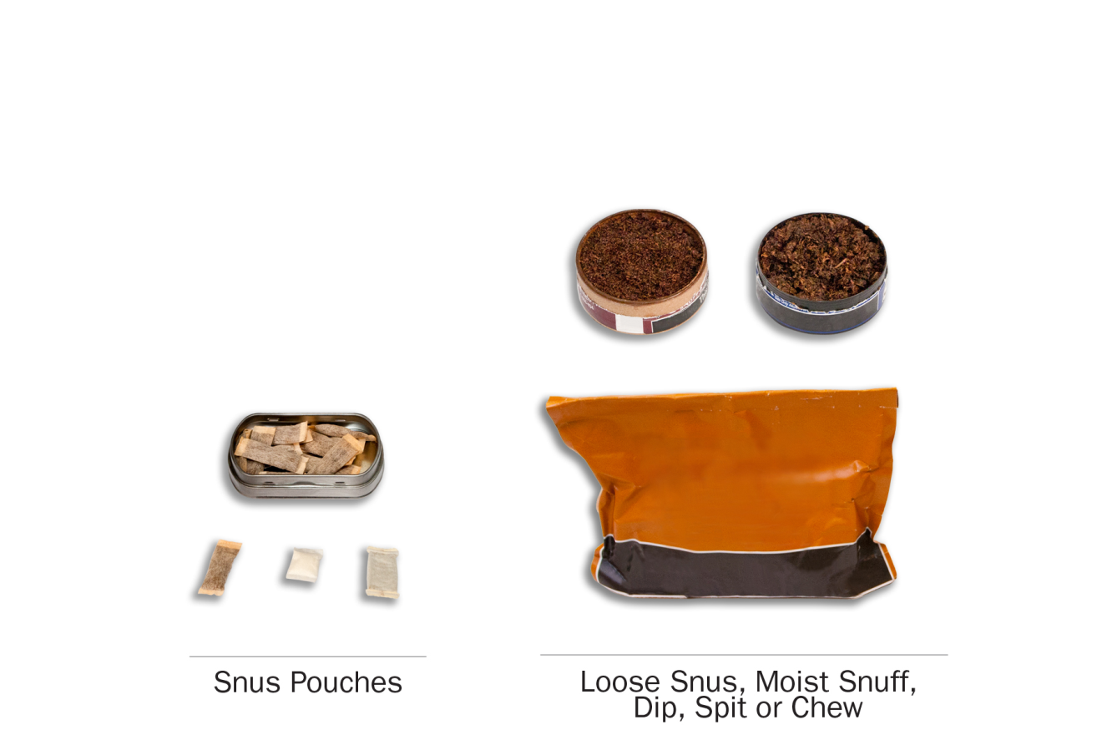PATH ID: YS1002
- Have you ever used any of the following smokeless tobacco products, even one or two times? Choose all that apply.
- Snus pouches MARK ON SKIP SHEET as snus user
- Loose snus, moist snuff, dip, spit, or chewing tobacco MARK ON SKIP SHEET as smokeless tobacco user
- I have never used a smokeless tobacco product go to NEXT SECTION

Snus
if do not use snus go to Q10

Use
PATH ID: R02_AU1003_SNUS
- You mentioned that you have used snus pouches. There are many brands of snus pouches. Have you ever used the brand called Skoal Bandits?
- Yes, I have used only Skoal Bandits go to Q10
- Yes, I have used both Skoal Bandits and other brands of snus pouches
- No, I have not used Skoal Bandits
- DON'T KNOW go to Q10
R02_AUT01
The next questions are about snus pouches. Common brands of snus pouches include Camel snus, General snus, Marlboro snus, and Nordic Ice, but there are many others.
Please think about your use of snus pouches as you answer these questions.
research question
Revised item. Testing inclusion of a fourth response category, “rarely.”
PATH ID: R02_AS1003_SNUS_USENOW_YOUTH
- Do you now use snus…
- Every day
- Some days
- Rarely go to Q7
- Not at all go to Q10
Tell me more about your answer. PROBE TO GET A BETTER SENSE OF FREQUENCY OF USE.
In the past 30 days, how many days did you use snus?
How easy or difficult was it to choose your answer from this list of choices? In your own words, what is the difference between using snus “some days” and using snus “rarely”?
IF RESPONDENT SELECTS “RARELY,” If “rarely” hadn’t been an answer choice, how would you have answered this question? IF NEEDED, Would you have chosen “not at all” or “sometimes”? Why?
PATH ID: R02_AS0100_SNUS
- When did you last use snus?
- In the past hour go to Q6
- Sometime today
- Yesterday
- Day before yesterday
- Three or more days ago go to Q7
research question
Testing the new response options.
PATH ID: R02_AS0102_SNUS_TIMEofday
- When you last used snus, was it…
- Midnight to 6 AM
- After 6 AM but before noon
- Noon to 6 PM
- After 6 PM but before midnight
When exactly did you last use snus?
How easy or difficult was it for you to answer this question? What made it easy or difficult?

PATH ID: R02_AS0103_SNUS_HOWMANY
- On the day you last used snus, how many snus pouches did you use?
___________________________________

- DON'T KNOW

Flavor
Research questions
Previous testing showed some recall issues and difficulties assigning categories to flavors. Test if respondents can identify flavors and whether the list is exhaustive.
Additionally, try to tease out if respondents consider non-flavored products to be unflavored, regular, tobacco flavored, traditional, etc.
Some youth previously showed confusion on the meaning of “menthol.” Test further.
PATH ID: R02_AS1130_Snus_Past30Flavor
- In the past 30 days, were any of the snus pouches you used flavored to taste like menthol, mint, clove, spice, fruit, chocolate, alcoholic drinks, candy or other sweets?
- Yes
- No go to Q9
- I don’t know go to Q9
IF NO, Are you familiar with these flavors? Which ones have you heard of?
IF NO, Was it flavored at all? Would you call it “unflavored” or “regular” or something else?

PATH ID: R02_AS1131_WHICHFLAVORS
- Which flavors have you used in the past 30 days? Choose all that apply.
- Menthol or mint
- Clove or spice
- Fruit
- Chocolate
- An alcoholic drink (such as wine, cognac, margarita or other cocktails)
- Candy or other sweets
- Some other flavor
- DON'T KNOW
IF CANDY, FRUIT, OR SWEETS, PROBE FOR EXACT FLAVOR.
Was each flavor a different pouch of snus, or did a single pouch of snus have multiple flavors?
How easy/difficult was it for you to answer this question?
How confident are you in your response(s)?
Are there any flavors we left out?

Switching
Research question
Earlier testing revealed that “switching” may not be a meaningful concept for all tobacco products (e.g., hookah users). Test further.
Test whether asking “Have you thought about…” works better than “Have you considered…” for respondents.
PATH ID: R02_AX0307_REVISED_SNUS
- Have you thought about switching from snus pouches to any of the following products? Choose all that apply.
- I have not thought about switching to another product
- Cigarettes
- E-cigarettes
- Traditional cigars
- Cigarillos
- Filtered cigars
- Pipes
- Hookahs
- Smokeless tobacco such as loose snus, moist snuff, dip, spit, or chewing tobacco
- Dissolvable tobacco
What reaction, if any, did you have to this question?
NOTE IF RESPONDENT FINDS CONCEPT OF “SWITCHING” TO BE INAPPROPRIATE FOR A PARTICULAR PRODUCT
In your own words, what does it mean to “switch” to another product?
PROBE IF RESPONDENT INTERPRETS IT AS GIVING THE FIRST PRODUCT UP COMPLETELY
Tell me more about your answer.
IF SELECTED PRODUCTS, Why have you thought about switching from X to X?
IF HAVE NOT THOUGHT ABOUT SWITCHING, Tell me more about why you haven’t thought about switching to these other products?
If this question asked “Have you considered switching…” instead of “Have you thought about switching…”, would that have changed your answer? Why or why not?
Which do you prefer? Why?

Smokeless Tobacco
if do not use smokeless tobacco go to next Section
The next questions are about your use of other kinds of smokeless tobacco, not including snus pouches. The questions will use the phrase “smokeless tobacco” to refer to these products.
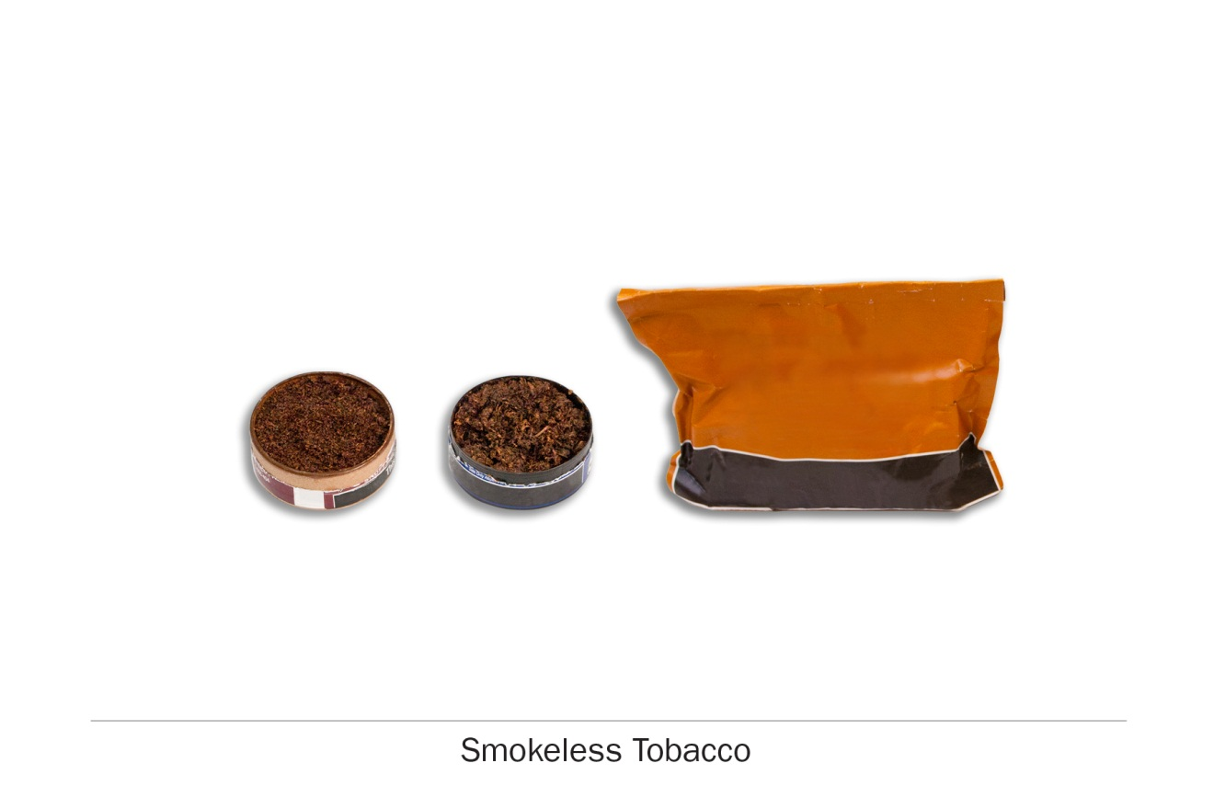

Use
research question
Revised item. Testing inclusion of a fourth response category, “rarely.”
PATH ID: R02_AS1003_SMOKELESS_USENOW
- Do you now use smokeless tobacco…
- Every day
- Some days
- Rarely go to Q14
- Not at all go to next Section
Tell me more about your answer. PROBE TO GET A BETTER SENSE OF FREQUENCY OF USE.
In the past 30 days, how many days did you use smokeless tobacco?
How easy or difficult was it to choose your answer from this list of choices? In your own words, what is the difference between using smokeless tobacco “some days” and using smokeless tobacco “rarely”?
IF RESPONDENT SELECTS “RARELY,” If “rarely” hadn’t been an answer choice, how would you have answered this question? IF NEEDED, Would you have chosen “not at all” or “sometimes”? Why?

PATH ID: R02_AS0100_Smokeless
- When did you last use smokeless tobacco?
- In the past hour go to Q13
- Sometime today
- Yesterday
- Day before yesterday
- Three or more days ago go to Q14
research question
Testing the new response options.
PATH ID: R02_AS0102_SMOKELESS_TIMEOFDAY
- When you last used smokeless tobacco, was it…
- Midnight to 6 AM
- After 6 AM but before noon
- Noon to 6 PM
- After 6 PM but before midnight
When exactly did you last use smokeless tobacco?
How easy or difficult was it for you to answer this question? What made it easy or difficult?
PATH ID: R02_AS0103_SMOKELESS_HowMANYTIMES
- On the day you last used smokeless tobacco, how many times did you use it?
___________________________________

- DON'T KNOW

Flavor
Research questions
Previous testing showed some recall issues and difficulties assigning categories to flavors. Test if respondents can identify flavors and whether the list is exhaustive.
Additionally, try to tease out if respondents consider non-flavored products to be unflavored, regular, tobacco flavored, traditional, etc.
Some youth previously showed confusion on the meaning of “menthol.” Test further.
PATH ID: R02_AS1130_Smokeless_PAST30Flavor
- In the past 30 days, was any of the smokeless tobacco you used flavored to taste like menthol, mint, clove, spice, fruit, chocolate, alcoholic drinks, candy or other sweets?
- Yes
- No go to Q16
- I don’t know go to Q16
IF NO, Are you familiar with these flavors? Which ones have you heard of?
IF NO, Was it flavored at all? Would you call it “unflavored” or “regular” or something else?

PATH ID: R02_AS1131_SMOKELESS_WHIChFLAVORS
- Which flavors have you used in the past 30 days? Choose all that apply.
- Menthol or mint
- Clove or spice
- Fruit
- Chocolate
- An alcoholic drink (such as wine, cognac, margarita or other cocktails)
- Candy or other sweets
- Some other flavor
- DON'T KNOW
IF CANDY, FRUIT, OR SWEETS, PROBE FOR EXACT FLAVOR.
IF CHECK MULTIPLE FLAVORS, Was each flavor a different package of smokeless tobacco, or did a single package of smokeless tobacco have multiple flavors?
How easy/difficult was it for you to answer this question?
How confident are you in your response(s)?
Are there any flavors we left out?

Switching
Research question
Earlier testing revealed that “switching” may not be a meaningful concept for all tobacco products (e.g., hookah users). Test further.
Test whether asking “Have you thought about…” works better than “Have you considered…” for respondents.
PATH ID: R02_AX0307_REVISED_SMOKELESS
- Have you thought about switching from smokeless tobacco to any of the following products? Choose all that apply.
- I have not thought about switching to another product
- Cigarettes
- E-cigarettes
- Traditional cigars
- Cigarillos
- Filtered cigars
- Pipes
- Hookahs
- Snus pouches
- Dissolvable tobacco
What reaction, if any, did you have to this question?
NOTE IF RESPONDENT FINDS CONCEPT OF “SWITCHING” TO BE INAPPROPRIATE FOR A PARTICULAR PRODUCT
In your own words, what does it mean to “switch” to another product?
PROBE IF RESPONDENT INTERPRETS IT AS GIVING THE FIRST PRODUCT UP COMPLETELY
Tell me more about your answer.
IF SELECTED PRODUCTS, Why have you thought about switching from X to X?
IF HAVE NOT THOUGHT ABOUT SWITCHING, Tell me more about why you haven’t thought about switching to these other products?
If this question asked “Have you considered switching…” instead of “Have you thought about switching…”, would that have changed your answer? Why or why not?
Which do you prefer? Why?

Dissolvable Tobacco

Screening
Research questions
We need further testing of dissolvable tobacco items.
R02_ADT01
The next questions ask about another type of tobacco called dissolvable tobacco. You don’t smoke dissolvable tobacco products – they are made of finely ground flavored tobacco that dissolves in your mouth.
Dissolvable tobacco products come in a variety of shapes, including small round pellets, thin sticks and flat strips. Some common brands are Ariva, Stonewall, and Camel Orbs, Sticks or Strips.
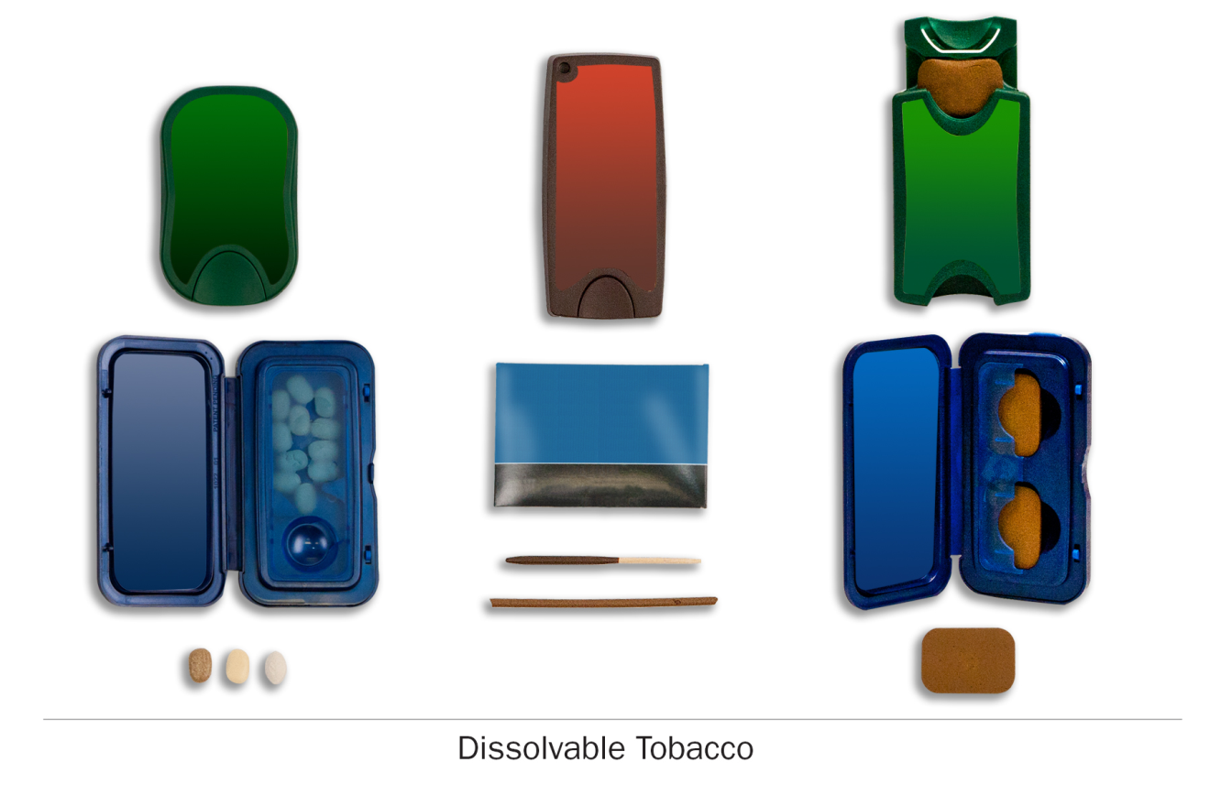

PATH ID: YD1002
- Have you ever used dissolvable tobacco products, such as Ariva, Stonewall, or Camel Orbs, Sticks, or Strips, even one or two times?
- Yes
- No GO TO next module

IF YES, Tell me about the product you used. What was its name? How did you use it? What did it look like? Where did you get it?

Youth Tobacco Use Module
youth tobacco users

Cigarettes

Screening
PATH ID: YC1002
- Have you ever tried cigarette smoking, even one or two puffs?
- Yes
- No go to Q20

research question
Revised item. Testing inclusion of a fourth response category, “rarely.”
PATH ID: R02_AC1003_Youth
- Do you now smoke cigarettes…
- Every day
- Some days
- Rarely
- Not at all go to Q20

research question
We need further testing of this item, especially with youth.
PATH ID: R02_YC9022
- Do you consider yourself a smoker?
- Yes
- No
- DON'T KNOW
Tell me more about your answer. How did you decide yes/no?
IF NO, Tell me more about why you don’t consider yourself a smoker?
In your own words, what makes someone a “smoker”?
Research questions
Questions about smokers self-perceptions (i.e., do they value it and consider it part of their identity versus feeling ambivalent) are being developed in order to allow for later analysis on the relationship between e-cigarette use and the value assigned to smoking by smokers.
PATH ID: new smoker identity YOUTH
- Do consider being a smoker part of your identity?
- Yes
- No
- DON'T KNOW
Tell me more about your answer. How did you decide yes/no?
IF NO, Why don’t you consider smoking part of your identity?

research question
We are testing how respondents interpret “fairly regularly” and “stayed off.” This item is new for the youth respondents. We need further testing with cigarette smokers.
PATH ID: R02_AC9002
- About how long have you been smoking fairly regularly? Do not count any time you may have stayed off cigarettes.
___________________________________
- I have never smoked cigarettes fairly regularly
In your own words, what is this question asking? IF NEEDED, What does it mean to say someone is smoking “fairly regularly”?
What does it mean to “stay off” cigarettes?
IF YES: During the TIME PERIOD you’ve been smoking fairly regularly, has there ever been a time when you weren’t smoking? Have you been smoking about the same amount the entire time, or have there been times when you’ve smoked less or more?

research questions
This is a new item. We want to test the construct of “regular use” further, especially with youth.
PATH ID: NEW regularly item
- Have you ever used tobacco or nicotine regularly, which means at least once a week, for at least one month, counting all forms of tobacco and nicotine you have ever used? Select only one response.
- Yes, I have used tobacco or nicotine at least once a week
- No, I have never used tobacco or nicotine at least once a week
How easy or difficult was it for you to answer this question? What made it easy or difficult?
In your own words, what is this question asking? IF NEEDED, What does it mean to use tobacco or nicotine “regularly”?

Flavor
Research questions
Previous testing showed some recall issues and difficulties assigning categories to flavors. Test if respondents can identify flavors and whether the list is exhaustive.
Additionally, try to tease out if respondents consider non-flavored products to be unflavored, regular, tobacco flavored, traditional, etc.
Some youth previously showed confusion on the meaning of “menthol.” Test further.
PATH ID: R02_YC1130
- In the past 30 days, were any of the cigarettes you smoked flavored to taste like menthol, mint, clove, spice, fruit, chocolate, alcoholic drinks, candy or other sweets?
- Yes
- No go to Q9
- I don’t know go to Q9
- Didn’t smoke a cigarette in the past 30 days go to Q9
IF NO, Are you familiar with these flavors? Which ones have you heard of?
IF NO, Was it flavored at all? Would you call it “unflavored” or “regular” or something else?

PATH ID: R02_YC1131
- Which flavors have you smoked in the past 30 days? Choose all that apply.
- Menthol or mint
- Clove or spice
- Fruit
- Chocolate
- An alcoholic drink (such as wine, cognac, margarita or other cocktails)
- Candy or other sweets
- Some other flavor
- DON'T KNOW
IF CANDY, FRUIT, OR SWEETS, PROBE FOR EXACT FLAVOR.
IF CHECK MULTIPLE FLAVORS, Was each flavor a different cigarette, or did a single cigarette have multiple flavors?
How easy/difficult was it for you to answer this question?
How confident are you in your response(s)?
Are there any flavors we left out?

PATH ID: R02_YC9118
- Are cigarettes flavored like menthol or mint harder to smoke, about the same, or easier to smoke than regular cigarettes?
- Harder to smoke
- About the same
- Easier to smoke
How did you decide on your answer?
What does “harder to smoke” mean? What does “easier to smoke” mean?
Have you heard of menthol or mint flavored cigarettes? What have you heard? In your own words, what is “menthol”?
PATH ID: R02_YC9040
- Are cigarettes flavored like menthol or mint less harmful, no different, or more harmful than regular cigarettes?
- Less harmful
- No different
- More harmful
What does “regular” cigarettes mean? If we said “compared to non-menthol cigarettes instead,” would that make this question easier or harder to understand?

Purchasing
youth
research questions
Further testing is needed with youth cigarette purchasing items.
PATH ID: R02_YC1123 – youth only
- In the past 30 days, did anyone refuse to sell you cigarettes because of your age?
- Yes
- No
- I did not try to buy cigarettes in the past 30 days
PATH ID: R02_YC1118 – youth only
- In the past 30 days, how did you usually get your own cigarettes?
- I gave someone else money to buy cigarettes for me go to Q16
- I bought cigarettes myself
- I asked someone to give me a cigarette go to Q19
- Someone offered me a cigarette go to Q19
- I bought cigarettes from another person go to Q19
- I took cigarettes from a store or another person go to Q19
- I got cigarettes some other way go to Q19
SPECIFY __________________________
- I haven’t smoked cigarettes in the past 30 days
Tell me how you came up with your answer.
How easy or difficult was it for you to answer this question?
Other than the ones listed here, are there any other ways people get cigarettes?

bought by self
PATH ID: R02_YC1033 – youth only_BOUGHT BY SELF
- Where do you buy your cigarettes most of the time?
- A convenience store or gas station
- A supermarket, grocery store, or drug store
- A warehouse club, such as Sam’s or Costco
- A smoke shop, tobacco specialty store or tobacco outlet store
- A duty free shop or military commissary
- A bar, pub, restaurant or casino
- A friend or relative
- A swap meet or flea market
- A store on an Indian reservation
- Or from somewhere else SPECIFY: ____________________________
How easy or difficult was it for you to answer this question?
Are there any places missing from this list?
Is there anything here you haven’t heard of?

research questions
This item is being added to the youth section and has never been tested before. We want to test whether youth respondents have issues with reporting. Can youth users report cost information in general? Are there any issues reporting cost for youth that purchase themselves vs. youth that give money to someone else to buy for them? Does the question wording work across the various product types? How do people formulate an answer, what factors are they including in the cost?
PATH ID: R02_YC1034 – test with youth only_BOUGHTFORSELF
- Think about the last time you bought cigarettes. How much did you pay for them?
$ ______________________

- DON'T KNOW
Tell me how you came up with your answer. PROBE ON WHETHER THERE WAS ANY DIFFICULTY COMING UP WITH COST.
PATH ID: R02_YC1039_CIGARETTESBOUGHTBYSELF
- The last time you bought cigarettes, did you buy them by the carton, pack, or as single cigarettes?
- Carton go to Q19
- Pack go to Q19
- Single Cigarette go to Q19
- DON'T KNOW go to Q19

bought by someone else
PATH ID: R02_YC1033 – youth only_BOUGHTBYSOMEONEELSE
- Where do they buy your cigarettes most of the time?
- A convenience store or gas station
- A supermarket, grocery store, or drug store
- A warehouse club, such as Sam’s or Costco
- A smoke shop, tobacco specialty store or tobacco outlet store
- A duty free shop or military commissary
- A bar, pub, restaurant or casino
- A friend or relative
- A swap meet or flea market
- A store on an Indian reservation
- Or from somewhere else SPECIFY: ____________________________
How easy or difficult was it for you to answer this question?
Are there any places missing from this list?
Is there anything here you haven’t heard of?

research questions
This item is being added to the youth section and has never been tested before. We want to test whether youth respondents have issues with reporting. Can youth users report cost information in general? Are there any issues reporting cost for youth that purchase themselves vs. youth that give money to someone else to buy for them? Does the question wording work across the various product types? How do people formulate an answer, what factors are they including in the cost?
PATH ID: R02_YC1034 – test with youth only_BOUGHTBYSOMEONEELSE
- Think about the last time you gave money to someone else to buy you cigarettes. How much did you pay for them?
$ ______________________

- DON'T KNOW
Tell me how you came up with your answer. PROBE ON WHETHER THERE WAS ANY DIFFICULTY COMING UP WITH COST.
Did you pay the person extra to buy the cigarettes for you? IF YES: Did you include that in your answer here?
PATH ID: R02_YC1039_CIGARETTESBOUGHTBYSOMEONEELSE
- The last time you gave money to someone else to buy you cigarettes, did they buy them by the carton, pack, or as single cigarettes?
- Carton
- Pack
- Single Cigarette
- DON'T KNOW
FOR THOSE WHO HAD SOMEONE ELSE PURCHASE, How confident are you in your answer?

Switching
Research question
Earlier testing revealed that “switching” may not be a meaningful concept for all tobacco products (e.g., hookah users). Test further.
Test whether asking “Have you thought about…” works better than “Have you considered…” for respondents.
PATH ID: R02_YX0307_REVISED_Cigarettes
- Have you thought about switching from cigarettes to any of the following products? Choose all that apply.
- I have not thought about switching to another product
- E-cigarettes
- Traditional cigars
- Cigarillos
- Filtered cigars
- Pipes
- Hookahs
- Snus pouches
- Smokeless tobacco such as loose snus, moist snuff, dip, spit, or chewing tobacco
- Dissolvable tobacco
What reaction, if any, did you have to this question?
NOTE IF RESPONDENT FINDS CONCEPT OF “SWITCHING” TO BE INAPPROPRIATE FOR A PARTICULAR PRODUCT
In your own words, what does it mean to “switch” to another product?
PROBE IF RESPONDENT INTERPRETS IT AS GIVING THE FIRST PRODUCT UP COMPLETELY
Tell me more about your answer.
IF SELECTED PRODUCTS, Why have you thought about switching from X to X?
IF HAVE NOT THOUGHT ABOUT SWITCHING, Tell me more about why you haven’t thought about switching to these other products?
If this question asked “Have you considered switching…” instead of “Have you thought about switching…”, would that have changed your answer? Why or why not?
Which do you prefer? Why?

Friends
research questions
This is a new item. We want to understand how respondents are answering this item, how respondents calculate their “four best friends,” and whether or not they know how many of their friends smoke cigarettes.
PATH ID: Best friends Smoke
- How many of your best friends smoke cigarettes?
- None
- A few
- Some
- Most
- All
How easy or difficult was it for you to answer this question? What made it easy or difficult?
Who were you thinking about when you answered this question? IF NEEDED: Were you thinking about specific people, or just about your friends in general?
How confident are you that [FILL ANSWER] of your best friends have smoked cigarettes? What makes you confident/not confident?

Electronic Products

Screening
Research questions
The intro and first few items are new. Testing is needed.
Additionally, how do the various users of different electronic device types report on daily use? What’s the best unit for these users to report on dosage – puffs versus volume (number of cartridges?)
BOX ID: R02_YET01
The next questions are about electronic nicotine products, such as e-cigarettes, e-cigars, e-hookahs, e-pipes, vape pens, hookah pens and personal vaporizers. These products are battery-powered, use nicotine fluid rather than tobacco leaves, and produce vapor instead of smoke. Some common brands include Fin, NJOY, Blu, e-Go and Vuse.
What reaction, if any, did you have to this description and the picture? In your own words, what is “vapor”?
Are you familiar with all of these products? IF NO, Which ones are new to you?
Are these the words you use, or do you call these products by different names?
All of these products together are called “electronic nicotine products.” What do you think of that name? Is there another word you use to refer to all of these products?
PATH ID: R02_YO1002
- Have you ever used an electronic nicotine product, even one or two times? (Electronic nicotine products include e-cigarettes, e-cigars, e-hookahs, e-pipes, vape pens, hookah pens and personal vaporizers.)
- Yes
- No go to Q30
- DON’T KNOW go to Q30
In your own words, what is this question asking?
In your own words, what is an “electronic nicotine product”?
PATH ID: R02_YO9035
- Which type of electronic nicotine product have you ever used? Choose all that apply.
- E-cigarette (including vape pens and personal vaporizers) MARK ON SKIP SHEET
- E-cigar MARK ON SKIP SHEET
- E-hookah (including hookah pens) MARK ON SKIP SHEET
- E-pipe MARK ON SKIP SHEET
- Something else SPECIFY:___________________
- DON’T KNOW go to Q30
Tell me more about your answer. PROBE ON WHETHER RESPONDENT KNOWS THE DIFFERENCE BETWEEN THESE PRODUCTS.

E-cigarette
if do not use e-cigarettes go to Q32

Description and Image
Research question
Test the revised introduction and images, which now includes the term “vaping” and a picture of a vaporizer. Determine if respondents properly distinguish between e-cigarettes and other electronic products.
Box ID: R02_AET02_Youth
The next questions are about e-cigarettes.

Some e-cigarettes can be bought as one-time, disposable products, while others can be bought as re-usable kits with a cartridge or tank system. Some people refill their own e-cigarettes with nicotine fluid, sometimes called “e-liquid”.

Disposable e-cigarettes, e-cigarette cartridges and e-liquid come in many different flavors and nicotine concentrations. Some common brands include Fin, NJOY, Blu, e-Go and Vuse.
Please think only about e-cigarettes as you answer these questions.

What reaction, if any, did you have to this description of e-cigarettes?
What did you think of the pictures?
Is there anything that you found confusing?
Is there anything that we left out that we should add?
Are you familiar with the different types of e-cigarettes? What type do you usually use?
Do you call nicotine fluid “e-juice,” “e-liquid,” or something else?
Does it always have nicotine in it?

Use
research question
Revised item. Testing inclusion of a fourth response category, “rarely.”
PATH ID: R02_AE1003_ECIG_YOUTH
- Do you now use e-cigarettes…
- Every day
- Some days
- Rarely
- Not at all go to NEXT SECTION
Tell me more about your answer. PROBE TO GET A BETTER SENSE OF FREQUENCY OF USE.
In the past 30 days, how many days did you use e-cigarettes?
How easy or difficult was it to choose your answer from this list of choices? In your own words, what is the difference between using e-cigarettes “some days” and using e-cigarettes “rarely”?
IF RESPONDENT SELECTS “RARELY,” If “rarely” hadn’t been an answer choice, how would you have answered this question? IF NEEDED, Would you have chosen “not at all” or “sometimes”? Why?

Determining Type
Research question
Determine if this series of items correctly identifies respondent e-cigarette types and appropriate fills for subsequent items.
PATH ID: R02_yE9005
Please think about the e-cigarette you use most of the time.
- Is your e-cigarette rechargeable?
- Yes MARK ON SKIP SHEET AS RECHARGEABLE
- No go to Q7
Do you call them rechargeable e-cigarettes or do you call them something else?
PATH ID: R02_yE9008
- Does your e-cigarette use cartridges?
- Yes
- No
Do you call them cartridges or do you call them something else?

PATH ID: R02_yE9038
- Does your e-cigarette use a tank system?
- Yes
- No
- Not sure
What is a tank system? Are you familiar with the term “tank system”? Is there another term that you use?
What reaction, if any, did you have to the picture? Was the picture helpful? Why or why not?
What reaction, if any, did you have to these questions?
How easy or difficult was it to answer these questions?

PATH ID: R02_yE9009
- Can you refill your e-cigarette or e-cigarette cartridges with “e-liquid”?
- Yes MARK ON SKIP SHEET as refillable
- No go to NEXT SECTION
ASK: Respondents who have used an e-cigarette (AO9035[1]=1)
PATH ID: R02_yE9036
- Who refills your e-cigarette or e-cigarette cartridge with the e-liquid that you use?
- I refill it myself
- I get it refilled at a vape shop or vapor lounge
- I buy it already filled
- I get it refilled some other way
Are you familiar with the term “vape shop” or “vapor lounge”? Is there another term that you use?
What brand of e-cigarette do you have? What type or version of [BRAND] is it?
Box ID: R02_AED01
User type | Rechargeable?  (R02_AE9005) | Cartridges?  (R02_AE9008) | Refillable?  (R02_AE9009) | Tank?  (R02_AE9038)
Disposable | No | Skip | No | Skip | go to Q9
Non-refillable Cartridges | Yes | Yes | No | Skip | go to Q13
Refillable Cartridges | Yes | Yes | Yes | Skip | go to Q19
Refillable Tank System | Yes | No | Yes | Yes | go to Q19
‘Unknown’ | When combination of answers don’t fit into the above categories.

Disposable E-cigarettes

Dosage
Research question
Testing has shown that asking respondents about the number of “puffs” taken in a given time period can be tricky, particularly for respondents who use refillable e-cigarettes, who may be able to more accurately report the volume of e-fluid. These new items attempt to give respondents more flexibility in reporting. Test effectiveness of new items.
PATH ID: R02_AE1021_Disposable_YOUTH
- On average, about how many e-cigarettes do you now use each day?
- Less than 1 each day
- _______________________

Tell me more about your answer. How did you come up with a number?
How easy or difficult was it to answer?
Is there a better way we could ask this question?
PATH ID: R02_yE1022
- On how many of the past 30 days did you use an e-cigarette?
_______________________
PATH ID: R02_AE9029_Disposable_LastPuff_Youth
- About how long has it been since you last took a puff from an e-cigarette?
_______________________

Modification
Research question
New item added for Wave 2. Test whether respondents can correctly answer this item. Also probe on ways in which respondents modify e-cigarettes, including modifications to the battery or voltage.
PATH ID: R02_AE9032_Disposable_Mod_Youth
- Have you modified your e-cigarette at all?
- Yes go to Q25
- No go to Q25
In your own words, what is this question asking?
IF YES, How have you modified it? Why did you modify it?
PROBE HOW AND WHY RESPONDENTS MODIFY THEIR E-CIGARETTES (E.G., TO IMPROVE BATTERY LIFE, CHANGE AMOUNTS OF E-LIQUID VAPORIZED, ETC.)
Where did you learn how to modify your e-cigarette?
IF NO, Have you ever heard of modifying e-cigarettes? Where did you hear about it? What types of modifications have you heard of?

Non-refillable Cartridges

Dosage
Research question
Testing has shown that asking respondents about the number of “puffs” taken in a given time period can be tricky, particularly for respondents who use refillable e-cigarettes, who may be able to more accurately report the volume of e-fluid. These new items attempt to give respondents more flexibility in reporting. Test effectiveness of new items.
PATH ID: R02_AE1021_Non-Refillable_YOUTH
- On average, about how many e-cigarette cartridges do you now use each day?
- Less than 1 each day
- _______________________

Tell me more about your answer. How did you come up with a number?
How easy or difficult was it to answer?
Is there a better way we could ask this question?
PATH ID: R02_AE1022_Non-Refillable_Past30_YOuth
- On how many of the past 30 days did you use an e-cigarette?
_______________________
PATH ID: R02_AE9029_Non-REfillable_LastPuff_Youth
- About how long has it been since you last took a puff from an e-cigarette?
_______________________
Do you typically call them “puffs” or is there another term you use?

Modification
Research question
New item added for Wave 2. Test whether respondents can correctly answer this item. Also probe on ways in which respondents modify e-cigarettes, including modifications to the battery or voltage.
IF NOT RECHARGEABLE go to Q17
PATH ID: R02_AE9037_Non-refillable_Voltage_Youth
- Can you change the voltage on your e-cigarette?
- Yes
- No
- Not sure
In your own words, what is this question asking? IF NEEDED, What does it mean to change the voltage?
IF YES, Have you changed the unit’s voltage? Why or why not?
PATH ID: R02_AE9032_Non-refillable_mod_youth
- Have you modified your e-cigarette at all?
- Yes
- No
In your own words, what is this question asking?
IF YES, How have you modified it? Why did you modify it?
PROBE HOW AND WHY RESPONDENTS MODIFY THEIR E-CIGARETTES (E.G., TO IMPROVE BATTERY LIFE, CHANGE AMOUNTS OF E-LIQUID VAPORIZED, ETC.)
Where did you learn how to modify your e-cigarette?
IF NO, Have you ever heard of modifying e-cigarettes? Where did you hear about it? What types of modifications have you heard of?
Research question
Test new items that ask about customization of constituents in e-liquids, particularly flavoring choices and modification of nicotine content.
PATH ID: NEW
- Do you customize or modify the e-liquid you use in your e-cigarette?
- Yes go to Q25
- No go to q25
IF YES, Tell me more about how you customize or modify the e-liquid. Why do you customize or modify the e-liquid?
PROBE TO DETERMINE HOW AND WHY RESPONDENTS ARE MODIFYING E-LIQUID (E.G., CHANGE NICOTINE CONTENT, CHANGE FLAVOR)
In this question, do the words customize and modify mean the same thing to you or do they mean different things? IF NEEDED: Tell me more.
Where did you learn how to customize or modify your e-liquid?
IF NO, Have you ever heard of modifying e-liquid? Where did you hear about it? What types of modifications have you heard of?
Have you ever heard of the term “dripping”? IF YES, Can you tell me more about it?

Refillable Cartridges or Tank

Dosage
Research question
Testing has shown that asking respondents about the number of “puffs” taken in a given time period can be tricky, particularly for respondents who use refillable e-cigarettes, who may be able to more accurately report the volume of e-fluid. These new items attempt to give respondents more flexibility in reporting. Test effectiveness of new items.
PATH ID: R02_AE1021_REfillable_YOUTH
- On average, about how many milliliters of e-liquid do you now use each day?
- Less than 1 each day
- _______________________

Tell me more about your answer. How did you come up with a number?
How easy or difficult was it to answer?
Is there a better way we could ask this question?
PATH ID: R02_AE1022_REfillable_Past30_YOUTH
- On how many of the past 30 days did you use an e-cigarette?
_______________________
PATH ID: R02_AE9029_REfillable_LastPuff_Youth
- About how long has it been since you last took a puff from an e-cigarette?
_______________________
Do you typically call them “puffs” or is there another term you use?

Modification
Research question
New item added for Wave 2. Test whether respondents can correctly answer this item. Also probe on ways in which respondents modify e-cigarettes, including modifications to the battery or voltage.
IF NOT RECHARGEABLE go to Q23
PATH ID: R02_AE9037_REfillable_Voltage_youth
- Can you change the voltage on your e-cigarette?
- Yes
- No
- Not sure
In your own words, what is this question asking? IF NEEDED, What does it mean to change the voltage?
IF YES, Have you changed the unit’s voltage? Why or why not?
PATH ID: R02_AE9032_Refillable_Mod_Youth
- Have you modified your e-cigarette at all?
- Yes
- No
In your own words, what is this question asking?
IF YES, How have you modified it? Why did you modify it?
PROBE HOW AND WHY RESPONDENTS MODIFY THEIR E-CIGARETTES (E.G., TO IMPROVE BATTERY LIFE, CHANGE AMOUNTS OF E-LIQUID VAPORIZED, ETC.)
Where did you learn how to modify your e-cigarette?
IF NO, Have you ever heard of modifying e-cigarettes? Where did you hear about it? What types of modifications have you heard of?
Research question
Test new items that ask about customization of constituents in e-liquids, particularly flavoring choices and modification of nicotine content.
NEW
- Do you customize or modify the e-liquid you use in your e-cigarette?
- Yes
- No
IF YES, Tell me more about how you customize or modify the e-liquid. Why do you customize or modify the e-liquid?
PROBE TO DETERMINE HOW AND WHY RESPONDENTS ARE MODIFYING E-LIQUID (E.G., CHANGE NICOTINE CONTENT, CHANGE FLAVOR)
Where did you learn how to customize or modify your e-liquid?
IF NO, Have you ever heard of modifying e-liquid? Where did you hear about it? What types of modifications have you heard of?
Have you ever heard of the term “dripping”? IF YES, Can you tell me more about it?

Flavor
Research questions
Previous testing showed some recall issues and difficulties assigning categories to flavors. Test if respondents can identify flavors and whether the list is exhaustive.
Additionally, try to tease out if respondents consider non-flavored products to be unflavored, regular, tobacco flavored, traditional, etc.
Some youth previously showed confusion on the meaning of “menthol.” Test further.
PATH ID: R02_AE1130_ECIGFLAVOR_YOuth
- In the past 30 days, were any of the e-cigarettes or e-liquid you used flavored to taste like menthol, mint, clove, spice, fruit, chocolate, alcoholic drinks, candy or other sweets?
- Yes
- No go to Q27
- I don’t know go to Q27
- Didn’t use an e-cigarette in the past 30 days go to Q27
IF NO, Are you familiar with these flavors? Which ones have you heard of?
IF NO, Was it flavored at all? Would you call it “unflavored” or “regular” or something else?

PATH ID: R02_AE1131_ECIGFLAVOR_PAST30_YOUTH
- Which flavors have you used in the past 30 days? Choose all that apply.
- Menthol or mint
- Clove or spice
- Fruit
- Chocolate
- An alcoholic drink (such as wine, cognac, margarita or other cocktails)
- Candy or other sweets
- Some other flavor
- DON'T KNOW
IF CANDY, FRUIT, OR SWEETS, PROBE FOR EXACT FLAVOR.
IF CHECK MULTIPLE FLAVORS, Was each flavor a different e-cigarette, or did a single e-cigarette have multiple flavors?
How easy/difficult was it for you to answer this question?
How confident are you in your response(s)?
Are there any flavors we left out?

PATH ID: R02_YE1146_YOUTH
- Some e-cigarettes come in flavors like menthol, mint, clove, spice, fruit, chocolate, alcoholic drinks, candy or other sweets.
Are flavored e-cigarettes easier to use, about the same, or harder to use than unflavored e-cigarettes?
- Easier to use
- About the same
- Harder to use
How did you decide on your answer?
What does “harder to use” mean? What does “easier to use” mean?
Have you heard of menthol or mint flavored e-cigarettes? What have you heard? In your own words, what is “menthol”?
What does “unflavored” e-cigarettes mean to you? Would it make more sense if we asked about “regular” e-cigarettes?

Purchasing
research questions
This item is being added to the youth section and has never been tested before. We want to test whether youth respondents have issues with reporting. Can youth users report cost information in general? Are there any issues reporting cost for youth that purchase themselves vs. youth that give money to someone else to buy for them? Does the question wording work across the various product types? How do people formulate an answer, what factors are they including in the cost?
PATH ID: R02_YE1034 – youth only
- Think about the last time you bought (or gave money to someone else to buy you) e-cigarettes or e-liquid. How much did you pay for them?
$ ______________________

- DON'T KNOW
Tell me how you came up with your answer. PROBE ON WHETHER THERE WAS ANY DIFFICULTY COMING UP WITH COST.
How easy or difficult was it for you to answer this question? What made it easy or difficult?
IF R gave money to someone else to buy the e-cigarettes: Did you pay the person extra to buy the e-cigarettes for you? IF YES: Did you include that in your answer here?

Switching
Research question
Earlier testing revealed that “switching” may not be a meaningful concept for all tobacco products (e.g., hookah users). Test further.
Test whether asking “Have you thought about…” works better than “Have you considered…” for respondents.
PATH ID: R02_YX0307_REVISED_ecig
- Have you thought about switching from e-cigarettes to any of the following products? Choose all that apply.
- I have not thought about switching to another product
- Cigarettes
- Traditional cigars
- Cigarillos
- Filtered cigars
- Pipes
- Hookahs
- Snus pouches
- Smokeless tobacco such as loose snus, moist snuff, dip, spit, or chewing tobacco
- Dissolvable tobacco
What reaction, if any, did you have to this question?
NOTE IF RESPONDENT FINDS CONCEPT OF “SWITCHING” TO BE INAPPROPRIATE FOR A PARTICULAR PRODUCT
In your own words, what does it mean to “switch” to another product?
PROBE IF RESPONDENT INTERPRETS IT AS GIVING THE FIRST PRODUCT UP COMPLETELY
Tell me more about your answer.
IF SELECTED PRODUCTS, Why have you thought about switching from X to X?
IF HAVE NOT THOUGHT ABOUT SWITCHING, Tell me more about why you haven’t thought about switching to these other products?
If this question asked “Have you considered switching…” instead of “Have you thought about switching…”, would that have changed your answer? Why or why not?
Which do you prefer? Why?

Use of Non-tobacco Products
Research question
Develop and test new items about smoking something other than tobacco in e-cigarette. Previous testing revealed confusion with the concepts of smoking marijuana in an e-cigarette vs. using e-liquid flavored to taste like marijuana vs. using e-liquid made from marijuana.
PATH ID: E-Liquid Non Tobacco
- Have you ever used an e-liquid made from something other than tobacco?
- Yes
- No
- Don’t know
IF YES, What was it made from?
Have you ever used an e-liquid made from marijuana concentrates, waxes or hash oils?
IF YES, What exactly was the e-liquid made from?
Was it flavored like marijuana, or did it contain actual marijuana?
IF NEEDED, Could it get you high?
IF NO, Have you ever heard of this type of e-liquid? What do you know about it? Is it flavored like marijuana, or does it contain actual marijuana?
IF NEEDED, Could it get you high?
PATH ID: POT from e-cig
- Have you ever smoked pot or hash from an e-cigarette?
- Yes
- No
- Don’t know
IF YES, Tell me more about your answer. How do you smoke pot from an e-cigarette?

Friends
research questions
This is a new item. We want to understand how respondents are answering this item, how respondents calculate their “four best friends,” and whether or not they know how many of their friends smoke e-cigarettes.
PATH ID: Best Friends that Smoke E-cig
- How many of your best friends smoke e-cigarettes?
- None
- A few
- Some
- Most
- All
How easy or difficult was it for you to answer this question? What made it easy or difficult?
Who were you thinking about when you answered this question? IF NEEDED: Were you thinking about specific people, or just about your friends in general?
How confident are you that [FILL ANSWER] of your best friends have smoked e-cigarettes? What makes you confident/not confident?

Cigars

Screening
RESEARCH QUESTIONS
Need further testing with cigar items. We want to know if we are routing cigar users correctly.
R02_AGT01_Youth
The next questions are about traditional cigars, cigarillos, and filtered cigars. These products go by lots of different names, so please use these descriptions and photos to understand what they are.
Traditional cigars contain tightly rolled tobacco that is wrapped in a tobacco leaf. Some common brands of traditional cigars include Macanudo, Romeo y Julieta, and Arturo Fuente, but there are many others.

R02_AGT02_YOuth
Cigarillos and filtered cigars are smaller than traditional cigars. They are usually brown. Some are the same size as cigarettes, and some come with filters or with plastic or wooden tips. Some common brands are Black & Mild, Swisher Sweets, Dutch Masters, Phillies Blunts, Prime Time, and Winchester.
R02_AGD01
PATH ID: YG1002_YOUTH
- Have you ever smoked a traditional cigar, cigarillo, or filtered cigar, even one or two puffs?
- Yes
- No GO TO NEXT SECTION
PATH ID: YG9104_YOUTH
- Which type of cigar have you ever smoked?
- Traditional cigars like Macanudo, Romeo y Julieta, Arturo Fuente, or others MARK ON SKIP SHEET as traditional cigar user GO TO Q4
- Cigarillos or filtered cigars like Black & Mild, Swisher Sweets, Dutch Masters, Phillies Blunts, Prime Time, Winchester, or others

PATH ID: R02_AG9009_Youth
- Which of the following kinds of cigarillos or filtered cigars have you smoked? Choose all that apply. The kind…
- With a plastic or wooden tip MARK ON SKIP SHEET as cigarillo
- With a filter (like a cigarette filter) MARK ON SKIP SHEET as little filtered cigar
- Without a tip or filter MARK ON SKIP SHEET as cigarillo
- DON'T KNOW

Did you bring a cigar with you? Can I take a picture of it?

Traditional cigars
if do not use traditional cigars go to Q10
R02_AGV01_CIGARS_YOuth
R02_AGD02_CigarsPic_youth
The next questions are about traditional cigars, like those shown below. As you answer these questions, please think ONLY about your use of traditional cigars.

Use
research question
Revised item. Testing inclusion of a fourth response category, “rarely.”
PATH ID: R02_AG1003
- Do you now smoke traditional cigars…
- Every day
- Some days
- Rarely
- Not at all go to Q10
Tell me more about your answer. PROBE TO GET A BETTER SENSE OF SMOKING FREQUENCY.
In the past 30 days, how many days did you smoke traditional cigars?
How easy or difficult was it to choose your answer from this list of choices? In your own words, what is the difference between smoking “some days” and smoking “rarely”?
IF RESPONDENT SELECTS “RARELY,” If “rarely” hadn’t been an answer choice, how would you have answered this question? IF NEEDED, Would you have chosen “not at all” or “sometimes”? Why?

Flavor
Research questions
Previous testing showed some recall issues and difficulties assigning categories to flavors. Test if respondents can identify flavors and whether the list is exhaustive.
Additionally, try to tease out if respondents consider non-flavored products to be unflavored, regular, tobacco flavored, traditional, etc.
Some youth previously showed confusion on the meaning of “menthol.” Test further.
PATH ID: R02_yG1130_CIGARS_FLAVOR
- In the past 30 days, were any of the traditional cigars that you smoked flavored to taste like menthol, mint, clove, spice, fruit, chocolate, alcoholic drinks, candy or other sweets?
- Yes
- No go to Q7
- I don’t know go to Q7
- Didn’t smoke a traditional cigar in the past 30 days go to Q7
IF NO, Are you familiar with these flavors? Which ones have you heard of?
IF NO, Was it flavored at all? Would you call it “unflavored” or “regular” or something else?

PATH ID: R02_yG1131_CIGARS_WHICHFLAVORS
- Which flavors have you smoked in the past 30 days? Choose all that apply.
- Menthol or mint
- Clove or spice
- Fruit
- Chocolate
- An alcoholic drink (such as wine, cognac, margarita or other cocktails)
- Candy or other sweets
- Some other flavor
- DON'T KNOW
IF CANDY, FRUIT, OR SWEETS, PROBE FOR EXACT FLAVOR.
IF CHECK MULTIPLE FLAVORS, Was each flavor a different traditional cigar, or did a single cigar have multiple flavors?
How easy/difficult was it for you to answer this question?
How confident are you in your response(s)?
Are there any flavors we left out?

PATH ID: R02_YG9146
- Some traditional cigars come in flavors like menthol, mint, clove, spice, fruit, chocolate, alcoholic drinks, candy or other sweets.
Are flavored traditional cigars easier to smoke, about the same, or harder to smoke than unflavored traditional cigars?
- Easier to smoke
- About the same
- Harder to smoke
How did you decide on your answer?
What does “harder to smoke” mean? What does “easier to smoke” mean?
Have you heard of menthol or mint flavored traditional cigars? What have you heard? In your own words, what is “menthol”?
What does “unflavored” traditional cigar mean to you? Would it make more sense if we asked about “regular” traditional cigars?

Purchasing
research questions
This item is being added to the youth section and has never been tested before. We want to test whether youth respondents have issues with reporting. Can youth users report cost information in general? Are there any issues reporting cost for youth that purchase themselves vs. youth that give money to someone else to buy for them? Does the question wording work across the various product types? How do people formulate an answer, what factors are they including in the cost?
PATH ID: R02_YG1034 – youth only_CIGARS
- Think about the last time you bought (or gave money to someone else to buy you) traditional cigars. How much did you pay for them?
$ ______________________

- DON'T KNOW
Tell me how you came up with your answer. PROBE ON WHETHER THERE WAS ANY DIFFICULTY COMING UP WITH COST.
How easy or difficult was it for you to answer this question? What made it easy or difficult?
IF R gave money to someone else to buy the CIGARS: Did you pay the person extra to buy the traditional cigars for you? IF YES: Did you include that in your answer here?

Switching
Research question
Earlier testing revealed that “switching” may not be a meaningful concept for all tobacco products (e.g., hookah users). Test further.
Test whether asking “Have you thought about…” works better than “Have you considered…” for respondents.
PATH ID: R02_YX0307_REVISED_Cigar
- Have you thought about switching from traditional cigars to any of the following products? Choose all that apply.
- I have not thought about switching to another product
- Cigarettes
- E-cigarettes
- Cigarillos
- Filtered cigars
- Pipes
- Hookahs
- Snus pouches
- Smokeless tobacco such as loose snus, moist snuff, dip, spit, or chewing tobacco
- Dissolvable tobacco
What reaction, if any, did you have to this question?
NOTE IF RESPONDENT FINDS CONCEPT OF “SWITCHING” TO BE INAPPROPRIATE FOR A PARTICULAR PRODUCT
In your own words, what does it mean to “switch” to another product?
PROBE IF RESPONDENT INTERPRETS IT AS GIVING THE FIRST PRODUCT UP COMPLETELY
Tell me more about your answer.
IF SELECTED PRODUCTS, Why have you thought about switching from X to X?
IF HAVE NOT THOUGHT ABOUT SWITCHING, Tell me more about why you haven’t thought about switching to these other products?
If this question asked “Have you considered switching…” instead of “Have you thought about switching…”, would that have changed your answer? Why or why not?
Which do you prefer? Why?

Friends
research questions
This is a new item. We want to understand how respondents are answering this item, how respondents calculate their “four best friends,” and whether or not they know how many of their friends smoke cigars.
PATH ID: Best friends smoke Cigars
- How many of your best friends smoke traditional cigars?
- None
- A few
- Some
- Most
- All
How easy or difficult was it for you to answer this question? What made it easy or difficult?
Who were you thinking about when you answered this question? IF NEEDED: Were you thinking about specific people, or just about your friends in general?
How confident are you that [FILL ANSWER] of your best friends have smoked traditional cigars? What makes you confident/not confident?

Cigarillos
if do not smoke cigarillos go to Q17
R02_AGV01_CIGARILLOS_YOUTH
R02_AGD02_CigarillosPic_Youth
The next questions are about cigarillos, like those shown below. As you answer these questions, please think ONLY about your use of cigarillos.
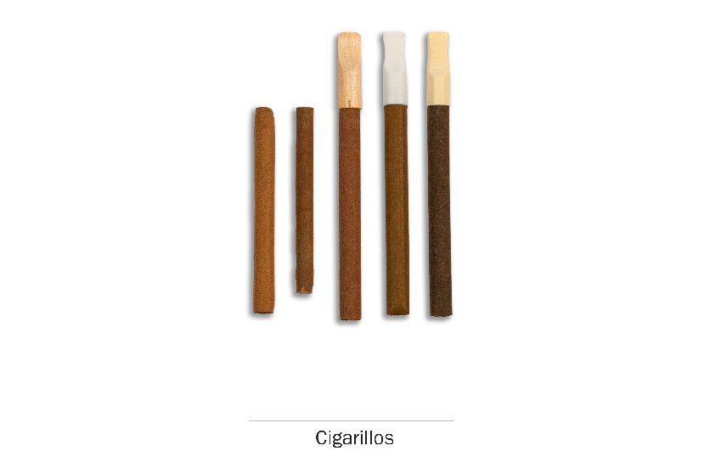

Use
research question
Revised item. Testing inclusion of a fourth response category, “rarely.”
PATH ID: R02_AG1003
- Do you now smoke cigarillos…
- Every day
- Some days
- Rarely
- Not at all go to Q17
Tell me more about your answer. PROBE TO GET A BETTER SENSE OF SMOKING FREQUENCY.
In the past 30 days, how many days did you smoke cigarillos?
How easy or difficult was it to choose your answer from this list of choices? In your own words, what is the difference between smoking “some days” and smoking “rarely”?
IF RESPONDENT SELECTS “RARELY,” If “rarely” hadn’t been an answer choice, how would you have answered this question? IF NEEDED, Would you have chosen “not at all” or “sometimes”? Why?

Flavor
Research questions
Previous testing showed some recall issues and difficulties assigning categories to flavors. Test if respondents can identify flavors and whether the list is exhaustive.
Additionally, try to tease out if respondents consider non-flavored products to be unflavored, regular, tobacco flavored, traditional, etc.
Some youth previously showed confusion on the meaning of “menthol.” Test further.
PATH ID: R02_yG1130_CIGARILLOS_FLAVOR
- In the past 30 days, were any of the cigarillos that you smoked flavored to taste like menthol, mint, clove, spice, fruit, chocolate, alcoholic drinks, candy or other sweets?
- Yes
- No go to Q14
- I don’t know go to Q14
- Didn’t smoke a cigarillo in the past 30 days go to Q14
IF NO, Are you familiar with these flavors? Which ones have you heard of?
IF NO, Was it flavored at all? Would you call it “unflavored” or “regular” or something else?

PATH ID: R02_yG1131_CIGARILLOS_WHICHFLAVORS
- Which flavors have you smoked in the past 30 days? Choose all that apply.
- Menthol or mint
- Clove or spice
- Fruit
- Chocolate
- An alcoholic drink (such as wine, cognac, margarita or other cocktails)
- Candy or other sweets
- Some other flavor
- DON'T KNOW
IF CANDY, FRUIT, OR SWEETS, PROBE FOR EXACT FLAVOR.
IF CHECK MULTIPLE FLAVORS, Was each flavor a different cigarillo, or did a single cigarillo have multiple flavors?
How easy/difficult was it for you to answer this question?
How confident are you in your response(s)?
Are there any flavors we left out?

PATH ID: R02_YG9147
- Some cigarillos come in flavors like menthol, mint, clove, spice, fruit, chocolate, alcoholic drinks, candy or other sweets?
Are flavored cigarillos easier to smoke, about the same, or harder to smoke than unflavored cigarillos?
- Easier to smoke
- About the same
- Harder to smoke
How did you decide on your answer? IF NEEDED, Did you answer based on your own experience or based on what you’ve heard? IF HEARD, Where did you hear that?
What does “harder to smoke” mean? What does “easier to smoke” mean?
Have you heard of menthol or mint flavored cigarillos? What have you heard? In your own words, what is “menthol”?
What does “unflavored” filtered cigarillo mean to you? Would it make more sense if we asked about “regular” cigarillos?

Purchasing
research questions
This item is being added to the youth section and has never been tested before. We want to test whether youth respondents have issues with reporting. Can youth users report cost information in general? Are there any issues reporting cost for youth that purchase themselves vs. youth that give money to someone else to buy for them? Does the question wording work across the various product types? How do people formulate an answer, what factors are they including in the cost?
PATH ID: R02_YG1034 – youth only_CIGARILLOs
- Think about the last time you bought (or gave money to someone else to buy you) cigarillos. How much did you pay for them?
$ ______________________

- DON'T KNOW
Tell me how you came up with your answer. PROBE ON WHETHER THERE WAS ANY DIFFICULTY COMING UP WITH COST.
How easy or difficult was it for you to answer this question? What made it easy or difficult?
IF R gave money to someone else to buy the CIGARILLOS: Did you pay the person extra to buy the cigarillos for you? IF YES: Did you include that in your answer here?

Switching
Research question
Earlier testing revealed that “switching” may not be a meaningful concept for all tobacco products (e.g., hookah users). Test further.
Test whether asking “Have you thought about…” works better than “Have you considered…” for respondents.
PATH ID: R02_YX0307_REVISED_cigarillos
- Have you thought about switching from cigarillos to any of the following products? Choose all that apply.
- I have not thought about switching to another product
- Cigarettes
- E-cigarettes
- Traditional cigars
- Filtered cigars
- Pipes
- Hookahs
- Snus pouches
- Smokeless tobacco such as loose snus, moist snuff, dip, spit, or chewing tobacco
- Dissolvable tobacco
What reaction, if any, did you have to this question?
NOTE IF RESPONDENT FINDS CONCEPT OF “SWITCHING” TO BE INAPPROPRIATE FOR A PARTICULAR PRODUCT
In your own words, what does it mean to “switch” to another product?
PROBE IF RESPONDENT INTERPRETS IT AS GIVING THE FIRST PRODUCT UP COMPLETELY
Tell me more about your answer.
IF SELECTED PRODUCTS, Why have you thought about switching from X to X?
IF HAVE NOT THOUGHT ABOUT SWITCHING, Tell me more about why you haven’t thought about switching to these other products?
If this question asked “Have you considered switching…” instead of “Have you thought about switching…”, would that have changed your answer? Why or why not?
Which do you prefer? Why?

Friends
research questions
This is a new item. We want to understand how respondents are answering this item, how respondents calculate their “four best friends,” and whether or not they know how many of their friends smoke cigarillos.
PATH ID: Best Friends Smoke Cigarillos
- How many of your best friends smoke cigarillos?
- None
- A few
- Some
- Most
- All
How easy or difficult was it for you to answer this question? What made it easy or difficult?
Who were you thinking about when you answered this question? IF NEEDED: Were you thinking about specific people, or just about your friends in general?
How confident are you that [FILL ANSWER] of your best friends have smoked cigarillos? What makes you confident/not confident?

Filtered cigars
if do not smoke little filtered cigars go to Q24
R02_AGD02_FilteredCigarsPic_Youth
The next questions are about filtered cigars, like those shown below. As you answer these questions, please think ONLY about your use of filtered cigars.

Use
research question
Revised item. Testing inclusion of a fourth response category, “rarely.”
PATH ID: R02_AG1003
- Do you now smoke filtered cigars…
- Every day
- Some days
- Rarely
- Not at all go to Q24
Tell me more about your answer. PROBE TO GET A BETTER SENSE OF SMOKING FREQUENCY.
In the past 30 days, how many days did you smoke filtered cigars?
How easy or difficult was it to choose your answer from this list of choices? In your own words, what is the difference between smoking “some days” and smoking “rarely”?
IF RESPONDENT SELECTS “RARELY,” If “rarely” hadn’t been an answer choice, how would you have answered this question? IF NEEDED, Would you have chosen “not at all” or “sometimes”? Why?

Flavor
Research questions
Previous testing showed some recall issues and difficulties assigning categories to flavors. Test if respondents can identify flavors and whether the list is exhaustive.
Additionally, try to tease out if respondents consider non-flavored products to be unflavored, regular, tobacco flavored, traditional, etc.
Some youth previously showed confusion on the meaning of “menthol.” Test further.
PATH ID: R02_yG1130_FILTEREDCIGARS_FLAVOR
- In the past 30 days, were any of the filtered cigars that you smoked flavored to taste like menthol, mint, clove, spice, fruit, chocolate, alcoholic drinks, candy or other sweets?
- Yes
- No go to Q21
- I don’t know go to Q21
- Didn’t smoke a filtered cigar in the past 30 days go to Q21
IF NO, Are you familiar with these flavors? Which ones have you heard of?
IF NO, Was it flavored at all? Would you call it “unflavored” or “regular” or something else?

PATH ID: R02_yG1131_FILTEREDCIGARS_WHICHFLAVORS
- Which flavors have you smoked in the past 30 days? Choose all that apply.
- Menthol or mint
- Clove or spice
- Fruit
- Chocolate
- An alcoholic drink (such as wine, cognac, margarita or other cocktails)
- Candy or other sweets
- Some other flavor
- DON'T KNOW
IF CANDY, FRUIT, OR SWEETS, PROBE FOR EXACT FLAVOR.
IF CHECK MULTIPLE FLAVORS, Was each flavor a different filtered cigar, or did a single filtered cigar have multiple flavors?
How easy/difficult was it for you to answer this question?
How confident are you in your response(s)?
Are there any flavors we left out?
PATH ID: R02_YG9148
- Some filtered cigars come in flavors like menthol, mint, clove, spice, fruit, chocolate, alcoholic drinks, candy or other sweets?
Are flavored filtered cigars easier to smoke, about the same, or harder to smoke than unflavored filtered cigars?
- Easier to smoke
- About the same
- Harder to smoke
How did you decide on your answer? IF NEEDED, Did you answer based on your own experience or based on what you’ve heard? IF HEARD, Where did you hear that?
What does “harder to smoke” mean? What does “easier to smoke” mean?
Have you heard of menthol or mint flavored filtered cigars? What have you heard? In your own words, what is “menthol”?
What does “unflavored” filtered cigar mean to you? Would it make more sense if we asked about “regular” filtered cigars?

Purchasing
research questions
This item is being added to the youth section and has never been tested before. We want to test whether youth respondents have issues with reporting. Can youth users report cost information in general? Are there any issues reporting cost for youth that purchase themselves vs. youth that give money to someone else to buy for them? Does the question wording work across the various product types? How do people formulate an answer, what factors are they including in the cost?
PATH ID: R02_YG1034 – youth only_FILTERED CIGARS
- Think about the last time bought (or gave money to someone else to buy you) filtered cigars. How much did you pay for them?
$ ______________________

- DON'T KNOW
Tell me how you came up with your answer. PROBE ON WHETHER THERE WAS ANY DIFFICULTY COMING UP WITH COST.
How easy or difficult was it for you to answer this question? What made it easy or difficult?
IF R gave money to someone else to buy the FILTERED CIGARS: Did you pay the person extra to buy the filtered cigars for you? IF YES: Did you include that in your answer here?

Switching
Research question
Earlier testing revealed that “switching” may not be a meaningful concept for all tobacco products (e.g., hookah users). Test further.
Test whether asking “Have you thought about…” works better than “Have you considered…” for respondents.
PATH ID: R02_YX0307_REVISED_FilteredCigar
- Have you thought about switching from filtered cigars to any of the following products? Choose all that apply.
- I have not thought about switching to another product
- Cigarettes
- E-cigarettes
- Traditional cigars
- Cigarillos
- Pipes
- Hookahs
- Snus pouches
- Smokeless tobacco such as loose snus, moist snuff, dip, spit, or chewing tobacco
- Dissolvable tobacco
What reaction, if any, did you have to this question?
NOTE IF RESPONDENT FINDS CONCEPT OF “SWITCHING” TO BE INAPPROPRIATE FOR A PARTICULAR PRODUCT
In your own words, what does it mean to “switch” to another product?
PROBE IF RESPONDENT INTERPRETS IT AS GIVING THE FIRST PRODUCT UP COMPLETELY
Tell me more about your answer.
IF SELECTED PRODUCTS, Why have you thought about switching from X to X?
IF HAVE NOT THOUGHT ABOUT SWITCHING, Tell me more about why you haven’t thought about switching to these other products?
If this question asked “Have you considered switching…” instead of “Have you thought about switching…”, would that have changed your answer? Why or why not?
Which do you prefer? Why?

Friends
research questions
This is a new item. We want to understand how respondents are answering this item, how respondents calculate their “four best friends,” and whether or not they know how many of their friends smoke filtered cigars.
PATH ID: Best friends smoke filtered cigars
- How many of your best friends smoke filtered cigars?
- None
- A few
- Some
- Most
- All
How easy or difficult was it for you to answer this question? What made it easy or difficult?
Who were you thinking about when you answered this question? IF NEEDED: Were you thinking about specific people, or just about your friends in general?
How confident are you that [FILL ANSWER] of your best friends have smoked filtered cigars? What makes you confident/not confident?

Use of Non-tobacco Products
All Respondents
research question
Test items with larger sample size including different cigar usage types. Additionally, identify the appropriateness of the current items we are asking blunt users and whether we are defining blunt users appropriately. Lastly, seek out information about which cigar types are associated with blunt use.

Screening
PATH ID: R02_yG9107
- Sometimes people take tobacco out of a traditional cigar, cigarillo or filtered cigar and replace it with marijuana. This is sometimes called a “blunt”.

In the past 12 months, have you smoked part or all of a traditional cigar, cigarillo or filtered cigar with marijuana in it?
- Yes
- No go to next Section
In your own words, what is this question asking?
Are you familiar with the term “blunt”? Is it one you use? Are there other terms you use?

PATH ID: R02_yG9106
- In the past 12 months, when you smoked a traditional cigar, cigarillo or filtered cigar, how often has tobacco been replaced with any marijuana?
- Every time
- Most of the time
- Sometimes
- Rarely
- Never
In your own words, what is this question asking?
How easy or difficult was it to answer?
When you smoke a blunt, do you remove all of the tobacco, or do you leave some in?

PATH ID: R02_yG1095
- Which group is most like the traditional cigar, cigarillo, or filtered cigar you last smoked as a blunt?
- Group 1
- Group 2
- Group 3
- Group 4

How easy or difficult was it for you to answer this question? What made it easy or difficult?
PROBE TO ENSURE RESPONDENT IS BEING CATEORIZED CORRECTLY

Pipes

Screening
R02_APT01_YOUTH
The next questions are about smoking tobacco in pipes.
We first ask about smoking tobacco in a regular pipe. There are many different types of regular pipes. They all have a bowl that holds the tobacco and a stem. The picture below shows a typical pipe.

PATH ID: YP1002
- Have you ever smoked a pipe filled with tobacco, even one or two puffs?
- Yes
- No go to next section

research question
Revised item. Testing inclusion of a fourth response category, “rarely.”
PATH ID: R02_AP1003_YOUTH
- Do you now smoke a pipe filled with tobacco…
- Every day
- Some days
- Rarely
- Not at all go to next Section
Tell me more about your answer. PROBE TO GET A BETTER SENSE OF SMOKING FREQUENCY.
In the past 30 days, how many days did you smoke a pipe filled with tobacco?
How easy or difficult was it to choose your answer from this list of choices? In your own words, what is the difference between smoking “some days” and smoking “rarely”?
IF RESPONDENT SELECTS “RARELY,” If “rarely” hadn’t been an answer choice, how would you have answered this question? IF NEEDED, Would you have chosen “not at all” or “sometimes”? Why?

Flavor
Research questions
Previous testing showed some recall issues and difficulties assigning categories to flavors. Test if respondents can identify flavors and whether the list is exhaustive.
Additionally, try to tease out if respondents consider non-flavored products to be unflavored, regular, tobacco flavored, traditional, etc.
PATH ID: R02_yP1130
- In the past 30 days, was any of the pipe tobacco you smoked flavored to taste like menthol, mint, clove, spice, fruit, chocolate, alcoholic drinks, candy or other sweets?
- Yes
- No go to Q5
- I don’t know go to Q5
- Didn’t smoke a pipe in the past 30 days go to Q5
IF NO, Are you familiar with these flavors? Which ones have you heard of?
IF NO, Was it flavored at all? Would you call it “unflavored” or “regular” or something else?

PATH ID: R02_yP1131
- Which flavors have you smoked in the past 30 days? Choose all that apply.
- Menthol or mint
- Clove or spice
- Fruit
- Chocolate
- An alcoholic drink (such as wine, cognac, margarita or other cocktails)
- Candy or other sweets
- Some other flavor
- DON'T KNOW
IF CANDY, FRUIT, OR SWEETS, PROBE FOR EXACT FLAVOR.
IF CHECK MULTIPLE FLAVORS, Was each flavor a different pipe tobacco, or did a single pipe tobacco have multiple flavors?
How easy/difficult was it for you to answer this question?
How confident are you in your response(s)?
Are there any flavors we left out?

PATH ID: R02_YP1146
- Some pipe tobacco comes in flavors like menthol, mint, clove, spice, fruit, chocolate, alcoholic drinks, candy or other sweets.
Is flavored pipe tobacco easier to smoke, about the same, or harder to smoke than unflavored pipe tobacco?
- Easier to smoke
- About the same
- Harder to smoke
How did you decide on your answer?
What does “harder to smoke” mean? What does “easier to smoke” mean?
What does “unflavored” pipe tobacco mean to you? Would it make more sense if we asked about “regular” pipe tobacco?

Switching
Research question
Earlier testing revealed that “switching” may not be a meaningful concept for all tobacco products (e.g., hookah users). Test further.
Test whether asking “Have you thought about…” works better than “Have you considered…” for respondents.
PATH ID: R02_YX0307_REVISED_PIPe
- Have you thought about switching from pipes to any of the following products? Choose all that apply.
- I have not thought about switching to another product
- Cigarettes
- E-cigarettes
- Traditional cigars
- Cigarillos
- Filtered cigars
- Hookahs
- Snus pouches
- Smokeless tobacco such as loose snus, moist snuff, dip, spit, or chewing tobacco
- Dissolvable tobacco
What reaction, if any, did you have to this question?
NOTE IF RESPONDENT FINDS CONCEPT OF “SWITCHING” TO BE INAPPROPRIATE FOR A PARTICULAR PRODUCT
In your own words, what does it mean to “switch” to another product?
PROBE IF RESPONDENT INTERPRETS IT AS GIVING THE FIRST PRODUCT UP COMPLETELY
Tell me more about your answer.
IF SELECTED PRODUCTS, Why have you thought about switching from X to X?
IF HAVE NOT THOUGHT ABOUT SWITCHING, Tell me more about why you haven’t thought about switching to these other products?
If this question asked “Have you considered switching…” instead of “Have you thought about switching…”, would that have changed your answer? Why or why not?
Which do you prefer? Why?

Hookah
PATH ID: Hookah intro YOUTH
research questioNS
Due to constraints in earlier testing, the hookah module was only tested with a small number of hookah users. Test with a larger number of respondents.
The next few questions are about smoking tobacco in a hookah. A hookah pipe is a type of water pipe that is sometimes also called a narghile pipe. From now on, we will use hookah to refer to a water pipe or narghile pipe that is often used to smoke tobacco.
There are many types of hookahs. People often smoke tobacco in hookahs in groups at cafes or in hookah bars.
What reaction, if any, did you have to this description and pictures of hookah?

People smoke shisha or hookah tobacco in a hookah. Some shisha contains tobacco and some does not. Shisha comes in many flavors.
What reaction, if any, did you have to this description and pictures of shisha?
Do you usually refer to it as shisha, or is there another term you use?

Screening
PATH ID: YH1002_YOuth
- Have you ever smoked tobacco in a hookah, even one or two puffs?
- Yes
- No go to next section
Was this a regular hookah, or an electronic hookah (e-hookah)?

research question
Revised item. Testing inclusion of a fourth response category, “rarely.”
PATH ID: R02_AH1003_Youth
- Do you now smoke hookah…
- Every day
- Some days
- Rarely
- Not at all go to next Section
Tell me more about your answer. PROBE TO GET A BETTER SENSE OF SMOKING FREQUENCY.
In the past 30 days, how many days did you smoke hookah?
How easy or difficult was it to choose your answer from this list of choices? In your own words, what is the difference between smoking “some days” and smoking “rarely”?
IF RESPONDENT SELECTS “RARELY,” If “rarely” hadn’t been an answer choice, how would you have answered this question? IF NEEDED, Would you have chosen “not at all” or “sometimes”? Why?

Frequency of Use
PATH ID: R02_YH1005
- How many times have you smoked hookah in your entire life? Count each sitting or session where you smoked tobacco in a hookah, whether alone or with others.
- 1
- 2 to 10
- 11 to 20
- 21 to 50
- 51 to 99
- 100 or more
Tell me more about how you came up with your answer.
How easy or difficult was it for you to answer this question? What made it easy/difficult?
RESEARCH QUESTION
Given the atypical nature of hookah use, how do respondents interpret the phrase “fairly regularly”?
PATH ID: R02_YH1100
- Have you ever smoked hookah fairly regularly?
- Yes
- No go to Q6
What does it mean to smoke hookah ‘fairly regularly’?
PATH ID: R02_yH1007
- How old were you when you first started smoking hookah fairly regularly?
___________________________________
How did you remember how old you were when you first started smoking hookah fairly regularly?
PATH ID: R02_YH9003
- Which of the following choices best describes your hookah smoking? Usually I smoke hookah…
- Every day go to Q9
- Weekly go to Q8
- Monthly
- Every couple of months go to Q10
- About once a year go to Q10
How did you decide to answer [ANSWER]? How easy or difficult was it to answer this question?
When do you smoke hookah?
PROBE TO SEE IF HOOKAH USE IS REGULAR (VERSUS SPORADIC).
IF ANSWER COUPLE OF MONTHS OR ABOUT ONCE A YEAR, Over a year, about how often do you smoke hookah? Count each sitting or session where you smoked tobacco in a hookah as one time, whether alone or with others.

PATH ID: R02_YH9004
- On average, about how many times do you smoke hookah in a month? Count each sitting or session where you smoked tobacco in a hookah, whether alone or with others.
___________________________________ go to Q10
How did you come up with your answer? How confident are you in your answer?
IF NEEDED, Do you smoke hookah about the same amount every month, or do you smoke less or more in some months?
Do you call it a “sitting” or “session,” or do you use another word?
PATH ID: R02_YH9005
- On average, about how many times do you smoke hookah in a week? Count each sitting or session where you smoked tobacco in a hookah, whether alone or with others.
___________________________________ go to Q10
How did you come up with your answer? How confident are you in your answer?
IF NEEDED, Do you smoke hookah about the same amount every week, or do you smoke less or more in some weeks?
Do you call it a “sitting” or “session,” or do you use another word?
PATH ID: R02_YH9006
- On average, about how many times do you smoke hookah each day? Count each sitting or session where you smoked tobacco in a hookah, whether alone or with others.
___________________________________
How did you come up with your answer? How confident are you in your answer?
IF NEEDED, Do you smoke hookah about the same amount every day, or do you smoke less or more in some days?
Do you call it a “sitting” or “session,” or do you use another word?

Ownership and How/Where to use
PATH ID: R02_YH1090
- Do you own a hookah?
- Yes
- No
FOR YOUTH: Do your parents/guardians own a hookah? How confident are you that they own/don’t own a hookah?
PATH ID: R02_YH9041
10a. Does anyone else living in your home own a hookah?
- Yes
- No
PATH ID: R02_YH9011
- Where do you usually smoke hookah? Choose all that apply.
- At home
- In a hookah bar or cafe
- At a friend’s house
- Somewhere else (SPECIFY:__________)

PATH ID: R02_YH9012
- Do you usually share the same hookah with others when you smoke?
- Yes
- No go to Q14
PATH ID: R02_YH9013
- How many people do you usually share hookah with?
- 1 other person
- 2 other people
- 3 other people
- 4 or more other people
Do you usually smoke hookah with the same number of people, or does it change? IF CHANGES, How did you decide on your answer?
PATH ID: R02_YH9014
- On average, how long is one hookah session for you (and the people you share it with)? A session is one sitting in which you smoke hookah, whether alone or with others.
- Less than 30 minutes
- 30 minutes – 1 hour
- More than 1 hour – 2 hours
- More than 2 hours
PATH ID: R02_YH9015
- On average, when you smoke hookah, how many times do you refill it with tobacco?
- 0 times
- 1 time
- 2 to 3 times
- 4 or more times
Are you usually the one who refills it? IF NOT, Who usually refills it?
PATH ID: R02_yH9016
- How often do you personally set up the hookah?
- Every time
- Most of the time
- Some of the time
- Rarely
- Never, someone else always sets it up for me
Tell me more about your answer. IF NEEDED, what does it mean to ‘set up the hookah’?

Regular Brand
PATH ID: R02_Ay1047
- Do you have a regular brand of shisha or hookah tobacco that you usually smoke?
- Yes
- No
How did you come up with your answer?
In your own words, what is a “regular” brand?

PATH ID: R02_Ay1048
- What brand of shisha or hookah tobacco did you last smoke?
SHOW RESPONDENT BRAND LIBRARY
___________________________________ go to Q20
- Something else
PATH ID: R02_Ay1049
- You said that your brand was not pictured. What is it?

___________________________________
PATH ID: R02_Ay1070
- You selected [BRANDFILL] as your brand. What kind of [BRANDFILL] did you last smoke?
SHOW RESPONDENT BRAND LIBRARY
___________________________________ go to Q22
- Something else
PATH ID: R02_Ay1071
- You said that the type of [BRANDFILL]s that you smoke is not pictured. What type is it?

___________________________________
PATH ID: R02_yH9108
- Does this brand of shisha contain tobacco?
- Yes
- No
How confident are you in your answer? How do you know whether or not your shisha contains tobacco?
Are you familiar with shisha that doesn’t have tobacco?

Flavor
Research questions
Previous testing showed some recall issues and difficulties assigning categories to flavors. Test if respondents can identify flavors and whether the list is exhaustive.
Additionally, try to tease out if respondents consider non-flavored products to be unflavored, regular, tobacco flavored, traditional, etc.
Some youth previously showed confusion on the meaning of “menthol.” Test further.
PATH ID: R02_yH1130
- In the past 30 days, was any of the shisha or hookah tobacco you smoked flavored to taste like menthol, mint, clove, spice, fruit, chocolate, alcoholic drinks, candy or other sweets?
- Yes
- No go to Q25
- I don’t know go to Q25
- Didn’t smoke hookah in the past 30 days go to Q25
IF NO, Are you familiar with these flavors? Which ones have you heard of?
IF NO, Was it flavored at all? Would you call it “unflavored” or “regular” or something else?

PATH ID: R02_yH1131
- Which flavors have you smoked in the past 30 days? Choose all that apply.
- Menthol or mint
- Clove or spice
- Fruit
- Chocolate
- An alcoholic drink (such as wine, cognac, margarita or other cocktails)
- Candy or other sweets
- Some other flavor
- DON'T KNOW
IF CANDY, FRUIT, OR SWEETS, PROBE FOR EXACT FLAVOR.
IF CHECK MULTIPLE FLAVORS, Was each flavor a different package of shisha, or did a single package of shisha have multiple flavors?
How easy/difficult was it for you to answer this question?
How confident are you in your response(s)?
Are there any flavors we left out?

PATH ID: R02_YH1146_YOUTH
- Some shisha or hookah tobacco comes in flavors like menthol, mint, clove, spice, fruit, chocolate, alcoholic drinks, candy or other sweets.
Is flavored shisha or hookah tobacco easier to smoke, about the same, or harder to smoke than unflavored shisha or hookah tobacco?
- Easier to smoke
- About the same
- Harder to smoke
How did you decide on your answer?
What does “harder to smoke” mean? What does “easier to smoke” mean?
Have you heard of menthol or mint flavored shisha or hookah tobacco? What have you heard? In your own words, what is “menthol”?
What does “unflavored” shisha or hookah tobacco mean to you? Would it make more sense if we asked about “regular” shisha or hookah tobacco?

Purchasing
PATH ID: R02_yH1097
The next questions ask about your experience buying shisha or hookah tobacco.
- In the past 30 days, did you use a coupon when buying shisha or hookah tobacco?
- Yes
- No go to Q28
IF YES, Where did you use the coupon? Was it at a restaurant, café, a tobacco store, etc.? IF NEEDED, Was the coupon just for the shisha, or did it include other things, such as the use of a hookah pipe?
IF YES, Where do you usually get your coupons? Have you ever used “Groupon” or something similar?
IF NO, Have you ever seen a coupon when buying shisha or hookah tobacco? Have you ever used one?
Do you usually buy the shisha or hookah tobacco? IF NO, How did you decide on your answer?
Have you ever bought shisha online? IF YES, If you did buy it online, and you used a discount code, how would you answer this question?
DETERMINE IF RESPONDENT INCLUDES A DISCOUNT CODE AS A COUPON.
PATH ID: R02_yH1098
- How many times in the past 30 days have you used a coupon to buy shisha or hookah tobacco?
___________________________________
PATH ID: R02_yH1030
- How do you usually buy your shisha or hookah tobacco? Is it…
- In person (such as at a store or hookah bar)
- From the internet go to Q31
- By telephone go to Q31
- I do not buy my own shisha or hookah tobacco go to Q31
PATH ID: R02_yH1032
- Do you usually buy shisha or hookah tobacco...?
- In your own state
- In another state
- Outside the US

PATH ID: R02_Ay1033
- Where do you buy your shisha or hookah tobacco most of the time?
- A hookah bar or cafe
- A convenience store or gas station
- A supermarket, grocery store, or drug store
- A warehouse club, such as Sam’s or Costco
- A smoke shop, tobacco specialty store or tobacco outlet store
- A duty free shop or military commissary
- A bar, pub, restaurant or casino
- A friend or relative
- A swap meet or flea market
- A liquor store
- Or from somewhere else SPECIFY: ____________________________
IF ANSWERS HOOKAH BAR OR CAFÉ, Do you usually call it a hookah bar or café, or is there another term you use?
Are there any places missing from this list?
Is there anything here you haven’t heard of?

research questions
This item is being added to the youth section and has never been tested before. We want to test whether youth respondents have issues with reporting. Can youth users report cost information in general? Are there any issues reporting cost for youth that purchase themselves vs. youth that give money to someone else to buy for them? Does the question wording work across the various product types? How do people formulate an answer, what factors are they including in the cost?
PATH ID: R02_YH1034
- Think about the last time you bought (or gave money to someone else to buy you) shisha or hookah tobacco. How much did you pay for it?
$ ______________________

- DON'T KNOW
Tell me how you came up with your answer. PROBE ON WHETHER THERE WAS ANY DIFFICULTY COMING UP WITH COST.
How easy or difficult was it for you to answer this question? What made it easy or difficult?
IF R gave money to someone else to buy the SHISHA OR HOOKAH TOBACCO: Did you pay the person extra to buy the shisha or hookah tobacco for you? IF YES: Did you include that in your answer here?

Reasons to Use
BEFORE RESPONDENT SEES QUESTIONS, PROBE GENERALLY,
Tell me more about why you smoke hookah.
PATH ID: R02_YH1060
The next questions are about the reasons people smoke hookah. Please select which reasons [apply to you I applied to you when you used to smoke hookah].
I smoke hookah because…
- It is affordable.
- Yes
- No
PATH ID: R02_YH1061
- People in the media or other public figures smoke hookah.
- Yes
- No
PATH ID: R02_YH1085
- I can smoke hookah at times when or in places where smoking cigarettes isn’t allowed.
- Yes
- No
PATH ID: R02_YH1062
- It might be less harmful than smoking cigarettes.
- Yes
- No
PATH ID: R02_YH1063
- Shisha or hookah tobacco comes in flavors I like.
- Yes
- No

PATH ID: R02_YH1064
- Smoking hookah helps people to quit smoking cigarettes.
- Yes
- No
PATH ID: R02_YH1068
- People who are important to me smoke hookah.
- Yes
- No
PATH ID: R02_YH1069
- I like socializing while smoking hookah.
- Yes
- No
PATH ID: R02_YH1072
- The advertising for hookah appeals to me.
- Yes
- No
PATH ID: R02_YH1073
- Smoking hookah is part of my cultural tradition.
- Yes
- No
How easy or difficult was it to answer this series of questions?
What did you think of these possible reasons to smoke hookah? Are there any that seemed strange or out of place? Are there other reasons someone might have for choosing a particular brand that are missing?

Switching
Research question
Earlier testing revealed that “switching” may not be a meaningful concept for all tobacco products (e.g., hookah users). Test further.
Test whether asking “Have you thought about…” works better than “Have you considered…” for respondents.
PATH ID: R02_YX0307_REVISED_Hookah
- Have you thought about switching from hookahs to any of the following products? Choose all that apply.
- I have not thought about switching to another product
- Cigarettes
- E-cigarettes
- Traditional cigars
- Cigarillos
- Filtered cigars
- Pipes
- Snus pouches
- Smokeless tobacco such as loose snus, moist snuff, dip, spit, or chewing tobacco
- Dissolvable tobacco
What reaction, if any, did you have to this question?
NOTE IF RESPONDENT FINDS CONCEPT OF “SWITCHING” TO BE INAPPROPRIATE FOR A PARTICULAR PRODUCT
In your own words, what does it mean to “switch” to another product?
PROBE IF RESPONDENT INTERPRETS IT AS GIVING THE FIRST PRODUCT UP COMPLETELY
Tell me more about your answer.
IF SELECTED PRODUCTS, Why have you thought about switching from X to X?
IF HAVE NOT THOUGHT ABOUT SWITCHING, Tell me more about why you haven’t thought about switching to these other products?
If this question asked “Have you considered switching…” instead of “Have you thought about switching…”, would that have changed your answer? Why or why not?
Which do you prefer? Why?

Use of Non-tobacco Products
research question
Developing new items to capture misuse of tobacco products, particularly the use of herbal substances which users think do not contain tobacco (but which might) and the use of liquid other than water in hookahs (e.g., alcohol, milk, Kool-Aid).
The next questions are about things other than shisha or hookah tobacco that someone might smoke in a hookah.
PATH ID: NEW_ HOOKAH MARIJUANA MISUSE YOUTH
- Have you ever smoked marijuana from a hookah?
- Yes
- No
Tell me more about how you came up with your answer.
IF YES, how do you smoke marijuana from a hookah?
IF NEEDED, Is it just marijuana, or do you mix it with tobacco?
IF NO, have you heard of people smoking marijuana from a hookah? What have you heard about it?

PATH ID: NEW_ HOOKAH OTHER SUBSTANCES MISUSE YOUTH
- Have you ever smoked anything else in a hookah?
- Yes
- No

In your own words, what is this question asking?
If YES, What else have you smoked in a hookah? Where did you learn that was something you could smoke from a hookah?
IF NO, Have you ever heard of people smoking something other than marijuana, shisha or hookah tobacco in a hookah? What have you heard? Where did you hear about it?
PATH ID: NEW_ HOOKAH LIQUID MISUSE YOUTH
- Have you ever used another liquid besides water in the bowl of the hookah?
- Yes
- No
IF YES, What type of liquid did you use? Where did you first hear about using liquid other than water in a hookah?
IF NO, Have you ever heard of using a liquid other than water in the bowl of the hookah? What kinds of liquids? Where did you hear about them?

PATH ID: NEW_ SHISHA WITH TOBACCO CLARIFICATION YOUTH
- Do you usually smoke shisha with tobacco when you smoke a hookah?
- Yes
- No
How do you know if shisha contains tobacco or not?
What kind of shisha do you usually smoke?

Smokeless Tobacco

Screening
R02_AST01_YOUTH
The next questions ask about smokeless tobacco which you put in your mouth. Frequently you chew, suck or spit while using smokeless tobacco, although there is no need to do so for some types. Snus, for instance, is a type of smokeless tobacco that comes in a small pouch that you put inside your lip.
There are many kinds of smokeless tobacco, such as snus pouches, loose snus, moist snuff, dip, spit, and chewing tobacco. Common brands include Redman, Levi Garrett, Beechnut, Skoal, Grizzly, Nordic Ice and Copenhagen.
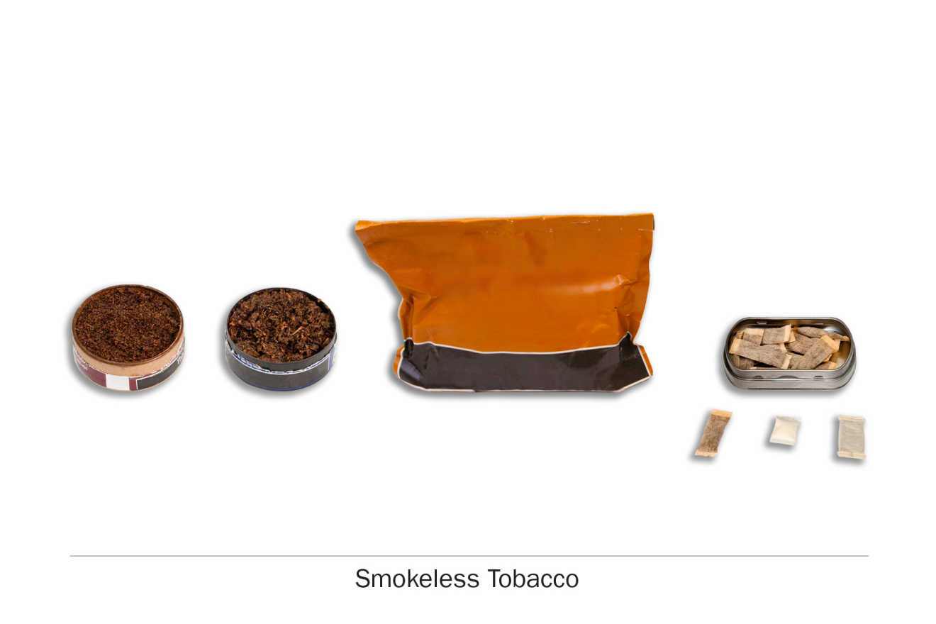

PATH ID: YS1002
- Have you ever used any of the following smokeless tobacco products, even one or two times? Choose all that apply.
- Snus pouches MARK ON SKIP SHEET as snus user
- Loose snus, moist snuff, dip, spit, or chewing tobacco MARK ON SKIP SHEET as smokeless tobacco user
- I have never used a smokeless tobacco product go to Q15

Snus
if do not use snus go to Q11

Use
PATH ID: R02_AU1003_SNUS_YOUTH
- You mentioned that you have used snus pouches. There are many brands of snus pouches. Have you ever used the brand called Skoal Bandits?
- Yes, I have used only Skoal Bandits go to Q9
- Yes, I have used both Skoal Bandits and other brands of snus pouches
- No, I have not used Skoal Bandits
- DON'T KNOW go to Q9
R02_AUT01_YOuTH
The next questions are about snus pouches. Common brands of snus pouches include Camel snus, General snus, Marlboro snus, and Nordic Ice, but there are many others.
Please think about your use of snus pouches as you answer these questions.
research question
Revised item. Testing inclusion of a fourth response category, “rarely.”
PATH ID: R02_AS1003_SNUS_USENOW
- Do you now use snus…
- Every day
- Some days
- Rarely
- Not at all go to Q9
Tell me more about your answer. PROBE TO GET A BETTER SENSE OF FREQUENCY OF USE.
In the past 30 days, how many days did you use snus?

How easy or difficult was it to choose your answer from this list of choices? In your own words, what is the difference between using snus pouches “some days” and using snus pouches “rarely”?
IF RESPONDENT SELECTS “RARELY,” If “rarely” hadn’t been an answer choice, how would you have answered this question? IF NEEDED, Would you have chosen “not at all” or “sometimes”? Why?

Flavor
Research questions
Previous testing showed some recall issues and difficulties assigning categories to flavors. Test if respondents can identify flavors and whether the list is exhaustive.
Additionally, try to tease out if respondents consider non-flavored products to be unflavored, regular, tobacco flavored, traditional, etc.
Some youth previously showed confusion on the meaning of “menthol.” Test further.
PATH ID: R02_yS1130_SNUS
- In the past 30 days, were any of the snus pouches you used flavored to taste like menthol, mint, clove, spice, fruit, chocolate, alcoholic drinks, candy or other sweets?
- Yes
- No go to Q6
- I don’t know go to Q6
- Didn’t use snus pouches in the past 30 days go to Q6
IF NO, Are you familiar with these flavors? Which ones have you heard of?
IF NO, Was it flavored at all? Would you call it “unflavored” or “regular” or something else?

PATH ID: R02_yS1131_SNUS_WHICHFLAVORS
- Which flavors have you used in the past 30 days? Choose all that apply.
- Menthol or mint
- Clove or spice
- Fruit
- Chocolate
- An alcoholic drink (such as wine, cognac, margarita or other cocktails)
- Candy or other sweets
- Some other flavor
- DON'T KNOW
IF CANDY, FRUIT, OR SWEETS, PROBE FOR EXACT FLAVOR.
IF CHECK MULTIPLE FLAVORS, Was each flavor a different pouch of snus, or did a single pouch of snus have multiple flavors?
How easy/difficult was it for you to answer this question?
How confident are you in your response(s)?
Are there any flavors we left out?

PATH ID: R02_YS1146_SNUS
- Some snus pouches comes in flavors like menthol, mint, clove, spice, fruit, chocolate, alcoholic drinks, candy or other sweets.
Is flavored snus pouches easier to use, about the same, or harder to use than unflavored snus pouches?
- Easier to use
- About the same
- Harder to use
How did you decide on your answer?
What does “harder to use” mean? What does “easier to use” mean?
Have you heard of menthol or mint flavored snus pouches? What have you heard? In your own words, what is “menthol”?
What does “unflavored” snus pouchesmean to you? Would it make more sense if we asked about “regular” snus pouches?

Purchasing
research questions
This item is being added to the youth section and has never been tested before. We want to test whether youth respondents have issues with reporting. Can youth users report cost information in general? Are there any issues reporting cost for youth that purchase themselves vs. youth that give money to someone else to buy for them? Does the question wording work across the various product types? How do people formulate an answer, what factors are they including in the cost?
PATH ID: R02_YS1034_SNUS_BOUGHT
- Think about the last time you bought (or gave money to someone else to buy you) snus pouches. How much did you pay for it?
$ ______________________

- DON'T KNOW
Tell me how you came up with your answer. PROBE ON WHETHER THERE WAS ANY DIFFICULTY COMING UP WITH COST.
How easy or difficult was it for you to answer this question? What made it easy or difficult?
IF R gave money to someone else to buy the SNUS POUCHES: Did you pay the person extra to buy the snus pouches for you? IF YES: Did you include that in your answer here?

Switching
Research question
Earlier testing revealed that “switching” may not be a meaningful concept for all tobacco products (e.g., hookah users). Test further.
Test whether asking “Have you thought about…” works better than “Have you considered…” for respondents.
PATH ID: R02_YX0307_REVISED_SNUS
- Have you thought about switching from snus pouches to any of the following products? Choose all that apply.
- I have not thought about switching to another product
- Cigarettes
- E-cigarettes
- Traditional cigars
- Cigarillos
- Filtered cigars
- Pipes
- Hookahs
- Smokeless tobacco such as loose snus, moist snuff, dip, spit, or chewing tobacco
- Dissolvable tobacco
What reaction, if any, did you have to this question?
NOTE IF RESPONDENT FINDS CONCEPT OF “SWITCHING” TO BE INAPPROPRIATE FOR A PARTICULAR PRODUCT
In your own words, what does it mean to “switch” to another product?
PROBE IF RESPONDENT INTERPRETS IT AS GIVING THE FIRST PRODUCT UP COMPLETELY
Tell me more about your answer.
IF SELECTED PRODUCTS, Why have you thought about switching from X to X?
IF HAVE NOT THOUGHT ABOUT SWITCHING, Tell me more about why you haven’t thought about switching to these other products?
If this question asked “Have you considered switching…” instead of “Have you thought about switching…”, would that have changed your answer? Why or why not?
Which do you prefer? Why?

Smokeless Tobacco
if do not use smokeless tobacco go to Q15
The next questions are about your use of other kinds of smokeless tobacco, not including snus pouches. The questions will use the phrase “smokeless tobacco” to refer to these products.

Use
research question
Revised item. Testing inclusion of a fourth response category, “rarely.”
PATH ID: R02_AS1003_SMOKELESS_USENOW_YOUTH
- Do you now use smokeless tobacco…
- Every day
- Some days
- Rarely
- Not at all go to Q15
Tell me more about your answer. PROBE TO GET A BETTER SENSE OF FREQUENCY OF USE.
In the past 30 days, how many days did you use smokeless tobacco?
How easy or difficult was it to choose your answer from this list of choices? In your own words, what is the difference between using smokeless tobacco “some days” and using smokeless tobacco “rarely”?
IF RESPONDENT SELECTS “RARELY,” If “rarely” hadn’t been an answer choice, how would you have answered this question? IF NEEDED, Would you have chosen “not at all” or “sometimes”? Why?

Flavor
Research questions
Previous testing showed some recall issues and difficulties assigning categories to flavors. Test if respondents can identify flavors and whether the list is exhaustive.
Additionally, try to tease out if respondents consider non-flavored products to be unflavored, regular, tobacco flavored, traditional, etc.
Some youth previously showed confusion on the meaning of “menthol.” Test further.
PATH ID: R02_yS1130_SMOKELESS
- In the past 30 days, was any of the smokeless tobacco you used flavored to taste like menthol, mint, clove, spice, fruit, chocolate, alcoholic drinks, candy or other sweets?
- Yes
- No go to Q12
- I don’t know go to Q12
- Did not use smokeless tobacco in the past 30 days go to Q12
IF NO, Are you familiar with these flavors? Which ones have you heard of?
IF NO, Was it flavored at all? Would you call it “unflavored” or “regular” or something else?

PATH ID: R02_yS1131_SMOKELESS_WHICHFLAVORs
- Which flavors have you used in the past 30 days? Choose all that apply.
- Menthol or mint
- Clove or spice
- Fruit
- Chocolate
- An alcoholic drink (such as wine, cognac, margarita or other cocktails)
- Candy or other sweets
- Some other flavor
- DON'T KNOW
IF CANDY, FRUIT, OR SWEETS, PROBE FOR EXACT FLAVOR.
IF CHECK MULTIPLE FLAVORS, Was each flavor a different package of smokeless tobacco, or did a single package of smokeless tobacco have multiple flavors?
How easy/difficult was it for you to answer this question?
How confident are you in your response(s)?
Are there any flavors we left out?

PATH ID: R02_YS1146_SMOKELESS
- Some smokeless tobacco comes in flavors like menthol, mint, clove, spice, fruit, chocolate, alcoholic drinks, candy or other sweets.
Is flavored smokeless tobacco easier to use, about the same, or harder to use than unflavored smokeless tobacco?
- Easier to use
- About the same
- Harder to use
How did you decide on your answer?
What does “harder to use” mean? What does “easier to use” mean?
Have you heard of menthol or mint flavored smokeless tobacco? What have you heard? In your own words, what is “menthol”?
What does “unflavored” smokeless tobacco mean to you? Would it make more sense if we asked about “regular” smokeless tobacco?

Purchasing
research questions
This item is being added to the youth section and has never been tested before. We want to test whether youth respondents have issues with reporting. Can youth users report cost information in general? Are there any issues reporting cost for youth that purchase themselves vs. youth that give money to someone else to buy for them? Does the question wording work across the various product types? How do people formulate an answer, what factors are they including in the cost?
PATH ID: R02_YS1034_SMOKELESS_BOUGHT
- Think about the last time you bought (or gave money to someone else to buy you) smokeless tobacco. How much did you pay for it?
$ ______________________

- DON'T KNOW
Tell me how you came up with your answer. PROBE ON WHETHER THERE WAS ANY DIFFICULTY COMING UP WITH COST.
How easy or difficult was it for you to answer this question? What made it easy or difficult?
IF R gave money to someone else to buy the SMOKELESS TOBACCO: Did you pay the person extra to buy the smokeless tobacco for you? IF YES: Did you include that in your answer here?

Switching
Research question
Earlier testing revealed that “switching” may not be a meaningful concept for all tobacco products (e.g., hookah users). Test further.
Test whether asking “Have you thought about…” works better than “Have you considered…” for respondents.
PATH ID: R02_YX0307_REVISED_SMOKeless
- Have you thought about switching from smokeless tobacco to any of the following products? Choose all that apply.
- I have not thought about switching to another product
- Cigarettes
- E-cigarettes
- Traditional cigars
- Cigarillos
- Filtered cigars
- Pipes
- Hookahs
- Snus pouches
- Dissolvable tobacco
What reaction, if any, did you have to this question?
NOTE IF RESPONDENT FINDS CONCEPT OF “SWITCHING” TO BE INAPPROPRIATE FOR A PARTICULAR PRODUCT
In your own words, what does it mean to “switch” to another product?
PROBE IF RESPONDENT INTERPRETS IT AS GIVING THE FIRST PRODUCT UP COMPLETELY
Tell me more about your answer.
IF SELECTED PRODUCTS, Why have you thought about switching from X to X?
IF HAVE NOT THOUGHT ABOUT SWITCHING, Tell me more about why you haven’t thought about switching to these other products?
If this question asked “Have you considered switching…” instead of “Have you thought about switching…”, would that have changed your answer? Why or why not?
Which do you prefer? Why?

Friends
research questions
This is a new item. We want to understand how respondents are answering this item, how respondents calculate their “four best friends,” and whether or not they know how many of their friends smoke smokeless tobacco.
PATH ID: Best friends smokeless tobacco
- How many of your best friends smoke smokeless tobacco?
- None
- A few
- Some
- Most
- All
How easy or difficult was it for you to answer this question? What made it easy or difficult?
Who were you thinking about when you answered this question? IF NEEDED: Were you thinking about specific people, or just about your friends in general?
How confident are you that [FILL ANSWER] of your best friends have smoked smokeless tobacco? What makes you confident/not confident?

Dissolvable Tobacco

Screening
Research questions
We need further testing of dissolvable tobacco items.
R02_ADT01_Youth
The next questions ask about another type of tobacco called dissolvable tobacco. You don’t smoke dissolvable tobacco products – they are made of finely ground flavored tobacco that dissolves in your mouth.
Dissolvable tobacco products come in a variety of shapes, including small round pellets, thin sticks and flat strips. Some common brands are Ariva, Stonewall, and Camel Orbs, Sticks or Strips.

YD1002
- Have you ever used dissolvable tobacco products, such as Ariva, Stonewall, or Camel Orbs, Sticks, or Strips, even one or two times?
- Yes
- No GO TO next module
IF YES, Tell me about the product you used. What was its name? How did you use it? What did it look like? Where did you get it?

Harm Module
ALL RESPONDENTS

Relative Harm
research question
Discover how respondents conceive the idea of “harm,” particularly when assigning relative harm among different tobacco products. Are respondents considering the intrinsic toxicity of different products (e.g., e-cigarettes have fewer carcinogens than regular cigarettes), the typical frequency of use (e.g., people usually only smoke hookah occasionally, but they smoke cigarettes every day), the delivery mechanism (e.g., cigars produce smoke that harm your lungs, while you just chew smokeless tobacco), or impact on others (e.g., items that product second-hand smoke are the worst because they harm others).
PATH ID: CARDSORT HARMFUL
I have here a set of cards with the name of different types of tobacco products.
What I’d like you to do is to sort the cards in a line from least harmful to most harmful. If you think two products are equally harmful, you can place them side-by-side.
ALLOW RESPONDENTS TO SORT CARDS. RECORD SORT ORDER IN YOUR NOTES.
Tell me how you decided the order of the cards.
IF NEEDED, How did you decide X was most harmful? That X was least harmful?
IF NEEDED, How did you decide X was more harmful than X? How did you decide X was less harmful than X? How did you decide these were equally harmful?
PROBE TO DETERMINE WHAT RESPONDENTS ARE CONSIDERING WHEN ASSIGNING RELATIVE HARM.
If you were thinking specifically about lung disease, would the order change? Why? What about emphysema? Or mouth cancer?
PATH ID: CARDSORT BLANK
I have here a blank card. It represents not using any tobacco product. Where would you place it?
Why did you place it here?
IF RESPONDENT FEELS NOT USING IS MORE HARMFUL THAN USING A PRODUCT, PROBE TO FIND OUT WHY.
PATH ID: CARDSORT ADDICTIVE
Now I’d like you to sort the cards from least addictive to most addictive.
Tell me how you decided the order of the cards.
IF NEEDED, How did you decide X was most addictive? That X was least addictive?

Advertising Claims about Relative Harm
Research question
Test asking about product-specific permutations rather than the current wording of AR0143 (If a tobacco product made a claim that it was less harmful to health than other tobacco products, how likely would you be to use that product?)
ask respondents only about products they currently use (REFER TO SKIP SHEET)
YOuth who do not use go to next module

cigarettes
PATH ID: AR0143_Cigarettes
- If a cigarette brand made a claim that it was less harmful to health than other cigarette brands, how likely would you be to use that product?
- Very likely
- Somewhat likely
- Somewhat unlikely
- Very unlikely
Tell me more about your answer. Why would you be {RESPONSE CHOICE} to use it?
What could make a particular brand less harmful than another brand?
If a brand claimed it was less harmful than other brands, how likely would you be to believe them? Why?

e-cigarettes
PATH ID: AR0143_E-Cigarette
- If an e-cigarette brand made a claim that it was less harmful to health than other e-cigarette brands, how likely would you be to use that product?
- Very likely
- Somewhat likely
- Somewhat unlikely
- Very unlikely
Tell me more about your answer. Why would you be {RESPONSE CHOICE} to use it?
What could make a particular brand less harmful than another brand?
If a brand claimed it was less harmful than other brands, how likely would you be to believe them? Why?

cigar
AR0143_Cigar
- If a traditional cigar brand made a claim that it was less harmful to health than other traditional cigar brands, how likely would you be to use that product?
- Very likely
- Somewhat likely
- Somewhat unlikely
- Very unlikely
Tell me more about your answer. Why would you be {RESPONSE CHOICE} to use it?
What could make a particular brand less harmful than another brand?
If a brand claimed it was less harmful than other brands, how likely would you be to believe them? Why?

cigarillo
PATH ID: AR0143_Cigarillo
- If a cigarillo brand made a claim that it was less harmful to health than other cigarillo brands, how likely would you be to use that product?
- Very likely
- Somewhat likely
- Somewhat unlikely
- Very unlikely
Tell me more about your answer. Why would you be {RESPONSE CHOICE} to use it?
What could make a particular brand less harmful than another brand?
If a brand claimed it was less harmful than other brands, how likely would you be to believe them? Why?

filtered cigar
PATH ID: AR0143_Filtered Cigar
- If a filtered cigar brand made a claim that it was less harmful to health than other filtered cigar brands, how likely would you be to use that product?
- Very likely
- Somewhat likely
- Somewhat unlikely
- Very unlikely
Tell me more about your answer. Why would you be {RESPONSE CHOICE} to use it?
What could make a particular brand less harmful than another brand?
If a brand claimed it was less harmful than other brands, how likely would you be to believe them? Why?

pipe
PATH ID: AR0143_Pipe
- If a pipe tobacco brand made a claim that it was less harmful to health than other pipe tobacco brands, how likely would you be to use that product?
- Very likely
- Somewhat likely
- Somewhat unlikely
- Very unlikely
Tell me more about your answer. Why would you be {RESPONSE CHOICE} to use it?
What could make a particular brand less harmful than another brand?
If a brand claimed it was less harmful than other brands, how likely would you be to believe them? Why?

hookah
PATH ID: AR0143_Hookah
- If a hookah tobacco brand made a claim that it was less harmful to health than other hookah tobacco brands, how likely would you be to use that product?
- Very likely
- Somewhat likely
- Somewhat unlikely
- Very unlikely
Tell me more about your answer. Why would you be {RESPONSE CHOICE} to use it?
What could make a particular brand less harmful than another brand?
If a brand claimed it was less harmful than other brands, how likely would you be to believe them? Why?

smokeless tobacco
PATH ID: AR0143_Smokeless Tobacco
- If a smokeless tobacco brand made a claim that it was less harmful to health than other smokeless tobacco brands, how likely would you be to use that product?
- Very likely
- Somewhat likely
- Somewhat unlikely
- Very unlikely
Tell me more about your answer. Why would you be {RESPONSE CHOICE} to use it?
What could make a particular brand less harmful than another brand?
If a brand claimed it was less harmful than other brands, how likely would you be to believe them? Why?

dissolvable tobacco
PATH ID: AR0143_Dissolvable Tobacco
- If a dissolvable tobacco brand made a claim that it was less harmful to health than other dissolvable tobacco brands, how likely would you be to use that product?
- Very likely
- Somewhat likely
- Somewhat unlikely
- Very unlikely
Tell me more about your answer. Why would you be {RESPONSE CHOICE} to use it?
What could make a particular brand less harmful than another brand?
If a brand claimed it was less harmful than other brands, how likely would you be to believe them? Why?

Media Module
ALL RESPONDENTS
RESEARCH QUESTION
Identify whether individuals use tobacco related applications rather than just downloading them. Test Items that ask about whether media has influenced the misuse of products. Test items that determine respondent level of engagement.

Internet Use
PATH ID: R02_AX0315
- Do you ever go on-line to access the Internet or World Wide Web, or to send and receive e-mail?
- Yes
- No go to Q18

General Use, Games, and Videos
PATH ID: R02_AX0489
- In the past 12 months, have you done any of the following online? Choose all that apply.
- Signed up for any email alerts about tobacco products, including e-cigarettes
- Read any articles online about tobacco products, including e-cigarettes
- Watched a video online about tobacco products, including e-cigarettes
- None of the above
Tell me more about your answer.

PATH ID: NEW_ SocialMediaVideos
- Have you ever used YouTube or another online video site to get information about a tobacco product or e-cigarette?
- Yes
- No
IF YES, what website did you use? Tell me more about the video that you saw PROBE TO FIND OUT CONTENT OF VIDEO.
IF NEEDED, Did any of the videos show how to modify or customize a tobacco product or e-cigarette?
Are there other kinds of videos about tobacco products you have seen online, what were they? How did you come across this video- were you actively searching for it or did you just happen to come upon it?
IF NO, Have you heard of online videos that talk about tobacco products or e-cigarettes? What kinds of videos have you seen or heard?

Social Media
PATH ID: R02_AX0062
- Sometimes people use the Internet to connect with other people online through social networks like Facebook, Google Plus, YouTube, MySpace, Linkedin, Twitter, Tumblr, Instagram, Pinterest, or Snapchat. This is often called “social media.”
Do you have a social media account?
- Yes
- No go to Q18
What reaction, if any, did you have to this list of examples of social media? Are there any that you feel don’t belong? Anything we should add?
Do you usually use the term “social media”? IF NO, is there another term you use?
IF YES, tell me about the social media accounts that you have. What kinds of things do you use them for?
IF NO, have you heard of social media accounts? Which have you heard of?

PATH ID: R02_AX0317
- How often do you visit your social media accounts? Your best guess is fine.
- Several times a day
- About once a day
- 3-5 days a week
- 1-2 days a week
- Every few weeks
- Less often
- Never go to Q18
How easy or difficult was this question for you to answer?
IF R HAS MULTIPLE ACCOUNTS: You talked about using multiple social media accounts. Did you answer for a particular account, or did you average across all of them? PROBE TO SEE IF RESPONDENT HAD DIFFICULY GIVING A SINGLE FREQUENCY FOR MULTIPLE ACCOUNTS.
PATH ID: R02_AX0320
- On a typical day, about how much time do you spend on social media sites? Your best guess is fine.
- Up to 30 minutes
- More than 30 minutes, up to 3 hours
- More than 3 hours, up to 6 hours
- More than 6 hours
How did you come up with your answer? How easy or difficult was it for you to come up with your answer?
What does a ‘typical day’ mean to you in this question?

PATH ID: R02_AX0321
- In the past 12 months, have you seen content posted about tobacco products (including e-cigarettes) on social media sites?
- Yes
- No
IF YES, What have you seen and where did you see it?
PROBE TO SEE IF THEY ARE THINKING ABOUT THINGS THEY POST ON THEIR OWN WALL OR FROM THEIR OWN TWITTER HANDLE, VERSUS SOMETHING THAT JUST SHOWS UP IN THEIR NEWS FEED.
PATH ID: R02_AX0506
- In the past 12 months, have you posted content about tobacco products (including e-cigarettes) on any of your social media accounts?
- Yes
- No
IF YES, What did you post? Where did you post it? IF NEEDED, Did you post on your own page or on other people’s pages?
IF NO, Do you post other types of things?
CONFIRM RESPONDENT UNDERSTANDS CONCEPT OF POSTING. Have you heard of or seen people post content related to tobacco? What kinds of things have you heard of or seen people post?
if never posted to ANYTHING go to Q15
RESEARCH QUESTION
Identify whether individuals use tobacco related applications rather than just downloading them. Test Items that ask about whether media has influenced the misuse of products. Test items that determine respondent level of engagement.
PATH ID: NEW_ SocialMedia Engagement
- Do you follow an individual or company that posts about tobacco products on any of the following social media sites? Mark all that apply.
- Blogs
- Facebook
- Twitter
- Pinterest
- YouTube
- I don’t follow any
In your own words, what is this question asking?
IF FOLLOWS, Who do you follow? What type of content do they post?
PATH ID: NEW_ SOCIAL MEDIA SITE POSTS
- Have you posted content related to tobacco (including e-cigarettes) on any of the following social media sites? Mark all that apply.
- Blogs MARK on Skip sheet
- Facebook
- Twitter
- Pinterest Mark on skip sheet
- YouTube
In your own words, what is this question asking?
Are there other sites you use?
PATH ID: NEW_ SOCIAL MEDIA POSTS
- What have you posted? Mark all that apply.
- Photo of yourself using tobacco
- Video of yourself using tobacco
- Video of your friends using tobacco
- Never posted these things
IF SELECTED ANYTHING BUT ‘NEVER’, tell me about the photo/video that you/your friends posted.
PATH ID: NEw_ SOCIAL MEDIA RE-TWEET
- How often do you re-post or re-tweet someone else’s discussion, videos or photos of tobacco?
- Never
- Rarely
- Sometimes
- Often
- Always
Tell me more about your answer. How did you decide between {ANSWER CHOICE} and {OPTION JUST ABOVE OR BELOW}?
IF ANYTHING OTHER THAN NEVER OR RARELY, What kinds of things have you re-posted or re-tweeted?
PATH ID: NEW_ SOCIAL MEDIA BLOG
if never posted to BLOGS go to Q15
- How often do you blog about quitting tobacco?
- Never
- Rarely
- Sometimes
- Often
- Always
Tell me more about your answer. How did you decide between {ANSWER CHOICE} and {OPTION JUST ABOVE OR BELOW}?
What does it mean to have a blog post about quitting tobacco?
PATH ID: NEW _PINTEREST
if never posted to PINTEREST go to Q16
- Which of the following have you done on Pinterest?
- Pinned a tobacco or e-cigarette product
- Created a board related to tobacco
- Liked a pin about tobacco or e-cigarette products
Tell me more about your answer. What kinds of products/items did you pin or like on pinterest?
PATH ID: R02_AX0686
- Have you liked or followed any of the following brands on Facebook, Twitter or other social media sites?
- Camel
- Marlboro
- Newport
- Swisher Sweets
- Blu
- Fin
- Vuse
- NJOY
- None of the above
In your own words, what is this question asking?
IF NEEDED, What does it mean to ‘like’ a brand? What does it mean to ‘follow’a brand?
FOR BRANDS CHECKED, What kinds of things does [BRAND] post about? Have you ever re-posted, shared or re-tweeted any content that [BRAND] posted?

PATH ID: R02_AX0687
- Have you sent a link or information about any of the following brands to others on Facebook, Twitter or other social media sites?
- Camel
- Marlboro
- Newport
- Swisher Sweets
- Blu
- Fin
- Vuse
- NJOY
- None of the above
IF YES, What did you share? Who did you share it with? How did you share it? PROBE TO SEE IN WHAT WAY THEY ARE SENDING IT (THROUGH PRIVATE MESSAGING, POSTING ON SOMEONE’S WALL, POSTING IT ON THEIR OWN WALL).
PATH ID: R02_AX0688
- Have you played an online game related to any of the following brands?
- Camel
- Marlboro
- Newport
- Swisher Sweets
- Blu
- Fin
- Vuse
- NJOY
- None of the above
IF YES, What game did you play? Tell me more about that game- how does it work? Where did you find the game?
IF NO, have you heard of any games related to any of these brands? What have you heard?

Apps
PATH ID: R02_AX0503
- Please indicate if you have any of the following. Choose all that apply.
- Tablet computer, such as an iPad, Samsung Galaxy, Motorola Xoom, or Kindle Fire
- Smartphone, such as an iPhone, Android, Blackberry, or Windows phone
- Cell phone
- I do not have any of the above
if do not have tablet or smartphone go to Q22
Is there anything that is missing from this list?
PATH ID: R02_AX0504
- Have you ever used a tobacco-related application (or app) on your tablet computer or smart phone?
- Yes
- No go to Q22
In your own words, what is a “tobacco-related app”?
PROBE TO DETERMINE BOTH FAMILIARITY WITH TERM “APP” AND THE CONCEPT OF A TOBACCO-RELATED APP.
IF YES, what kinds of apps have you used?
IF NO, have you heard of these kinds of apps? What ones have you heard of?

PATH ID: R02_AX0505
- Have you ever used an app on your tablet computer or smart phone to help you quit using tobacco?
- Yes
- No
IF YES, what app did you use? Tell me more about how you use it. How did you hear about this app?
IF NO, Have you heard of any apps that help you quit using tobacco? What have you heard?
NEW_ ProTobaccoApp
- Other than apps that help people quit smoking, have you ever used an app on your smart phone or tablet computer that is related to using tobacco products?
- Yes
- No
- Don’t Know
IFYES, What app did you use? How did you use it? How did you hear about this app? Why did you decide to get this app?
IF NO, have you heard of any of these kinds of apps? Which have you heard of? What do you know about them?

Health Promotion
RESEARCH QUESTION
Test new health promotion items.
PATH ID: NEW_HealthPromotion1
- In the past 12 months, have you seen or heard the following slogan or theme?
- *X0192. Tips from Former Smokers (Tips) [INSERT PHOTO]
- *X0199. Truth Campaign Brand [INSERT PHOTO]
- *X0201. The Real Cost [INSERT PHOTO]
- Haven’t seen or heard any of the above

IF SELECTED ANY, Tell me more about the slogan/theme you have seen or heard. Where did you hear/see it?
PATH ID: NEW_ HealthPromotion2
- In the past 12 months, have you seen or heard of any ads on television or radio with the following themes or slogans?
- *X0234. Tips from Former Smokers (Tips) [INSERT CAMPAIGN MESSAGE OR THEME]
- *X0235. Truth Campaign Brand [INSERT CAMPAIGN MESSAGE OR THEME]
- *X0236. The Real Cost [INSERT CAMPAIGN MESSAGE OR THEME]
- *X0674. The Real Cost [INSERT CAMPAIGN MESSAGE OR THEME]
- Haven’t seen or heard any of the above

IF SELECTED ANY, Tell me more about any ads you have seen on TV or radio with those themes/slogans.

Marketing and Promotion Items
RESEARCH QUESTION
Test items measuring respondent exposure to marketing and promotion tools.
PATH ID: R02_YX0477
- In the past 30 days, have you received any discount coupons or promotions for tobacco products or e-cigarettes, whether it was online or some other way?
- 1 Yes
- 2 No go to Q28
IF NO, Do you ever receive discount coupons or promotions?
PATH ID: R02_YX0478
- Where did you get discount coupons or promotions from? Choose all that apply.
- The mail
- E-mail MARK ON SKIP SHEET
- The Internet
- Social Networks (such as Facebook and Twitter)
- A text message
- On a cigarette pack or other tobacco product
- From a friend or other person
- Some other way: SPECIFY___________________
Are there any other places we should add to this list?

if did not receive via mail go to Q27
PATH ID: R02_YX0216
- Which products did you receive discount coupons or promotions for in the mail? Choose all that apply.
- Cigarettes
- E-cigarettes
- Cigars
- Smokeless tobacco
- Other tobacco products
if did not receive via e-mail go to Q28
PATH ID: R02_YX0204
- Which products did you receive discount coupons or promotions for in an e-mail message? Choose all that apply.
- Cigarettes
- E-cigarettes
- Cigars
- Smokeless tobacco
- Other tobacco products
PATH ID: R02_YX0182
- In the past 30 days, how often did you visit a convenience store, small market, or liquor store?
- Never go to Q30
- Once a month
- 2-3 times per month
- Once a week
- 2-3 times per week
- Almost every day
How easy or difficult was it to answer this question?
Are there other places besides the ones listed where you see tobacco ads?

PATH ID: R02_YX0183
- In the past 30 days, when you visited convenience stores, small markets, or liquor stores, how often did you see ads for e-cigarettes?
- Never
- Rarely
- Sometimes
- Often
PATH ID: R02_YX0297
- What is the brand of your favorite e-cigarette advertisement? Choose only one.
If you do not see the brand listed below, select “Something else”.

- I do not have a favorite e-cigarette advertisement
- Blu
- eSmoke
- Fin
- GreenSmoke
- Logic
- MarkTen
- NJOY
- ProVape
- Smoking Everywhere
- Vapor King
- Vuse
- V2Cigs
- Something else SPECIFY: __________________
Tell me about your favorite ad.
How easy or difficult was it to remember the brand? What made it easy/difficult?
PATH ID: R02_AX0475
- In the past 30 days, have you seen a tobacco sweepstakes ad?
- Yes
- No
Have you ever seen a “tobacco sweepstakes ad”? IF YES, Describe it to me.
IF YES, tell me more about the ad you saw.
PATH ID: R02_AX0476
- In the past 30 days, have you participated in a tobacco sponsored sweepstakes?
- Yes
- No
IF YES, tell me more about the sweepstakes you participated in.
IF do not use e-cigarette go to Q34
PATH ID: R02_AX0678
- In the past 30 days, have you gotten a free sample of an e-cigarette or e-liquid?
- Yes
- No
IF YES, what free sample did you get? Where or how did you get it?
IF NO, have you heard of people getting free samples of e-cigarettes or e-liquid?
PATH ID: R02_AX0481
- In the past 30 days, have you gotten a free sample of a tobacco product?
- Yes
- No
IF YES, what free sample did you get?
PATH ID: R02_AX0223_NB
- In the past 30 days, has this happened just once or twice, a few times, or quite regularly?
- Once or twice
- A few times
- Quite regularly

PATH ID: R02_AX0203
- In the past 30 days, have you noticed e-cigarettes being advertised in any of the following places?
- On posters or billboards
- In newspapers or magazines
- On websites or social media sites
- On radio
- On television
- At events like fairs, festivals, or sporting events
- Haven’t noticed any advertisements

Tell me more about the e-cigarette ad(s) that you saw.
How easy or difficult was it to answer this? What made it easy/difficult?
Is there any place that you have seen advertising that we didn’t mention in this list?
When you were answering, were you thinking just about e-cigarettes, or were you including other electronic products such as e-hookah, e-cigars, or vape pens?

PATH ID: R02_AX0677
- In the past 30 days, have you noticed cigarettes or other tobacco products being advertised in any of the following places?
- On posters of billboards
- In newspapers or magazines
- On websites or social media sites
- On radio
- On television
- At events like fairs, festivals, or sporting events
- Haven’t noticed any advertisements
Tell me more about the cigarette ad(s) that you saw.
How easy or difficult was it to answer this? What made it easy/difficult?
Is there any place that you have seen advertising that we didn’t mention in this list?

Adult Demographics Module
Adult respondents
R02_AMT01 (MODIFIED)
Finally, we have a few additional questions about you, your income, and health insurance.

Income
asked of adult respondents

Research question
Do respondents have difficulty reporting their income within the response categories given, and do they include all types of income specified?
PATH ID: R02_AM0030
- Which of the following categories best describes your total household income in the past 12 months?
This is the total income before taxes of all persons in your household combined. Please include money from jobs, relatives, pensions, dividends, interest, social security payments or retirement benefits, net income from business, farm or rent, and any other money received by household members.
- Less than $10,000 go to Q3
- $10,000 to $14,999 go to Q3
- $15,000 to $24,999 go to Q3
- $25,000 to $34,999 go to Q3
- $35,000 to $49,999 go to Q3
- $50,000 to $74,999 go to Q3
- $75,000 to $99,999 go to Q3
- $100,000 to $149,999 go to Q3
- $150,000 to $199,999 go to Q3
- $200,000 or more go to Q3
- DON'T KNOW

How easy or difficult was it to answer this question? What made it easy or difficult?
You don’t have tell me specific amounts, but can you tell me what types of income you included when you were coming up with your answer?
IF NEEDED, Did you include everyone in your household?
IF NEEDED, Did you include money you might have received from relatives?
IF NEEDED, Did you include other types of income, such as social security or retirement benefits, alimony, interest from investments, or money from a part-time job?
PATH ID: R02_AM0031
- Is your total household income during the past 12 months above or below $50,000?
- Above $50,000
- Below $50,000
- DON'T KNOW
How confident are you of your answer?
How easy or difficult was it to decide whether it was above or below $50,000?

Residence
asked of young adult respondents
if age 25 or up go to Q7
Research question
Do young adults (particularly college students) have difficulty selecting a single response? Is the list comprehensive and mutually exclusive?
PATH ID: R02_AM0038
- Where do you currently live?
- At home with parents or guardians
- In a dorm or other campus housing
- In a fraternity or sorority house
- In an apartment, condo or house on my own (without a spouse, children or roommates)
- In an apartment, condo or house with a spouse or romantic partner
- In an apartment, condo or house with friends or other roommates
- In an apartment, condo or house with another relative or family friend
- Someplace else
Tell me more about where you currently live.
IF NEEDED: Do you live here year-round? IF NO, Where else do you live? How did you decide how to answer?
IF RESPONDENT SELECTS MORE THAN ONE, Tell me about your answer.
NOTE IF RESPONDENT IS SELECTING MULTIPLE BECAUSE THEIR RESIDENCE CHANGES THROUGHOUT THE YEAR, OR BECAUSE MULTIPLE OPTIONS APPLY (E.G., LIVES WITH BOYFRIEND AND OTHER ROOMATES).
If you had to select only one response, how would you decide which one to pick?
What do you think of these answer choices? Are there any that seem out-of-place, or anything we should add?

Ladder
asked of young adult respondents
Research question
Identify if young adults have difficulty answering this question, particularly college students who may currently have little money and no job, but are obtaining an education and expect to have a respected job.
PATH ID: R02_AM0040
- Think of this ladder as representing where people stand in the United States.
At the top of the ladder (step 10) are the people who have the most money and education, and the most respected jobs.
At the bottom of the ladder (step 1) are the people who have the least money and education, and the least respected jobs or no job.
Where would you place yourself on this ladder? Pick the number for the step that shows where you think you stand at this time in your life, relative to other people in the United States.
    - Ten
    - Nine
    - Eight
    - Seven
    - Six
    - Five
    - Four
    - Three
    - Two
    - One

How easy or difficult was it to answer this question? What made it easy or difficult?
How did you decide on your answer?

Parents Income
asked of young adult respondents
Research question
Do respondents have difficulty reporting their parents’ income within the response categories given, and do they include all types of income specified?
PATH ID: R02_AM0036
- Which of the following categories best describes your parents’ total household income in the past 12 months?
This is the total income before taxes of all persons in your parents’ household combined. Please include money from jobs, relatives, pensions, dividends, interest, social security payments or retirement benefits, net income from business, farm or rent, and any other money received by household members.
- Less than $10,000 go to Q7
- $10,000 to $14,999 go to Q7
- $15,000 to $24,999 go to Q7
- $25,000 to $34,999 go to Q7
- $35,000 to $49,999 go to Q7
- $50,000 to $74,999 go to Q7
- $75,000 to $99,999 go to Q7
- $100,000 to $149,999 go to Q7
- $150,000 to $199,999 go to Q7
- $200,000 or more go to Q7
- DON'T KNOW
How easy or difficult was it to answer this question? What made it easy or difficult?
How confident are you in your answer?
IF NEEDED, Did you include things such as social security or retirement benefits, alimony, interest from investments, or gifts from relatives? Would you know how much those amounts are?
PATH ID: R02_AM0037
- Is your parents’ total household income during the past 12 months above or below $50,000?
- Above $50,000
- Below $50,000
- DON'T KNOW
How confident are you of your answer?
How easy or difficult was it to decide whether it was above or below $50,000?

Health Insurance
asked of ADULT respondents
Research question
Do respondents have any difficulty reporting their type of health insurance?
PATH ID: R02_AM0026
- Are you currently covered by any of the following types of health insurance or health coverage plans?
- Insurance through a current or former employer or union (of yourself or a family member)
- Insurance purchased directly from an insurance company (by yourself or a family member)
- Medicare, for people 65 and older, or people with certain disabilities
- Medicaid, Medical Assistance, or any kind of government-assistance plan for those with low incomes or a disability
- TRICARE or other military health care
- VA (including those who have ever enrolled for or used VA health care)
- Indian Health Service
- Any other type of health insurance or health coverage plan
- I don’t have health insurance
- DON'T KNOW
How easy or difficult was it to answer this question? What made it easy/difficult?
Are you familiar with “VA health care”? If we asked about “Veterans Affairs Health Care” instead would that be more or less clear? Why?

PATH ID: R02_AM0029
- To your knowledge, compared to people who don’t use tobacco, do you pay more for your health insurance coverage because of your tobacco use?
- Yes
- No
IF YES, How do you know you pay more?

Youth Demographics Module
YOUTH respondents

Allowance
asked of YOUTH respondents
Research question
Do respondents whose allowance is monthly, or who have irregular income have difficulty giving an average for each week?
PATH ID: R02_YM0008
- During an average week, how much money do you receive in total? Please include money from a job, your family, an allowance, or any other sources.
- None
- Less than $1
- $1 to $5
- $6 to $10
- $11 to $20
- $21 to $50
- $51 to $100
- $101 to $150
- $151 or more
- DON'T KNOW
How easy or difficult was it to answer this question? What made it easy or difficult?
Does the amount of money you receive vary widely from week to week or is it typically the same amount each week?
IF VARIES, How did you decide on your answer?

Adult Pregnancy Module
adult females under the age of 40 who are/have been pregnant
research questions
During previous phases of testing, respondents have exhibited social desirability when answering this series. In addition to assessing respondents’ overall reactions for the whole pregnancy module, we are particularly interested in applicability of the new alcohol consumption items, which ask respondents to report average weekly alcohol consumption by trimester, rather than for an entire pregnancy. We are also concerned about respondents’ understanding and interpretation of the phrase “developmental delays.”
PATH ID: R02_AX0134
The next questions are about your pregnancy history.
- Have you ever been pregnant? Please include current pregnancy, live births, miscarriages, abortions, ectopic or tubal pregnancies and stillbirths.
- Yes
- No go to next module
- Don’t know go to next module
PATH ID: R02_AX0135_NB
- Have any of your pregnancies ended in the following? Choose all that apply.
- Miscarriage
- Abortion
- Ectopic or tubal pregnancy
- Stillbirth
- None of the above
- Don’t know
Are there any terms that you were unfamiliar with?
PATH ID: R02_AX0308_NB
- How many of your pregnancies have resulted in a live birth?
___________________________________
- None go to Q6

PATH ID: R02_AX0300_NB
- For those births, did any of the following occur? Choose all that apply.
- Preterm birth (birth of baby less than 37 weeks gestational age)
- Baby with low birth weight (less than 5 pounds 8 ounces)
- Baby with birth defects
- Placenta Previa
- Placenta Abruption
- Pre-eclampsia
- None of the above
Are there any terms that you were unfamiliar with?
if low weight did not occur go to Q6
research questions
We are concerned whether respondents understand the phrase “developmental delays” as intended and whether they have any reaction to being asked this item in conjuction with the alcohol and smoking items.
PATH ID: R02_AX0299
- Do any of your children have any developmental delays?
- Yes
- No
- Don’t know
In your own words, what is this question asking?
IF NEEDED: What does the phrase “development delays” mean to you?
PATH ID: R02_AX0136
- Are you pregnant now?
- Yes
- No go to Q8
- Don’t know go to Q8

PATH ID: R02_AX0137
- How many months or weeks pregnant are you? Please enter the number of months or weeks.
I___I___I Months I___I___I Weeks go to Q9

- Don’t know go to Q9
PATH ID: R02_AX0309
- In thinking of your most recent pregnancy, in what year did you become pregnant?
I___I___I___I___I

- Don’t know

research items
Respondents may have difficulty reporting alcohol consumption before pregnancy.
The next questions are about drinking alcohol around the time of your most recent pregnancy. (If you are currently pregnant, answer for this pregnancy.)
A drink is a can or bottle of beer; a wine cooler or a glass of wine, champagne, or sherry; a shot of liquor or a mixed drink or cocktail.
PATH ID: NEW PREGNANCY 1
- During the 3 months before you got pregnant, how many alcoholic drinks did you have in an average week?
- 14 drinks or more a week
- 7 to 13 drinks a week
- 4 to 6 drinks a week
- 1 to 3 drinks a week
- Less than 1 drink a week
- I didn’t drink then go to q11
PATH ID: NEW PREGNANCY 2
- During the 3 months before you got pregnant, how many times did you drink 4 alcoholic drinks or more in one sitting? A sitting is a two hour time span.
- 6 or more times
- 4 to 5 times
- 2 to 3 times
- 1 time
- I didn’t have 4 drinks or more in 1 sitting
research items
We are concerned with respondents’ reactions to, and applicability of, the new alcohol consumption items. Instead of asking about the “average week” over the course of the entire pregnancy, we are now asking about the “average week” by trimester. We want to know whether respondents are able to answer by trimester and how easy or difficult it is to respond to these items.
PATH ID: NEW PREGNANCY 3
- During the first trimester of your pregnancy, how many alcoholic drinks did you have in an average week?
- 14 drinks or more a week
- 7 to 13 drinks a week
- 4 to 6 drinks a week
- 1 to 3 drinks a week
- Less than 1 drink a week
- I didn’t drink then go to q13
PATH ID: NEW PREGNANCY 4
- During the first trimester of your pregnancy, how many times did you drink 4 alcoholic drinks or more in one sitting? A sitting is a two hour time span.
- 6 or more times
- 4 to 5 times
- 2 to 3 times
- 1 time
- I didn’t have 4 drinks or more in 1 sitting
PATH ID: NEW PREGNANCY 5
- During the second trimester of your pregnancy, how many alcoholic drinks did you have in an average week?
- 14 drinks or more a week
- 7 to 13 drinks a week
- 4 to 6 drinks a week
- 1 to 3 drinks a week
- Less than 1 drink a week
- I didn’t drink then go to Q15
- My pregnancy did not reach (or has not yet reached) the second trimester go to next module

PATH ID: NEW PREGNANCY 6
- During the second trimester of your pregnancy, how many times did you drink 4 alcoholic drinks or more in one sitting? A sitting is a two hour time span.
- 6 or more times
- 4 to 5 times
- 2 to 3 times
- 1 time
- I didn’t have 4 drinks or more in 1 sitting
PATH ID: NEW PREGNANCY 7
- During the third trimester of your pregnancy, how many alcoholic drinks did you have in an average week?
- 14 drinks or more a week
- 7 to 13 drinks a week
- 4 to 6 drinks a week
- 1 to 3 drinks a week
- Less than 1 drink a week
- I didn’t drink then go to next module
- My pregnancy did not reach (or has not yet reached) the /third trimester go to next module
PATH ID: NEW PREGNANCY 8
- During the third trimester of your pregnancy, how many times did you drink 4 alcoholic drinks or more in one sitting? A sitting is a two hour time span.
- 6 or more times
- 4 to 5 times
- 2 to 3 times
- 1 time
- I didn’t have 4 drinks or more in 1 sitting

In your own words, what is a “trimester”?
How easy or difficult was it to answer this series of questions about how many alcoholic drinks you had during your pregnancy? What made it easy or difficult?
IF NEEDED: How easy or difficult was it to answer alcohol consumption by trimester?
How easy or difficult was it to answer about alcohol consumption in the three months before you were pregnant? What made it easy or difficult?
What does the phrase “average week” mean to you?

Youth Health Module
Youth Respondents
REsearch Question
Conduct testing of item revisions with youth to ensure they understand that the question is asking about a health condition rather than an isolated incident.
PATH ID: R02_YX0239
- Do you have shortness of breath compared to your peers?
- Yes
- No
In your own words, what is this question asking about?
IF NEEDED, what does it mean to have ‘shortness of breath compared to your peers’?
How confident of your answer are you?
IF NEEDED, How do you know if your peers experience shortness of breath?

PATH ID: R02_YX0240
- Is it hard to exercise compared to your peers?

- Yes
- No
In your own words, what is this question asking about?
IF NEEDED, what does ‘hard to exercise compared to your peers’ mean?
How confident are you of your answer?
How do you know if your peers have a hard time exercising?
PATH ID: R02_YX0046
- Have you ever had wheezing or whistling in the chest at any time in the past?

- Yes
- No go to Q6

What does it mean to have ‘wheezing or whistling’ in your chest?
How often has/does this happen[ed]? When does the wheezing or whistling happen (e.g., exercise, when you are sick, at night, all the time)?

PATH ID: R02_YX0048

- How many attacks of wheezing have you had in the past 12 months?
- None go to Q6
- 1 to 3
- 4 to12
- More than 12

In your own words, what is this question asking? IF NEEDED, What does it mean to have an ‘attack of wheezing’?
How easy or difficult was it to answer this? IF NEEDED, How did you remember how many ‘attacks of wheezing’ you had?
PATH ID: R02_YX0050
- In the past 12 months, has wheezing ever been severe enough to limit your speech to only one or two words between breaths?
- Yes
- No

In your own words, what is this question asking?
What does it mean to have wheezing that is severe enough to limit your speech?

PATH ID: R02_YX0053
- In the past 12 months, have you had a dry cough at night, apart from a cough associated with a cold or chest infection?

- Yes
- No
Tell me how you came up with your answer.
CONFIRM RESPONDENTS ARE ONLY THINKING ABOUT A DRY COUGH AT NIGHT AND EXCLUDING COLDS OR CHEST INFECTIONS.
How easy or difficult was it to answer this question? What made it easy/difficult?
In your own words, what is a ‘dry cough’?

Adult Barcode Scanning Module
adult tobacco users
Reserch questions
The barcode scanning section is being revised for Wave 2 and includes two new interviewer-administered questions. The purpose of testing is to refine and streamline the scanning procedures, instructions and question wording. We want to know whether respondents understand the introduction and whether they might be willing to comply.

Next, I’d like you to read some instructions that will appear at the end of the actual survey. Once you have finished reading, please let me know when you are finished.
PATH ID: R02_AX0214
- We would like to scan the bar code on any tobacco products that you have right now for your own use. We are only interested in the products that you have used or intend to use soon.
Our interviewer will do the scanning for you. The interviewer will also ask you a couple of questions about the products we are scanning. Other people in your home might see the products as you hand them to the interviewer or hear the questions we ask you about the products. Is it OK to scan your tobacco products now?
- Yes
- No
What do you think about what you just read? What do you think might happen next?
How likely do you think you would be to let the interviewer scan your products? Why is that?
IF NEEDED: How do you think the scanning will work? Why do you think we are scanning the products?

I don’t have a scanner with me, but I’d like to ask you a few questions about each product you use. Do you have any of your products with you today?
IF NO: GO TO NEXT MODULE
IF YES: ASK THE FOLLOWING ITEMS FOR EACH PRODUCT R HAS WITH HIM/HER.
PATH ID: R02_AX0233_1
- Think about the very last time you used this type of tobacco. Was it from this specific package or container?
- Yes
- No
- DON'T KNOW

PATH ID: R02_AX0232_1_ITAH
- How much did you pay for this?
$_________ . ______
DOLLARS CENTS

- DON'T KNOW

FOR EACH PRODUCT, NOTE ANY DIFFICULTY RESPONDENTS HAVE ANSWERING QUESTIONS ABOUT A GENERIC “THIS” INSTEAD OF THE SPECIFIC PRODUCT NAME.
AFTER ASKING ABOUT ALL PRODUCTS:
How easy or difficult was it to answer these questions about your products? What made it easy or difficult?
How confident are you in each of your answers?

