Revised CareerTrac Screenshots – Trainees Not in Xtrain = FIC/NCI/SRP

# Fogarty International Center Tenant

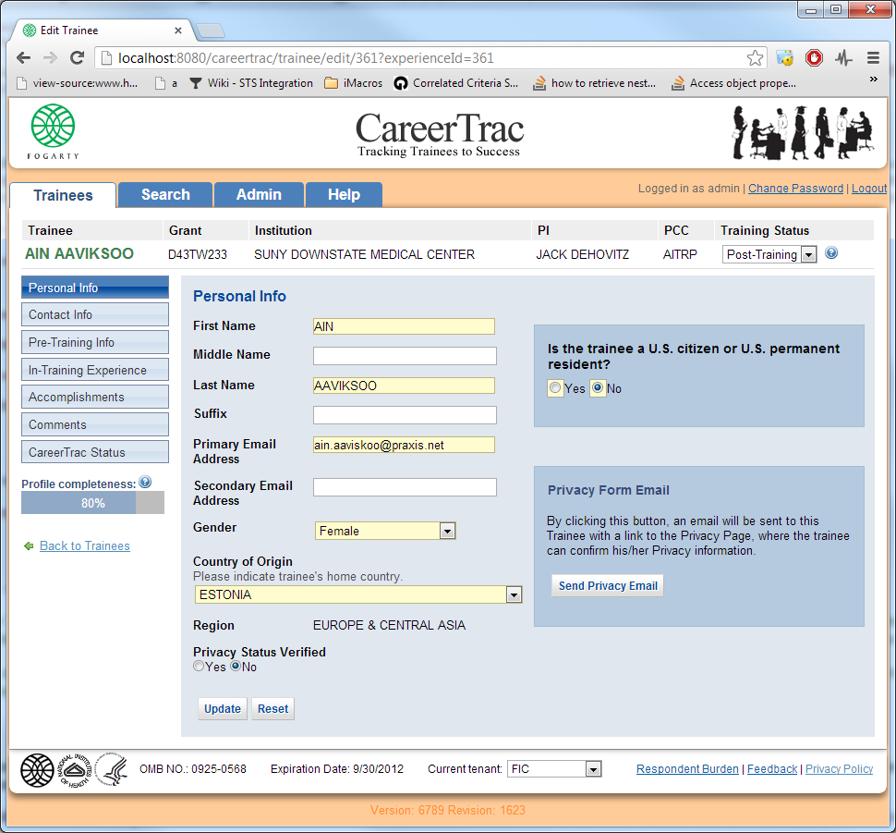

Main screen showing new required question

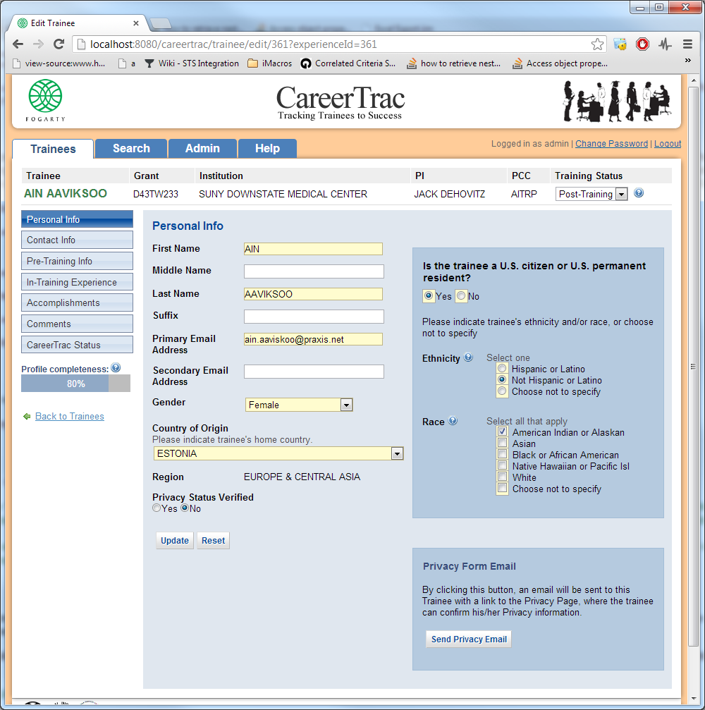

If select yes.. new required questions on ethnicity and race, revised responses per request

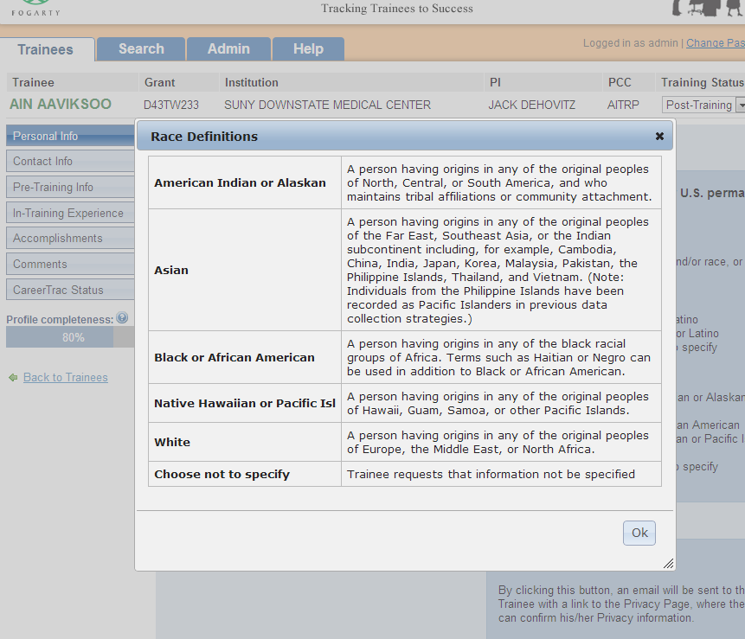

Definitions showing in a tool tip

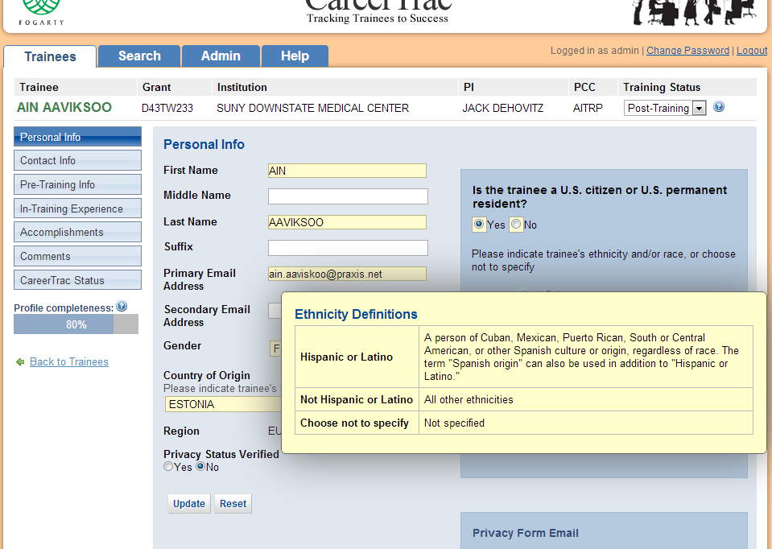

Tool tip with ethnicity definitions. This is the same for all tenants.

# Superfund Tenant

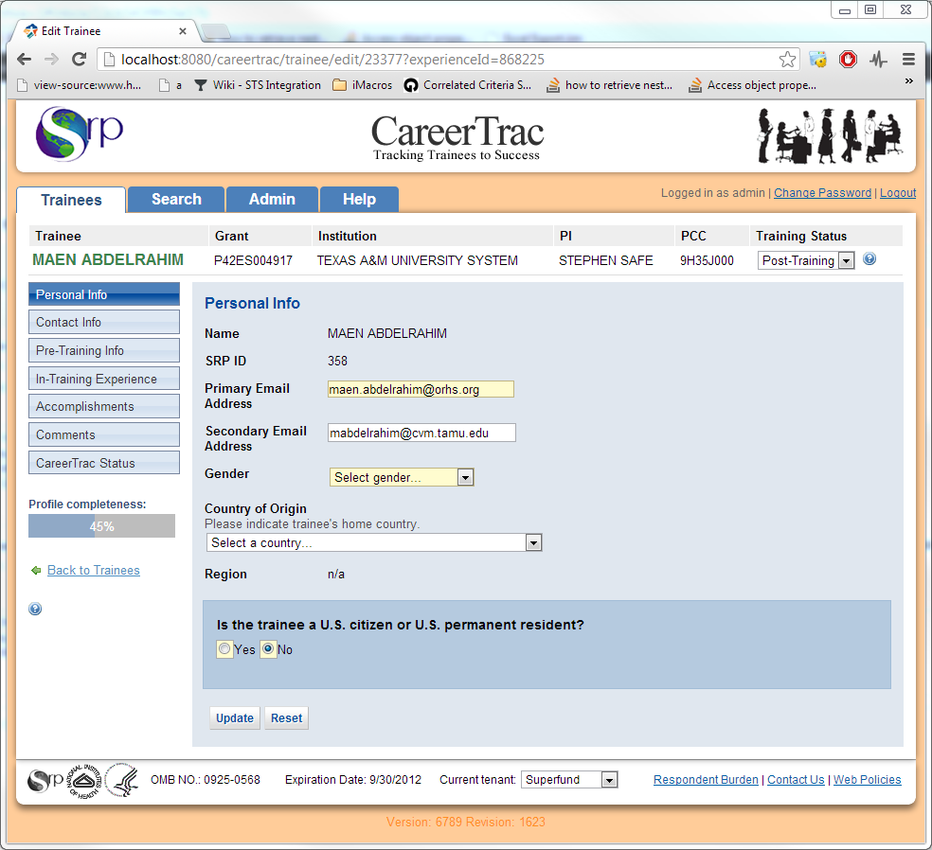

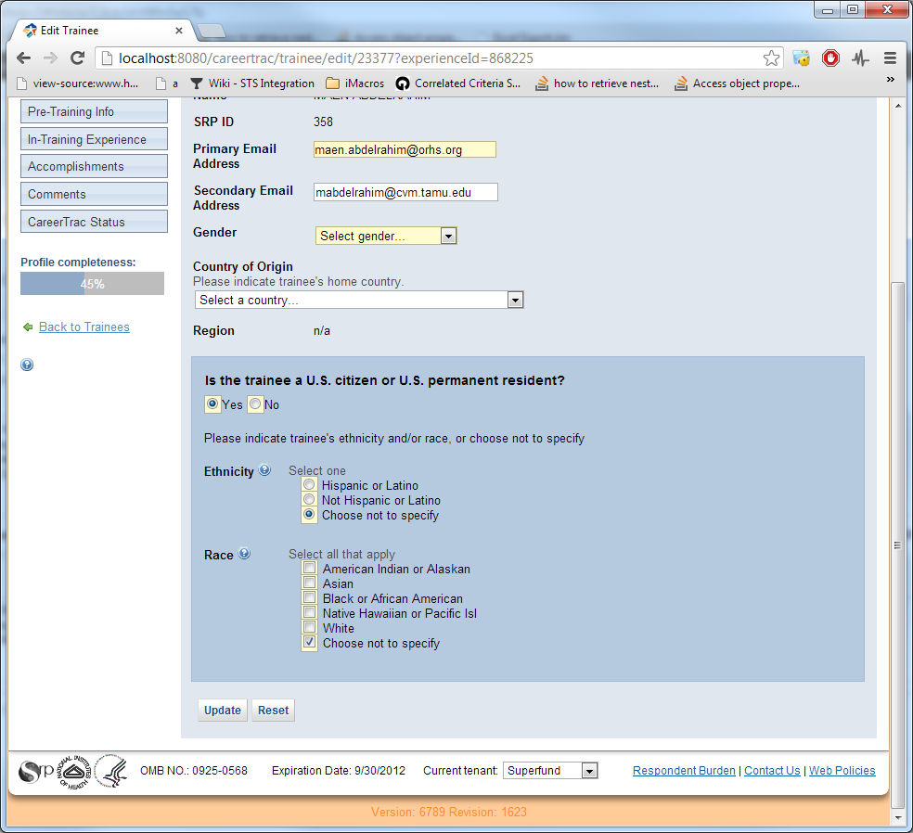

# NCI Tenant:

