Revised CareerTrac Screenshots – Trainees who are in Xtrain = NIEHS

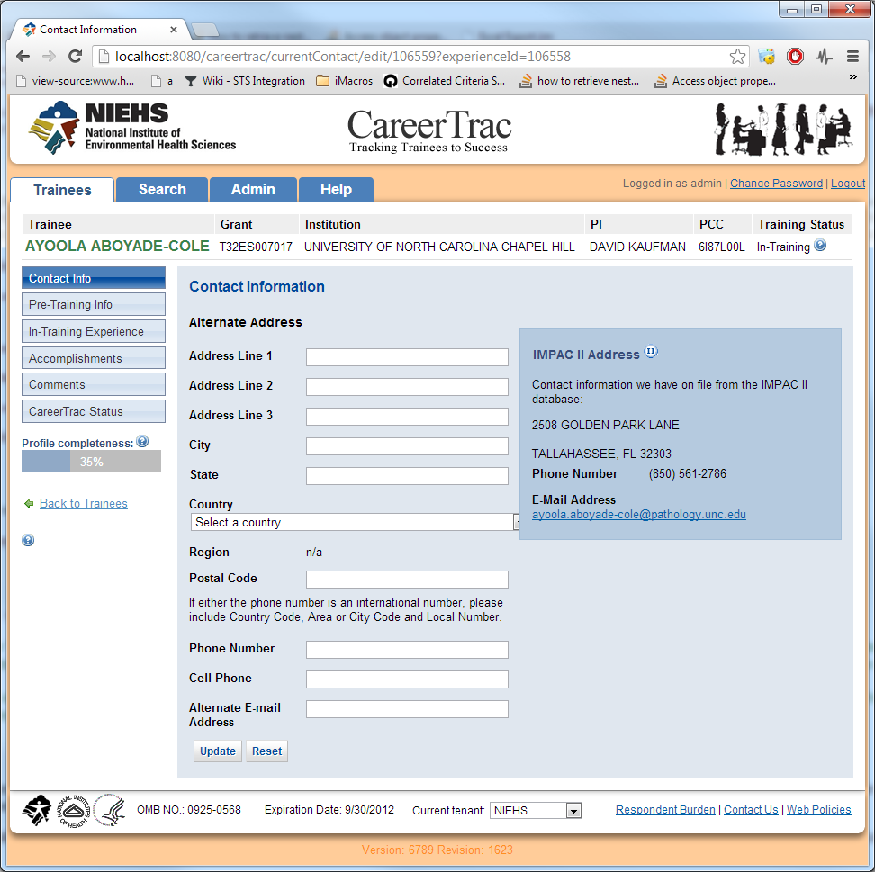

Combined personal info and contact info tabs. Removed gender and ethnicity questions