

Contact Group ID#: «PROVIDER_ID»

HTTP://WWW.MEPS.AHRQ.GOV
«DATE»
«CONTACT_NAME»
«FAX_NUMBER»
Record File Number: «RECORD_FILE_NUMBER»
Account File Number: «ACCOUNT_FILE_NUMBER»
Total Pages (including cover sheet): «TOTAL_PAGES»
Thank you for taking the time to speak with me earlier, and agreeing to help us with this research study. This package contains the study information and signed customer authorization forms that I said I would send to you. These forms were signed by your customers who are actively participating in this research study. These signed forms allow us to contact you for a few pieces of information about the medical events that you provided to these customers in 2010.

FOR EACH CUSTOMER EVENT WE NEED THE FOLLOWING:
- DATE FILLED
- NDC
- QUANTITY DISPENSED
- MEDICINE NAME
- PAYMENT AND WHO PAYMENT WAS MADE BY

«SPECIAL_COMMENT»
TO FAX RECORDS:
«TOLL_FAX_NUMBER»

TO MAIL RECORDS:
«MEPS_MAIL_ADDRESS»

TO PROVIDE DATA VIA PHONE:
«TOLL_PHONE_NUMBER»

This fax includes confidential information, and may be used only by the person or entity to which it is addressed. If the receiver of this fax is not the intended recipient or his or her authorized agent, the receiver is hereby notified that dissemination, distribution or copying of this fax is prohibited. If you have received this fax in error, please notify the sender by calling «TOLL_PHONE_NUMBER» and destroy the contents of this fax immediately. Thank you.
Notice - Public reporting burden for this collection of information is estimated to average 5 minutes per patient. Any comments regarding this burden estimate or any other aspect of this collection of information, including suggestions for reducing this burden should be sent to: AHRQ/MEPS Reports Clearance Officer, John M. Eisenberg Building, Room 5036, 540 Gaither Road, Rockville, MD 20850, Attention: PRA Paperwork Reduction Project (0935-0118). (Please do not send patient data to this address as it will delay data processing.)
 | DEPARTMENT OF HEALTH & HUMAN SERVICES Agency for Healthcare  Research and Quality
 | Contact Group ID#: «PROVIDER_ID»

Dear «PROVIDER_NAME»:

We understand that one of our data collection specialists has talked to you about the Medical Provider Component of the Medical Expenditure Panel Survey. We are appreciative of the contributions you and your health care agency are providing to this important study that is being conducted for the Agency for Healthcare Research and Quality (AHRQ) and the Centers for Disease Control and Prevention (CDC), both part of the U.S. Department of Health and Human Services. We wanted to take this opportunity to tell you more about the study.

The objective of the study is to provide accurate information to government policymakers and private researchers about the rapidly changing health care situation in this country. To accomplish this goal, we have collected data from a cross-section of American households on how they used and paid for health care during 2010. With the written permission of members of these households, we are now contacting their pharmacy providers to determine the actual fill dates, NDC, charges, sources of payment and the amount that was paid. One or more of your pharmacy customers have given us written authorization to request this information from your records.

The study materials enclosed with this letter include a list of your pharmacy customers who have agreed to participate in the survey and an authorization form for each customer.

This survey is authorized by section 902(a) of the Public Health Service Act [42 U.S.C. 299a]. Participation is voluntary, but we are depending on you to help us toward a more complete understanding of the nation’s health care. The client information we obtain will be used for research purposes only and will be released publicly only in summary form in which establishments or individuals cannot be identified. The confidentiality of client information is protected by Sections 944(c) and 308(d) of the Public Health Service Act [42 U.S.C. 299c-3(c) and 242m(d)]. Information that could identify an client or establishment will not be disclosed unless that client or establishment has consented to such a disclosure.

A Data Collection Specialist from our contractors, RTI International (RTI) and Social and Scientific Systems, Inc. (SSS), will call shortly after you have received these materials to see if you have any questions and to arrange for the collection of these data. If you have questions about the forms or procedures, call RTI-SSS, toll-free at «TOLL_PHONE_NUMBER».

Sincerely,
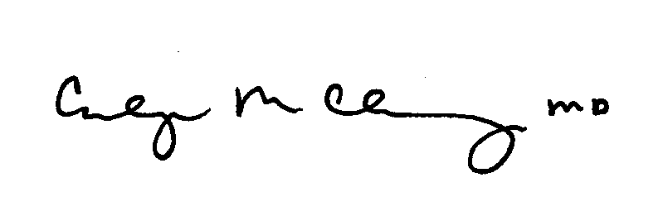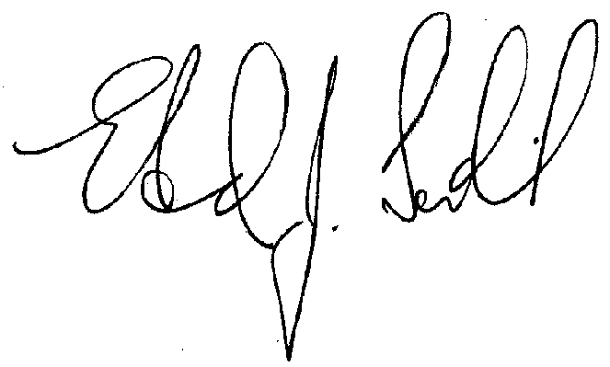
Carolyn M. Clancy, M.D. Edward J. Sondik, Ph.D.
Director Director
Agency for Healthcare National Center for Health Statistics
Research and Quality Centers for Disease Control and Prevention
Contact Group ID#: «PROVIDER_ID»

Instructions

«INSTRUCTION»

«PROVIDER_ID»
«PROVIDER_NAME»:
Thank you for taking the time to provide this medical billing information. We realize your time is valuable and limited. A data collection specialist will be calling you soon to collect this information over the telephone. If you would like to contact us directly, please call «TOLL_PHONE_NUMBER».
The customer(s) listed below have given us written authorization to contact you and request information from your records. Copies of the signed authorization forms are included in this fax.
Please complete the following steps to provide us with the records we need.
Step 1: Please Locate Medical Billing Records for Each Customer in Your Records: For each customer included in the Confidential Customer Check List, please locate the following information on all services each customer received between January 1, 2010 and December 31, 2010:
- Date filled  - NDC  - Quantity dispensed | - Medicine name  - Payments and who made them (private insurance, Medicare, Medicaid, out-of-pocket, etc.)
Step 2: Please Record Outcome on the Confidential Customer Check List: You can use the Confidential Customer Check List as a reference tool to record whether you were able to locate the records for each customer on the list. You can indicate whether you were able to locate the 2010 customer records, if you were able to locate the customer but there were no 2010 records, or if the individual is not a customer, by checking the appropriate box next to the customer in the Confidential Customer Check List.

Step 3: Please Provide Information to Data Collection Specialist via Telephone: We will be calling you shortly to collect the information. Should you prefer, you can fax or mail the information using the Fax Cover Sheet or Mail Return Form included in this fax. If returning records by fax or mail, please include the completed Confidential Customer Check List, with the appropriate box checked for each customer, in the package.

Contact Group ID#: «PROVIDER_ID»
Instructions (Continued)

If you provide the medical billing information over the telephone, you may use this list on the following page as a reference tool for recording the outcome of locating each customer record in your files. If you choose to mail or fax the medical billing information for each customer, please include this Confidential Customer Check List with your materials.
REMINDER:
IF RETURNING RECORDS BY FAX OR MAIL,
PLEASE INCLUDE THIS CHECK LIST FORM.
If faxing material, please fax to:  «TOLL_FAX_NUMBER» | If mailing material, please send to:  MEPS-Medical Provider Component Director  «MEPS_MAIL_ADDRESS»
Contact Group ID#: «PROVIDER_ID»
Confidential Customer Check List
«PROVIDER_ID»
«PROVIDER_NAME»
 |  | CHECK ONE FOR EACH CUSTOMER:
 | Customer Name | Date of Birth | Gender | 2010 Customer  Records Located | Found Customer  No 2010 Records | Is Not  A Customer
«N» | «PATIENT_NAME» | «DOB» | «GEN» | «CB» | «CB» | «CB»
«N» | «PATIENT_NAME» | «DOB» | «GEN» | «CB» | «CB» | «CB»
«N» | «PATIENT_NAME» | «DOB» | «GEN» | «CB» | «CB» | «CB»
«N» | «PATIENT_NAME» | «DOB» | «GEN» | «CB» | «CB» | «CB»
«N» | «PATIENT_NAME» | «DOB» | «GEN» | «CB» | «CB» | «CB»
«N» | «PATIENT_NAME» | «DOB» | «GEN» | «CB» | «CB» | «CB»
«N» | «PATIENT_NAME» | «DOB» | «GEN» | «CB» | «CB» | «CB»
«N» | «PATIENT_NAME» | «DOB» | «GEN» | «CB» | «CB» | «CB»
«N» | «PATIENT_NAME» | «DOB» | «GEN» | «CB» | «CB» | «CB»
«N» | «PATIENT_NAME» | «DOB» | «GEN» | «CB» | «CB» | «CB»
«N» | «PATIENT_NAME» | «DOB» | «GEN» | «CB» | «CB» | «CB»
«N» | «PATIENT_NAME» | «DOB» | «GEN» | «CB» | «CB» | «CB»
«N» | «PATIENT_NAME» | «DOB» | «GEN» | «CB» | «CB» | «CB»
«N» | «PATIENT_NAME» | «DOB» | «GEN» | «CB» | «CB» | «CB»
«N» | «PATIENT_NAME» | «DOB» | «GEN» | «CB» | «CB» | «CB»
«N» | «PATIENT_NAME» | «DOB» | «GEN» | «CB» | «CB» | «CB»
«N» | «PATIENT_NAME» | «DOB» | «GEN» | «CB» | «CB» | «CB»
«N» | «PATIENT_NAME» | «DOB» | «GEN» | «CB» | «CB» | «CB»
«N» | «PATIENT_NAME» | «DOB» | «GEN» | «CB» | «CB» | «CB»
«N» | «PATIENT_NAME» | «DOB» | «GEN» | «CB» | «CB» | «CB»
«N» | «PATIENT_NAME» | «DOB» | «GEN» | «CB» | «CB» | «CB»
«N» | «PATIENT_NAME» | «DOB» | «GEN» | «CB» | «CB» | «CB»
«N» | «PATIENT_NAME» | «DOB» | «GEN» | «CB» | «CB» | «CB»
«N» | «PATIENT_NAME» | «DOB» | «GEN» | «CB» | «CB» | «CB»
«N» | «PATIENT_NAME» | «DOB» | «GEN» | «CB» | «CB» | «CB»

Contact Group ID#: «PROVIDER_ID»

Questions and Answers

What is the Medical Expenditure Panel Survey (MEPS)?
MEPS is a nationwide research study conducted to learn more about the health care services people use, the charges for those services and the sources that pay for them. MEPS is conducted annually by the U.S. Department of Health and Human Services through the Agency for Healthcare Research and Quality and the Centers for Disease Control and Prevention. Major components of MEPS include surveys of:
- A nationally representative sample of households;
- Hospitals, physicians, home care providers, and pharmacies reported by the household participants; and
- Providers of health insurance.
MEPS is the most complete source of data available
on health care use and expenses in the United States and is used by government policymakers and private researchers.

How are pharmacies chosen for the MEPS Pharmacy Component?
Pharmacies were named by respondents in the household data collection as sources of prescribed drugs during 2010. These household respondents signed HIPAA-compliant forms authorizing and requesting each of their pharmacies to release the information sought by the study.

Why should this pharmacy participate?
Prescription medicines are a major component of health care costs. The information that you supply will supplement that given by your customer and help us build a more complete picture of health care expenditures for respondents in our study. Your customers have asked specifically for your help by signing the authorization form.

What information is needed?
For each of the customers on the enclosed list, we need this information about their 2010 prescriptions:
- Date filled
- Payment sources and amounts
- NDC code
- Quantity dispensed
How do I know the information will be kept confidential?
The confidentiality of data collected for MEPS is protected by Federal law under Sections 944(c) and 308(d) of the Public Health Service Act [42 U.S.C. 299c-3(c) and 242m(d)]. No information that could identify an individual or establishment will be disclosed unless that individual or establishment has consented to such a disclosure.

Personal identifying information such as names or addresses are removed before information from the study is made available to researchers. Findings are published in statistical summaries and tables and micro-data is released on “public use” data files.

Who is collecting this data?
The U.S. Department of Health and Human Services has chosen RTI International (RTI) and Social and Scientific Systems, Inc. (SSS) to administer the study. A professionally trained data collection specialist from RTI-SSS will contact each pharmacy.

What questions will the data collected answer?
MEPS data provide answers to many important
questions. For example:
- How much of prescription costs are covered by insurance?
- What do people pay out of pocket for medications?
- What medicines are people receiving?
- What types of medications are not covered by insurance plans?
Any further questions?

Please call toll-free, at
«TOLL_PHONE_NUMBER».
For direct access to information about MEPS, go to
http://www.meps.ahrq.gov.

Contact Group ID#: «PROVIDER_ID»

Fax Cover Sheet or Mail Return Form

TO | Data Collection Specialist
Fax | «TOLL_FAX_NUMBER»
Phone | «TOLL_PHONE_NUMBER»
From
Date
Total Pages (including cover sheet)

If mailing material, please include this Fax Cover Sheet or Mail Return Form in your envelope. Please remember to include the Confidential Customer Check List. Thank you.
Please send to:
MEPS-Medical Provider Component Director

«MEPS_MAIL_ADDRESS»

REFERENCE:
«PROVIDER_NAME»
«PROJECT_CHARGE_NUMBER»
Provider Name: «PROVIDER_NAME»
This fax includes confidential information, and may be used only by the person or entity to which it is addressed. If the receiver of this fax is not the intended recipient or his or her authorized agent, the receiver is hereby notified that dissemination, distribution or copying of this fax is prohibited. If you have received this fax in error, please notify the sender by calling «TOLL_PHONE_NUMBER» and destroy the contents of this fax immediately. Thank you.

