Note: Section headers will not be included in online survey. Items in **BOLD AND CAPS** are programmer instructions. Response options will be randomized, except when sequential. All rated questions include will include a “Don’t Know” and/or “NA” option. When a “RANDOMIZE” instruction is provided, any “Other,” “Don’t Know,” or “None” style of responses will be forced to the bottom of the response set.

**Introduction**

The National Oceanic and Atmospheric Administration’s (NOAA) National Weather Service (NWS) is committed to serving the needs of all of its users. The NWS is undertaking research on how satisfied users are and would appreciate your feedback. The purpose of this research, conducted in partnership with the federal government as part of the American Customer Satisfaction Index, is to help the NWS improve its services for you and others like you.

Your answers are voluntary, but your opinions are very important for this research. Your responses will be held completely confidential, and you will never be identified by name. CFI Group, a third party research and consulting firm, is administering this survey via a secure server. The time required to complete this survey will depend on how certain questions are answered, but will likely take about 10 minutes, and is authorized by Office of Management and Budget Control No. 1505-0191.

Please click on the “Next” button below to begin the survey.

**Screener/Demographics**

S-1. To understand age-specific uses of weather information, please select your age category.

1. Under 18
2. 18-25
3. 26-35
4. 36-45
5. 46-55
6. 56-65
7. 66 and above

S-2. Are you? (select one)

1. Male
2. Female

S-3. Please provide the zip code for the area in which you live:

S-4. I use weather information for (select all that apply):

1. Dress for the day
2. Vacation, travel, or social activity planning
3. Personal safety and protection of property
4. Educational purposes
5. Job or business activities
6. Exterior home or yard work
7. Transportations decisions for work, school, recreation, etc.
8. Other
9. None of the above; I don’t use weather information **TERMINATE**

S-5. **IF MORE THAN ONE; SHOW ONLY RESPONSES SELECTED**. Please indicate your PRIMARY reason for accessing weather information? (select one)

a. Dress for the day

b. Vacation, travel, or social activity planning

c. Personal safety and protection of property

d. Educational purposes

e. Job or business activities

f. Exterior home or yard work

g. Transportations decisions for work, school, recreation, etc.

S-6. If S-5-1=e, Please indicate the type of job or business activities for which you use weather information? (open-end)

S-7. Have you ever obtained weather-related safety or educational materials from the NWS or other sources?

1. Yes
2. No **(skip to Q1)**

S-8. Where did you obtain weather-related safety or educational materials (select all that apply)?

1. Internet
2. Libraries
3. Local Community Events
4. Schools
5. Governmental Outreach Activities
6. Newspaper
7. NWS Office
8. Other **(please specify)**

S-9. What is your PREFERRED format for weather-related safety or educational materials (select only one)?

1. Web pages
2. Newspaper
3. Books and guides (more than 2 pages)
4. Brochures and pamphlets (2 pages or less)
5. Promotional materials (e.g., bookmarks, magnets)
6. Exhibits & displays
7. CD/DVD/VHS-tapes

h. Other **(please specify)**

**Familiarity with NWS**

1. On a scale where 1=not familiar at all and 10=very familiar, how familiar are you with the National Weather Service?
2. **IF MORE THAN 1.** How would you describe the role of the National Weather Service? **(CAPTURE)**
3. How often do you visit the Weather.gov website (shown below)?
4. A couple times a day or more
5. Once a day
6. Weekly
7. Monthly
8. Less than monthly
9. I have never visited the Weather.gov website

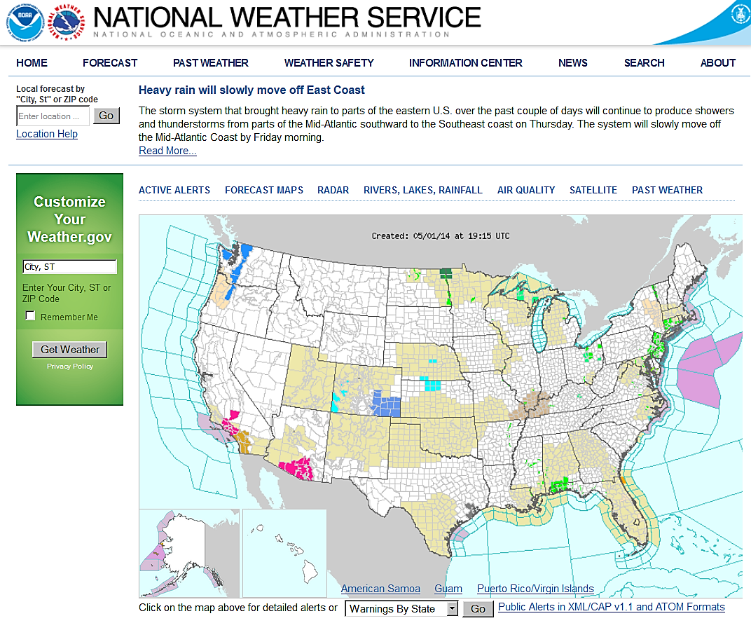

1. Please rate the degree to which you have used each of the following sources or devices in the **past year** to obtain weather information. Use a scale from 1 to 10, where 1 means you have used it “Very Infrequently,” and 10 means you have used it “Very Frequently.” **(RANDOMIZE)**

[The selections below must all have a NEVER USE option]

1. Desktop/laptop computer
2. Mobile Device (e.g., Tablet PC, Cell Phone/Smart Phone)
3. Social Media (e.g., Facebook, Twitter)
4. Direct Interaction with NWS Staff (e.g., in-person, telephone, NWSChat)
5. NOAA Weather Radio All-Hazards **(If NEVER USE, skip to Q6)**
6. Commercial radio
7. Television
8. When do you listen to your NOAA Weather Radio All-Hazards? (Select all that apply)
9. I listen to NWR to seek information about expected or ongoing severe weather
10. I listen to NWR only when the tone alert sounds
11. I listen to NWR as a backup when there is no other source of weather information
12. I listen to NWR routinely for general weather information (e.g., climate data, marine data)
13. I listen to NWR as my **primary** source of weather information
14. Don’t listen at all

## Hazardous Services

1. What is your **primary** source for information about potential or ongoing **severe** weather? **(CAPTURE)**
2. Severe weather watches, warnings, and advisories (e.g., winter weather advisory, severe thunderstorm watch, flash flood warning) that you receive through various means are all issued by the Federal Government.
3. True
4. False
5. I am confused about the difference in meaning between a "watch" and a "warning."
6. True
7. False
8. Using a 1 to 10 scale, where 1 means “Not at all Satisfied” and 10 means “Very Satisfied,” please rate your satisfaction with NWS efforts to explain the difference between an advisory, a watch, and a warning?
9. Think back to a hazardous weather event that occurred in your city or state within the past year that had a direct effect on you or your family and friends. Select that event type from the list below. (**If more than one, select the most recent event.)**
10. Tornado
11. Severe Thunderstorm
12. Flood/Flash Flood
13. Winter Storm
14. Hurricane
15. Dust Storm
16. Drought
17. Wildfire
18. Coastal Flood
19. Other
20. None **(Skip to display text before Q12)**
21. Referring specifically to warning information provided for the hazardous weather event you selected in the previous question, please indicate the extent to which you agree or disagree with the following statements. Use the following 1 to 10 scale, where 1 means “Strongly disagree” and 10 means “Strongly agree,”
22. The hazard occurred as predicted
23. I knew what action to take based on the warning I received
24. I had enough time to take the action necessary to protect my life
25. I had enough time to take the action necessary to protect my property

Below is a current statement included in tornado watches:

REMEMBER...A TORNADO WATCH MEANS CONDITIONS ARE FAVORABLE FOR TORNADOES AND SEVERE THUNDERSTORMS IN AND CLOSE TO THE WATCH AREA. PERSONS IN THESE AREAS SHOULD BE ON THE LOOKOUT FOR THREATENING WEATHER CONDITIONS AND LISTEN FOR LATER STATEMENTS AND POSSIBLE WARNINGS.

1. Using a 1 to 10 scale, where 1 means “Strongly disagree” and 10 means “Strongly agree,” please indicate the extent to which you agree or disagree with the following statement: I would take protective action based on the above statement.
2. Using a 1 to 10 scale, where 1 means “Not at all Satisfied” and 10 means “Very Satisfied,” please rate your satisfaction with the above statement.

**Weather Ready Nation and Decision Support Services**

1. Do you have a safety plan for coping with hazardous weather?
   1. Yes
   2. No
2. Does your safety plan include a hazardous weather emergency preparedness kit?
   1. Yes
   2. No

**Dissemination**

1. Using a 1 to 10 scale, where 1 means “Poor” and 10 means “Excellent,” please rate the performance of NWS presence on the following social media platforms.

[The selections below must all have a “Didn’t know NWS had a social media presence on…” option]

1. Facebook
2. Twitter
3. YouTube

A Wireless Emergency Alert (WEA) is a brief, text-like message accompanied by a loud tone on your cell phone that notifies you of life-threatening hazards such as Tornadoes, Flash Floods, and Amber Alerts.

1. Have you ever received a WEA message on your cell phone for a weather-related event?
   1. Yes
   2. No **(skip to Q19)**
   3. Don’t Know **(skip to Q19)**
2. Using a 10-point scale, where 1 means “Not at All Useful” and 10 means “Very Useful,” please rate the usefulness of WEA messages on your cell phone.

**Outreach and Weather Education**

1. Using a 1 to 10 scale, where 1 means “Poor” and 10 means “Excellent,” how would you rate the following two methods the NWS provides to view weather safety information?

[The selections below must all have a “I have never viewed NWS weather safety information” option]

A) Printed/hardcopy (e.g., brochures)

B) On the Internet

1. Using a 1 to 10 scale, where 1 means “Not at all Satisfied” and 10 means “Very Satisfied,” how satisfied are you with the number of severe weather awareness weeks (e.g., hurricane awareness week, lightning awareness week) conducted by the NWS each year?

[Include “I am not familiar with NWS severe weather awareness weeks”]

1. Using a 1 to 10 scale, where 1 means “Poor” and 10 means “Excellent,” in your experience, how well does the NWS communicate best practices as it relates to encountering water-covered roadways while driving?

[Include “I am not familiar with NWS communication on encountering water-covered roadways while driving”]

1. Using a 1 to 10 scale, where 1 means “Poor” and 10 means “Excellent,” in your experience, how well does the NWS communicate best practices as it relates to protecting yourself from lightning?

[Include “I am not familiar with NWS communication on best practices as it relates to protecting yourself from lightning”]

## Customer Satisfaction Index

Now, based on your knowledge of the National Weather Service, please think about your overall satisfaction with the NWS.

1. First, please consider all of your experiences with the NWS. Using a 10-point scale on which 1 means “Very Dissatisfied” and 10 means “Very Satisfied,” how satisfied are you with the NWS?
2. **(If less than 8)** Please indicate what the NWS should change to improve your satisfaction. **(CAPTURE)**
3. Using a 10-point scale on which 1 now means “Falls Short of your Expectations” and 10 means “Exceeds your Expectations,” to what extent has the NWS fallen short of, or exceeded your expectations?
4. **(If less than 8)** How has the NWS fallen short of your expectations? **(CAPTURE)**
5. Now, imagine what an ideal organization providing weather information would be like. How well do you think the NWS compares with that ideal organization you just imagined? Please use a 10-point scale on which 1 means “Not Very Close to the Ideal,” and 10 means “Very Close to the Ideal.”

**Desired Outcomes**

1. Using a 10-point scale on which 1 means “Not at all Likely” and 10 means “Very Likely,” how likely would you be to take action based on the information you receive from the NWS?
2. Using a 10-point scale, on which 1 means “Not at all Likely” and 10 means “Very Likely,” how likely are you to use the NWS as a source of weather information in the future?
3. Using a 10-point scale on which 1 means “Not at all Likely” and 10 means “Very Likely,” how likely are you to recommend the NWS to a colleague or friend?

And one final question.

1. The National Weather Service is a Federal Government Agency funded by your tax dollars.
2. True
3. False