Note: Section headers will not be included in online survey. Items in **BOLD AND CAPS** are programmer instructions. Response options will be randomized, except when sequential. All rated questions include will include a “Don’t Know” and/or “NA” option. When a “RANDOMIZE” instruction is provided, any “Other,” “Don’t Know,” or “None” style of responses will be forced to the bottom of the response set.

**Introduction**

The National Oceanic and Atmospheric Administration’s (NOAA) National Weather Service (NWS) is committed to serving the needs of all of its users. The NWS is undertaking research on how satisfied users are and would appreciate your feedback. The purpose of this research, conducted in partnership with the federal government as part of the American Customer Satisfaction Index, is to help the NWS improve its services for you and others like you.

Your answers are voluntary, but your opinions are very important for this research. Your responses will be anonymous, and you will never be identified by name. CFI Group, a third party research and consulting firm, is administering this survey via a secure server. The time required to complete this survey will depend on how certain questions are answered, but will likely take about 15 minutes, and is authorized by Office of Management and Budget Control No. 1090-0007 which expires on March 31, 2015.

Please click on the “Next” button below to begin the survey.

**Familiarity with NWS**

1. On a scale where 1=not very familiar and 10=very familiar, how familiar are you with the National Weather Service?
2. IF MORE THAN 1. How would you describe the role of the National Weather Service? **(CAPTURE)**
3. How do you use information provided by the NWS? (Select all that apply)
   1. Agriculture
   2. Commercial Aviation
   3. Amateur Radio
   4. Broadcast/Print Media
   5. Commodities Markets
   6. Consulting/Added Value Customer Forecast Services
   7. Education (e.g., formal education or training of children and adults)
   8. Health Services
   9. Land Management Decisions (e.g., fire weather)
   10. Commercial Marine (e.g., commercial transport, commercial fishing, harbor management, search and rescue)
   11. NWS Data Provider (e.g., storm spotter, co-op observer)
   12. Personal (e.g., how to dress for the day)
   13. Outdoor Recreation (e.g., boating, flying, fishing and hunting, beachgoer, etc.)
   14. Research (applied and basic)
   15. Weather Enthusiast
   16. Decision Support (e.g., emergency response, community service program, school closures)
   17. Other (please specify) **(CAPTURE)**
4. How often do you visit the Weather.gov website (shown below)?

* A couple times a day or more
* Once a day
* Weekly
* Monthly
* Less than monthly
* I have never visited the Weather.gov website

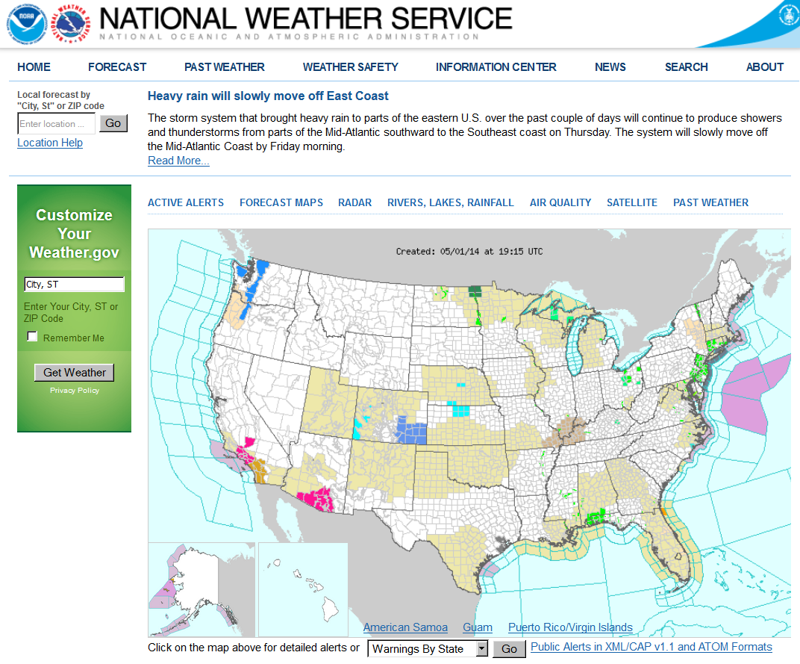

**IF VISITED WEBSITE:** Using a 1 to 10 scale, where 1 means “Not at all useful” and 10 means “Very Useful,” please rate the usefulness of the NWS **Weather.Gov** website on the following:

1. Satellite Imagery display
2. Doppler Radar display
3. Please rate the degree to which you used each of the following sources or devices in the **past year** to obtain weather information. Use a scale from 1 to 10, where 1 means you have used it “Very Infrequently,” and 10 means you have used it “Very Frequently.” **(RANDOMIZE)**

[The selections below must all have a NEVER USE option]

* 1. Desktop/laptop computer
  2. Mobile Device (e.g., Tablet PC, Cell Phone/Smart Phone)
  3. Social Media (e.g., Facebook, Twitter)
  4. Direct Interaction with NWS Staff (e.g., in-person, telephone, NWSChat)
  5. NOAA Weather Radio All-Hazards **(If NEVER USE, skip to Q8)**
  6. Commercial radio
  7. Television

1. When do you listen to your NOAA Weather Radio All-Hazards? (Select all that apply)
   1. I listen to NWR when seeking information about expected or ongoing severe weather
   2. I listen to NWR only when the tone alert sounds
   3. I listen to NWR as a backup when there is no other source of weather information
   4. I listen to NWR routinely when obtaining general weather information (e.g., climate data, marine data)
   5. Don’t listen to NWR at all

## Hazardous Services

1. What is your **primary** source for information about potential or ongoing **severe** weather? **(CAPTURE)**
2. Severe weather watches, warnings, and advisories (e.g., winter weather advisory, severe thunderstorm watch, flash flood warning) that you receive through various means are all issued by the Federal Government.
3. True
4. False
5. I am confused about the difference in meaning between "watch" and "warning."
6. True
7. False
8. Using a 1 to 10 scale, where 1 means “Not at all Satisfied” and 10 means “Very Satisfied,” please rate your satisfaction with NWS efforts to explain the difference between an advisory, a watch, and a warning?
9. Think back to a hazardous weather event that occurred in your city or state within the past year that had a direct effect on you or your family and friends. Select that event type from the list below. (**If more than one, select the most recent event.)**
   1. Tornado
   2. Severe Thunderstorm
   3. Flood/Flash Flood
   4. Winter Storm
   5. Hurricane
   6. Dust Storm
   7. Drought
   8. Wildfire
   9. Coastal Flood
   10. Other
   11. None (Skip to Q15)
10. Referring specifically to warning information provided for the hazardous weather event you selected in the previous question, please indicate the extent to which you agree or disagree with the following statements. Use the following 1 to 10 scale, where 1 means “Strongly disagree” and 10 means “Strongly agree,”
11. The hazard occurred as predicted
12. I knew what action to take based on the warning I received
13. I had enough time to take the action necessary to protect my life
14. I had enough time to take the action necessary to protect my property

Below is a current statement included in tornado watches: REMEMBER...A TORNADO WATCH MEANS CONDITIONS ARE FAVORABLE FOR TORNADOES AND SEVERE THUNDERSTORMS IN AND CLOSE TO THE WATCH AREA. PERSONS IN THESE AREAS SHOULD BE ON THE LOOKOUT FOR THREATENING WEATHER CONDITIONS AND LISTEN FOR LATER STATEMENTS AND POSSIBLE WARNINGS.

1. Using a 1 to 10 scale, where 1 means “Strongly disagree” and 10 means “Strongly agree,” please indicate the extent to which you agree or disagree with the following statement: I would take protective action based on the above statement.
2. Using a 1 to 10 scale, where 1 means “Not at all Satisfied” and 10 means “Very Satisfied,” please rate your satisfaction with the above statement.

**Weather Ready Nation and Decision Support Services**

1. Do you have a safety plan for coping with hazardous weather?
   1. Yes
   2. No
2. Does your safety plan include a hazardous weather emergency preparedness kit?
   1. Yes
   2. No

**Dissemination**

1. Using a 1 to 10 scale, where 1 means “Poor” and 10 means “Excellent,” please rate the performance of the NWS presence on the following social media platforms.

[The selctions below must all have a “Didn’t know NWS had a social media presence on…” option]

1. Facebook
2. Twitter
3. YouTube

A Wireless Emergency Alert (WEA) is a brief, text-like message accompanied by a loud tone on your cell phone that notifies you of life-threatening hazards such as Tornadoes, Flash Floods, and Amber Alerts.

1. Have you ever received a WEA message on your cell phone for a weather-related event?
   1. Yes
   2. No **(skip to Q22)**
   3. Don’t Know **(skip to Q22)**
2. Using a 10-point scale, where 1 means “Not at All Useful” and 10 means “Very Useful,” please rate the usefulness of WEA messages on your cell phone.

**Outreach and Weather Education**

1. If at all, where have you obtained weather-related safety or educational materials (select all that apply)?
2. Internet
3. Libraries
4. Local Community Events
5. Schools
6. Governmental Outreach Activities
7. Newspaper
8. NWS Office
9. Social Media
10. Radio/TV Public Service Announcements
11. Other **(please specify)**
12. None of the above, haven’t received
13. What is your PREFERRED format for weather-related safety or educational materials (select only one)?
14. Web pages
15. Newspaper
16. Books and guides (more than 2 pages)
17. Brochures and pamphlets (2 pages or less)
18. Promotional materials (e.g., bookmarks, magnets)
19. Exhibits & displays
20. CD/DVD
21. Social Media (e.g., Facebook, Twitter, YouTube)
22. Radio/TV Public Service Announcements
23. Other **(please specify)**
24. Using a 1 to 10 scale, where 1 means “Poor” and 10 means “Excellent,” how would you rate the following two formats that the NWS provides to view weather safety information?

[The selections below must all have a “I have never viewed NWS weather safety information” option]

A) Printed/hardcopy (e.g., brochures)

B) On the internet

1. Using a 1 to 10 scale, where 1 means “Not at all Satisfied” and 10 means “Very Satisfied,” how satisfied are you with the number of severe weather awareness weeks (e.g., hurricane awareness week, lightning awareness week) conducted by the NWS each year?

[Include “I am not familiar with NWS severe weather awareness weeks”]

1. Using a 1 to 10 scale, where 1 means “Poor” and 10 means “Excellent,” in your experience, how well does the NWS communicate best practices as it relates to encountering water-covered roadways while driving?

[Include “I am not familiar with NWS communication on encountering water-covered roadways while driving”]

1. Using a 1 to 10 scale, where 1 means “Poor” and 10 means “Excellent,” in your experience, how well does the NWS communicate best practices as it relates to protecting yourself from lightning?

[Include “I am not familiar with NWS communication on best practices as it relates to protecting yourself from lightning”]

## Customer Satisfaction Index

Now, based on your knowledge of the National Weather Service, please think about your overall satisfaction with the NWS.

1. First, please consider all of your experiences with the NWS. Using a 10-point scale on which 1 means “Very Dissatisfied” and 10 means “Very Satisfied,” how satisfied are you with the NWS?
2. **(If less than 8)** Please indicate what the NWS should change to improve your satisfaction. **(CAPTURE)**
3. Using a 10-point scale on which 1 now means “Falls Short of your Expectations” and 10 means “Exceeds your Expectations,” to what extent has the NWS fallen short of, or exceeded your expectations?
4. **(**If **less than 8)** How has the NWS fallen short of your expectations? **(CAPTURE)**
5. Now, imagine what an ideal organization providing weather information would be like. How well do you think the NWS compares with that ideal organization you just imagined? Please use a 10-point scale on which 1 means “Not Very Close to the Ideal,” and 10 means “Very Close to the Ideal.”

**Desired Outcomes**

1. Using a 10-point scale on which 1 means “Not at all Likely” and 10 means “Very Likely,” how likely would you be to take action based on the information you receive from the NWS?
2. Using a 10-point scale, on which 1 means “Not at all Likely” and 10 means “Very Likely,” how likely are you to use the NWS as a source of weather information in the future?
3. Using a 10-point scale on which 1 means “Not at all Likely” and 10 means “Very Likely,” how likely are you to recommend the NWS to a colleague or friend?
4. The National Weather Service is a Federal Government Agency funded by your tax dollars.
5. True
6. False

**Demographics**

1. Please enter your zip code **(CAPTURE)**
2. What is your age? (**CAPTURE**)

1. What is your gender?
2. Male
3. Female
4. What is your race or origin?
5. White, Caucasian
6. Black, African American
7. Hispanic, Latino, or Spanish
8. Pacific Islander
9. Asian
10. American Indian/Native Indian or Alaska Native
11. Other (please specify) (**CAPTURE**)
12. What is the highest degree or level of school you have completed?
13. 12th grade or less (no diploma)
14. High school diploma or GED
15. Some college, no degree
16. Associate or technical degree
17. Bachelor’s degree
18. Graduate degree/Professional degree

**Aviation Weather Survey Questions**

1a. How often do you use NWS aviation weather information?

a) Several times a day

b) Daily

c) Several times weekly

d) Weekly

e) Rarely

f) Never **END SURVEY/MOVE TO NEXT SECTION**

1b.What is the primary role for which you need aviation weather information? **ROTATE RESPONSES**

a) Commercial Pilot

b) General Aviation Pilot

c) Air Traffic Controller

d) Flight Dispatcher

e) Meteorologist

f) Other

2a. How often do you use the Terminal Aerodrome Forecast (TAF) the NWS produces?

a) Several times a day

b) Daily

c) Several times a week

d) Weekly

e) Rarely

f) I do not use the NWS TAF product

If no, skip to question 3. If yes, go to 2b.

2b. When using the TAF product, what time frame do you focus your attention on?

a) The first 3 hours of the TAF

b) The first 6 hours of the TAF

c) The first 12 hours of the TAF

d) The whole TAF time period  
  
2c. When using the TAF product, I understand "VC" in the TAF to mean…

a) The general vicinity of the terminal  
b) Within a 10-mile radius of the terminal, including the terminal

c) Within a 10-mile radius of the terminal, but not at the terminal  
d) Not at the terminal, not within a 5-mile radius of the terminal, but within a 5-10- mile donut around the terminal

3. How often do you use the NWS AIRMET product?

a) Multiple times per day

b) Daily

c) Weekly

d) Monthly

e) A few times a year

f) I do not use the NWS AIRMET product

**If you selected “I do not use the NWS AIRMET product”, skip to question 4. If yes, go to 3b.**

3b) On a scale of 1 (Poor) to 10 (Excellent), please rate how well AIRMETs informs you of turbulent conditions.

3c) **IF 6 OR BELOW**: Which of the following most accurately describes the reason you rated

AIRMETs forecasts of turbulent conditions low?

a) Usually over-forecast turbulence

b) Usually under-forecast turbulence

c) Combination of both

3d) On a scale of 1 (Poor) to 10 (Excellent), please rate how well AIRMETs informs you of icing conditions?

3e) **IF 6 OR BELOW**: Which of the following most accurately describes the reason you rated

AIRMETs forecasting of icing conditions low?

a) Usually over-forecast icing

b) Usually under-forecast icing

c) Combination of both

4) What social media sites do you currently use to access aviation weather information? **ROTATE RESPONSES**

Click all that apply…

a) Facebook

b) Twitter

c) Tumblr

d) Instagram

e) Other

f) I do not use social media sites to obtain aviation weather information **DO NOT ROTATE**

**If you answered “I do not use social media sites to obtain aviation weather information”, go to 5. Otherwise, go to 4b.**

4b) Specifically, what NWS social media sites do you currently use to access aviation weather information, if any? **ROTATE RESPONSES**

Click all that apply…

a) Facebook

b) Twitter

c) Tumblr

d) Instagram

e) Other

f) None of the above **DO NOT ROTATE**

**If “None of the above” skip to 4d.**

4c) On a scale of 1 (Very dissatisfied) to 10 (Very satisfied), how satisfied or dissatisfied are you with the weather information you receive on NWS social media sites?

4d) Would you like more NWS aviation weather products (TAFs, AIRMETs, SIGMETs, CWAs, etc) available via social media?

a) Yes

b) No

5) Do you use the aviation portion of the Area Forecast Discussion (AFD)?

a) Multiple times per day

b) Daily

c) Weekly

d) Monthly

e) A few times a year

f) I do not use the NWS AFD product

**If you chose “I do not use the NWS AFD product” go to 6. All other answers go to 5b.**

5b. On a scale of 1 (Very dissatisfied) to 10 (Very satisfied), how satisfied or dissatisfied are you with the AFD for flight planning?

6) How do you receive weather training? (Click all that apply) **ROTATE RESPONSES**

a) AOPA on-line

b) FAA Events

c) Corporate Training

d) COMET

e) “The Front” Newsletter

f) Other

g) I do not receive weather training **DO NOT ROTATE**

**If you chose “I do not receive weather training” go to 7, for all other selections go to 6b.**

6b. How often do you receive weather training

a) 3 or more times per year

b) 1 or 2 times per year

c) Once every other year

d) Less than once every other year

7. What is your preferred method of getting aviation weather information for flight planning? **ROTATE RESPONSES**

a) ADDS

b) DUAT/DUATS

c) Flight Service

d) TV

e) Various websites

f) Other **DO NOT ROTATE**

7b.How satisfied or dissatisfied are you with your preferred method of gettingaviationweather information for flight planning, **INSERT RESPONSE FROM Q7**? Please use the scale 1, Very dissatisfied to 10, Very satisfied.

8. On a scale of 1 (Very dissatisfied) to 10 (Very satisfied), how would you rate the following: **ROTATE PRODUCTS**

|  |  |  |  |  |  |  |  |  |  |  |  |  |
| --- | --- | --- | --- | --- | --- | --- | --- | --- | --- | --- | --- | --- |
| Product | Score | | | | | | | | | | | |
|  | 1 | 2 | 3 | 4 | 5 | 6 | 7 | 8 | 9 | 10 | I do not use this product |
| All Non Convective Significant Meteorological Information (SIGMETs) |  |  |  |  |  |  |  |  |  |  |  |
| Convective SIGMET |  |  |  |  |  |  |  |  |  |  |  |
| Terminal Aerodrome Forecast (TAF) |  |  |  |  |  |  |  |  |  |  |  |
| Airmen’s Meteorological Information (AIRMET) |  |  |  |  |  |  |  |  |  |  |  |
| Area Forecast (FA) |  |  |  |  |  |  |  |  |  |  |  |
| Center Weather Advisory (CWA) |  |  |  |  |  |  |  |  |  |  |  |
| Meteorological Impact Statement (MIS) |  |  |  |  |  |  |  |  |  |  |  |
| Collaborative Convective Forecast Product (CCFP) |  |  |  |  |  |  |  |  |  |  |  |
| Graphical Turbulence Guidance (GTG) |  |  |  |  |  |  |  |  |  |  |  |
| Current Icing Product/Forecast Icing Product (CIP/FIP) |  |  |  |  |  |  |  |  |  |  |  |
| Radar Summary Chart |  |  |  |  |  |  |  |  |  |  |  |
| **IF LOCATED IN ALASKA ONLY:** Alaska Initial Geopotential Heights and Winds Chart |  |  |  |  |  |  |  |  |  |  |  |