September 2012
Draft of Modernized My PBA Screens
The screen mockups are intended to show the expected placement of the data elements for the modernized MyPBA. Please disregard
- any data reflected on the screens, e.g., 2012
- inconsistent data
- review tags shown in brackets (e.g., [*F*], [*R*], etc.).
Contents
Form 700 Apply for Pension Benefits 2
Form 701 Payee Information Form 9
Form 705 Beneficiary Application for Pension Benefits 10
Form 706 Beneficiary Application For Pension Benefits – OF 18
Form 707 Designation of Beneficiary for Benefits Owed at Death 26
Form 708 Designation of Beneficiary 27
Form 711 Change of Beneficiary for Certain & Continuous (C&C) Benefits Only 28
Form 716 Continuous Eligibility Certification 29
Form 716A Continuous Eligibility Certification 30
Form 720 Application for Lump-Sum Payment 31
Update Electronic Direct Deposit Screen 33
Election to Withhold Federal Income Tax from Periodic Payments Screen 34

Form 700 Apply for Pension Benefits
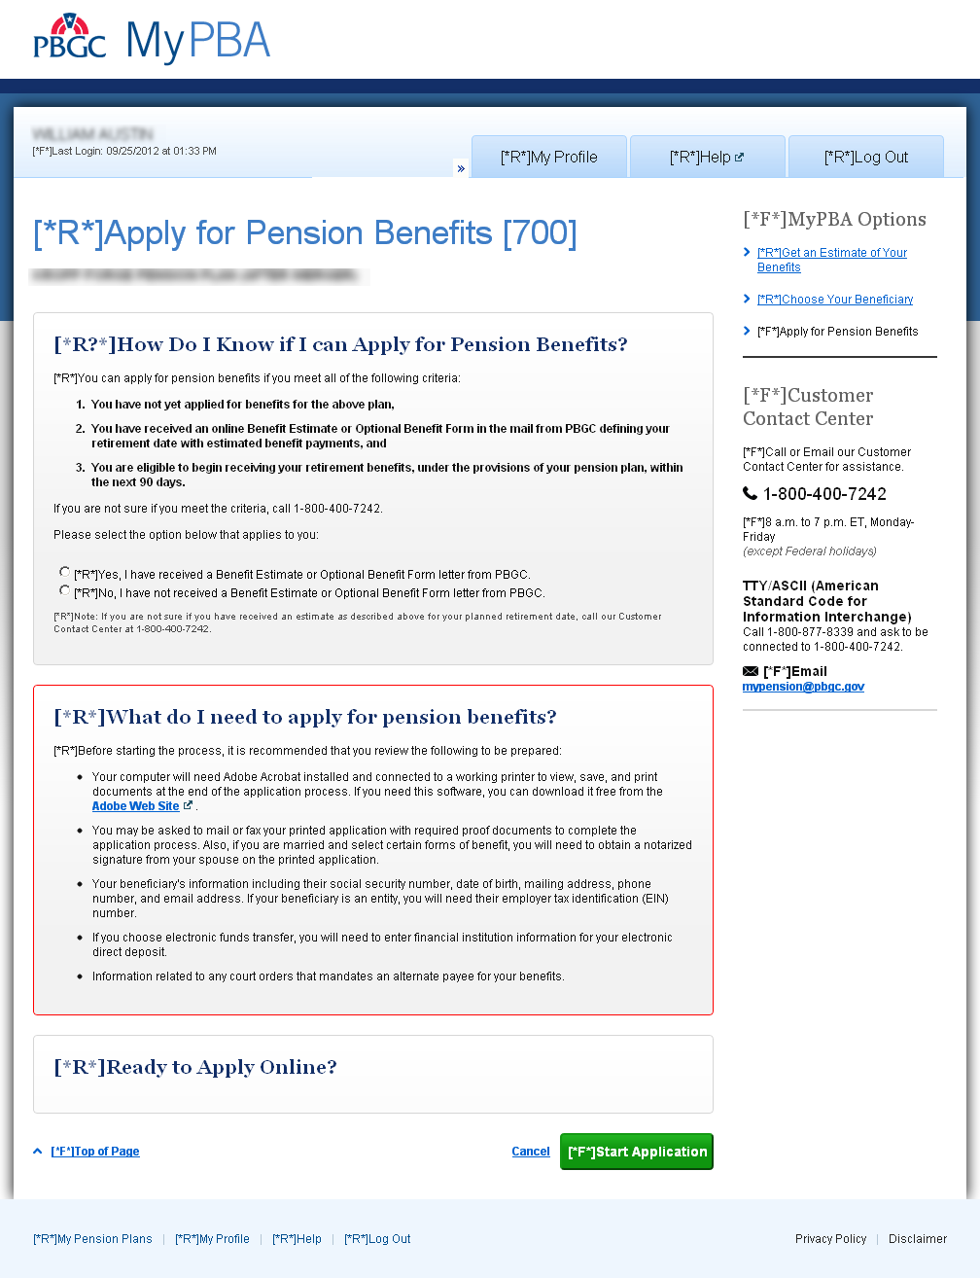
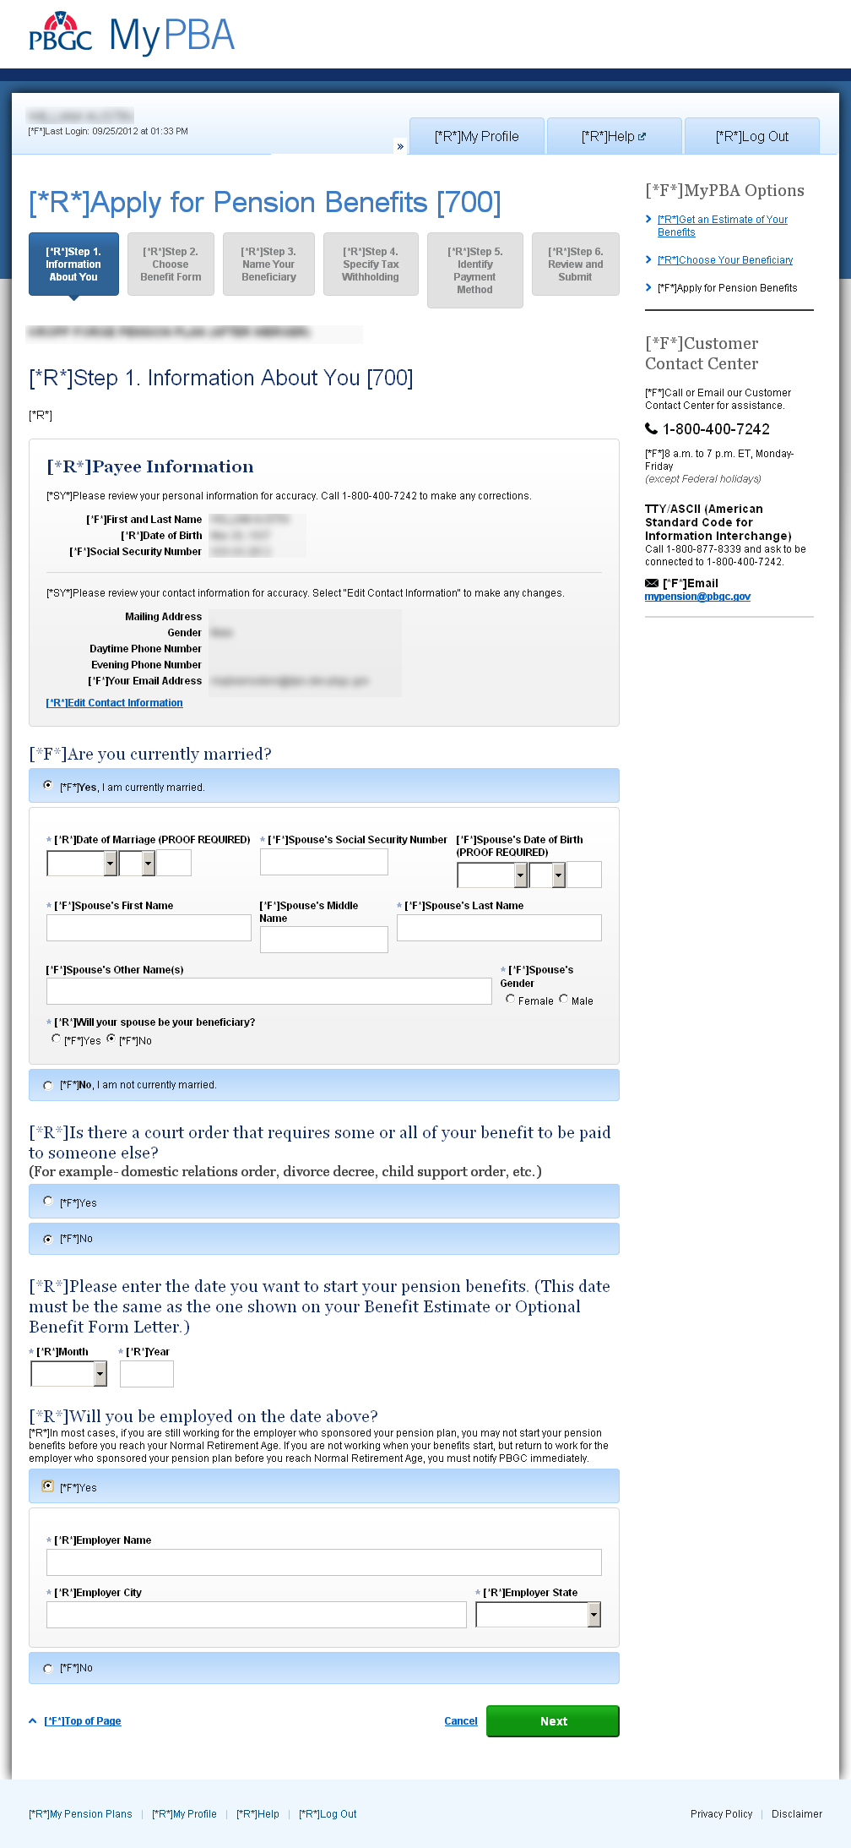
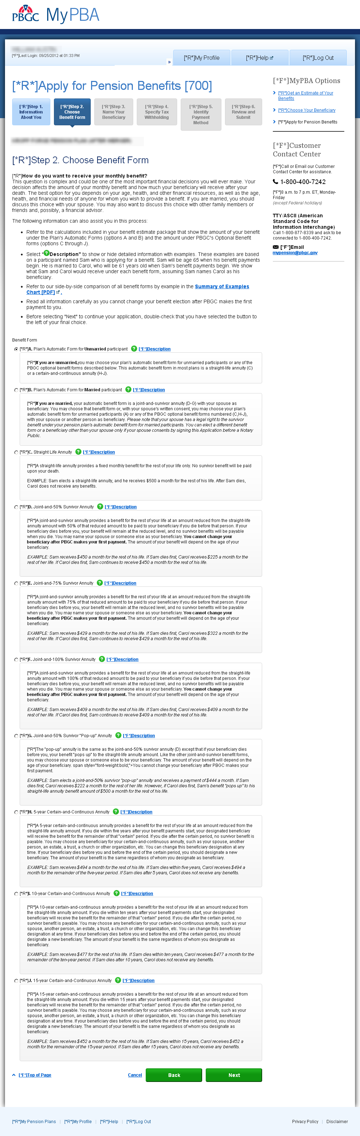
Step 4 Tax Withholding: if option B is selected, fields for that option are displayed.
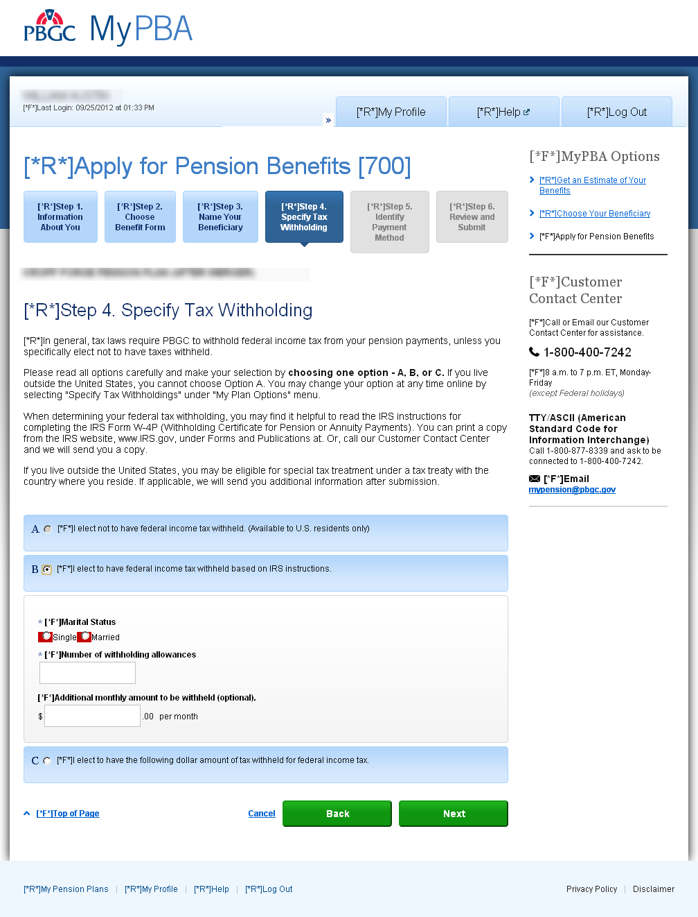

Step 4 Tax Withholding: if option C is selected, fields for that option are displayed.

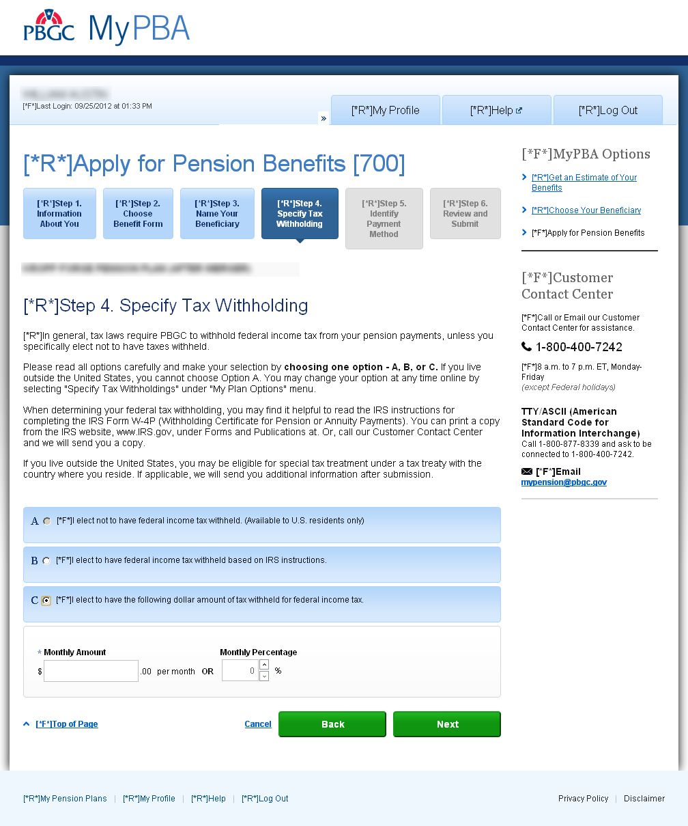

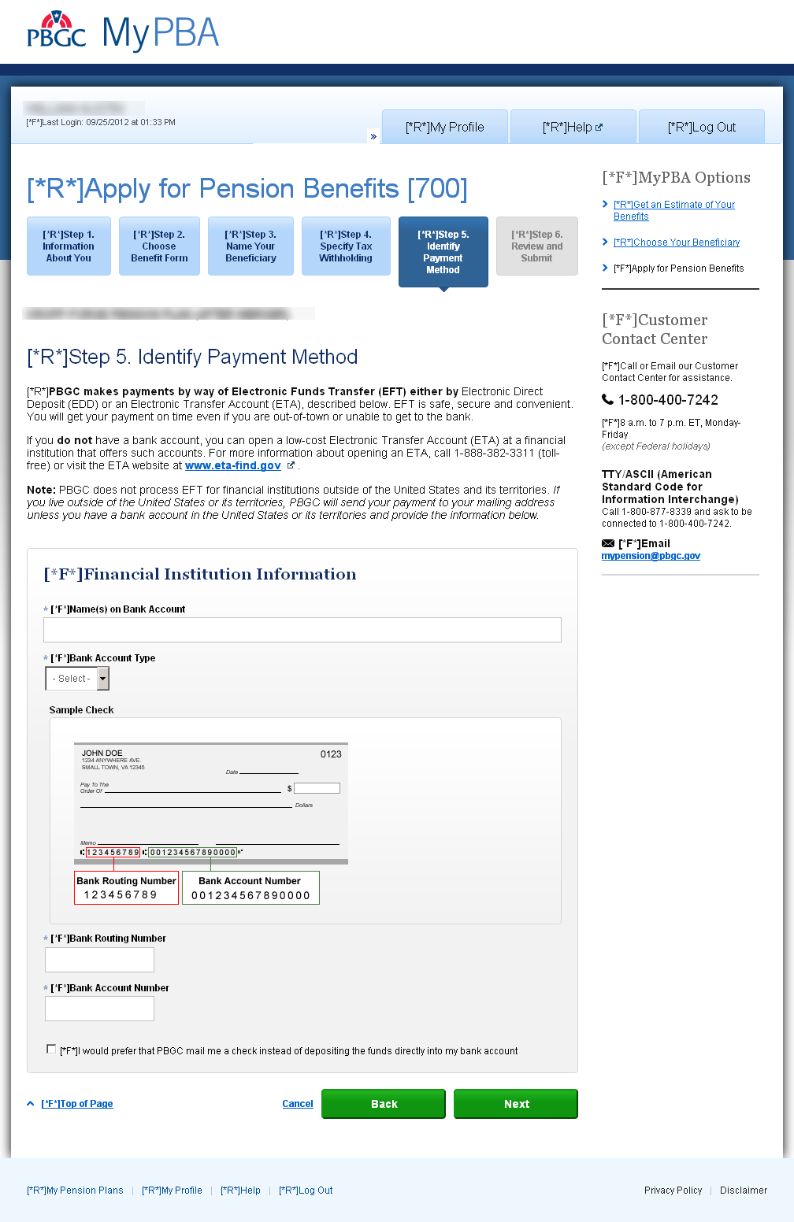
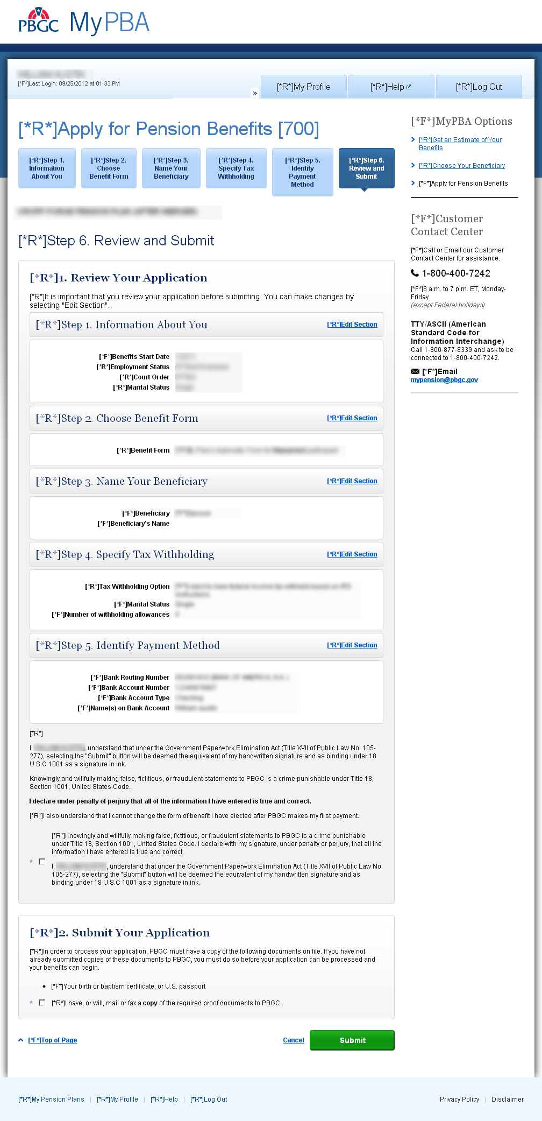

Form 701 Payee Information Form
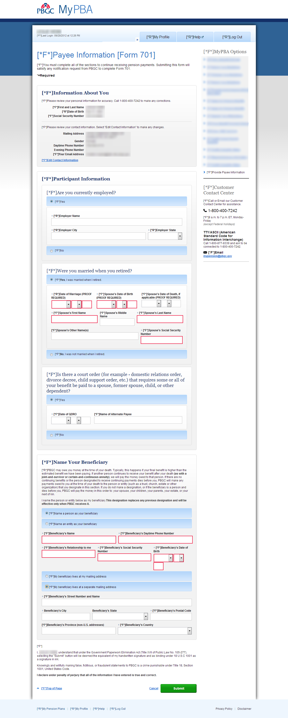

Form 705 Beneficiary Application for Pension Benefits
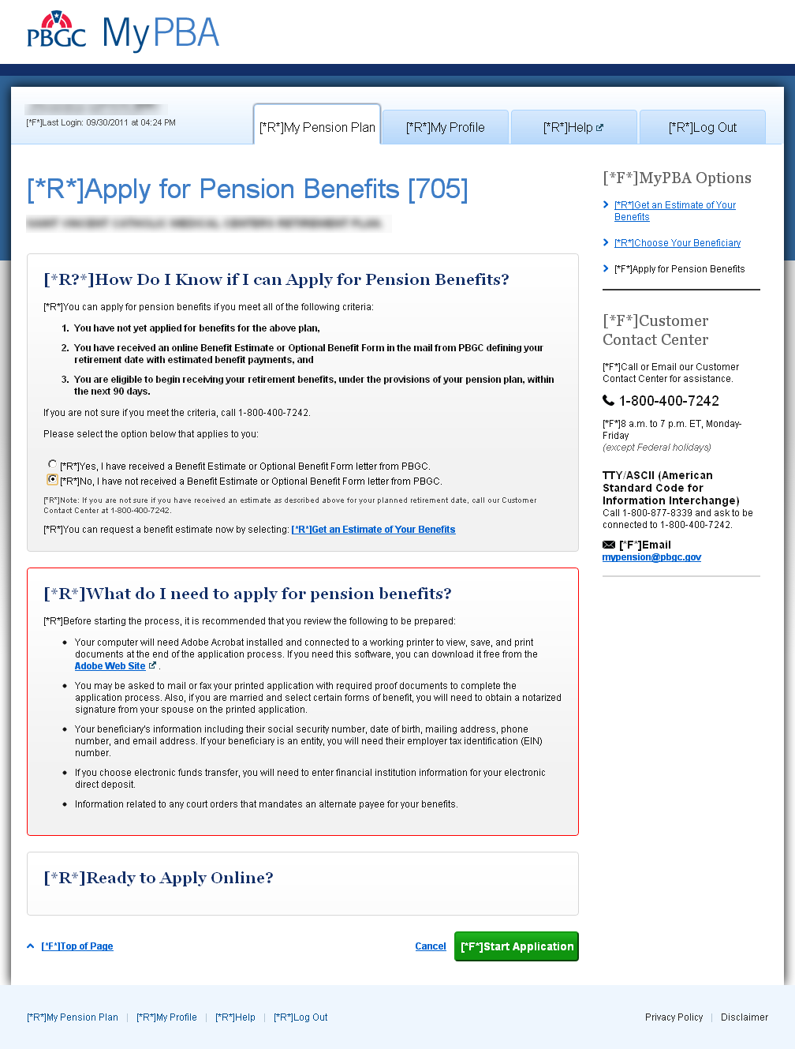
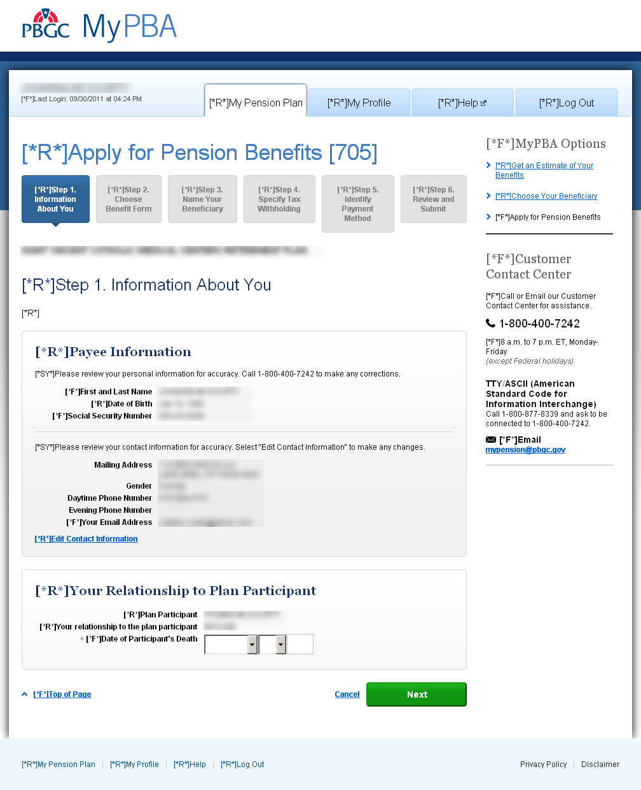

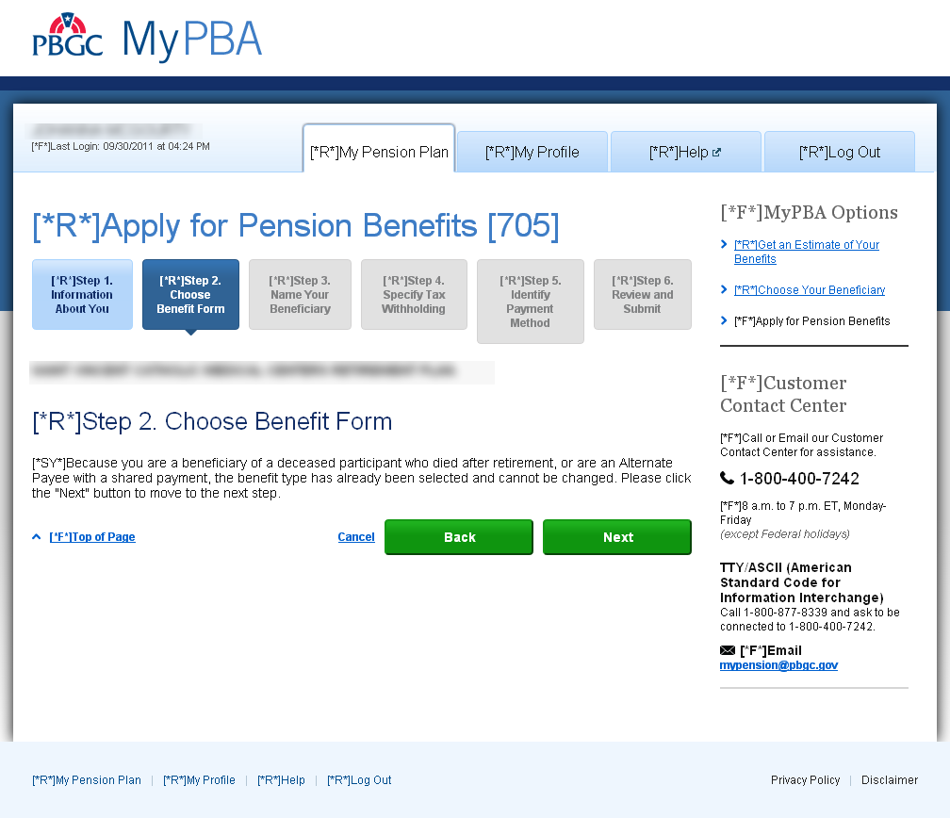

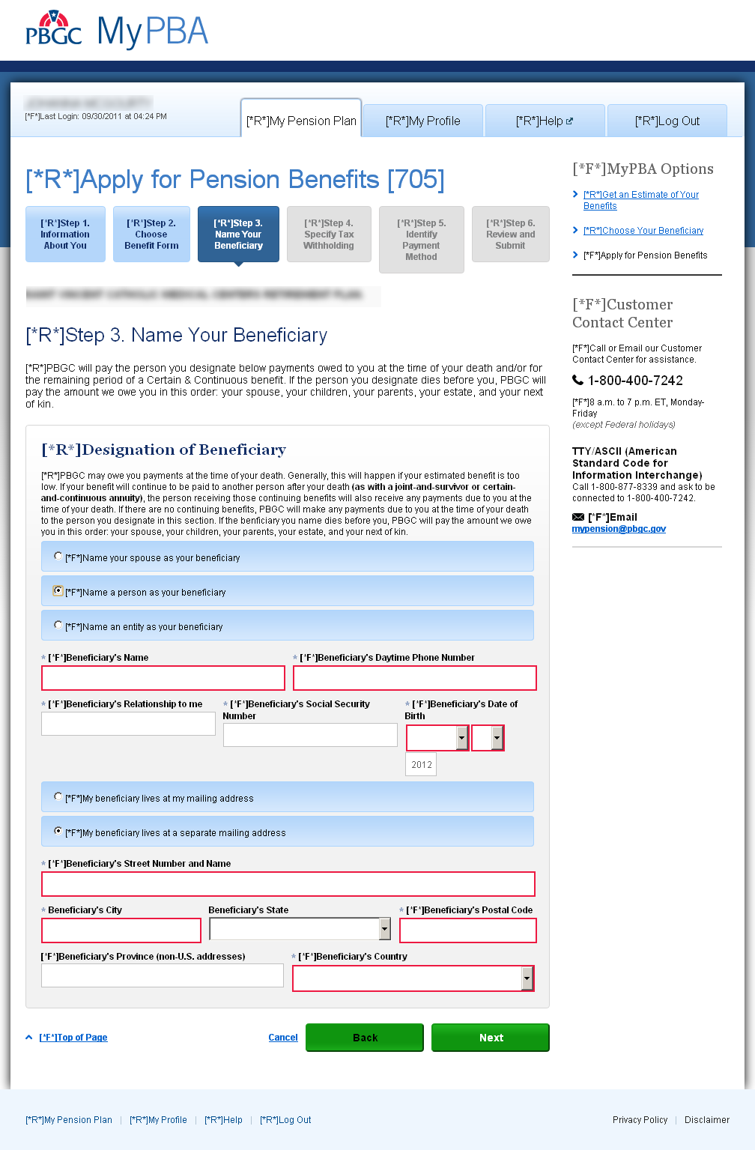
Step 4 Tax Withholding: if option B is selected, fields for that option are displayed.
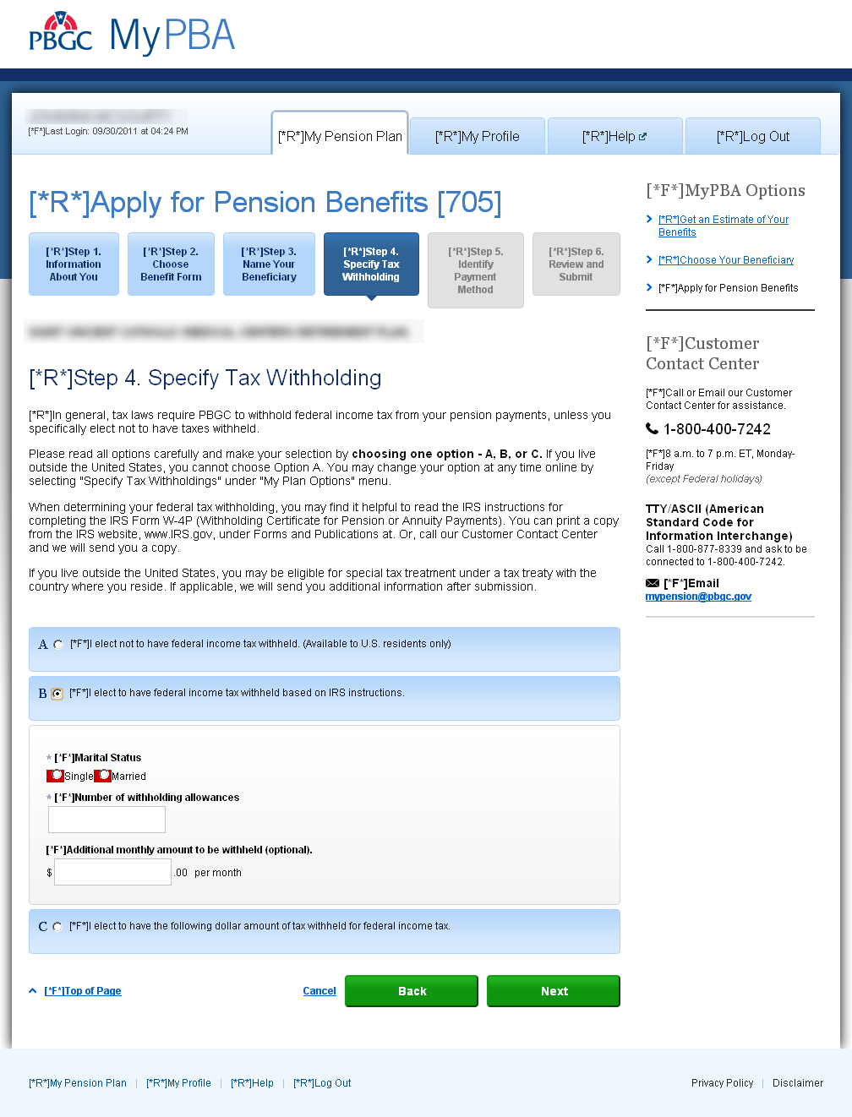

Step 4 Tax Withholding: if option C is selected, fields for that option are displayed.
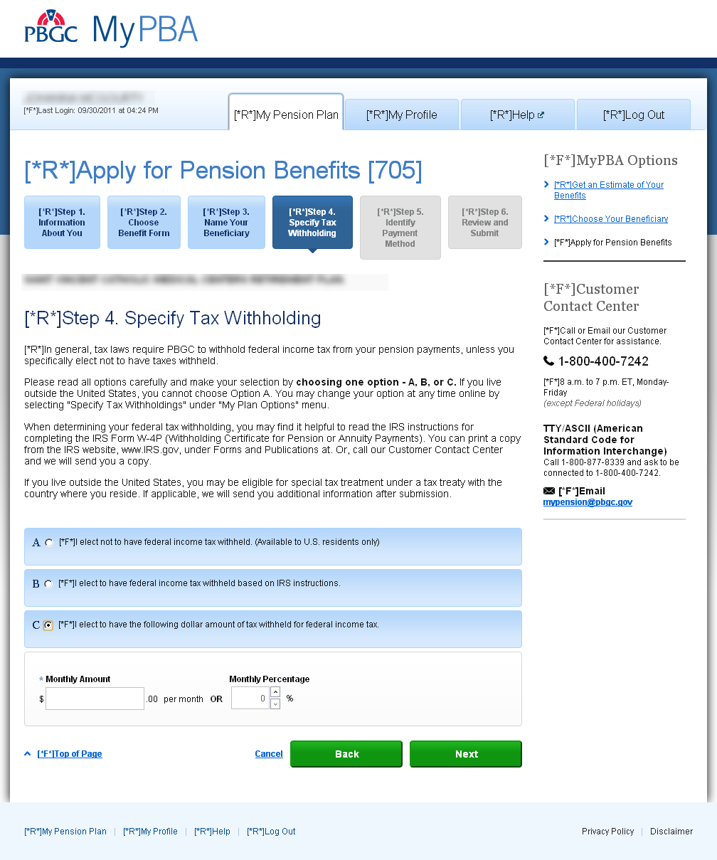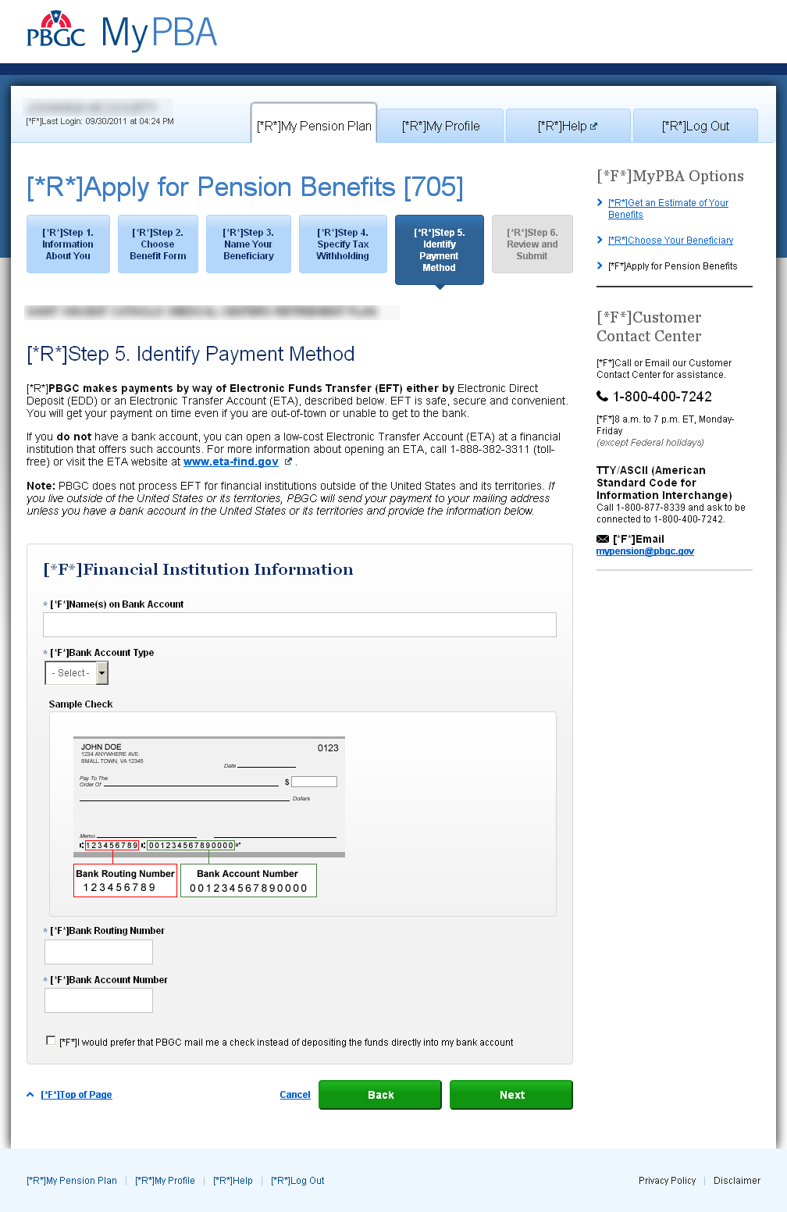
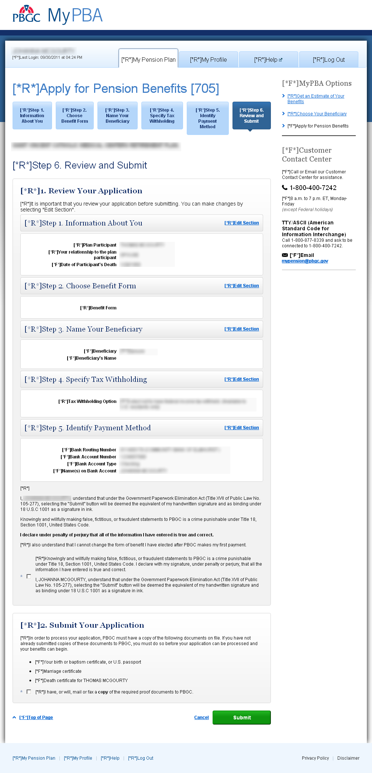

Form 706 Beneficiary Application For Pension Benefits – OF
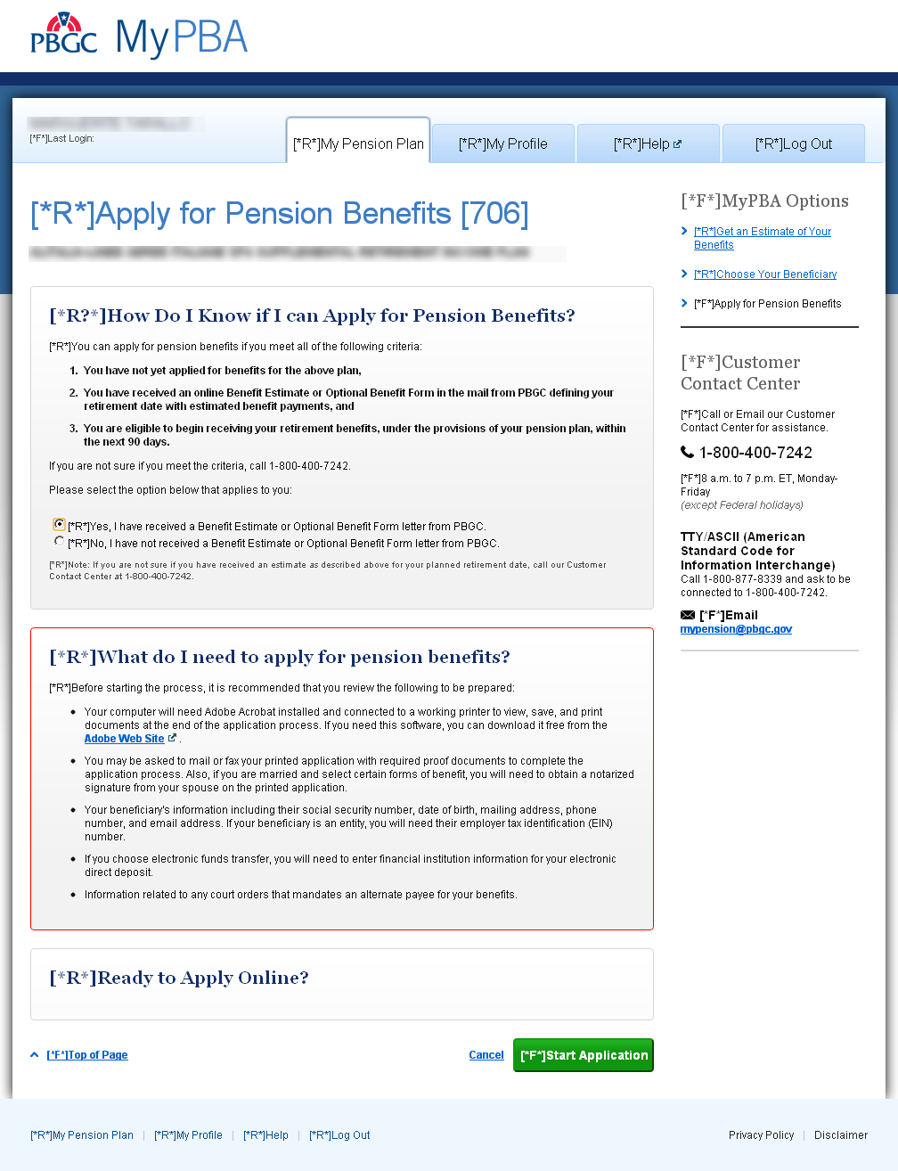
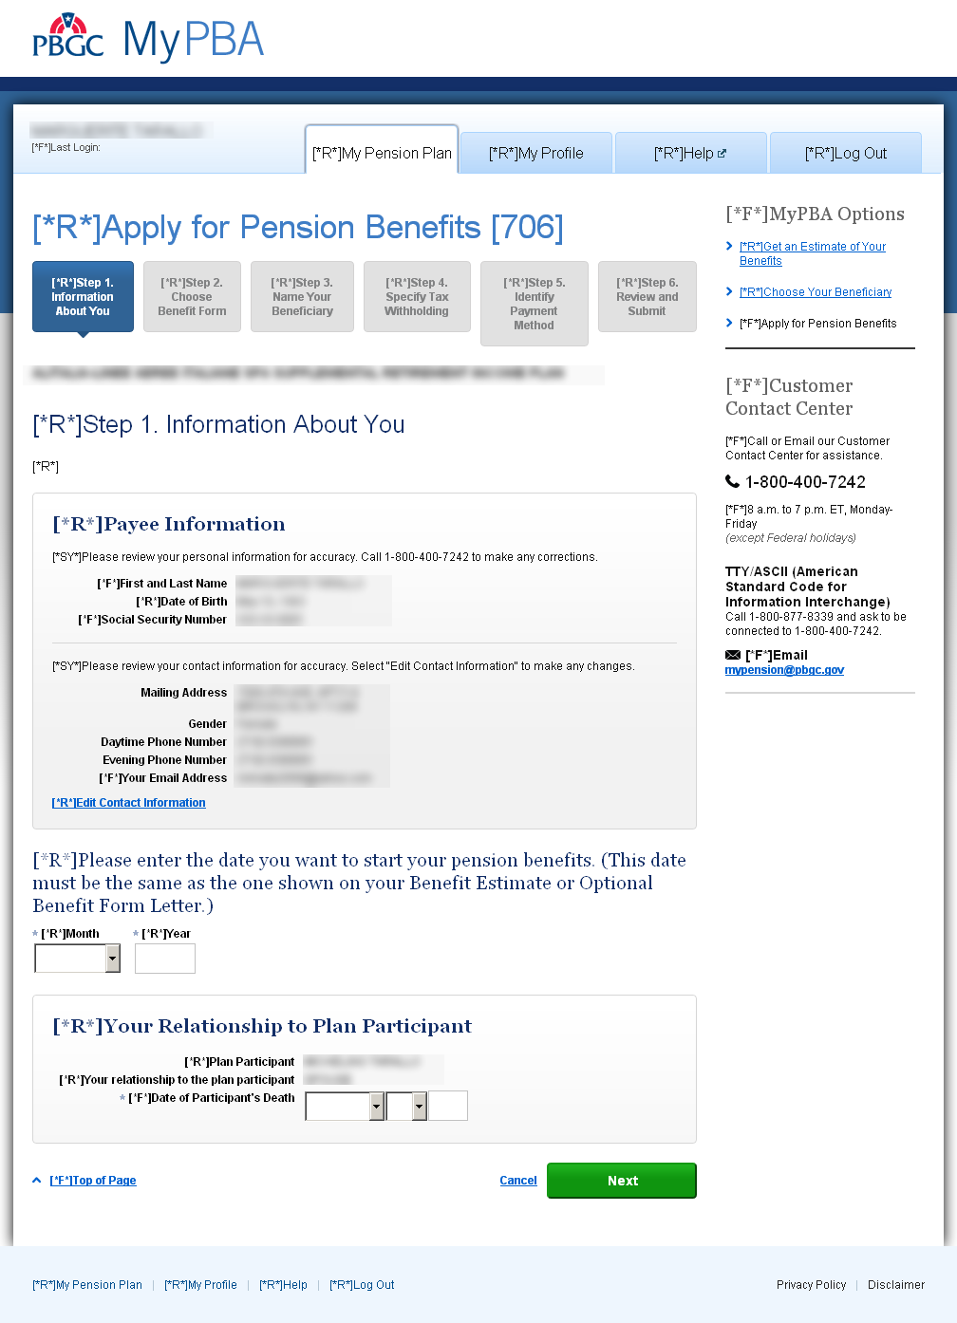
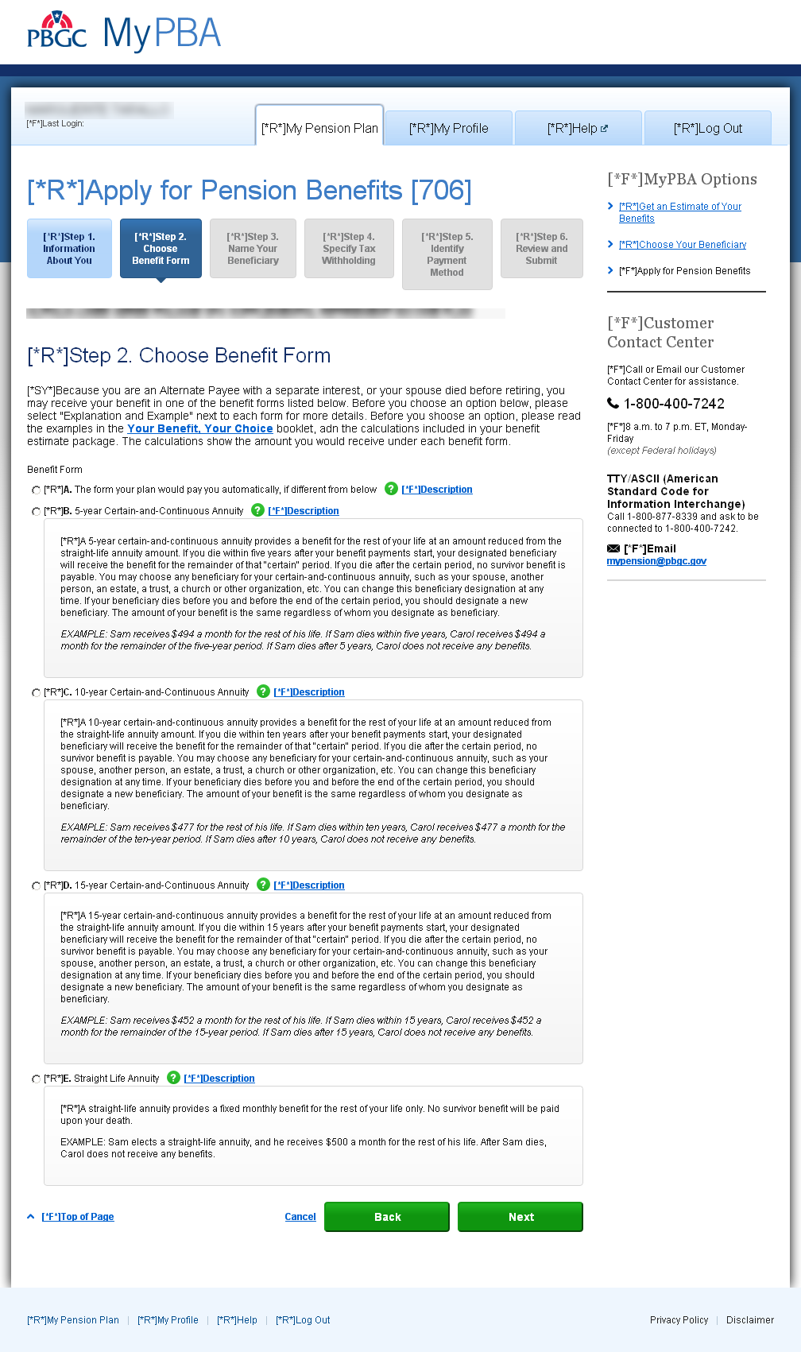
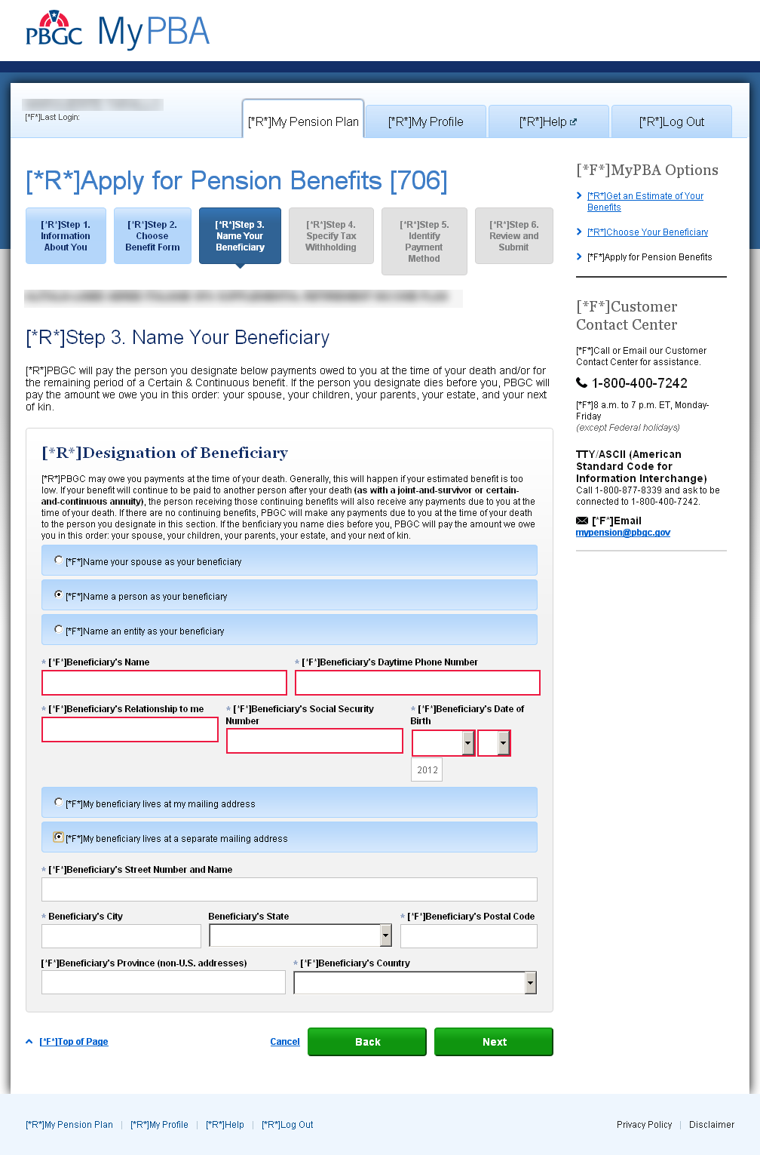
Step 4 Tax Withholding: if option B is selected, fields for that option are displayed.
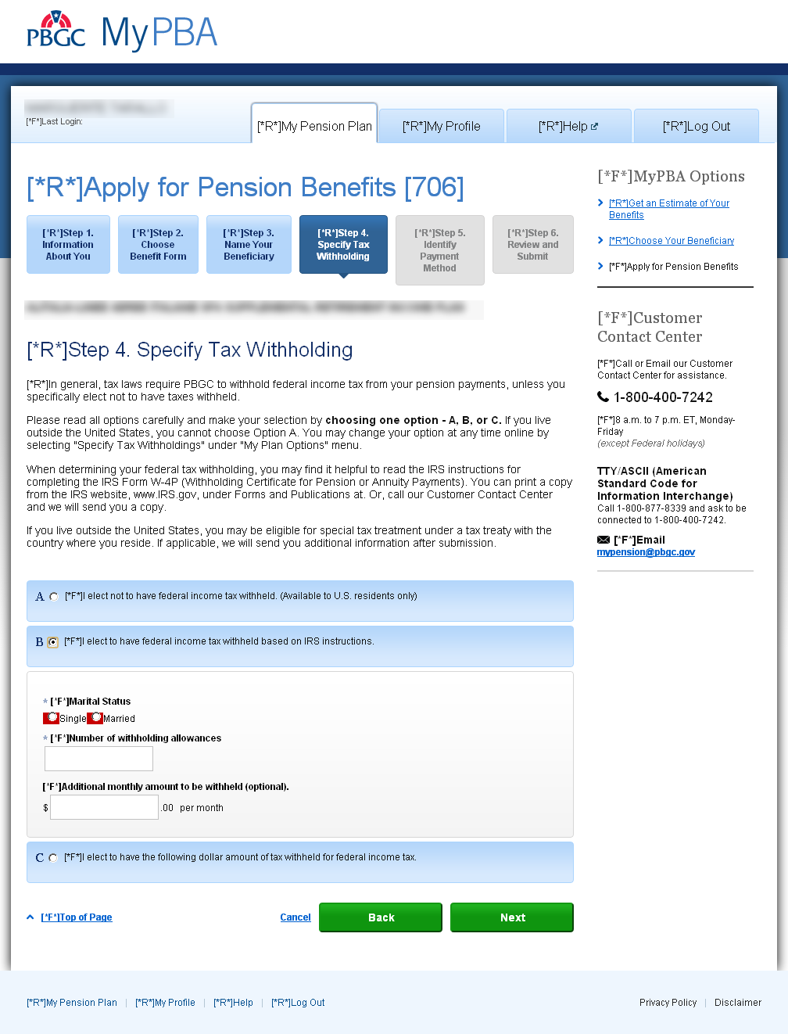

Step 4 Tax Withholding: if option C is selected, fields for that option are displayed.
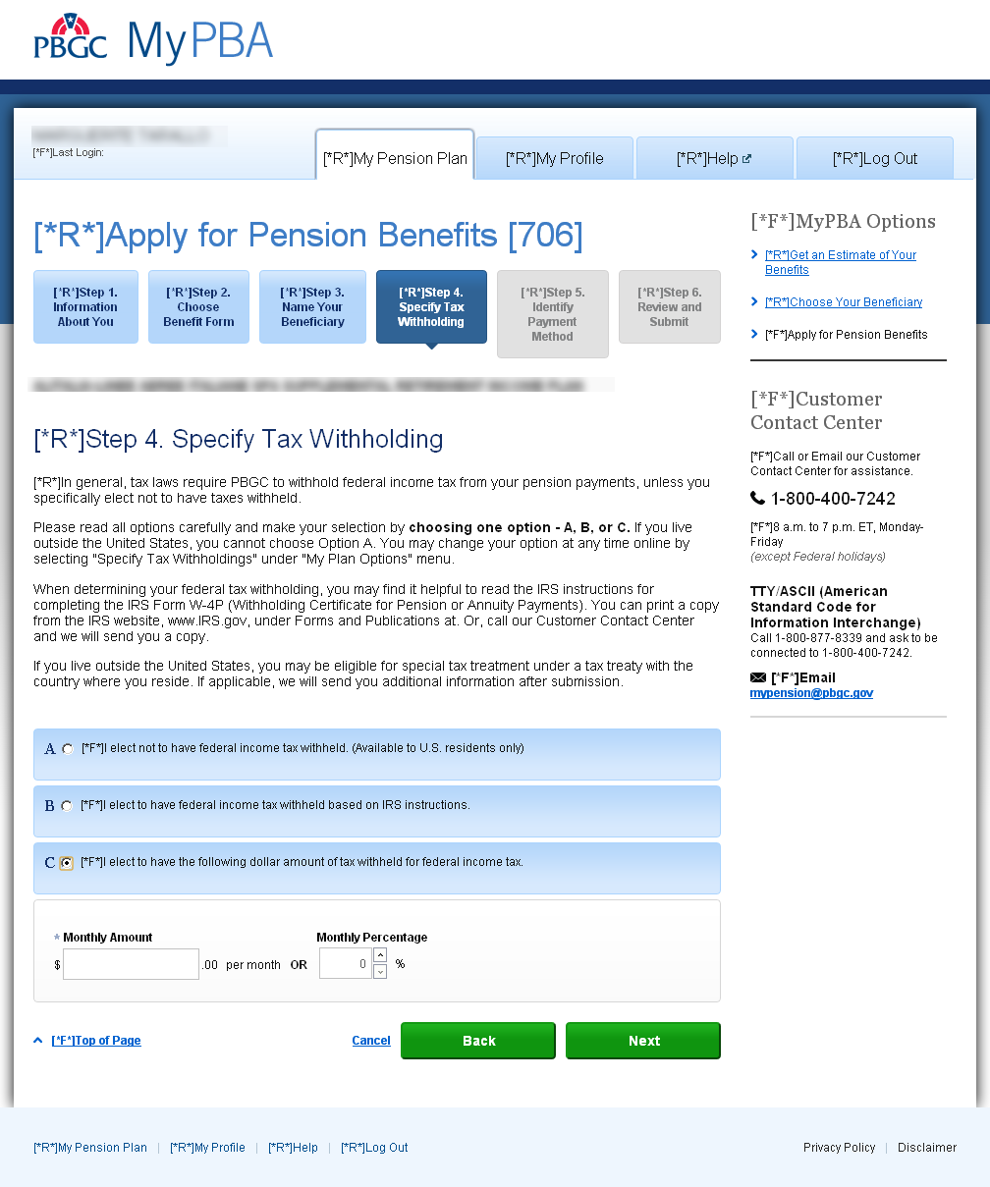

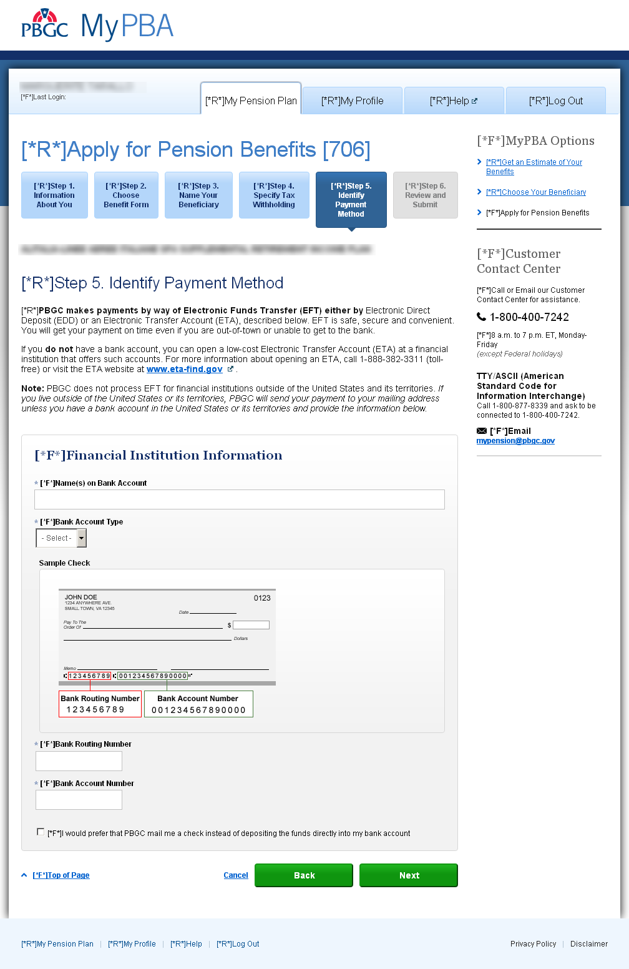
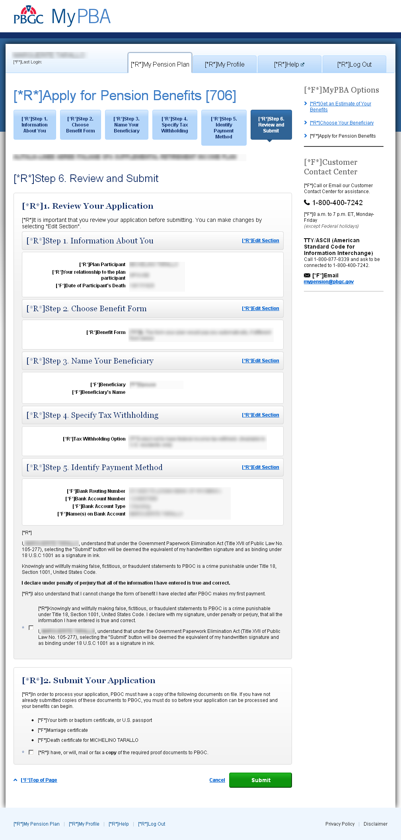

Form 707 Designation of Beneficiary for Benefits Owed at Death
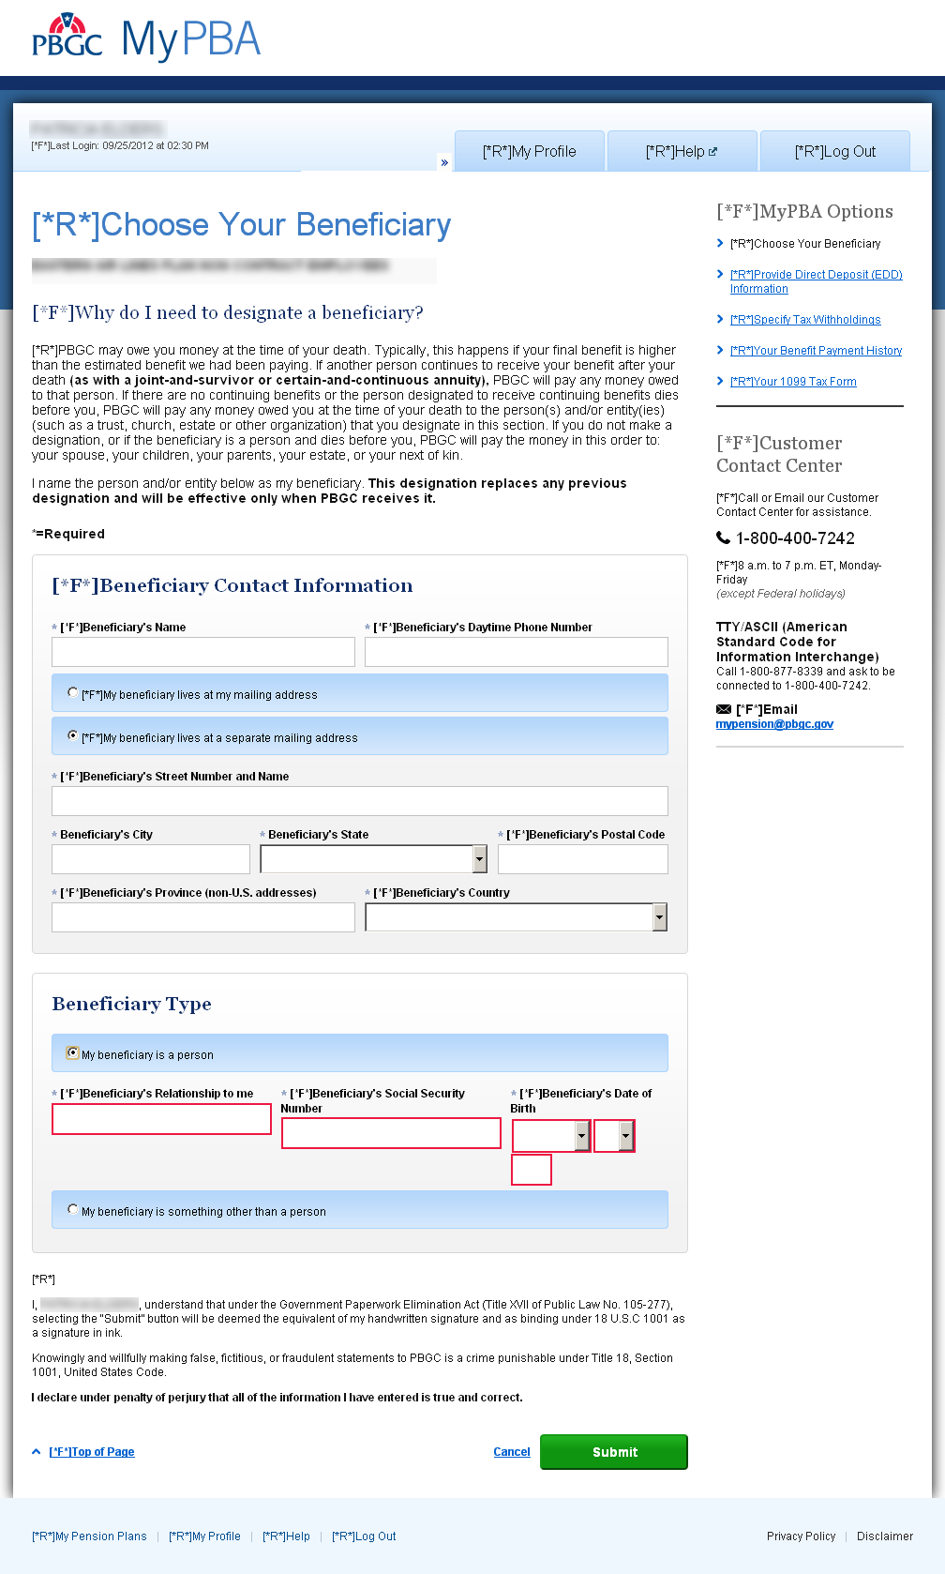

Form 708 Designation of Beneficiary
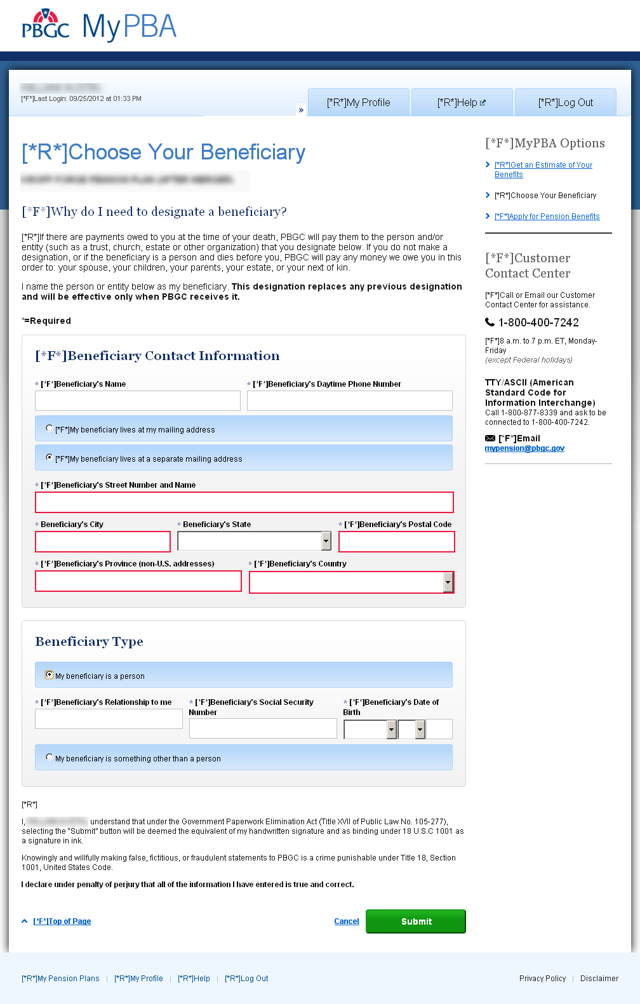

Form 711 Change of Beneficiary for Certain & Continuous (C&C) Benefits Only
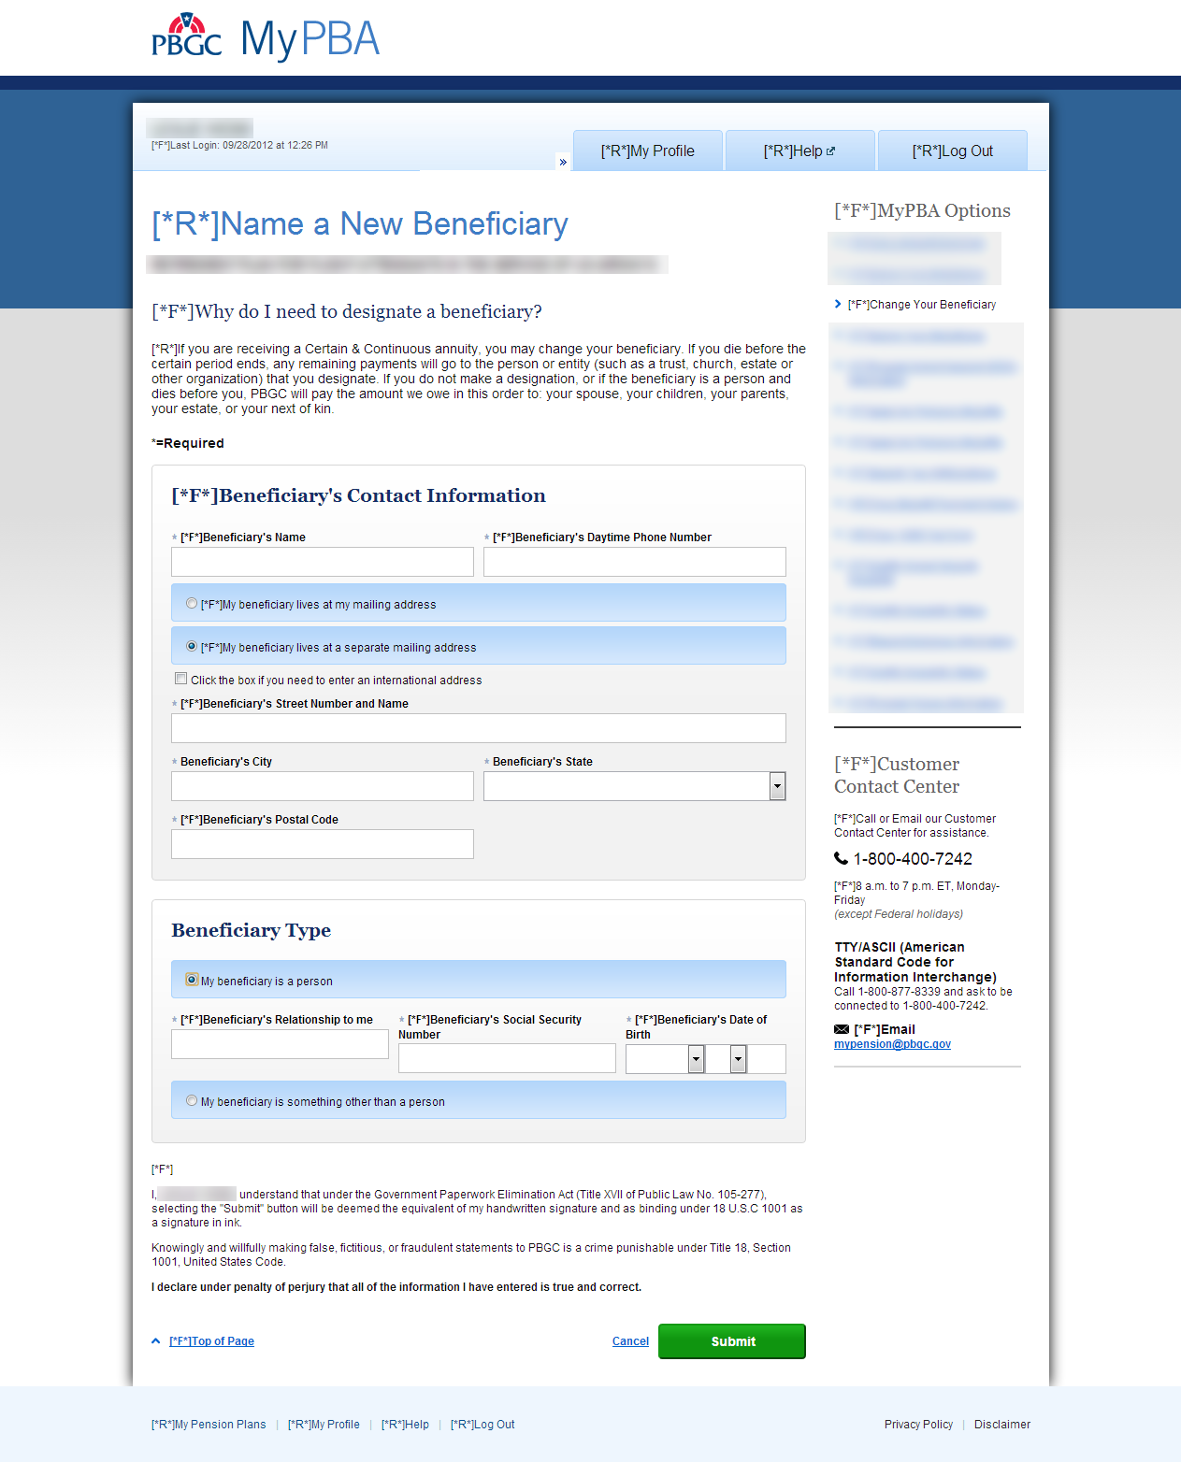

Form 716 Continuous Eligibility Certification
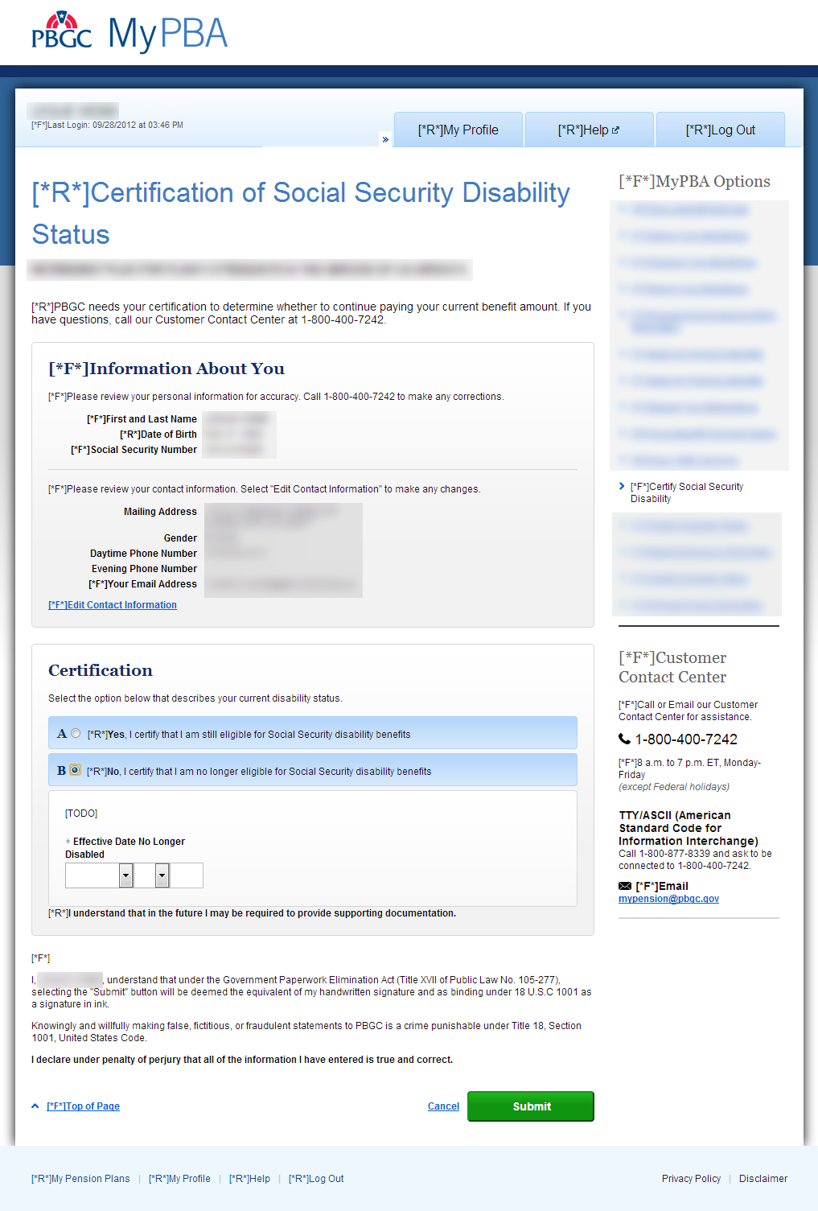

Form 716A Continuous Eligibility Certification
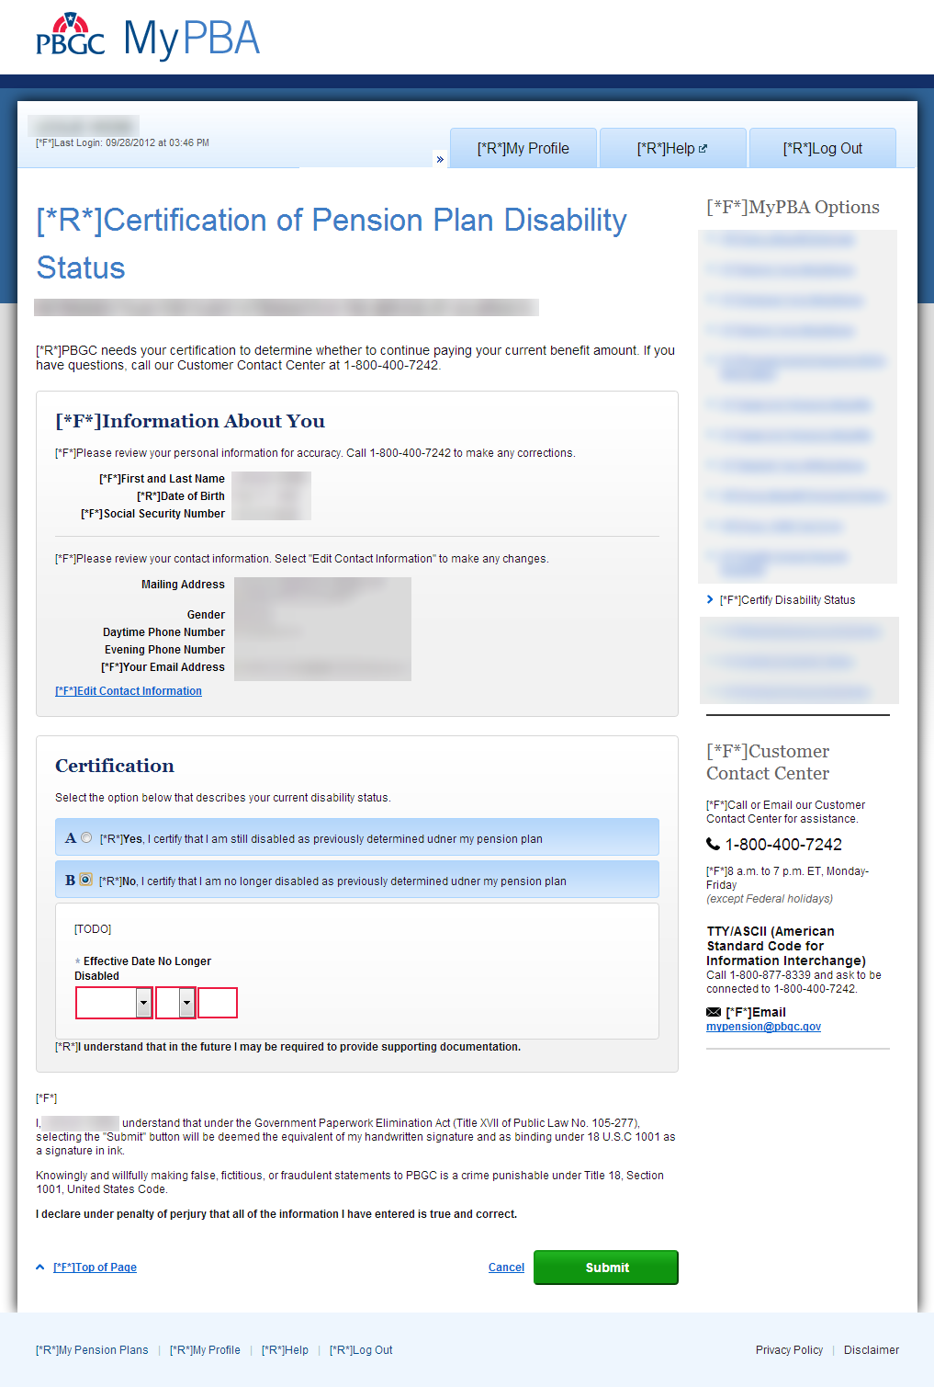

Form 720 Application for Lump-Sum Payment
Lump sum Payment Election: if option A is selected, fields for that option are displayed.
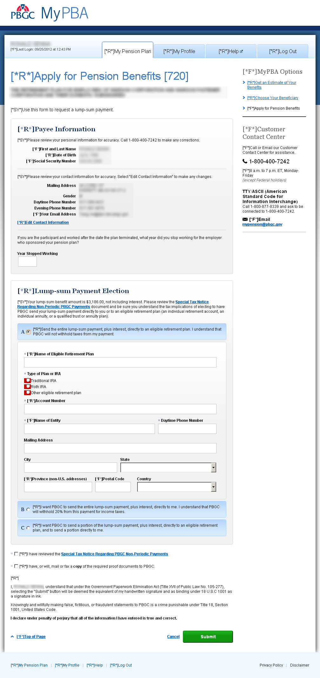

Lump sum Payment Election: if option C is selected, fields for that option are displayed.
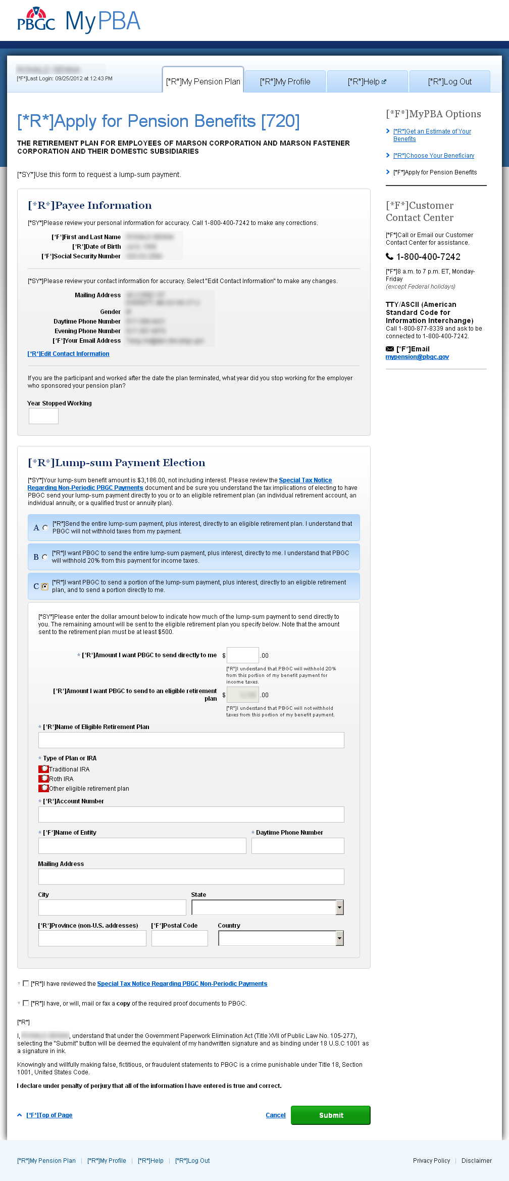

Update Electronic Direct Deposit Screen
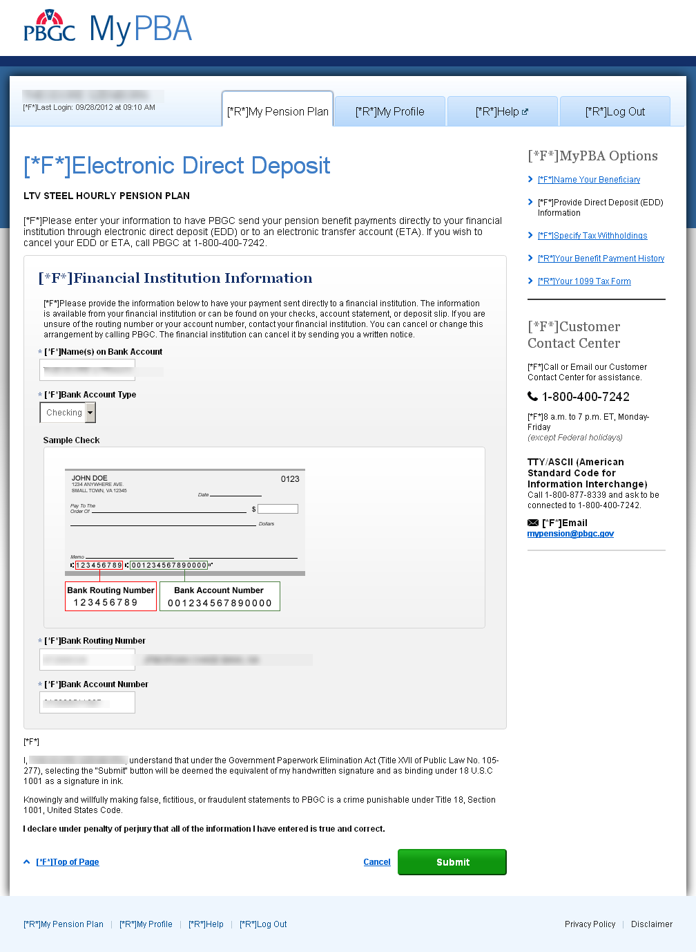

Election to Withhold Federal Income Tax from Periodic Payments Screen
Tax Withholding: if option B is selected, fields for that option are displayed.

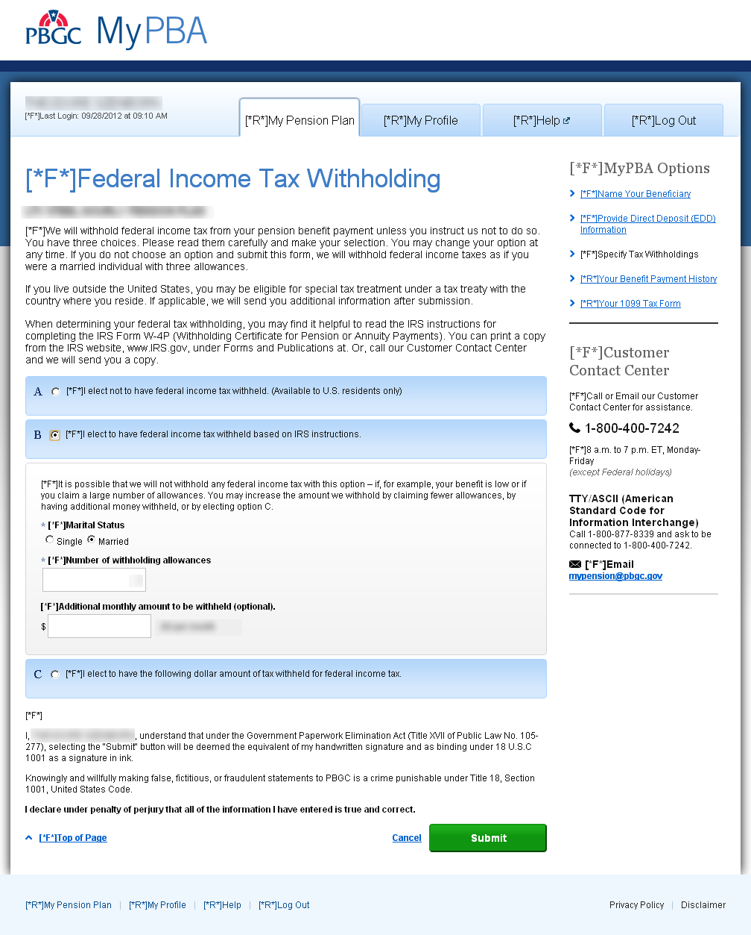
Tax Withholding: if option C is selected, fields for that option are displayed.
