Changes to SOII Webpage and Adobe Data Collection Instruments

SOII Website 2
Updated Years 2
Add Establishments 3
Section 1 4
Update Establishment Information 5
Section 3 6
Cases Page 8
Section 4 10
Page Footer 12
Mouseover Text 13
Blank Numeric Fields Displayed as Zeroes 14
Help System 15
Session Time Out 16
Browser Titles 17
Adobe PDF Form 19
Updated Years 19
Mailing Label 20
Error Message 21

SOII Website

Updated Years

Year-specific text was updated.

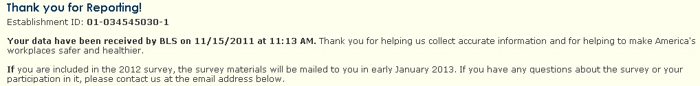

Add Establishments

A new mailing label image is displayed. It reflects the new design of the mailing label.
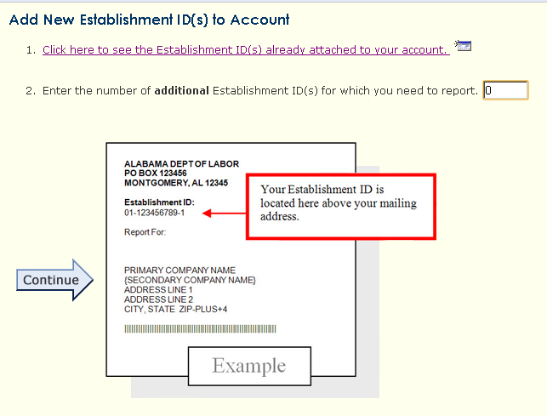

Section 1

The text “Option” was added to the worksheet hyperlinks to indicate that they are optional.
Additionally, the average hours worked per employee field was gray-filled to indicate that it is read only.
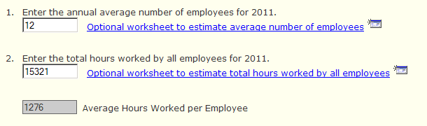

Update Establishment Information

The Unit Description field was changed to be non-required
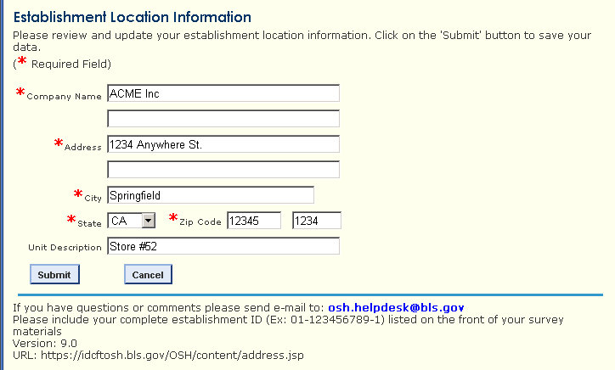

Section 3

Section 3 was changed to be specific to the type of respondent (DJTR or non-DJTR) and to whether or not they have cases to enter.

DJTR respondent with cases:
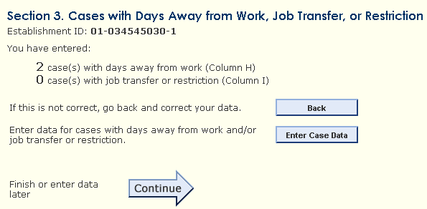

Non-DJTR respondent with cases:
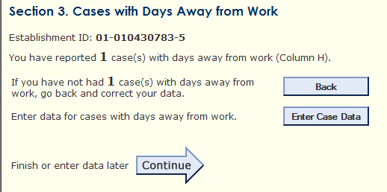

When a respondent indicates that they do not have detailed cases to report, the Enter Case Data button does not appear.

DJTR respondent without cases
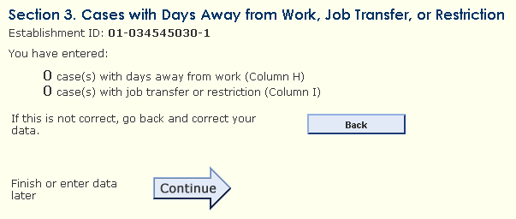

Non-DJTR respondent without cases
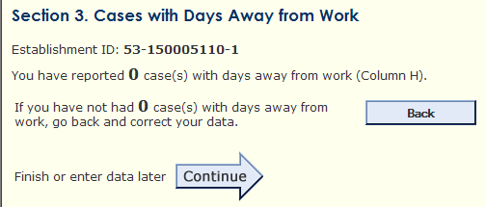

Cases Page

The title of the case page was changed to be specific to the type of respondent.
For DJTR respondents: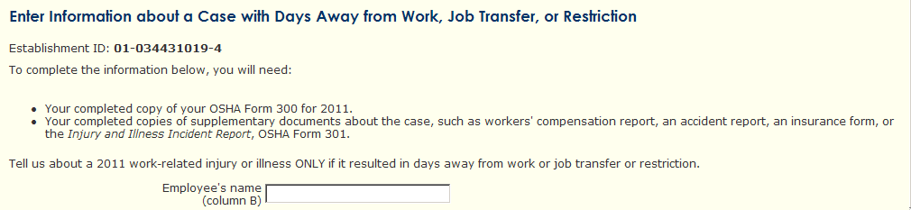

For non-DJTR respondents:
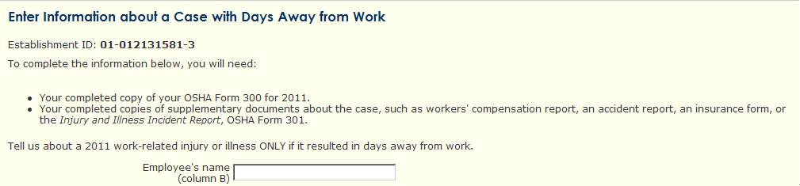

The text “(optional)” was added to indicate that the Event occurred and Case Comments responses are optional. Instructions were added below Case Comments.
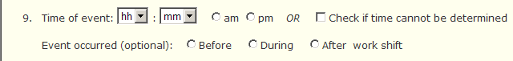
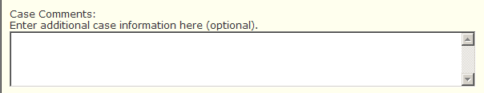

The no-days away from work error message for non-DJTR respondents was customized for DJTR respondents
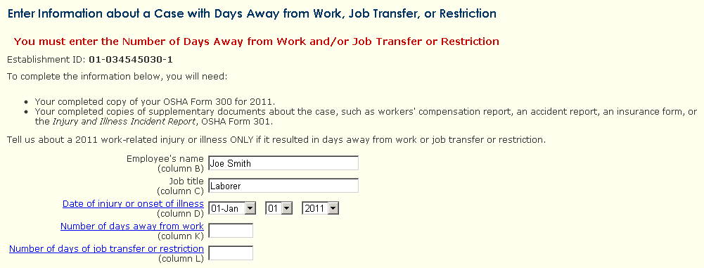

Section 4

The error message was updated to be clearer and specific to DJTR and DAFW respondents.
The error message for DJTR respondents: 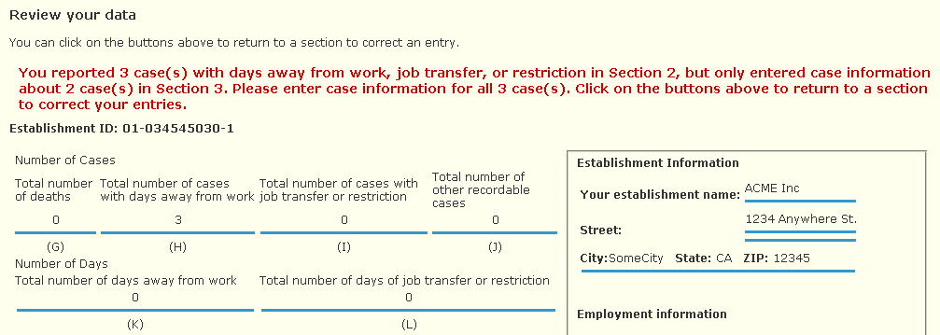

The error message for non-DJTR respondents:

The summary of case information includes question labels for items 3 and 4. Previously no text was displayed next to items 3 or 4 if no data was supplied.
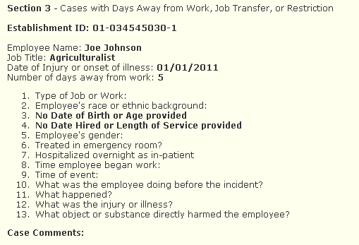

Page Footer

Additional instructions were added below the helpdesk email address to encourage respondents to provide their establishment ID when they submit a help request. This will allow us to resolve many help requests more quickly and accurately.
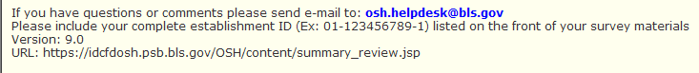

Mouseover Text

Mouseover text for numerous webpage elements was updated to accurately and clearly reflect the functionality of these elements.
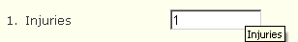
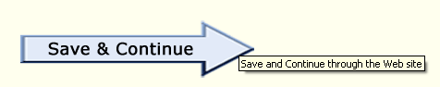

Blank Numeric Fields Displayed as Zeroes

Blanks in numeric fields are displayed as zeroes on subsequent pages that reference those fields.
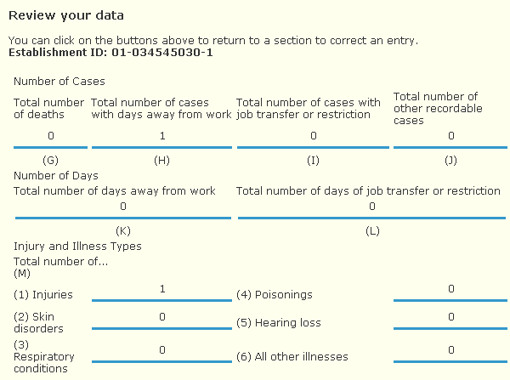

Help System

Language in the help system was updated to keep it consistent with the changes to the website.
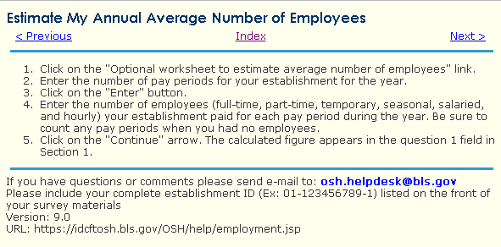

Session Time Out

The respondent receives a notification before their session times out.
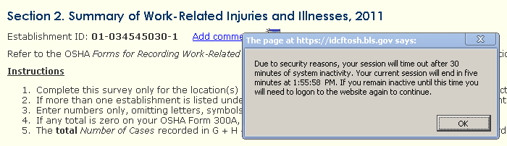

Browser Titles

The webpage titles displayed by the browser match the titles displayed in the webpage. For example, in Section 1 the browser displays “Section 1” and the webpage shows “Section 1. Establishment Information”.
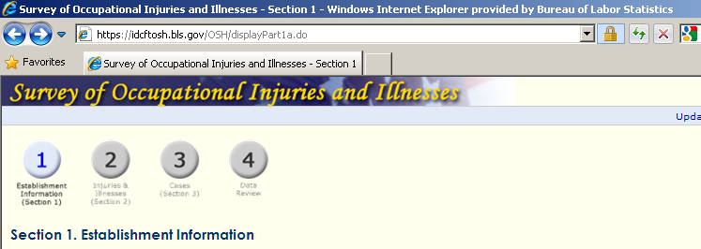

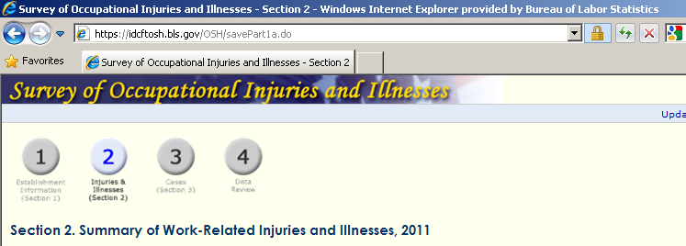
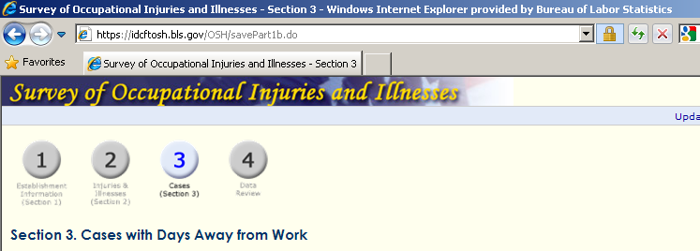

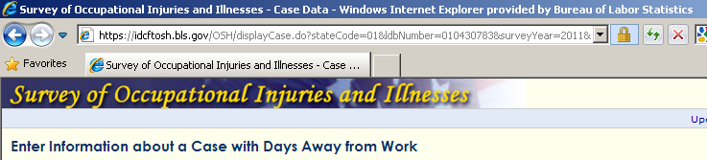

Adobe PDF Form

Updated Years

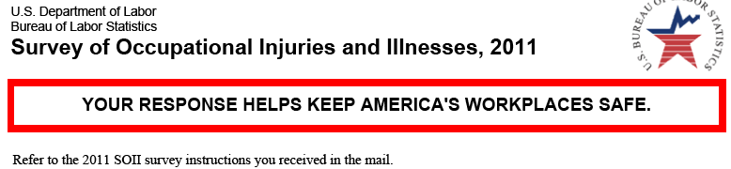

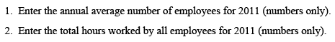

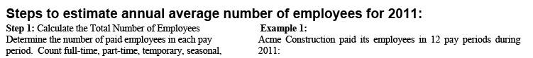

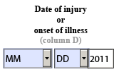

Mailing Label

A new mailing label image was added to the PDF form to accurately reflect its new design.
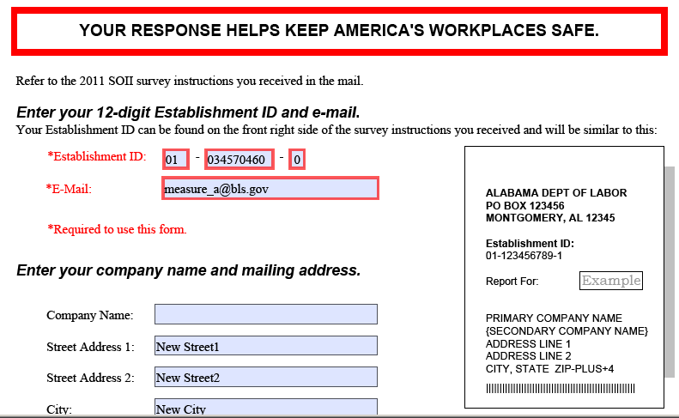

Error Message

The error message window in the PDF form was modified to put the instructions for how to proceed at the bottom of the window so users could read it immediately before deciding to click “Yes” or “No”.
