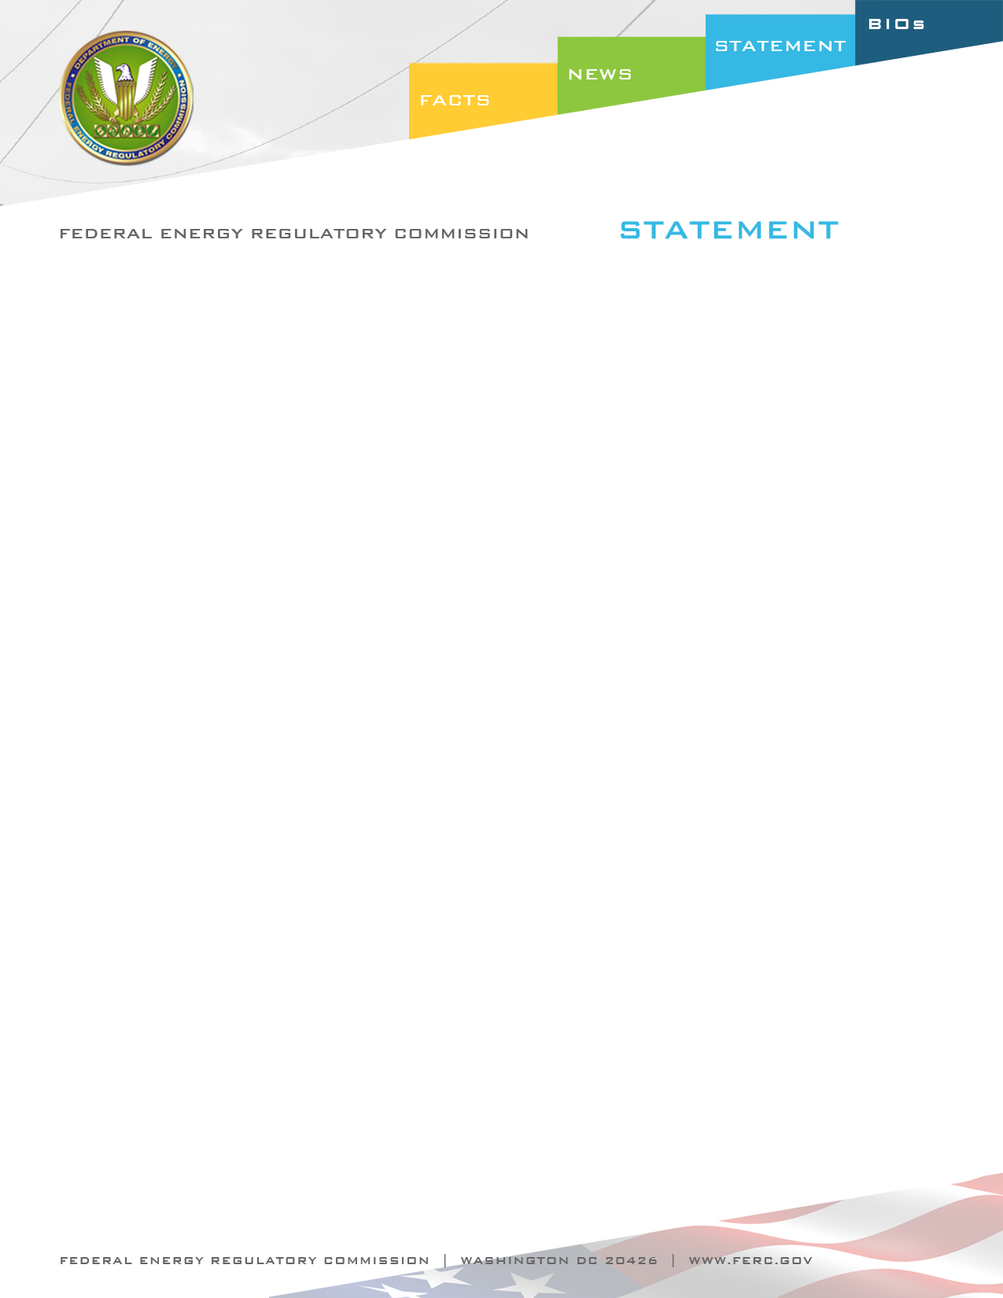

Docket Nos. RM12-18-000 & RM11-21-000
Item Nos. G-1 & G-2

September 20, 2012
Commissioner John R. Norris

Statement of Commissioner John R. Norris on
Oil Pipeline Rulemakings

“We are all familiar with the shale gas revolution that is occurring today and the impact that this revolution is having on the supply and prices of our nation’s energy resources. The same technology that is powering this revolution is also fueling a dramatic increase in the production of oil and oil products in many parts of the country. In addition, “wet” shale plays are producing significant new supplies of propane and other natural gas liquids. As industry looks to maintain and build out the infrastructure that brings these resources from production to market, it is critical to ensure that the rates which underwrite this infrastructure are just and reasonable. Just and reasonable rates protect shippers from paying excessive charges while also ensuring that oil and liquid products pipelines have adequate incentives to construct needed new infrastructure, all of which is to the benefit of our nation’s consumers.

“The notice of proposed rulemaking (NOPR) and final rule we are issuing today are intended to better enable this Commission to fulfill our responsibility to ensure that rates are just & reasonable.

“In passing the Energy Policy Act of 1992, Congress made clear that the Commission was to “adopt a simplified, generally applicable ratemaking methodology” for oil pipelines, and this Commission has adopted indexing procedures to “streamline oil pipeline rate matters.”

“I believe the additional information that these rules propose to be included on FERC Form 6, page 700 are in-line with the 1992 legislation, this Commission’s subsequent rules and procedures adopted to implement that legislation, and the spirit of what Congress intended when it asked that the Commission adopt a more simplified approach to ratemaking.

“As the NOPR indicates, the additional information proposed to be reported will impose almost no additional burden on oil pipelines. While this would impose a de minimus cost to oil pipelines - the NOPR estimates 30 minutes of additional time required - the information will better enable both this Commission and shippers to more accurately and easily evaluate a pipeline’s rates.

“As the NOPR also states, prior to this proposal, any attempt to estimate an oil pipeline’s actual return on equity required assumptions regarding several cost of service components. Where access to readily available data can better enable this Commission to do our most fundamental job of ensuring that rates are just and reasonable, we should take action to ensure that such data is in fact available. We are that doing here.

“This also empowers shippers by allowing them to see important data regarding the rates they have to pay and provides them a reasonable level of self-protection. The Interstate Commerce Act provides an important avenue for oil and liquid product pipeline shippers to initiate actions on rates where they believe those rates are unjust and unreasonable. Under that construct, I believe there is a heightened level of importance that shippers have access to data to enable them to have a reasonable level of protection. I believe the action we are taking today helps to restore some balance and provides a better process for maintaining just and reasonable rates.”

