Project Code 171 QID 050127 Dealers |  | OMB No. 0535-0003 Approval Expires 12/31/2009
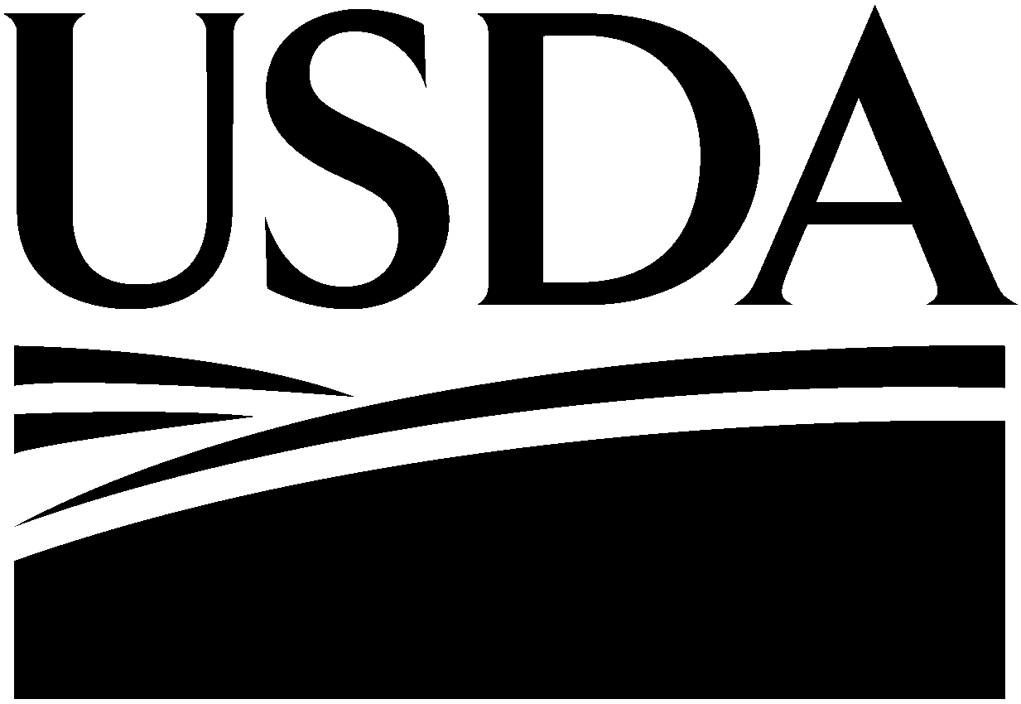 | RETAIL SUNFLOWER SEED  PRICE INQUIRY  March 2009 |  |  |  | 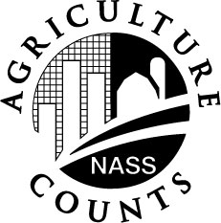 | NATIONAL  AGRICULTURAL  STATISTICS  SERVICE
North Dakota Field Office
P.O. Box 3166
Fargo, ND 58108-3166
701-239-5306
Fax: 701-239-5613
nass-nd@nass.usda.gov
This inquiry is to obtain information on prices farmers are paying for sunflower seed. Data from this survey is used to compute the Index of Prices Paid by Farmers, which is used in measuring price trends and the purchasing power of farm commodities.

Response to this survey is voluntary and not required by law. However, your cooperation is very important in order to accurately estimate these prices. Individual reports are kept confidential.
Please make corrections in name, address and zip code, if necessary.

- INSTRUCTIONS –

Please report quantity sold and to be sold to farmers this spring for planting and prices currently in effect (include transportation and handling costs). Enter price for the type MOST COMMONLY SOLD to farmers. Exclude state sales tax.

PLEASE RETURN BY MARCH 30, 2009

SUNFLOWER SEED PURCHASED BY GROWERS FOR PLANTING IN 2009
Item | Quantity (sold/to be sold)  Pounds | Price (paid/to be paid)  Dollars/Pound
Oil Type
Non-Oil Type

Reported by: ______________________________________________________ Date: _______________________________________

According to the Paperwork Reduction Act of 1995, an agency may not conduct or sponsor, and a person is not required to respond to, a collection of information unless it displays a valid OMB control number. The valid OMB control number for this information collection is 0535-0003. The time required to complete this information collection is estimated to average 10 minutes per response, including the time for reviewing instructions, searching existing data sources, gathering and maintaining the data needed, and completing and reviewing the collection of information.

