Project Code 171 |  | OMB No. 0535-0003: Approval Expires 12-31-09
 | PRICES PAID - SEED PEANUT PRICE SURVEY  April 2009 |  | 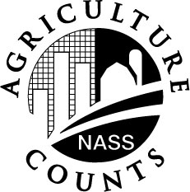 | NATIONAL  AGRICULTURAL STATISTICS  SERVICE
Oklahoma Field Office
2500 N. Lincoln Blvd.
Third Floor
Oklahoma City, OK 73152
405-522-6190
Fax: 1-405-528-2296
E-mail: nass-ok@nass.usda.gov

The purpose of this survey is to determine prices paid by farmers for seed peanuts. Your firm is included in a small sample and your report is needed to insure accurate estimates.

Participation in this survey is voluntary and not required by law. Individual reports are confidential, and your report will be destroyed after the data are summarized.

1. Does your firm sell peanuts for seed to farmers either directly or through your own retail outlets?

_________ Yes (Continue with Question 2)

_________ No (Conclude the interview)

2. How many pounds or cwt. have you sold or do you expect to
sell to farmers to seed the 2009 crop (include the amount sold or
expected to be sold through your own retail outlets)? …………………..
100

Lb | Cwt

3. What is the average price per lb. or cwt. you have received or
200
$ __ __.__ __
expect to receive for these peanuts? ………………………………….
Lb | Cwt

Reported by :__________________________ Date:__________________

