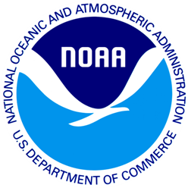
<<DATE>>
<<STATE>> Resident
<<Add 1>>
<<Add 2>>
<<CITY>>, <<State>> <<Zip>>

Dear <<STATE>> Resident,

A few weeks ago we sent a questionnaire to your household in an effort to collect information about severe weather events and participation in outdoor activities. If you have already returned the questionnaire, we thank you. If you have not returned it, we ask you to please complete the enclosed questionnaire and return it as soon as possible. For the results of this study to be scientific, we need all households who receive this short questionnaire to complete the questionnaire and send it back.

We are very grateful for your help. Your completed questionnaire will contribute to our understanding of the state’s access to information about the environment and ensure the quality of marine and coastal resources.

Your address was randomly selected from a list of all addresses in <<STATE>>. This is a voluntary survey. Responses are kept confidential as required by section 402(b) of the Magnuson- Stevens Act and NOAA Administrative Order 216-100, Confidentiality of Fisheries Statistics, and will not be released for public use except in aggregate statistical form without identification as to its source.

If you have any questions or comments about this study, we would be happy to talk with you. Please contact XXXXXXXX at 1-XXX-XXX-XXXX.

Thank you again for your help with this important study.

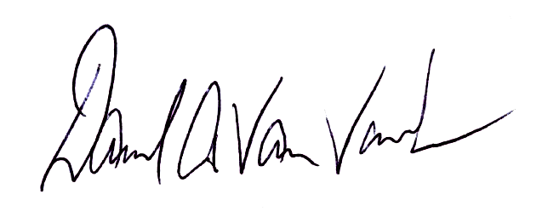
Yours sincerely,

Dave Van Voorhees
Chief, Fisheries Statistics Division
NOAA Fisheries, Office of Science and Technology

