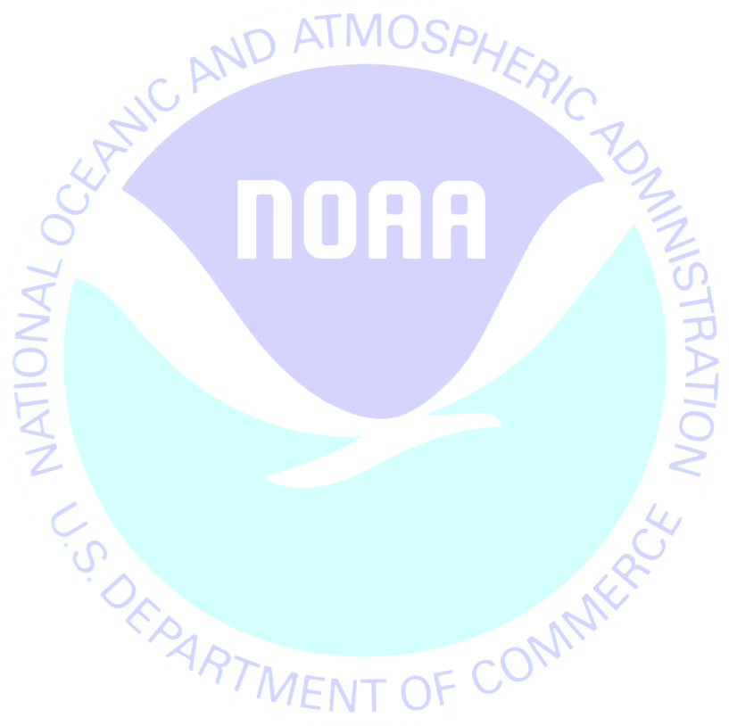
June 6, 2012

Last week we sent you a survey on behalf of the National Oceanic and Atmospheric Administration. If you have already completed and returned the survey, please accept our sincere thanks. If not, I encourage you to do so today.
Information collected in this study will help us to better understand how people use recreation resources in <<STATE>>. Please know that your answers are completely confidential and will be used only for this study in accordance with the Magnuson-Stevens Act and NOAA Administrative Order 216-100.
If you did not receive the survey or need another copy, please call XXXXXXXX toll-free at 1-XXX-XXX-XXXX.
Sincerely,
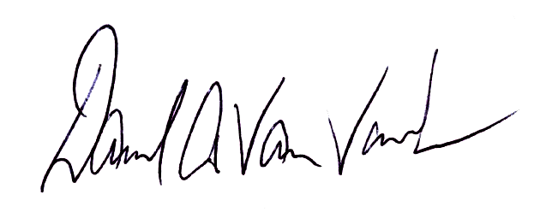

Dave Van Voorhees
Chief, Fisheries Statistics Division
NOAA Fisheries, Office of Science and Technology
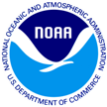
Weather and Outdoor Activities Survey
7431 College Parkway, Ste A
Fort Myers, FL 33907

<<STATE>> Resident
Add1
Add2
City, St Zip

