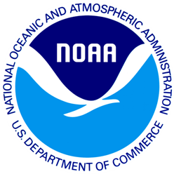
June 6, 2012
[State] Resident
(Add 1)
(Add 2)
(City), (State) (Zip)

Dear [State] Resident:
I am writing to ask you for your help in a study being conducted for the National Oceanic and Atmospheric Administration. This study is part of an effort to learn about recreational saltwater fishing activities in [State]. This survey provides vital information that is used to enhance recreational fishing opportunities for [State] residents.
For the results to be scientific, we need all anglers who receive this short questionnaire to complete the questionnaire and send it back, even if you have not fished. Your name was randomly selected from a list of all anglers licensed for saltwater fishing in [State], and we cannot replace you with someone else. We have enclosed a small token of appreciation as a way of saying thanks for your help.
This is a voluntary survey. Responses are kept confidential as required by section 402(b) of the Magnuson- Stevens Act and NOAA Administrative Order 216-100, Confidentiality of Fisheries Statistics, and will not be released for public use except in aggregate statistical form without identification as to its source.
If you have any questions or comments about this study, we would be happy to talk with you. Please contact XXXXXXXXX at XXX-XXX-XXXX, or you can write to us at the address at the bottom of this letter.
Thank you very much for your help with this important study. Please return your completed questionnaire in the postage paid envelope provided.
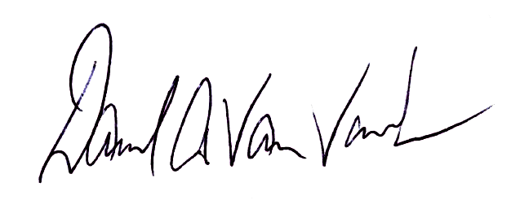
Yours sincerely,

Dave Van Voorhees
Chief, Fisheries Statistics Division
NOAA Fisheries, Office of Science and Technology

