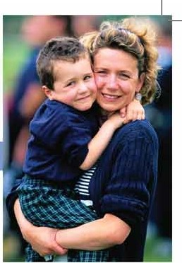
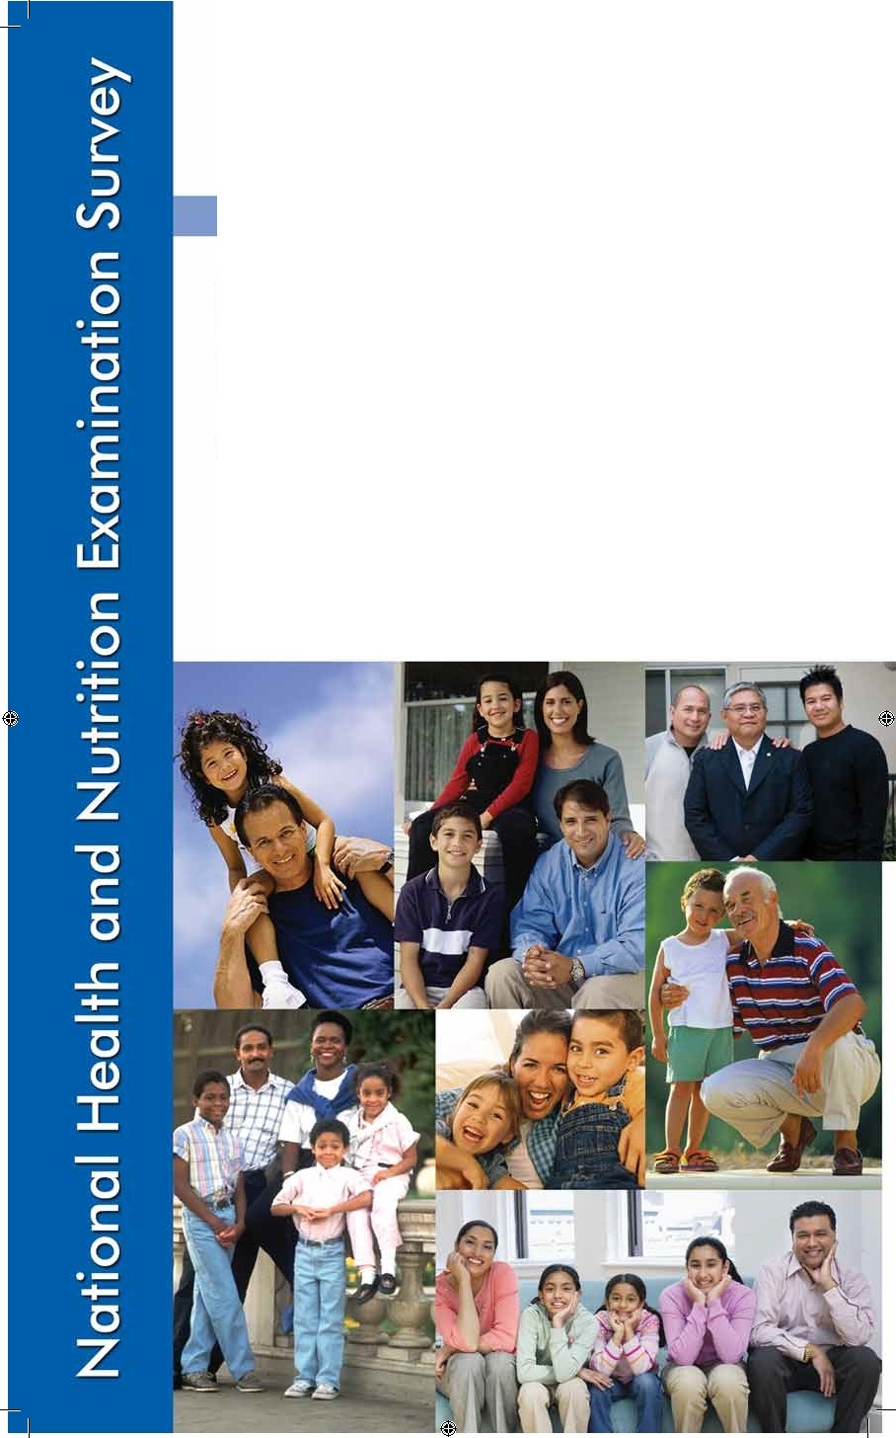
Attachment 5a

NHANES
Examination
Consent Brochure

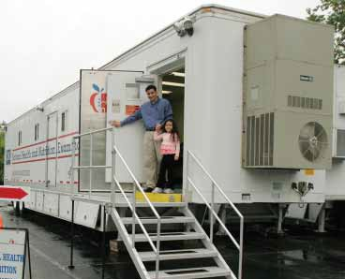
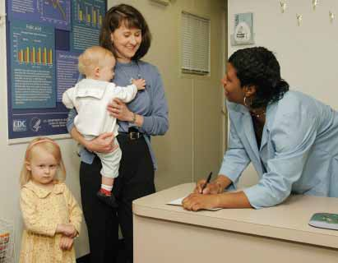
Overview
National Health and Nutrition Examination Survey

The National Health and Nutrition Examination Survey (NHANES) is a survey conducted by the National Center for Health Statistics, part of the Centers for Disease Control and Prevention. We have designed the survey to learn about the health and diet of people in the United States.

Our survey is unique. It combines a home interview with health
measurements, which we do in mobile units. These special mobile centers travel across the country with a highly trained medical team. Our team looks at special health topics. We use the most up-to-date methods and equipment for medical and dental exams and other lab tests.

Why is this health survey important?

We will use the data gathered in
this survey to find out the number of people with certain health problems— for example, diabetes and high blood pressure. We will look at diet and
other habits that affect health, such as smoking and exercise. NHANES data will tell us the health and nutrition of people of all ages. It will also help design health programs and services, and expand our knowledge about the health of people in the United States.

What do I gain by taking part in the exam?

• Free health test results.

• The chance to help learn more about the health of the
Nation.

• A token of thanks for your time and effort.

You may choose to be in the survey and you may allow your child to be in it, too. That is your choice. There is no penalty if you refuse. You may refuse any part of the exam and are free to drop out anytime. Also, during the interviews you may choose not to answer every question.

2

What will I be asked to do at the mobile center?

Upon arriving at the mobile center, you will be asked to change into a two-piece examination outfit.

Our medical team will then guide you to private rooms where we will check your:

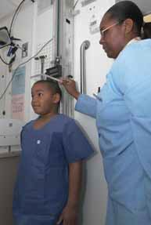
Height and weight

Blood pressure

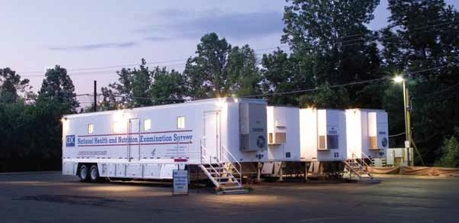
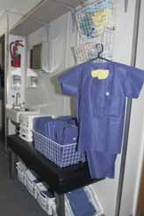
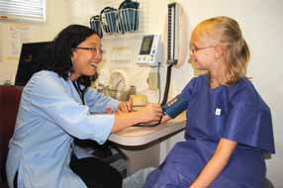

Physical Activity Ears

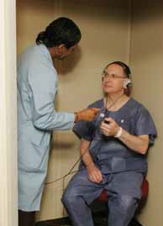
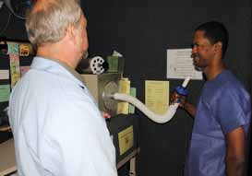

3

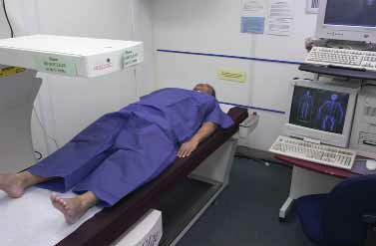
Teeth Body composition
National Health and Nutrition Examination Survey

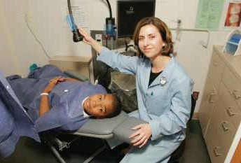

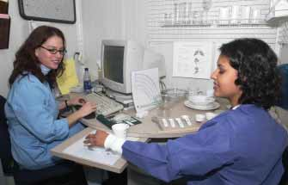
We will collect blood and urine samples
And ask you questions about what you eat

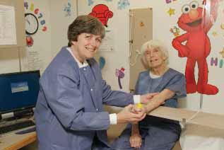

If your appointment is scheduled in the morning, we will ask you not
to eat or drink anything overnight. The health tests may take up to 4 hours. The time spent in the mobile center and the tests you receive will be based on your age and current medical condition. (For a full list of exams you may receive, see the Health Measurements List.)

Are the tests safe?

The tests are safe. Some tests may cause you slight discomfort. Examples are having a blood sample taken or not eating for 9 hours. For the blood sample, a person will have a small amount of blood drawn from a vein in his or her arm with a needle. People 12 years and older that have a morning exam will be asked to drink a sugary drink and have blood taken a second time. Although rare, the sugary drink can cause nausea, vomiting, bloating, or headache. We will not ask you to have any test that is wrong for you because of a health problem you have.

We will give a body composition test that involves low-dosage x-rays to persons aged 8 and older. Radiation exposure during this test is equal to a cross-country airline flight or a few days of natural background radiation. But because the body composition scan involves x-rays, no one who is pregnant should get this exam. We will get information about periods from girls and women, and those who have started their periods will have a urine pregnancy test. Those with a positive test will not have the body composition scan.

4

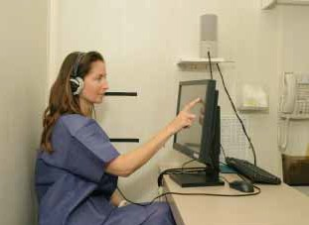
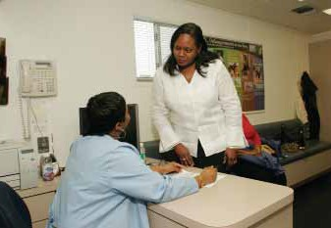

Medical errors and injuries are very rare. The NHANES program cannot provide money or other compensation if they occur. However, if you believe you have been harmed as a result of your participation in NHANES, we want to know about it. Please call us at 1–800–452–
6115. You also have a right to file a claim under the Federal Tort Claims Act with the Centers for Disease Control and Prevention. We can provide you with information about how to do so. You must file the claim within two years after the date you became aware of the personal injury, loss of property, or other damage.

Will you ask personal questions?

At the mobile center you will be asked some personal questions. A
trained interviewer will ask some of these questions. Other questions, like those about stages of body development for children and teens, sexual behaviors, and drug use, will
be asked in complete privacy. The interviewer will leave the room. The questions will be on
a computer screen. You answer by touching an answer on the screen.

Like all of the other data we collect, the answers you give us are kept strictly private. If you are under 18 years of age, we may notify your parents if we have reason to believe you may harm yourself because of sad feelings.

Will I get my results?

Yes, you will get a report of your results. If the exam shows urgent health problems, we will notify you at once
and refer you for treatment. If some urgent problem is found through your lab tests, we will immediately send that information in
a letter to your home address. If you wish, we will mail the routine results to you about
3–4 months after the exam. In general, we give results only to the person examined
or to the parents or guardians of children.
Some results, like those for sexually transmitted disease (STD) tests and pregnancy tests, are not put in writing. We report positive pregnancy test results only to the person tested if she is 14 years or older and doesn’t already know she is pregnant. If a girl is younger than 14 and has a positive pregnancy test, we will inform both her and her parent
or guardian. How we report STD test results is explained in the next section.

5

Some tests are not reported because they will be used only for research and are not used for medical care. Better ways to look at some of the tests may be developed in the future. Some of the tests may be read again. We will not report the results of future tests to you.
National Health and Nutrition Examination Survey

NHANES does not cover the cost of any health care you may decide
to get after the exam. If you have questions about getting your results, please call 1–800–452–6115.

Will you test for sexually transmitted diseases (STDs)?

Teenagers (14 years and older) and adults under 60 years will have tests for STDs. We will not put these results in writing, but you can get STD test results a few weeks after the exam.

Before you leave the mobile center, you will be given a toll-free number, a password, and the dates to call for your results. Only you will get your test results by calling in and telling us your password. Parents will not be told their child’s STD test results. If your test results show that you have a current health problem, we will talk with you about the results and tell you how to get treatment. We will keep all STD test results completely private, just like all other test results. If you do not want to be tested, you can tell a staff member. For details on the tests, please see the Health Measurements List.

Will my information be kept private?

We respect your privacy. Public laws keep all information you give private.

These laws do not allow us to give out data that identifies you or your family without your permission. This means that we cannot give out any facts about you, even if a court of law asks for them. However, if we
find signs of child abuse during an exam, we will report it to the local department of social services or the police.

We will keep all survey data safe and secure. When we share data with our partners, we do so in a way that protects your privacy as required and guaranteed by law. Our interviewer can provide you a list of our partners if you wish to learn more.

6

How are NHANES data used?

What you tell us, your exam results, and samples you give are a good resource for health science. Many federal agencies, universities, and other public and private groups use NHANES data. They use it to help find new cures and treatments for diseases and disabilities. The aim
is to make the health of all people better. Results of this survey may
be reported in journals, at major scientific meetings, or through other news media. None of these reports will ever name or use data that can point to any person who took part in the survey.

NHANES has been used in important national reports. One of these highlights the food we eat. Another tells us about the exposures we have to chemicals in the environment. The survey has also been used to track the number of people who are overweight or obese. Research using NHANES can be found on our website, listed on the back of this brochure.

Health research using NHANES can be enhanced by combining your survey records with other data sources. An example is linking your survey results with vital statistics and Medicare claims. To do this, we will ask your permission to collect your Social Security and Medicare numbers. As we told you before, we keep this information safe and secure.

Also, we may need to contact you in the future. To do this we will ask public or private agencies, such as the Post Office, to give us changes to your address. In the past, we have had the chance to call or revisit people who took part in this survey. We may contact you in the future to ask you to be part of other research projects. Your participation in future studies is voluntary.

7

More questions?
National Health and Nutrition Examination Survey

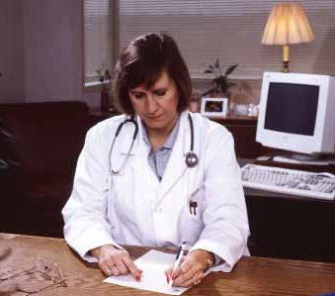
Our survey representative can discuss other questions or concerns you might have or give you printed material that can help you. She or he can give you
a phone number in your area that you can call for more facts about the survey.

Also, you can make a free call to
Dr. Kathryn Porter of the U.S. Public Health Service to discuss any aspect of the survey.

She can be reached at 1–800–452–6115, Monday–Friday, 8:30 a.m.–
6:00 p.m. EST. You may also contact her regarding any harm to you resulting from this survey. You can also get answers to your questions by mail (Room 4322, 3311 Toledo Rd., Hyattsville, MD 20782).

You may have questions about your rights as a participant in this research study. If so, please call the Research Ethics Review Board at
the National Center for Health Statistics, toll-free, at 1–800–223–8118. Please leave a brief message with your name and phone number.
Say that you are calling about Protocol # 2011-20. Your call will be returned as soon as possible.

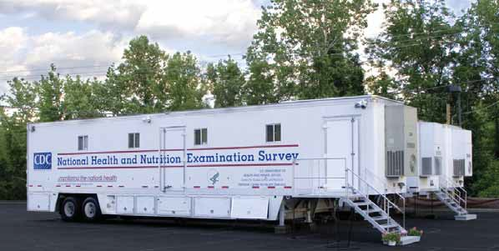

8

