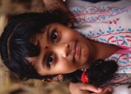
Examination Assent Brochure
Attachment 5b

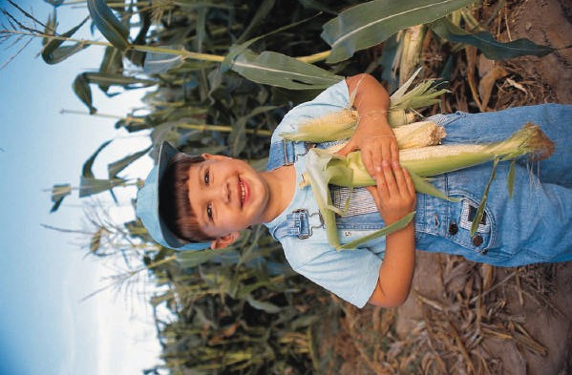

This booklet contains facts
National Health and Nutrition Examination Survey
for you about the National Health and Nutrition Examination Survey

2

The National Health and Nutrition
About Your Exam
Examination Survey (NHANES) studies the

health and diet of people in this country.

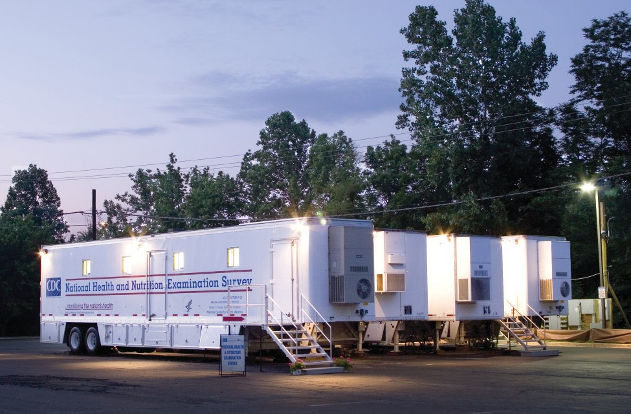
The survey will look at how young people grow
and develop. We will ask questions about what your body looks like. We will look at special health problems that may affect kids.

We go all over the United States in these vans.

3

Our survey wants you to come to this exam
National Health and Nutrition Examination Survey
center. The exam is like going to the doctor. Your exam will help us find out more about the health of children your age.

We will ask questions about what you eat and drink.

You will change into
special exam clothes at the exam center.

4

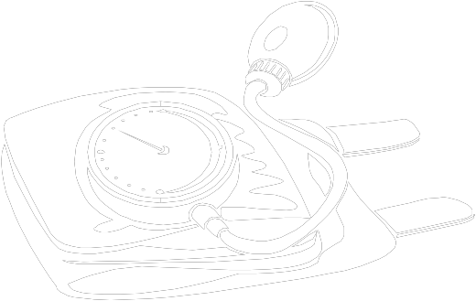
Our doctor will take
your pulse.
We will take your blood
pressure.
About Your Exam

5

4

3

2

We will see how much
you weigh and how tall you are.
We will look at your
teeth.

5

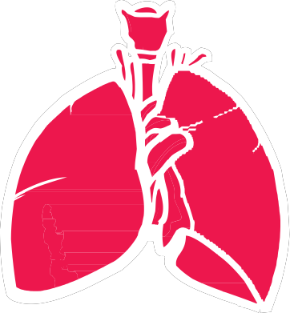
We will test your
National Health and Nutrition Examination Survey
activity level.

We will check your blood
and urine in our lab.

We will send you and
your parents a report on your exam.

6

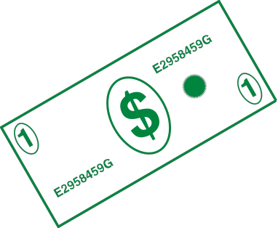
We will give you money
About Your Exam
to thank you for helping us with our survey.

Our staff will answer
any questions you have.

We would like you to go to our mobile exam
center vans for an exam. You will help us learn
more about all children in the United States. 7

Notes
8

