Attachment 6b. NY Mail-in eligibility screening survey and maps, licensed anglers
Form Approved
OMB No. 0923-XXXX
Exp. Date xx/xx/20xx xxxxxx/xx/xx/20xx

[Name and address from fishing license]
[Date of birth from fishing license]
Instructions:
- You can fill out this form or complete it online at [LINK TO ONLINE SURVEY].
- Please read statements #1-3 below. Mark the box at the right if the statement is true.
- Please correct your name, address, or date of birth above if they are wrong.
- Return the form in the stamped addressed envelope.
- Yes, I currently live at the address above.
- Yes, I have lived at this address for one year or longer.
- Yes, during 2011 <2012, I ate at least one fish that was caught in the bodies of water listed below.
Please look at the enclosed maps and read this list of bodies of water. We want to know if you have eaten fish that were caught in any of these rivers, creeks, lakes, or ponds.
- Buffalo area including the Buffalo River, Cazenovia Creek, Niagara River, Hoyt Lake, shore of Lake Erie in Buffalo
- Lockport area in Erie County including the area around Eighteenmile Creek, shore of Lake Ontario near the mouth of Eighteenmile Creek, Hopkins Creek, Keg Creek, Golden Hill Creek, Johnson Creek, Bull Creek, Erie Canal
- Rochester area including Genesee River, Rochester Embayment (Lake Erie between Bogus Point and Nine Mile Point), Irondequoit Bay, creeks, lakes, and ponds along the Rochester Embayment (see map), Erie Canal

If you checked all three boxes above, please fill out the information below. (This information will be used for this project only.)
Email address: __________________________________________________
Telephone numbers where we can reach you:
(_________) _________ - ______________ home/work/cell (circle one)
(_________) _________ - ______________ home/work/cell (circle one)
(_________) _________ - ______________ home/work/cell (circle one)
Check the best days and times to reach you by telephone.
 | Mon. | Tues. | Wed. | Thurs. | Fri. | Sat. | Sun.
Morning
Afternoon
Evening
Thank you for filling out this survey and returning it to us.
Public reporting burden of this collection of information is estimated to average 5 minutes per response for total participation, including the time for reviewing instructions, searching existing data sources, gathering and maintaining the data needed, and completing and reviewing the collection of information. An agency may not conduct or sponsor, and a person is not required to respond to collection of information unless it displays a currently valid OMB control number. Send comments regarding this burden estimate or any other aspect of this collection of information, including suggestions for reducing this burden to CDC/ATSDR Reports Clearance Officer; 1600 Clifton Road, MS D-74, Atlanta, GA 30333, ATTN: PRA (0923-XXXX).
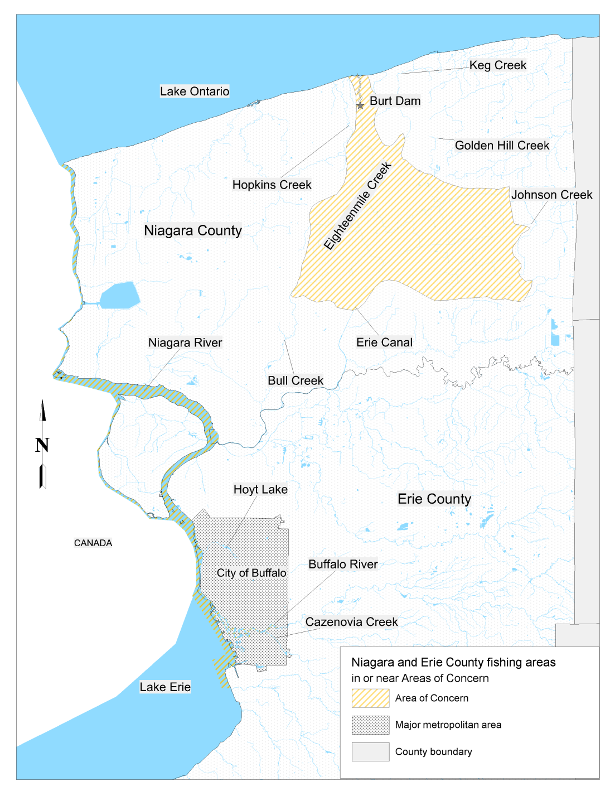
Map of the Buffalo and Lockport areas

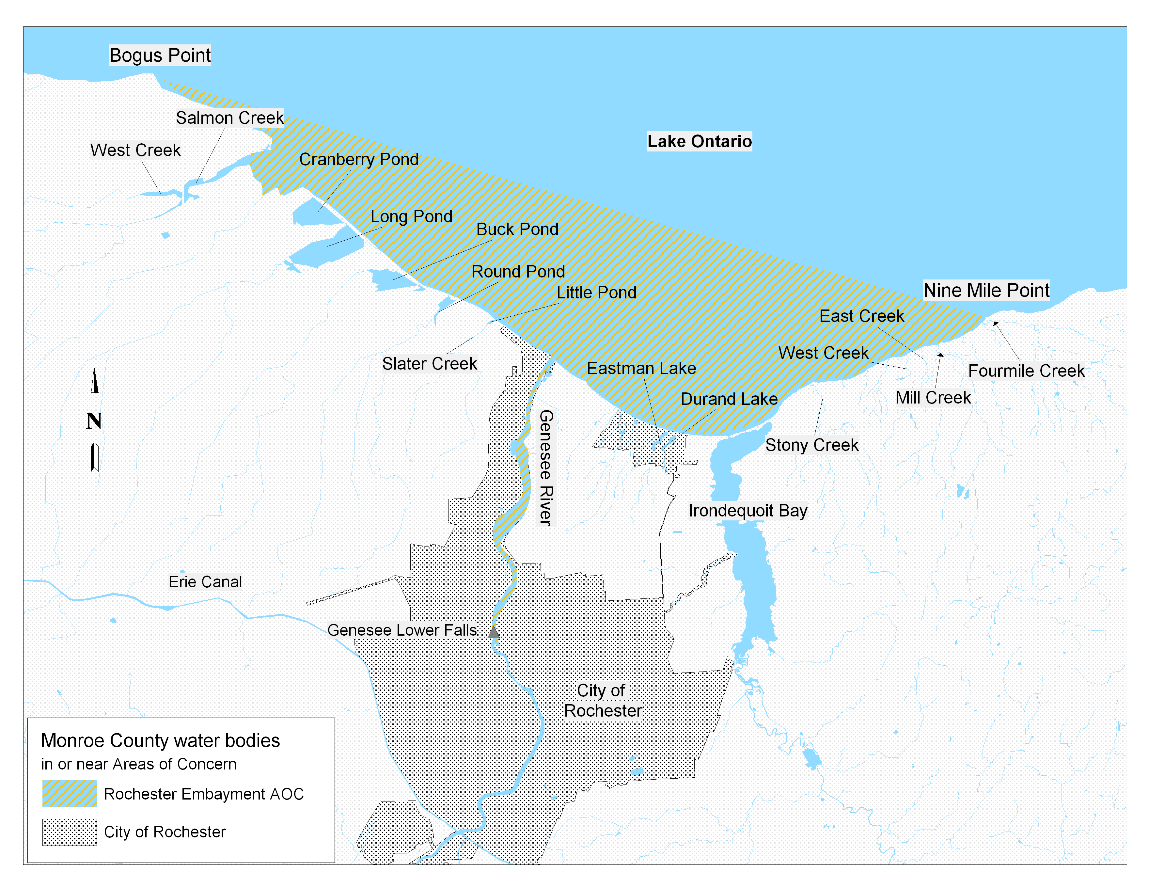
Map of the Rochester area

