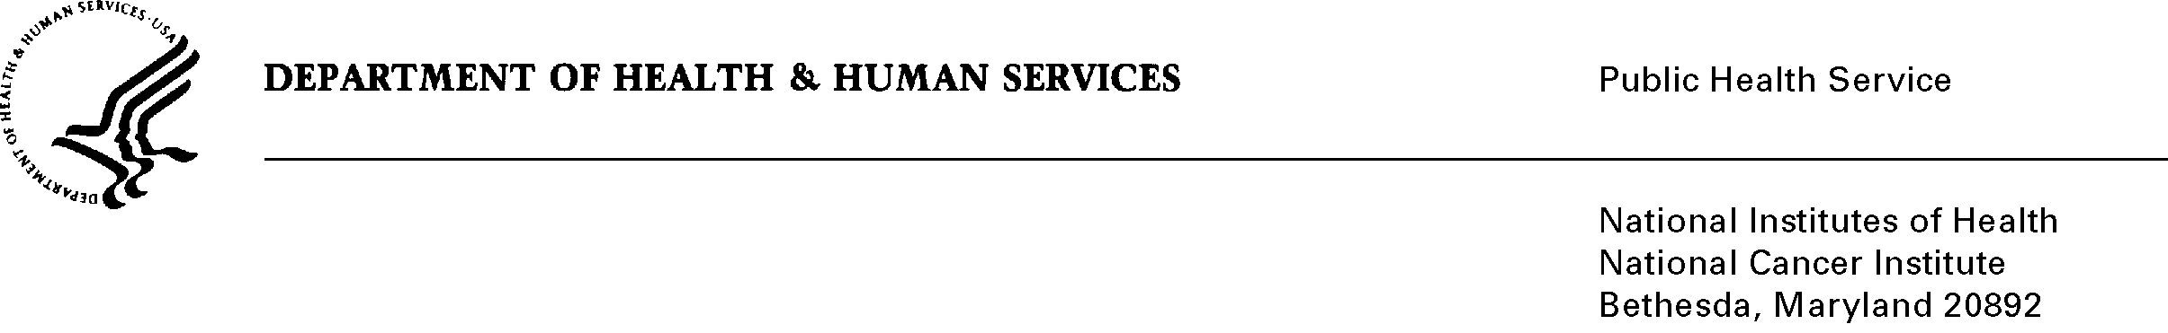
TO: Office of Information and Regulatory Affairs,
Office of Management and Budget

THRU: Department of Health and Human Services
Office of the Chief Information Officer
Office of Resources Management

FROM: Mikia P. Currie, Program Analyst

SUBJECT: Title Change for 0925-0002 Individual Ruth L. Kirschstein National Research Service Award Applications and Related Forms, Expiration date 8/2015

This change request is being submitted to change the title of 0925-0002 to PHS Research Performance Progress Report and Other Post-award Reporting. The submission represented a consolidation of post-award reporting requirements into a revised data collection.

