Date: September 25, 2012

TO: Office of Management and Budget (OMB)

Through: Keith Tucker, Reports Clearance Officer, HHS
Seleda Perryman, Program Clearance Officer, NIH
Vivian Horovitch-Kelley, PRA OMB Project Clearance Liaison, NCI

FROM: Christine D. Berg, Chief, Early Detection Research Group
National Cancer Institute (NCI)/NIH

SUBJECT: Revisions of Prostate, Lung, Colorectal, and Ovarian Cancer Screening Trial (PLCO) (OMB No. 0925-0407, Expiry Date: 9/30/2014)

This is a request for OMB to approve the revision of the submission titled, “Prostate, Lung, Colorectal and Ovarian Cancer Screening Trial (PLCO)” for 3 years.

We are submitting for re-approval in advance of the schedule due to a replacement in one of the study questionnaires. The investigators have chosen to replace the Supplemental Questionnaire (SQX) with the Medication Use Questionnaire (MUQ). There is a lack of research on commonly used medication in relation to cancer incidence and major causes of cancer mortality in the elderly population. As PLCO participants now range from 74-94 years of age, we focus on collecting additional information on medications that are particularly common among older adults. This change results in a decrease in the total number of annual burden hours.
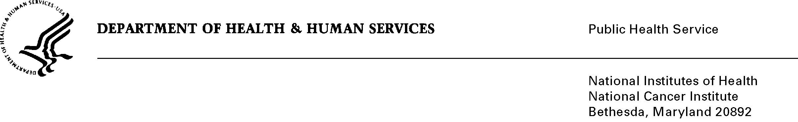
This trial was designed to determine if screening for prostate, lung, colorectal, and ovarian cancer can reduce mortality from these cancers which currently cause an estimated 255,700 deaths annually in the U.S. The design is a two-armed randomized trial of men and women aged 55 to 74 at entry. OMB first approved this study in 1993 and has approved it every 3 years since then through 2014. During the first approval period a pilot study was conducted to evaluate recruitment methods and data collection procedures. Recruitment was completed in 2001, screening was completed in 2006, and data collection continues through 2016. When participants enrolled in the trial, they agreed to be followed for at least 13 years from the time of enrollment. In 2011, participants were re-consented for at least an additonal 5 years of follow-up.

The current number of respondents in the study is limited to the approximately 94,000 participants being actively followed up. This is down from the initial total. The reports on screening and prostate, lung, colorectal, and ovarian cancer mortality based on this trial have been published in peer review medical journals. The additonal follow-up will provide data that will further clarify the long term effects of the screening on cancer incidence and mortality for the four targeted cancers. Further, demographic and risk factor information may be used to analyze the differential effectiveness of screening in high versus low risk individuals.

