APPENDIX 1C Revised
(October, 2012)

REACTIVE SMOKING CESSATION Questions
customer service and demographics questions -
TEXT AND SCREENSHOTS

DATA COLLECTION INSTRUMENTS and
electronic contact Record Form (ECRF)

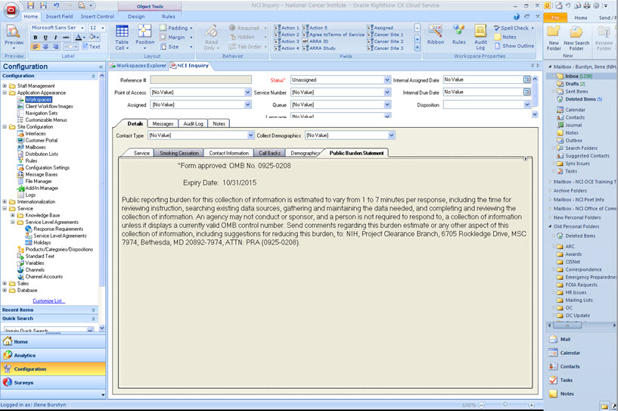

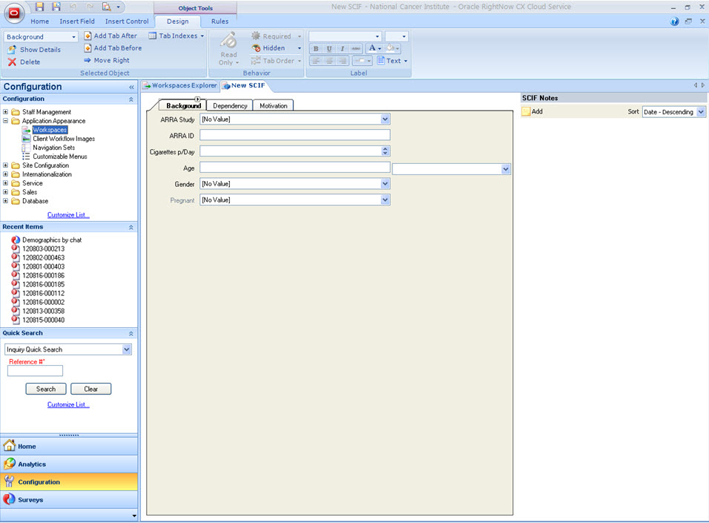

BACKGROUND

1. On the average, about how many cigarettes do you now smoke each day?
- Free text or value 999 = “Did not ask”

- What is your age?
- Free text
Or
- Callers age 95 or older = 95
- Don't know = 00
- Refused = 98
- Did not ask = 99

- Are you female or male?
- Female = 1
- Male = 2

- To the best of your knowledge, are you pregnant?
- Yes = 1
- No = 2
- Valid Skip = 3
- Don’t know = 4
- Refused = 8
- Did not ask = 9

Smoking Cessation Intake Form (SCIF): Dependency Tab > Summary

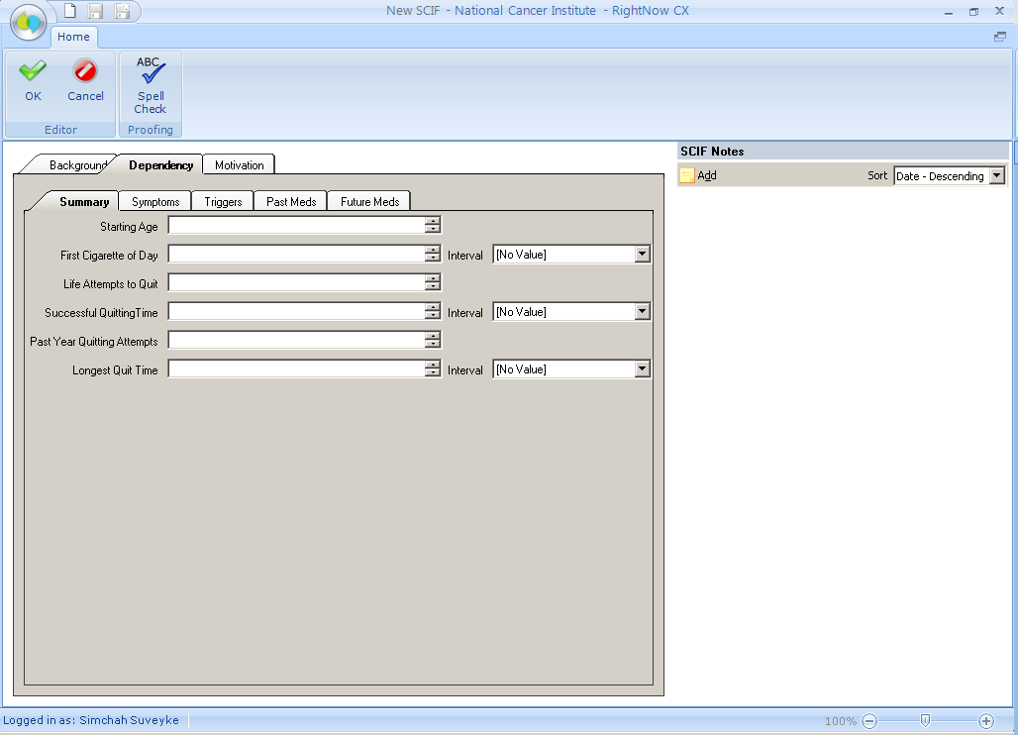
DEPENDENCY

- Age when starting smoking cigarettes regularly?
- Free text or value 999 = “Did not ask”

- First cigarette of the day after awakening?
- Free text or value 999 = “Did not ask
UNIT REPORTED
- Minutes = 1
- Hours = 2

- In life, number of quit attempts for 1 day or longer?
- Free text or value 999 = “Did not ask”

- Duration (beyond a day) of successful quitting?
- Free text or value 999 = “Did not ask”
UNIT REPORTED
- Days = 1
- Weeks = 2
- Months = 3
- Years = 4

- In past year, number of quit attempts?
- Free text or value 999 = “Did not ask”

- Longest time quit?
- Free text or value 999 = “Did not ask”
UNIT REPORTED
- Days = 1
- Weeks = 2
- Months = 3

Smoking Cessation Intake Form (SCIF): Dependency Tab Symptoms
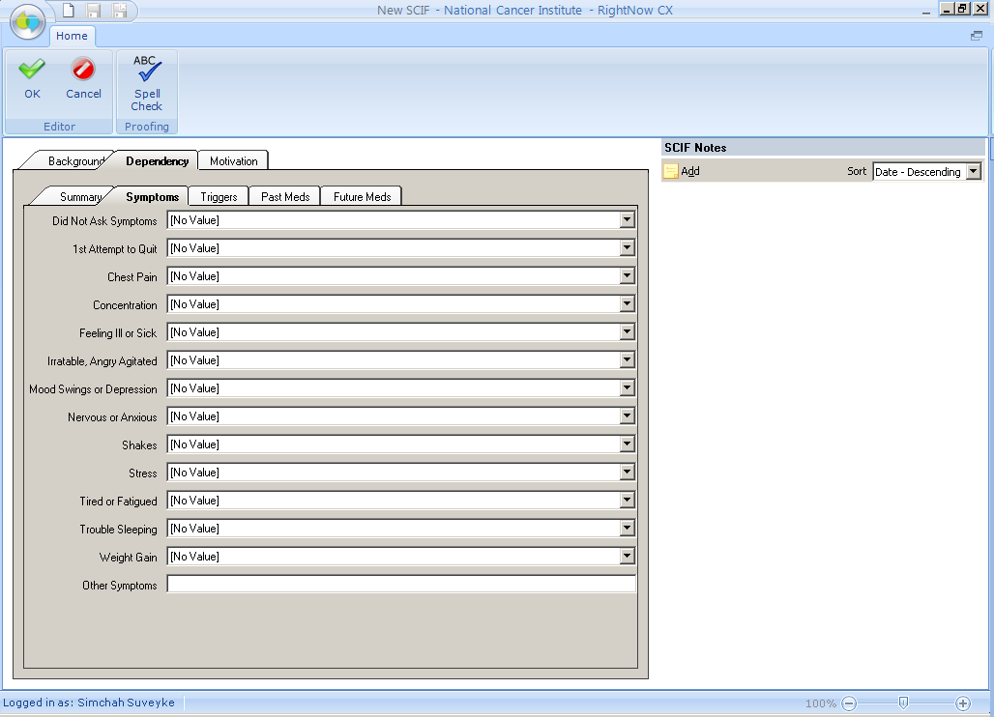
- Symptoms experienced after quitting? (can select multiple values)
- Feeling irritable, angry, agitated = 1
- Mood swings, depressed, down, or blue = 1
- Nervous, anxious, jumpy = 1
- Cravings = 1
- Trouble sleeping, nightmares, dreams = 1
- Has not tried to quit before (1st quit attempt) = 1
- Weight gain = 1
- Increased appetite or hunger = 1
- Tired, fatigued = 1
- Feeling ill/sick/nausea/general malaise = 1
- Headache = 1
- Chest pain, shortness of breath = 1
- Stress = 1
- Unable to concentrate = 1
- Dizzy/lightheaded = 1
- Shakes = 1
- Did not ask = 1
- Other = 1 If “other”, describe = Free text

Smoking Cessation Intake Form (SCIF): Dependency Tab > Triggers
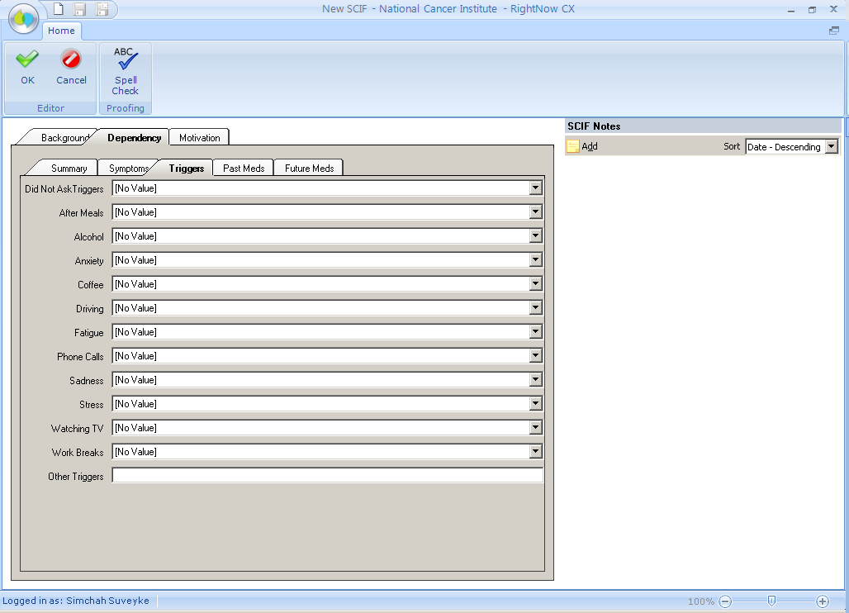

- Triggers? (can select multiple values)
- Alcohol = 1
- Sadness = 1
- Anxiety = 1
- Stress = 1
- Fatigue = 1
- After Meals = 1
- Coffee = 1
- Work breaks = 1
- Driving = 1
- Watching TV = 1
- Phone calls = 1
- Did not ask = 1
- Other = 1 If “other”, describe = Free text

Smoking Cessation Intake Form (SCIF): Dependency Tab > Past Meds
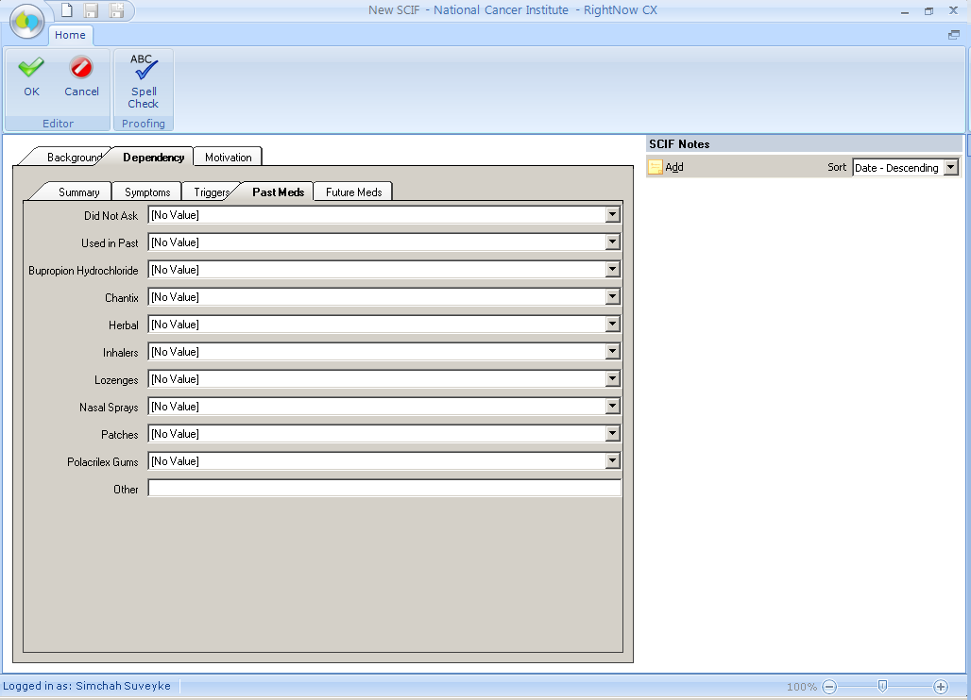
- Used medication in the past?
- Yes = 1
- No = 1
- Did not ask = 99

If Yes (can select multiple values)
- Patches = 1
- Polacrilex Gums = 1
- Lozenges = 1
- Inhalers = 1
- Nasal Sprays = 1
- Bupropion Hydrochloride (e.g. Zyban, Wellbutrin) = 1
- Other = 1 If “other”, describe = Free text
- Herbal (e.g. Smoke Away) = 1
- Chantix = 1

Smoking Cessation Intake Form (SCIF): Dependency Tab > Future Meds
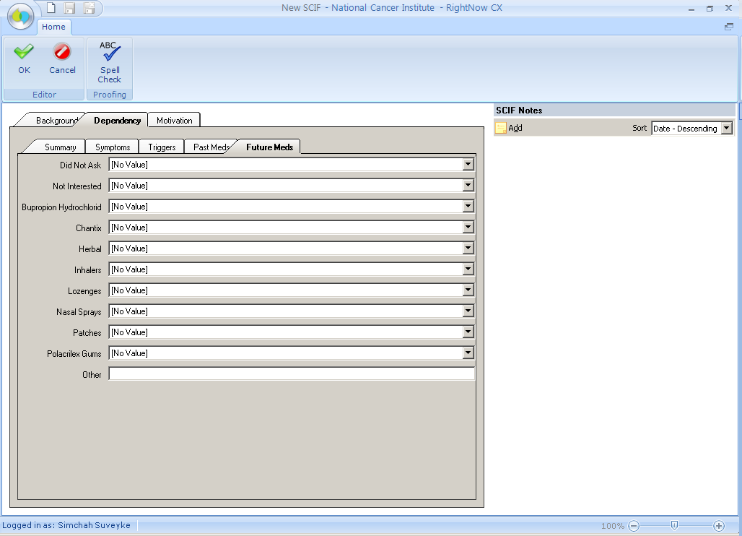
- Is medication to help quit a consideration this time?
- Yes = 1
- No = 1
- Did not ask = 99

If Yes (can select multiple values)
- Patches = 1
- Polacrilex Gums = 1
- Lozenges = 1
- Inhalers = 1
- Nasal Sprays = 1
- Bupropion Hydrochloride (e.g. Zyban, Wellbutrin) = 1
- Other = 1 If “other”, describe = Free text
- Herbal (e.g. Smoke Away) = 1
- Not sure/Don't know= 1
- Chantix = 1

Smoking Cessation Intake Form (SCIF): Motivation Tab
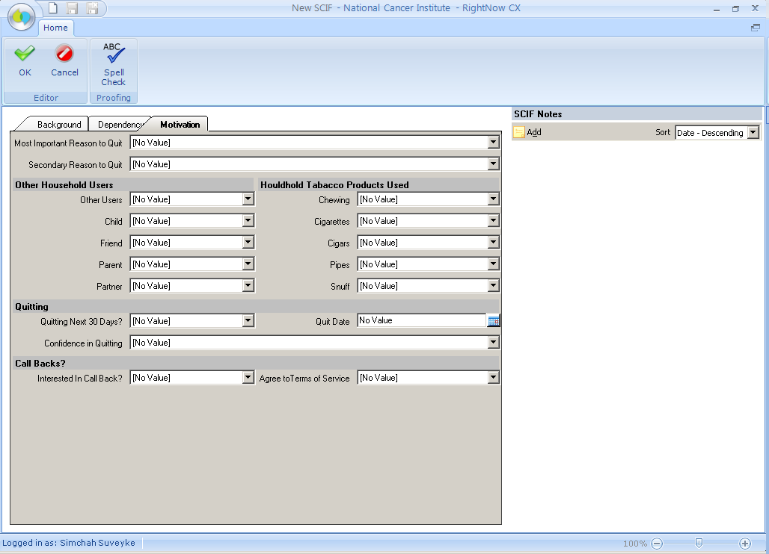
MOTIVATION
- Most important reason for wanting to quit?
- Restrictions placed on smokers in restaurants, work, and other public places = 1
- Family or friends = 2
- To feel more in control of your life = 3
- To improve your health (live longer, recent cancer diagnosis) = 4
- To save money = 5
- Because your doctor told you to = 6
- Because of your children (grandkids) = 7
- For a healthy pregnancy = 8
- Just tired of smoking = 9
- Other = 10 If “other”, describe = Free text
- Professionalism/Role model = 11
- Extracurricular activities (ex. Basketball, jogging, dancing, volleyball, etc.) = 12
- Religious reasons = 13
- Age = 14
- Concern about cancer prompted by death of family member or public figure = 15
- Dirty/bad habit = 16
- Smell = 17
- Did not ask = 99

- Secondary Reason?
- Restrictions placed on smokers in restaurants, work, and other public places = 1
- Family or friends = 2
- To feel more in control of your life = 3
- To improve your health (live longer, recent cancer diagnosis) = 4
- To save money = 5
- Because your doctor told you to = 6
- Because of your children (grandkids) = 7
- For a healthy pregnancy = 8
- Just tired of smoking = 9
- Other = 10 If “other”, describe = Free text
- Professionalism/Role model = 11
- Extracurricular activities (ex. Basketball, jogging, dancing, volleyball, etc.) = 12
- Religious reasons = 13
- Age = 14
- Concern about cancer prompted by death of family member or public figure = 15
- Dirty/bad habit = 16
- Smell = 17
- No other reason = 18
- Did not ask = 99

- Person most likely to positively influence effort to quit?
- Your spouse = 1
- Your domestic partner/significant other (boyfriend/girlfriend) = 2
- Your friend (neighbors) = 3
- Your boss or co-worker = 4
- Your parent = 5
- Your child (grandkids) = 6
- Health Professional = 7
- Other = 10 If “other”, describe = Free text
- No one = 11
- Don't know = 12
- Church leader/member = 13
- Self = 14
- Extended family (sibling, in-laws, aunt/uncle) = 15
- Did not ask = 99

- Others in the household currently using tobacco products (one or more)?
- Yes = 1
- No = 2
- Did not ask = 99
If Yes (can select multiple values)
- Your spouse = 1
- Your domestic partner/significant other = 2
- Your friend = 3
- Your parent = 4
- Your child = 5
- More than 1 person = 6

- Chewing = 1
- Snuff = 1
- Pipes = 1
- Cigars =1
- Cigarettes = 1

QUITTING

- Interest in quitting within next 30 days?
- Yes = 1
- No = 2
- Don’t know = 4
- Refused = 8

- Confidence in ability to quit within the next 30 days?
- Not confident at all = 1
- Somewhat confident = 2
- Neutral = 3
- Confident = 4
- Very confident = 5

- Quit Date? Date Value

CALLBACK

- Interest in Callback Service?
- Yes = 1
- No = 2

- Acceptability in terms of service?
- Yes = 1
- No = 2 If “No”, describe concerns = Free text

Electronic Coding Records Form (ECRF): seen within the Service Tab
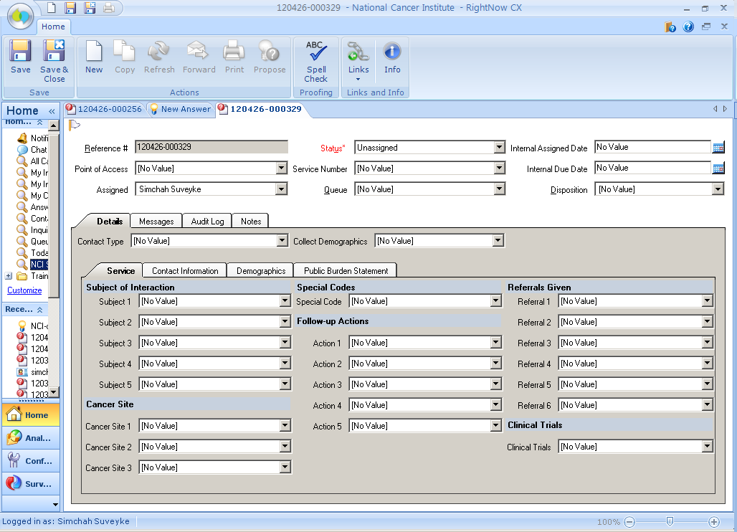

CALLBACK NOTE

- Callback #1
- Smoker Name = Free Text (derive from Name field on Contact tab)
- Phone = Free Text (derive from Name field on Contact tab)
- Call Date = Free text (from Callback Tracker)
- Time = Free text (from Callback Tracker)
- Notes = Free text
- Caller Quit
- Yes = 1
- No = 2
- Disposition (from Callback Tracker)

- Callback #2
- Smoker Name = Free Text (derive from Name field on Contact tab)
- Phone = Free Text (derive from Name field on Contact tab)
- Call Date = Free text (from Callback Tracker)
- Time = Free text (from Callback Tracker)
- Notes = Free text
- Caller Quit
- Yes = 1
- No = 2
- Disposition (from Callback Tracker)

- Callback #3
- Smoker Name = Free Text (derive from Name field on Contact tab)
- Phone = Free Text (derive from Name field on Contact tab)
- Call Date = Free text (from Callback Tracker)
- Time = Free text (from Callback Tracker)
- Notes = Free text
- Caller Quit
- Yes = 1
- No = 2
- Disposition (from Callback Tracker)

- Callback #4
- Smoker Name = Free Text (derive from Name field on Contact tab)
- Phone = Free Text (derive from Name field on Contact tab)
- Call Date = Free text (from Callback Tracker)
- Time = Free text (from Callback Tracker)
- Notes = Free text
- Caller Quit
- Yes = 1
- No = 2
- Disposition (from Callback Tracker)

Spanish Version

Electronic Coding Records Form (ECRF): seen within the Service Tab

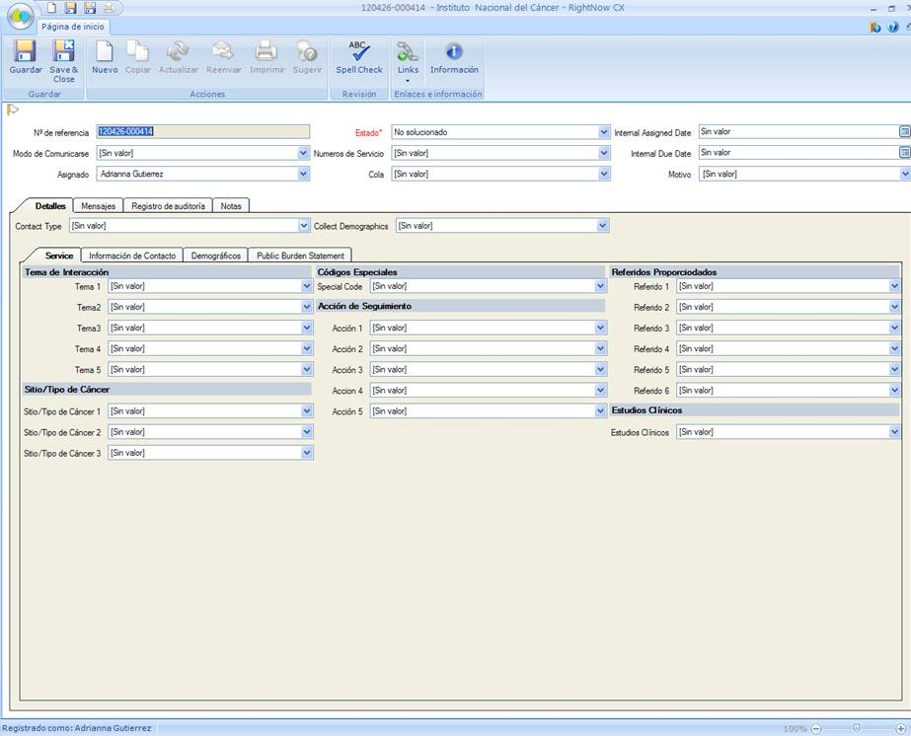

Customer Service Questions
Customer Service Questions Asked of CIS Client:
      - Have you used our service before?
      - How did you find our number to call?
      - What is your zip code?

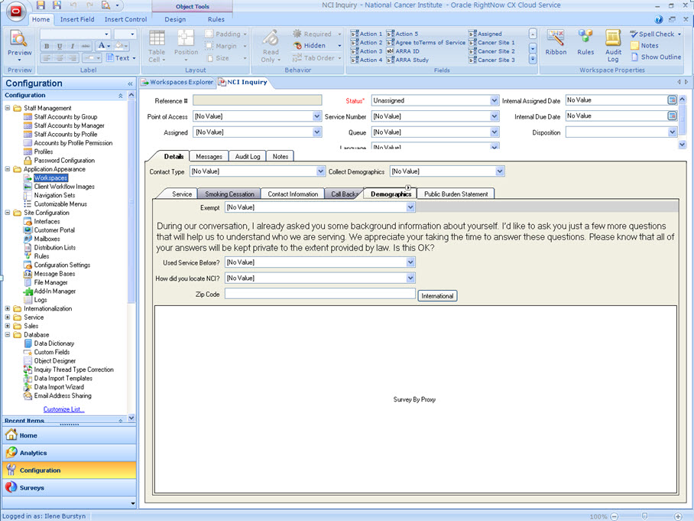

CONTACT
- Name (First, Middle, Last) = Free text
- Address 1 = Free text
- Address 2 = Free text
- Address 3 = Free text
- City = Free text
- County = Free text
- State = Free text
- ZIP Code = Free text, ZIP Code plus 4 = Free text
- Email = Free text
- Phone (Area, Prefix, Suffix) = Free text, Extension = Free Text
Phone Type
- Home
- Work
- Cell
Note = Free text

- Alt. Phone (Area, Prefix, Suffix) = Free text, Extension = Free Text
Phone Type
- Home
- Work
- Cell

Note = Free text

Demographic Survey Text Questions
What is your age?
Age
Don’t know
Break off
Did not complete
Callers age 96 or older
Not sampled
Refusal
Did not ask

Which of These Ethnicities Best Describes You?
Hispanic or Latino
Not Hispanic or Latino

Which of These Races Best Describes You? You can select more than one:
American Indian or Alaska Native
Asian
Black or African American
Native Hawaiian or Other Pacific Islander
White

What Is the Highest Level of Education You Have Completed?
Grade school
Some high school
High school graduate
Some college
College graduate
Post-graduate
Not sampled
Refusal
Did not ask
Don’t know
Did not complete

Is There a Place You Usually Go to When You are Sick or Need Advice About Your Health?
Yes
No
Don't Know
Did not complete
Not sampled
Refused
Did not ask

What Kind of Place Do You Go Most Often?
A doctor’s office
A clinic, health center, or hospital clinic
The emergency room, or
Some other place
No one place
Valid skip
Don’t know
Did not complete
Not sampled
Refused
Did not ask

In the Last 12 Months, Did You Have Any Kind of Healthcare Coverage, Including Health Insurance, Prepaid Plans Such As HMOs or Government Plans Such as Medicare?
Yes
No
Don’t know
Did not complete
Not sampled
Refused
Did not ask

Would You Say You Had This Coverage During All 12 Months or Less Than 12 Months?
All 12 months
Less than 12 months
Valid skip
Don’t know
Did not complete
Not sampled
Refused
Did not ask

Which Type of Coverage Did You Have?
Was it public, such as Medicare, Medicaid, or other government plans?
Was it private, such as an HMO, Blue Cross, Kaiser, Aetna?
Or, was it both public and private?
Valid skip
Don’t know
Did not complete
Not sampled
Refused
Did not ask

The final questions are about your family income. I understand that this is sensitive information and I would like to stress again that all of the information you provide is confidential. What Was Your Total Household Income from All Sources Before Taxes Last Year? Just Stop Me When I Get to the Right Category
Less than $10,000
$10,000 to $19,000
$20,000 to $29,000
$30,000 to $39,000
$40,000 to $59,000
$60,000 to $79,000
$80,000 or more
Don’t know
Did not complete
Not sampled
Refused

Including Yourself, How Many People Living in Your Household are Supported by This Total Household Income?
Total People
Valid skip
Don’t know
Did not complete
Not sampled
Refused
Did not ask

Demographic Survey Screen Shots

Note: The Information Specialist only asks callers their age. The other radio buttons are only for internal coding.

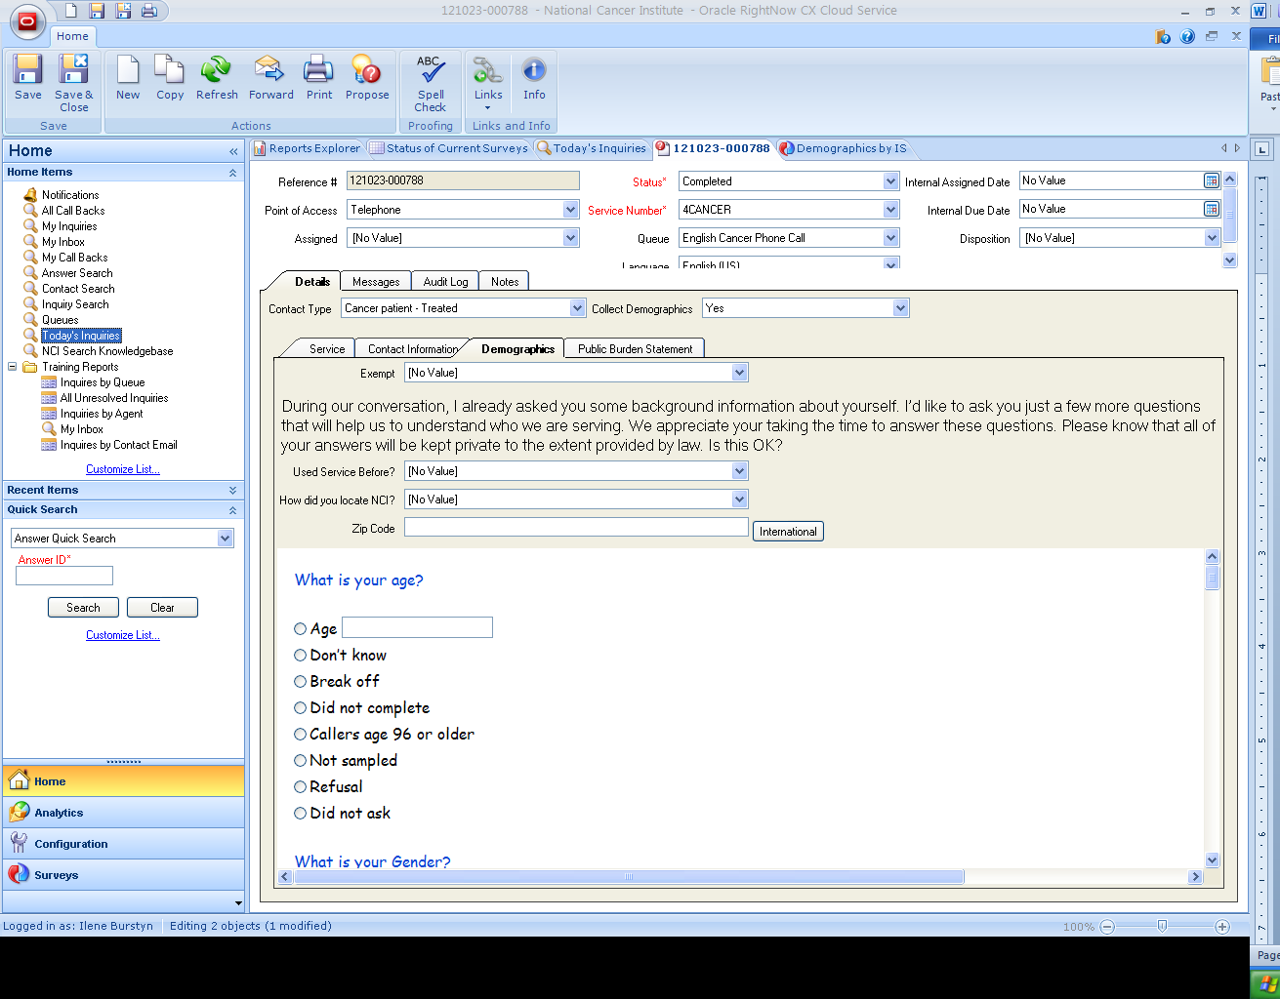

Note: The Information Specialist only asks callers their gender. The other radio buttons are only for internal coding.

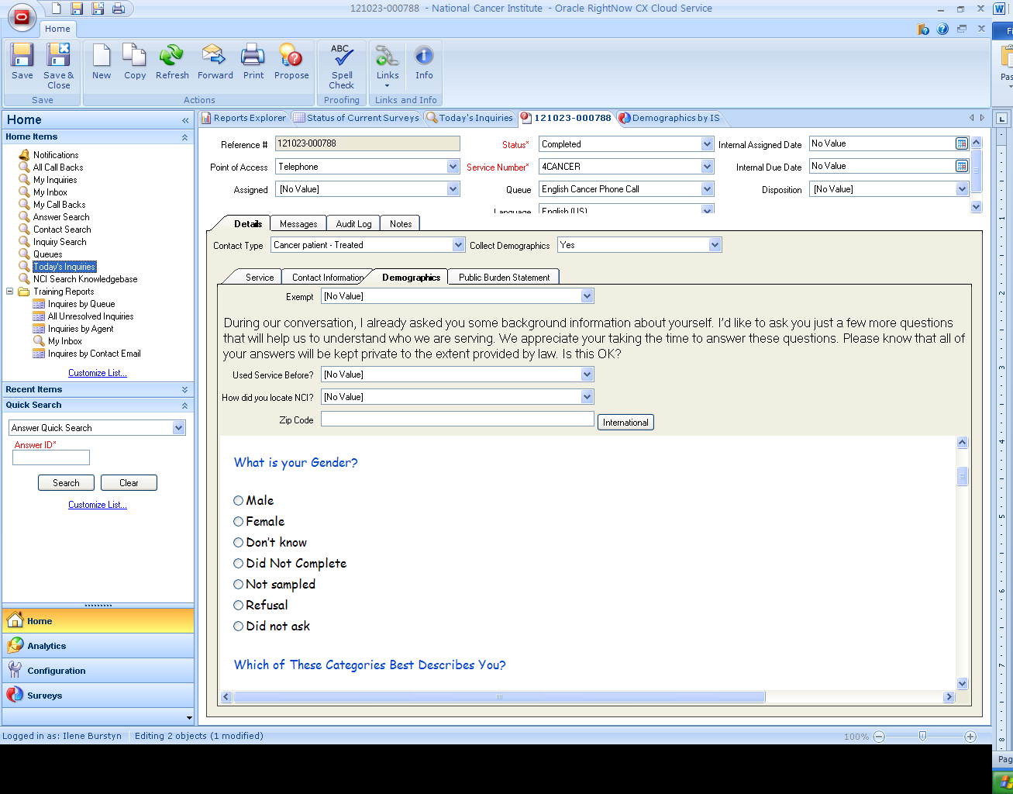
Note: The Information Specialist only asks callers whether they are Hispanic or Latino or Not Hispanic or Latino. The other radio buttons are only for internal coding.

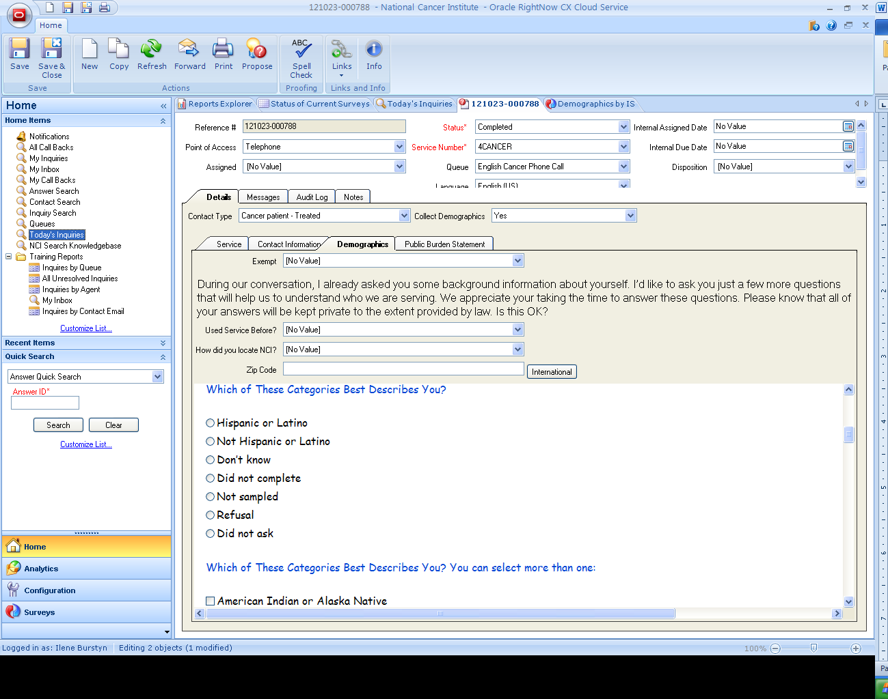

Note: The Information Specialist only asks callers their heritage (first 5 options). The other radio buttons are only for internal coding.

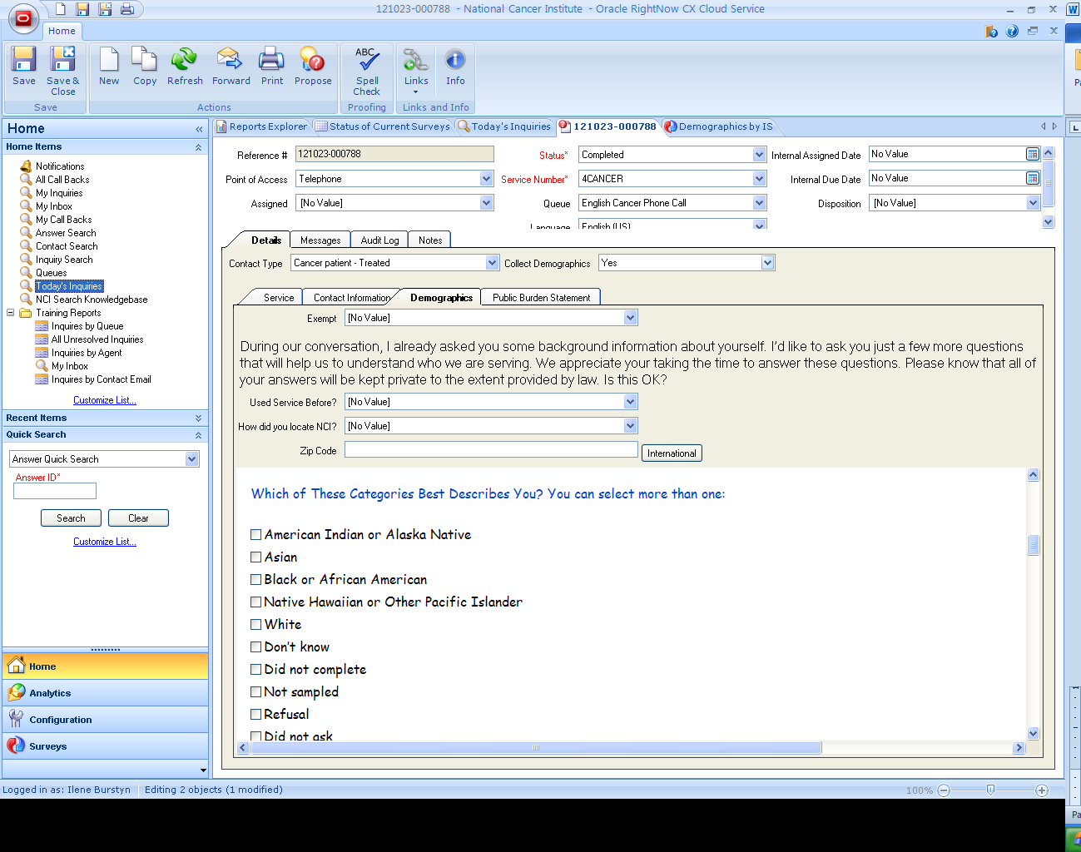
Note: The Information Specialist only asks callers their level of education. The other radio buttons are only for internal coding.

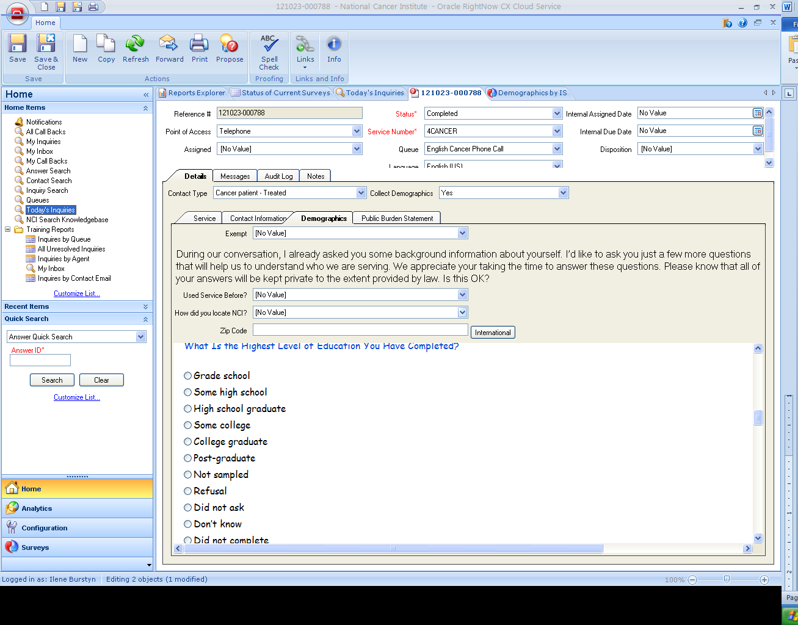

Note: The Information Specialist only asks callers if there is a specific place they go to for medical advice. The other radio buttons are only for internal coding.

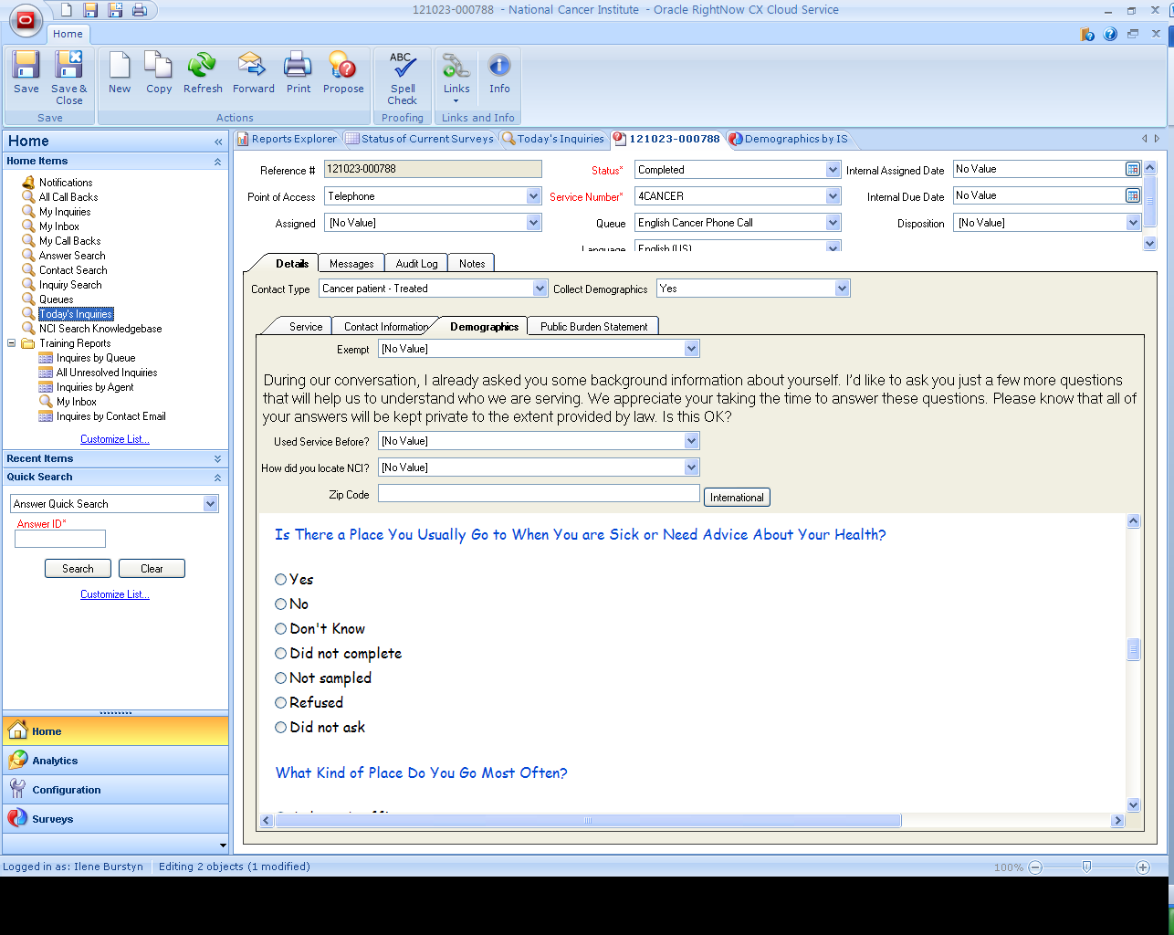

Note: The Information Specialist only asks callers where they go for medical advice. The other radio buttons are only for internal coding.

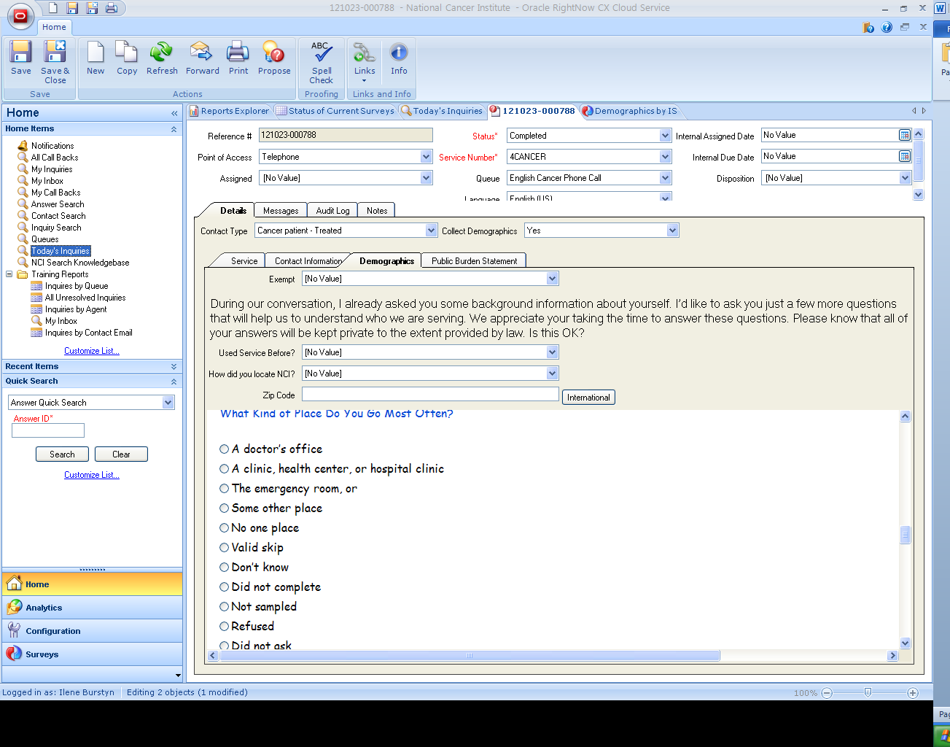

Note: The Information Specialist only asks callers if they have healthcare coverage including health insurance, prepaid plans such as HMOs, or government plans such as Medicare. The other radio buttons are only for internal coding.

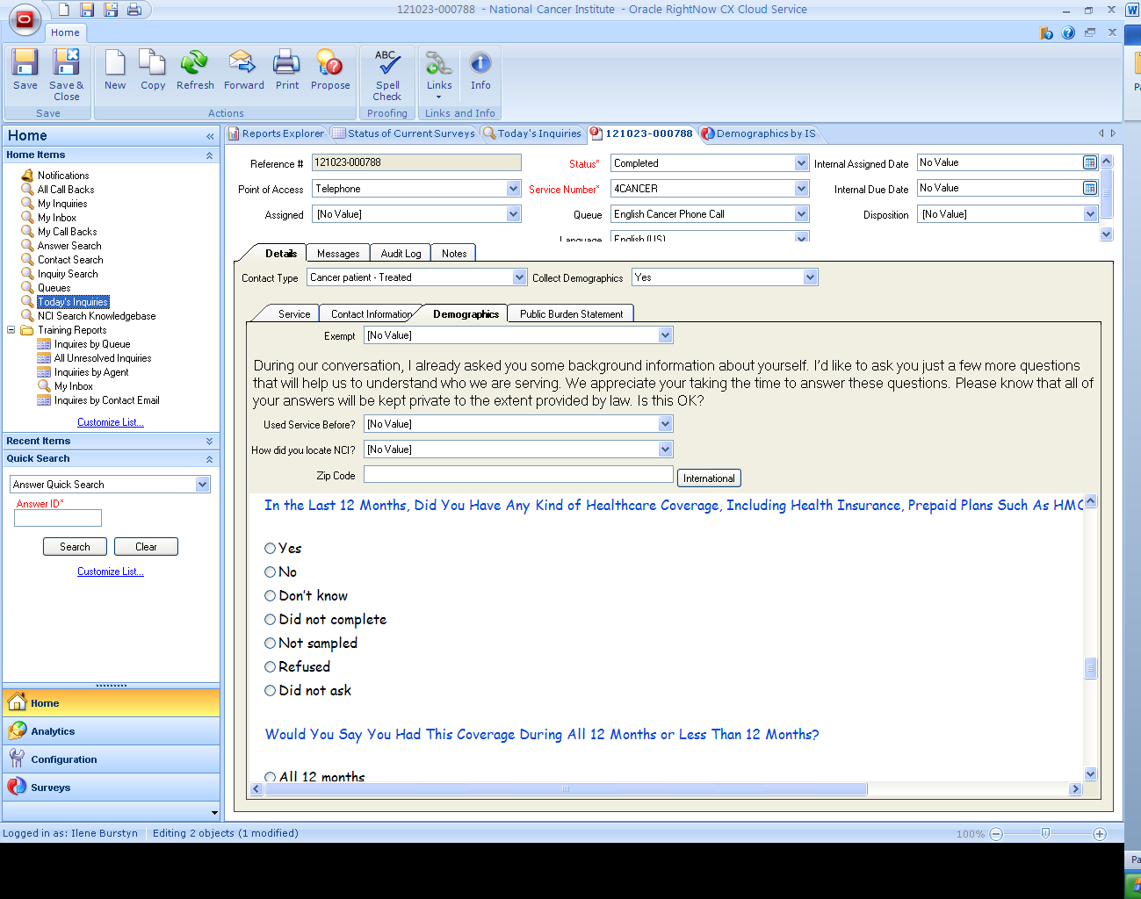

Note: The Information Specialist only asks callers whther or not the have had coverage for 12 months or less than 12 months. The other radio buttons are only for internal coding.

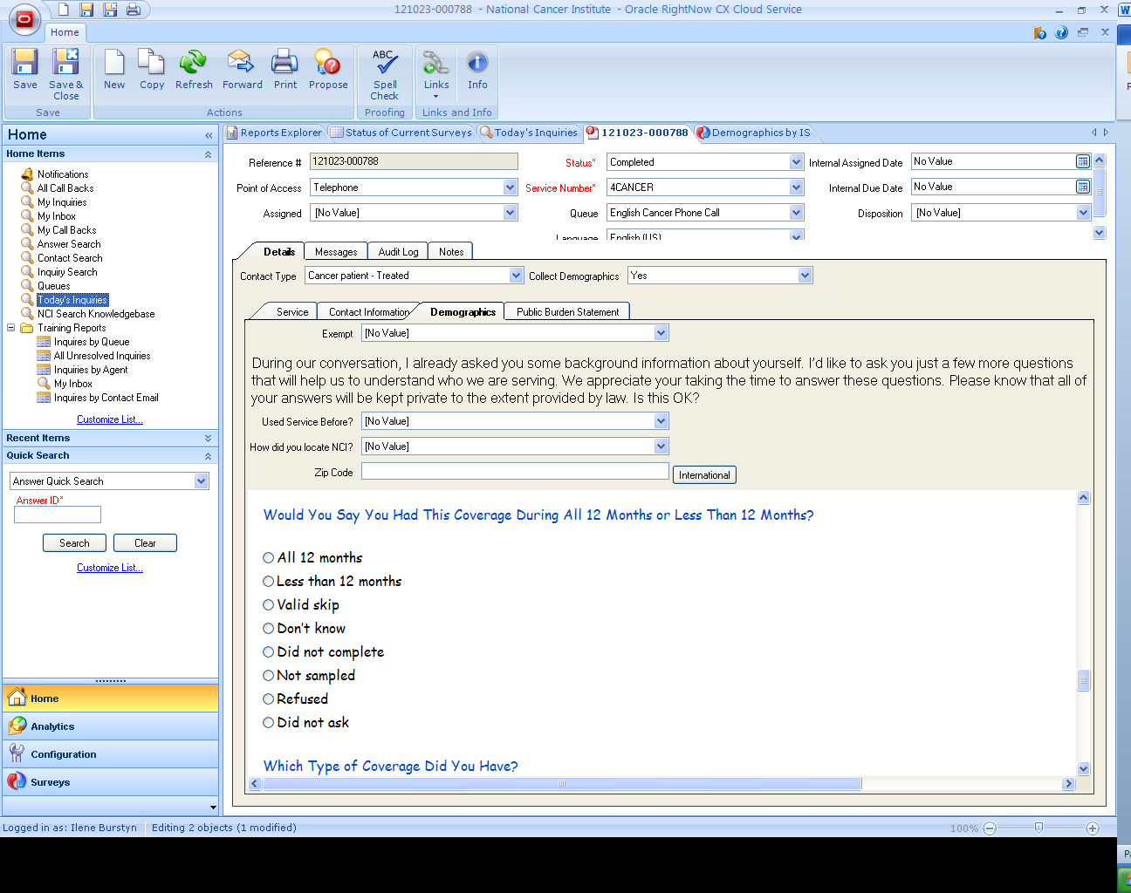

Note: The Information Specialist only asks callers what type of coverage they have/had. The other radio buttons are only for internal coding.

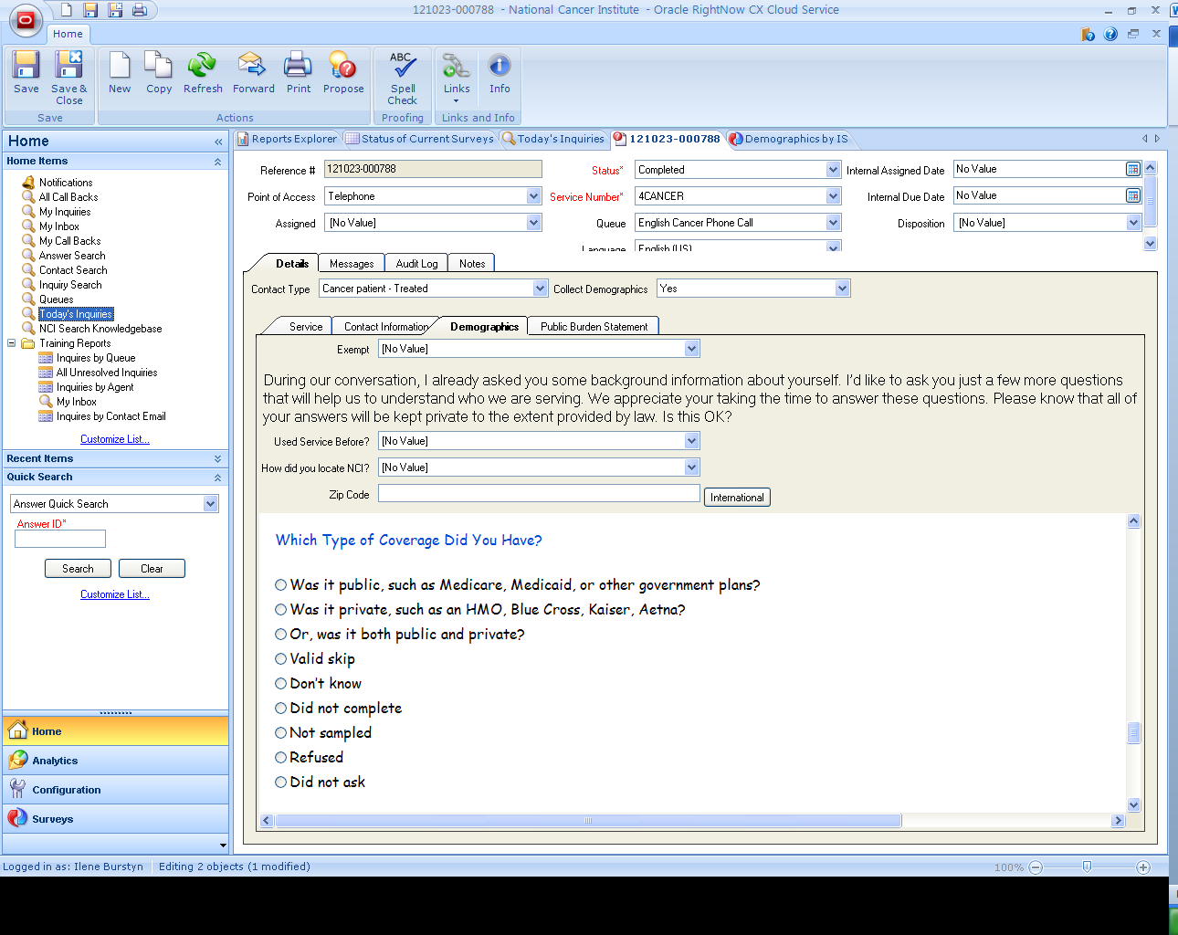

Note: The Information Specialist only asks callers their income range. The other radio buttons are only for internal coding.

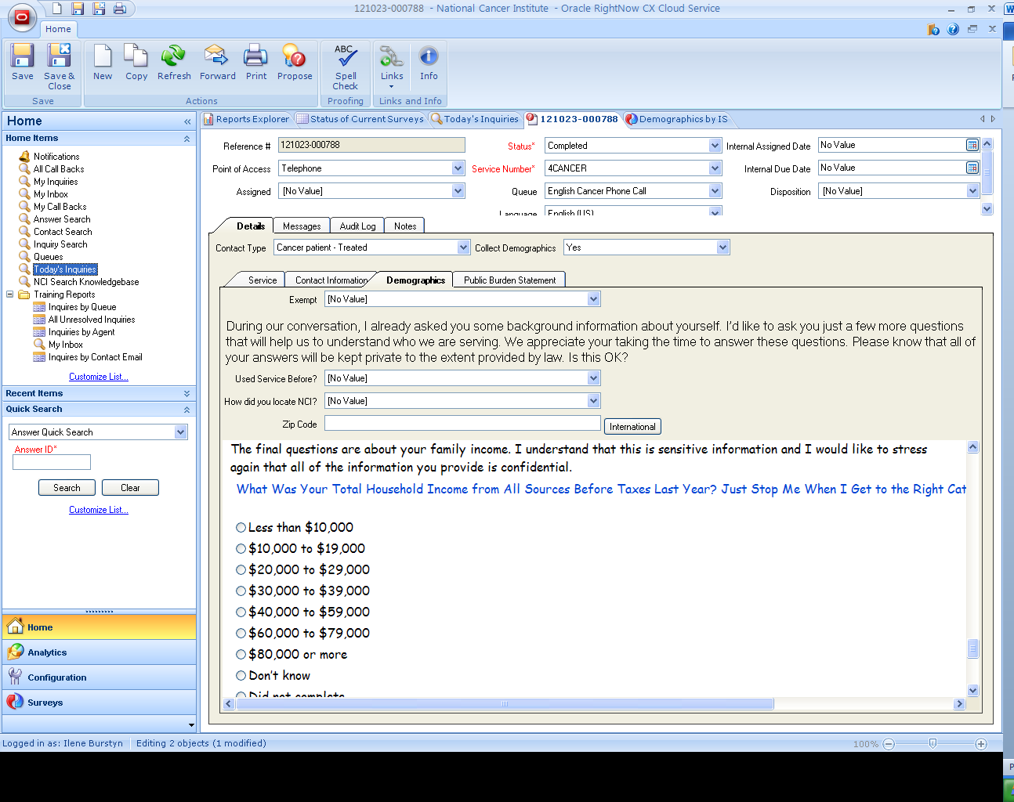

Note: The Information Specialist only asks callers how many people live in their household that are supported by their total household income. The other radio buttons are only for internal coding.

