**APPENDIX 2**

**DATA COLLECTION INSTRUMENTS**

**Email Intake Form**

**(customer service and demographics questions)**

Email Intake Form- (upper half of page) [**http://www.cancer.gov/global/contact/email-us**](http://www.cancer.gov/global/contact/email-us)

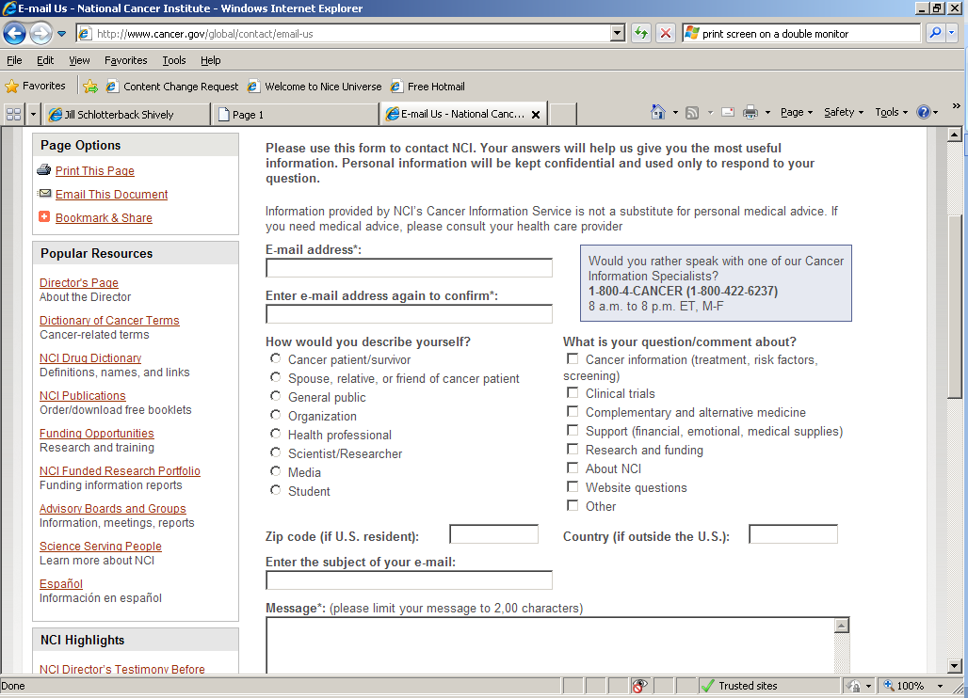

Email Intake Form- (lower half of page)

