Private IDCF screens Estimated 4 minutes to use these screens (3 screens are mock ups)

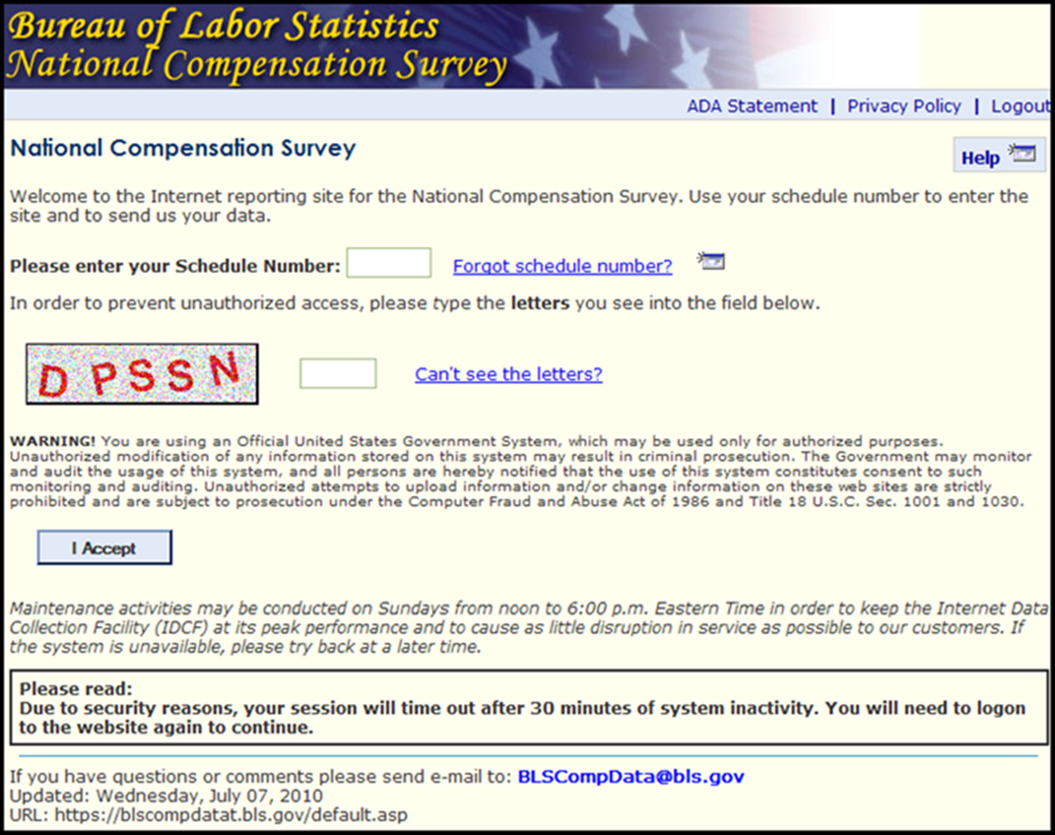

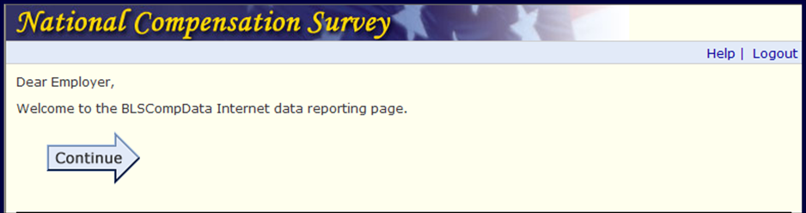

The Bureau of Labor Statistics, its employees, agents, and partner statistical agencies, will use the information you provide for statistical purposes only and will hold the information in confidence to the full extent permitted by law. In accordance with the Confidential Information Protection and Statistical Efficiency Act of 2002 (Title 5 of Public Law 107-347) and other applicable Federal laws, your responses will not be disclosed in identifiable form without your informed consent. | This report is authorized by law, 29 U.S.C. 2. Your voluntary cooperation is needed to make the results of this survey comprehensive, accurate and timely. | O.M.B. # 1220-0164  Expires 4/30/15
We estimate that it will take an average of 4 minutes to complete this form, including time for reviewing instructions, searching existing data sources, gathering and maintaining the data needed, and completing and reviewing this information. If you have any comments regarding this estimate or any other aspect of this survey; including suggestions for reducing this burden, please send them to the Bureau of Labor Statistics, Office of Compensation and Working Conditions (1220-0164), 2 Massachusetts Avenue N.E., Washington, D.C. 20212. You are not required to respond to the collection of information unless it displays a currently valid OMB control number.
