**Survey of Post-Graduate Outcomes for International Education Fellowship Recipients**

**Authorizing Legislation**

Website: <http://www.gpo.gov/fdsys/pkg/PLAW-110publ315/pdf/PLAW-110publ315.pdf>

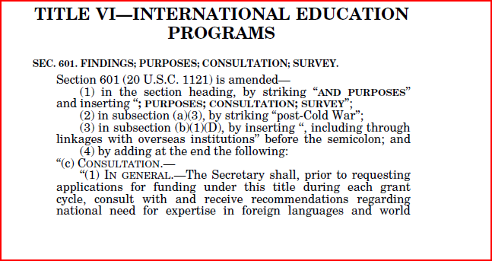

Website - <http://www.gpo.gov/fdsys/pkg/PLAW-110publ315/pdf/PLAW-110publ315.pdf>

