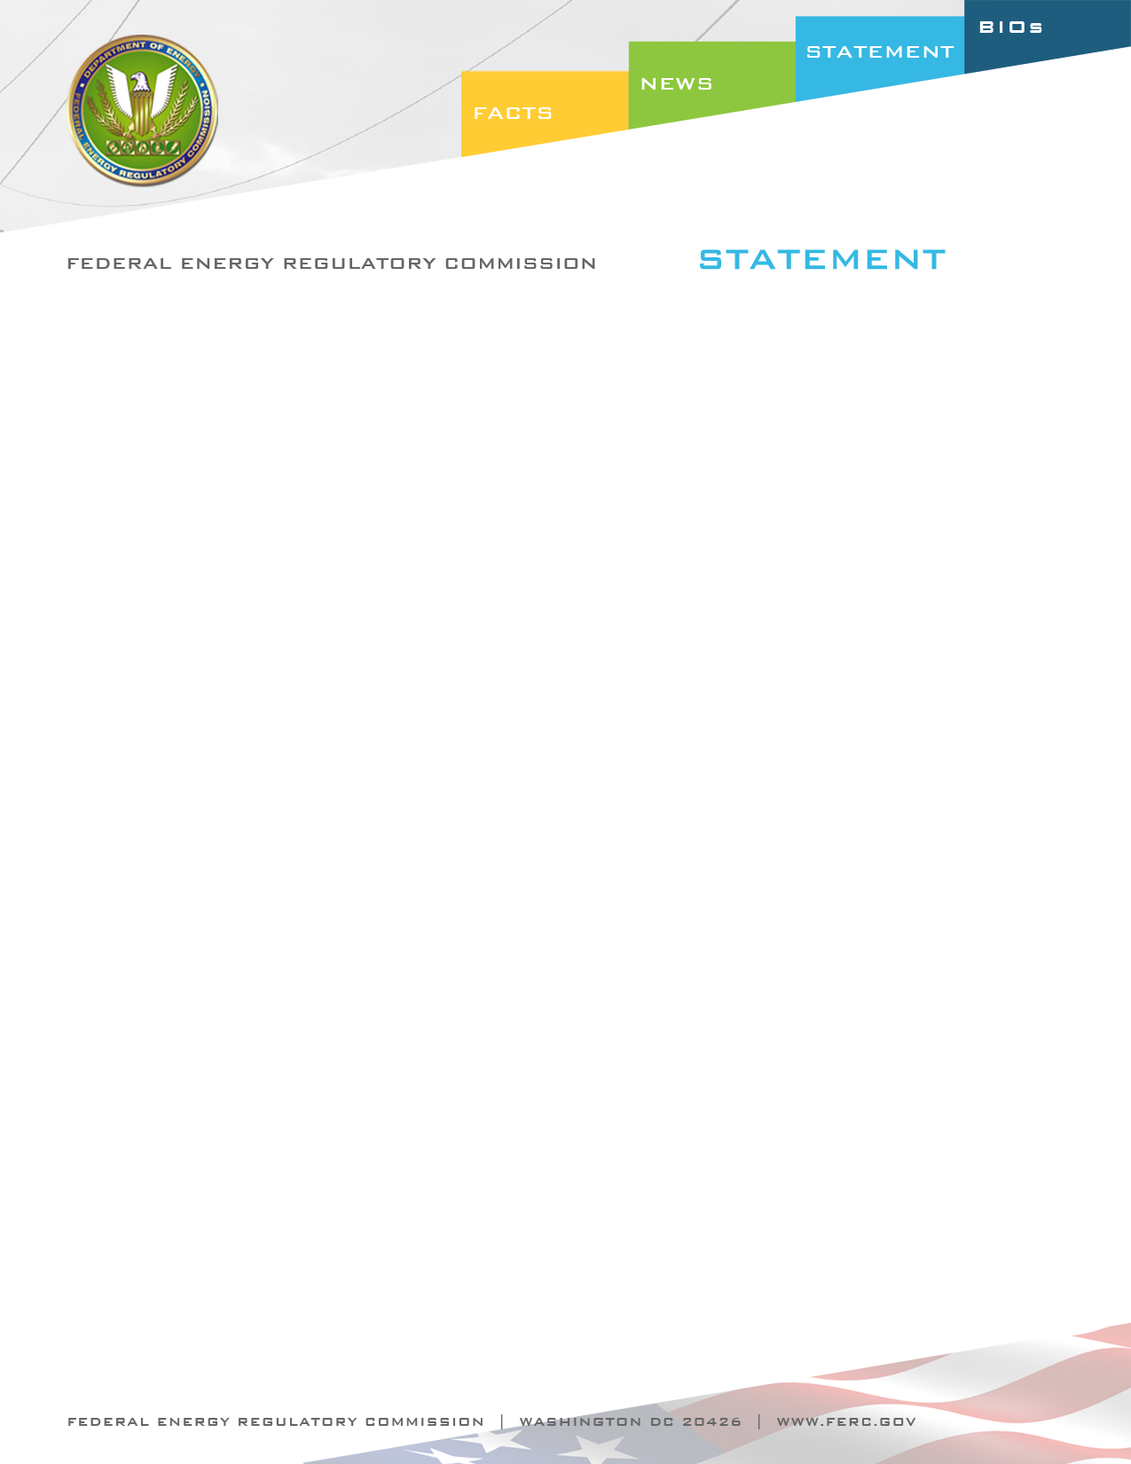

Docket Nos. RM12-22-000 and RM12-4-000
Item Nos. E-2 and E-3

October 18, 2012
Commissioner Cheryl A. LaFleur

Statement of Commissioner Cheryl A. LaFleur on
Proposed Enhancements to Reliability of Bulk Power System

“Protecting the reliability of the nation’s bulk electric system requires both day-to-day blocking and tackling to make sure that the lights stay on, and preparing for emerging issues including high-impact low-frequency events. Today, we are voting out Notices of Proposed Rulemaking that speak to both these components of reliability.
Vegetation Management Standard

“No issue is more central to reliability than timely and effective tree trimming to keep the transmission system operational. Indeed, a tree contact was a key contributing cause of the 2003 blackout that gave rise to this Commission’s jurisdiction over reliability.

“I believe the vegetation management standard (FAC-003-2) that we propose to approve today represents an important step forward in addressing this basic reliability issue. In particular, I note that the new standard includes a requirement to maintain a defined Minimum Vegetation Clearing Distance (MVCD) for all transmission lines above 200 kv and lines below 200 KV that are part of an Interconnection Reliability Operating Limit or WECC Transfer Path, and, for the first time, a requirement to annually inspect 100 percent of the lines subject to the standard. These requirements are both clear and concrete.

“The standard we propose to approve today is one of the first results-based standards put forward by NERC. As I understand the concept of a results-based standard, it includes a clearly defined result – avoidance of outages caused by vegetation within a MVCD—on the basis of which to judge compliance with the standard. Because the standard is judged by results, it proposes to give more flexibility to transmission owners about how to meet those results, as long as they are met. This is an important concept, and the successful implementation of this standard may be a model for further results-based standards.

“I also appreciate the commitment by NERC and the industry, working with EPRI, to fund further empirical research on the proposed MVCD, since that is such a critical element of the proposed standard.
I recognize that years of hard work went into this proposed standard, and appreciate the efforts of the NERC standards team as well as everyone here at FERC that worked on the standard.
Geomagnetic Disturbances

“The second Notice of Proposed Rulemaking relates to a very different issue, preventing or mitigating damage to the bulk electric system caused by geomagnetic disturbances resulting from solar storms. Solar storms are an acute example of “High Impact Low Frequency” events, which I believe are among the most difficult, but also the most necessary, to address through standards. Just as our society has over the centuries developed standards to protect elements of our infrastructure from high impact low frequency events like earthquakes and fires, I believe we must begin to address the challenge of making our electric grid resilient to geomagnetic disturbances.
This is an issue in which I have taken a strong personal interest. As I have observed, the threat of geomagnetic disturbances damaging the power grid sounds like science fiction, but is in fact based on scientific fact. However, while the fact that geomagnetic disturbances can cause substantial harm to the electric grid is undisputed, the way in which that harm would occur is not without controversy. The technical community has debated whether geomagnetic disturbances caused by solar events would cause the bulk electric system to break apart due to excessive reactive power consumption, cause damage to high-voltage transformers and other key elements of the system due to inductive currents, or some combination of the two. Any of these results is unacceptable, and is exactly the sort of cascading disturbance to the bulk power system that section 215 of the Federal Power Act requires us to address.
I believe that, while continuing to explore the technical issues, we can and should adopt “No Regrets” actions to prevent and mitigate grid damage from geomagnetic disturbances. The Notice of Proposed Rulemaking we are voting on today includes two such No Regrets actions, both of which are consistent with NERC’s assessment report on GmD issued earlier this year.

“First, we would require NERC to develop and propose a standard that requires transmission owners to take operational steps, to prepare for geomagnetic disturbances. This is one of the first actions proposed in NERC’s assessment and action plan. Because we are approaching a periodic solar maximum in 2013, increasing the threat of damaging solar storms, we are proposing to seek fast action on an operational standard.

“Second, we would require NERC to develop and propose a standard that would require transmission owners to undertake an assessment of the most vulnerable elements of the bulk electric system, and propose steps to prevent or mitigate damage to those elements from geomagnetic disturbances. As indicated in the Notice of Proposed Rulemaking, those steps could include installation of automatic blocking in certain vulnerable and critical transformers, requirement of withstand capability in transformers, inventory management strategies, operational plans to address critical elements of the system, and/or other steps that the industry and NERC may propose. Importantly, the proposed rule gives industry and NERC considerable flexibility of how to address this issue, but not the flexibility to ignore it.

“As with any other program to address pieces of the electric grid—and I have lived through quite a few—the appropriate action steps would likely vary based on how critical an asset was, where it was located, when it was scheduled to be replaced, whether it could be protected by islanding or operating protocols, or whether it needed to be retrofitted with protective equipment. Our collective understanding of these options would likely grow once we started the process.

“I know that the challenge of preparing our bulk electric system for geomagnetic disturbances is very complicated, and complicated challenges require complicated solutions. In the past, the electric grid has undergone many large-scale efforts to refurbish or replace electrical equipment to improve reliability, safety or environmental performance. Because of the size, diversity and continuous operation of the electric grid, these efforts are inevitably more complicated and take longer than expected. To me, that argues for getting started sooner rather than later.

“Finally, I believe it is appropriate to tackle this challenge now because the US is facing considerable investment in our transmission grid, driven by a change in power supply and replacement of aging infrastructure. We have a big opportunity to make sure the next generation of transmission equipment is built to withstand geomagnetic disturbances.
“I hope we will receive a broad range of comments on both Notice of Proposed Rulemaking. I would like to thank the FERC teams that worked on these proposed rules, and on the technical conference on GmD last spring on this issue. Thank you.”

