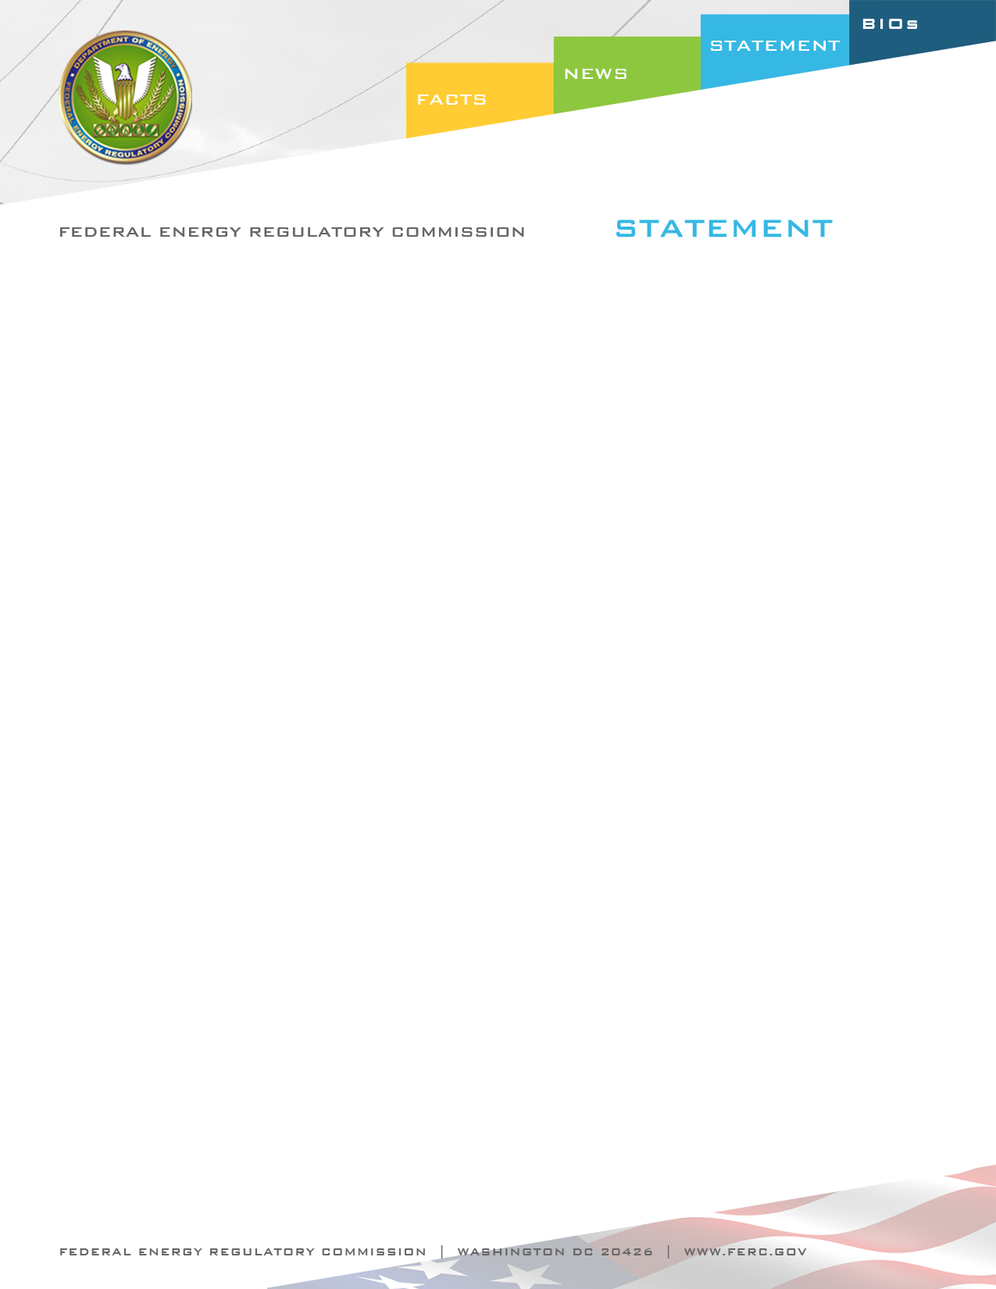

Docket Nos. RM12-22-000 and RM12-4-000
Item Nos. E-2 and E-3

October 18, 2012
Commissioner John R. Norris

Statement of Commissioner John R. Norris on
Proposed Enhancements to Reliability of Bulk Power System

“These two reliability orders address two distinctly different challenges, and represent two different approaches to maintaining reliability. E-3, concerning Reliability Standard FAC-003-2 on Transmission Vegetation Management (FAC-003), to me is about executing the fundamentals necessary to keep the lights on. We know that, without continuous care of transmission rights of way, vegetation growth will, without question, grow into power lines and impact reliability. This second version of FAC-003 recognizes the inevitability of outages if vegetation management is not in a continual state of maintenance, and also recognizes that this maintenance must be preformed on all transmission facilities that have an impact on reliability. The inclusion of Interconnection Operating Limit (IROL) elements and Major Western Electricity Coordinating Council (WECC) Transfer Path elements is a good step in recognizing that the applicability of FAC-003 should include sub-200 kV facilities that are critical to grid reliability.

“The threat of geomagnetic disturbances (GMD) addressed in the proposed rule in E-2 is a different but equally important reliability challenge. A poster child for a Low Frequency–High Impact threat, GMD involves a judgment call that requires us to assess the likelihood of occurrence, how severe the impact could be, and the options to guard against that impact. Like a cyber attack, the potential size and duration of an outage that could result from a GMD demands that we take the precautions necessary to prevent, limit, or contain the potential impact. While I do not believe there is a reasonable option that will guarantee that GMDs will never impact the grid, there are shorter and longer-term steps that we can take to guard against their potential impacts. Recognizing that taking these steps will come with costs, we have to find a “sweet spot”, if you will, where the cost of implementing reasonable reliability measures to guard against GMD impacts is appropriately balanced against the potential costs of a GMD event.

“Given the magnitude of the potential damage, I believe we are taking the right approach in this order by proposing to require that in stage two, there must be more extensive standards developed than just those that address operational and enhanced training procedures (the subject of stage one). The evidence before us today suggests that some or all vulnerable elements of the system will need further hardening to withstand a GMD. I think we appropriately give deference to NERC to make a needs assessment and design the additional measures necessary (through the development of the stage two standards) to meet the reliability needs identified in those assessments. But, as the proposed rule indicates, timing is of the essence. With the prediction of high solar flare activity on the very near time horizon, NERC will need to develop standards and industry to implement them much more rapidly than has previously been required. Again, this is another judgment call where we must decide what is reasonable and what is necessary. I ask NERC and the industry to accept this challenge and work as expeditiously as possible to meet it.

“In summary I think we have approached vegetation management like you would approach changing the oil in your car. You know that, if you do not do it, at some point your car will breakdown. And, preparing for GMDs is like buying insurance for you car. You hope that you will never need it - and in fact, you might not - but, it would be irresponsible to not determine what level of coverage you do need and to make the necessary investment to protect yourself and others from the risk and potential severity of an occurrence.”

