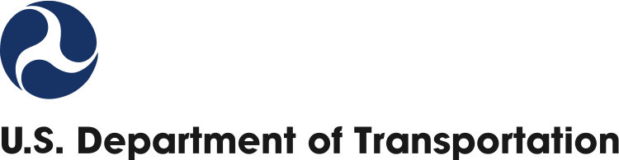

OMB No: 2105-0556

Expiration Date: MM/DD/YYYY

Public Burden Statement

A federal agency may not conduct or sponsor, and a person is not required to respond to, nor shall a person be subject to a penalty for failure to comply with a collection of information subject to the requirements of the Paperwork Reduction Act unless that collection of information displays a current valid OMB Control Number.  The OMB Control Number for this information collection is 2105-0556.  Public reporting for this collection of information is estimated to be approximately 2.5 hours per respondent, including the time for reviewing instructions, gathering the data needed, and completing and reviewing the collection of information.  All responses to this collection of information are voluntary.  Send comments regarding this burden estimate or any other aspect of this collection of information, including suggestions for reducing this burden to: Information Collection Clearance Officer, U.S. Department of Transportation, Room W56-440, 1200 New Jersey Ave, SE, Washington, D.C. 20590.

Privacy Act Statement

The Privacy Act requires that we provide you with the following information regarding our use of your Personally Identifiable Information. The information on this form is solicited under the authority of 29 C.F.R. Part 1614. The purpose of this form is to inform Complainants about the EEO complaint process. Information provided on this form will be used by the Department of Transportation to determine whether the complaint was timely filed, whether the claims in the complaint are within the purview of 29 C.F.R. Part 1614, to provide a factual basis for investigation of the complaint, and to ensure that the proper processes were followed. Formal complaints of employment discrimination must be in writing, signed by the Complainant (or attorney representative), and must identify the parties and action or policy at issue. Failure to comply may result in the Department of Transportation dismissing the complaint. It is not mandatory that this form be used to provide the requested information.

**Departmental Office of Civil Rights**

**MEDIATION PROGRAM FOR THE EEO COMPLAINT PROCESS**

**AGREEMENT TO MEDIATE**

This agreement is between _________________________________________________

(Aggrieved Person/Complainant)

and

_________________________________________________

(Affected Office)

represented by _________________________________________________

(Agency Official)

The parties agree to enter into mediation with the intent of reaching a mutually agreeable resolution of the dispute [*presented to the EEO Counselor on date of initial contact* **or** *filing date of complaint*]. The following are the basis(es) and issue(s) to be mediated by the parties:

Basis(es):

Issue(s):

**Designation of Representative:**

The aggrieved person/complainant has a right to obtain a representative of his/her choice throughout the EEO complaint process. The aggrieved person/complainant designates the following individual as his/her representative for the purpose of this mediation:

________________________________________________________

Name of Aggrieved Person/Complainant’s Representative

________________________________________________________

Phone Number

________________________________________________________

E-Mail address

**Privacy Act Statement**

The Privacy Act requires that we provide you with the following information regarding our use of your Personally Identifiable Information. The information on this form is solicited under the authority of 29 C.F.R. Part 1614. The purpose of this form is to inform Complainants about the EEO complaint process. Information provided on this form will be used by the Department of Transportation to determine whether the complaint was timely filed, whether the claims in the complaint are within the purview of 29 C.F.R. Part 1614, to provide a factual basis for investigation of the complaint, and to ensure that the proper processes were followed. Formal complaints of employment discrimination must be in writing, signed by the Complainant (or attorney representative), and must identify the parties and action or policy at issue. Failure to comply may result in the Department of Transportation dismissing the complaint. It is not mandatory that this form be used to provide the requested information.

**Privacy Act Statement**

The Privacy Act requires that we provide you with the following information regarding our use of your Personally Identifiable Information. The information on this form is solicited under the authority of 29 C.F.R. Part 1614. The purpose of this form is to inform Complainants about the EEO complaint process. Information provided on this form will be used by the Department of Transportation to determine whether the complaint was timely filed, whether the claims in the complaint are within the purview of 29 C.F.R. Part 1614, to provide a factual basis for investigation of the complaint, and to ensure that the proper processes were followed. Formal complaints of employment discrimination must be in writing, signed by the Complainant (or attorney representative), and must identify the parties and action or policy at issue. Failure to comply may result in the Department of Transportation dismissing the complaint. It is not mandatory that this form be used to provide the requested information.