Appendix C—Scrapie National Generic Database (SNGD) data entry forms
- Home page

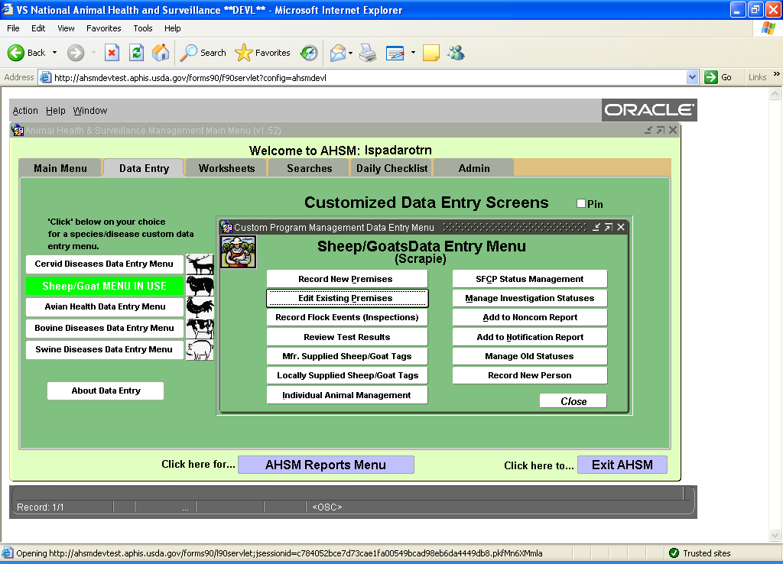

- New Premises or updates to premises information--Information usually obtained from VS Forms 5-19A-D and 5-22, but may be entered from other forms that include premises information, or through phone, e-mail, fax, or other communications not using a form.
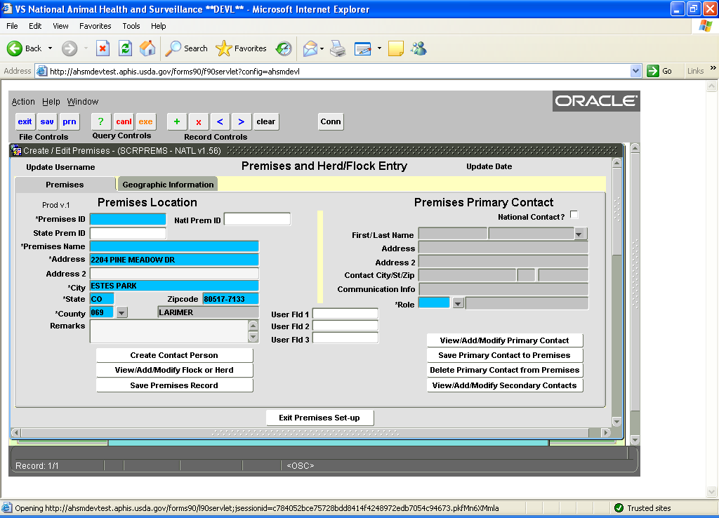

- Primary Contact for Premises--Information typically obtained from VS Forms 5-19A-D and 5-22, but may be entered from other forms that include owner or contact information, or through phone, e-mail, fax, or other communications not using a form.

- Auto-fill from

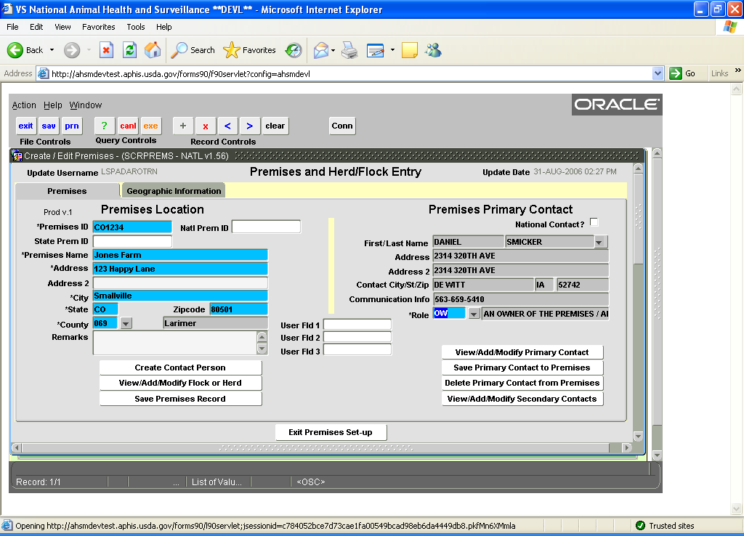
  - Manual data entry from for Premises Primary Contact

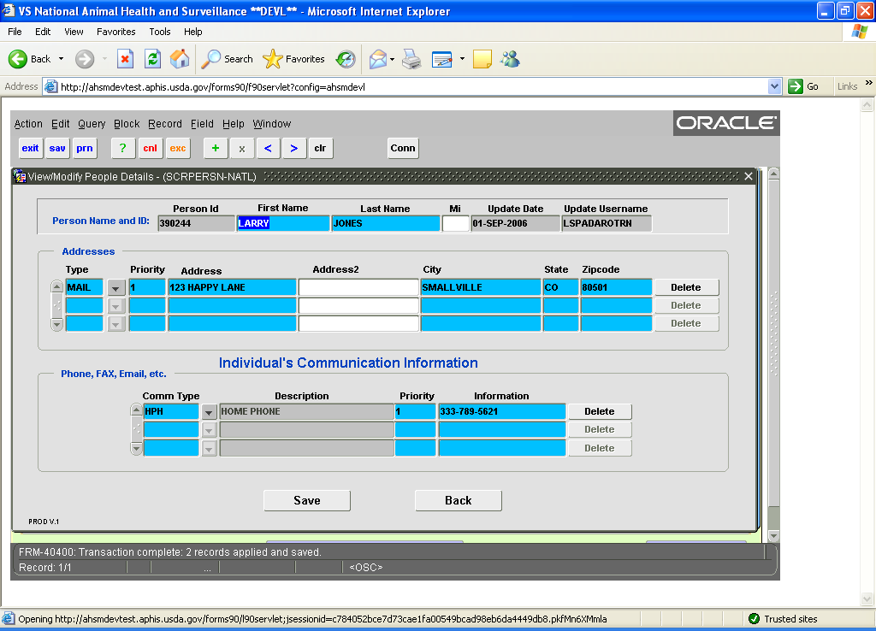

- Herd/flock Information Collection--Information typically obtained from VS Forms 5-19A-D and 5-22, but may be entered from other forms that include this information, or through phone, e-mail, fax, or other communications not using a form.

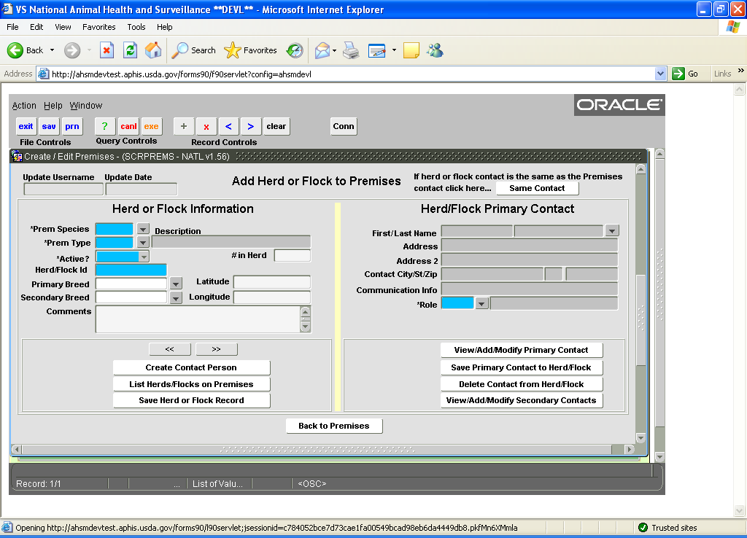

- Record Events—Inspections and Tests--Information typically obtained from VS Form 5-19A-D, VS Form 5-29, and VS Form 10-4, but may be entered from State forms that include this information, or through phone, e-mail, fax, or other communications not using a form.

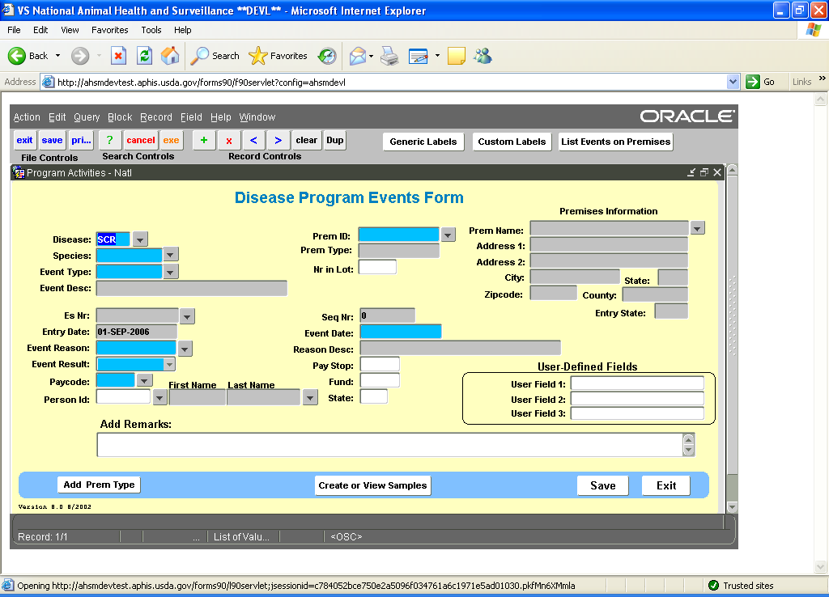

- Individual Animal Management--Information obtained from VS Form 5-18, 5-18A and VS Form 5-20 or copies of owner created records

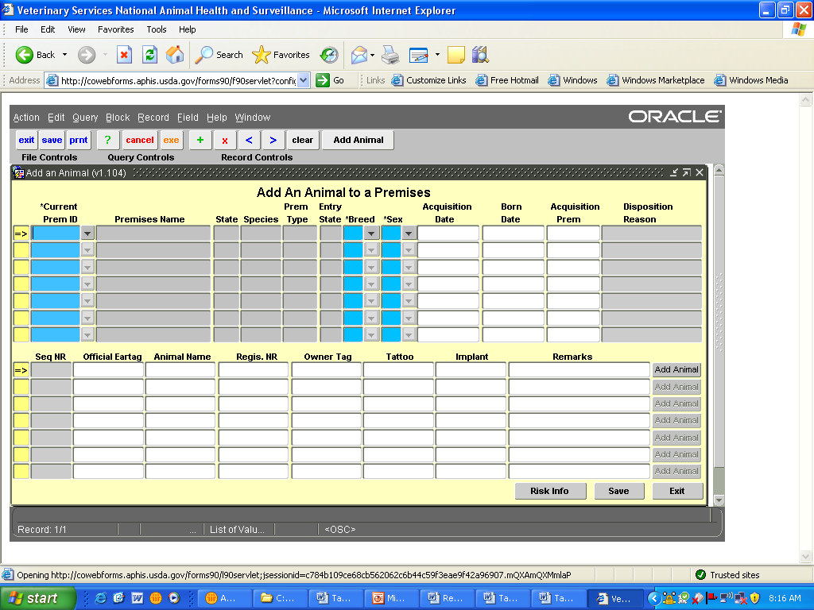

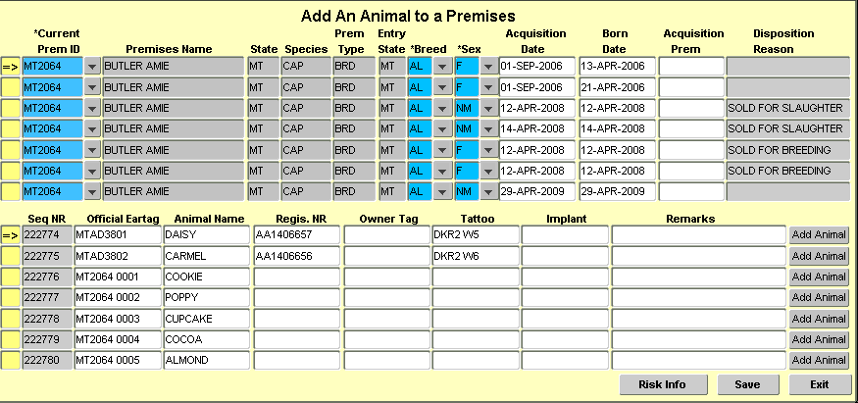

Appendix D--VSLS Information Collection

- Regulatory Scrapie Slaughter Surveillance (RSSS)--Information obtained from VS Form 10-4, RSSS Worksheets (Appendix B), or entered directly as samples are collected.
  - Create lab submission form

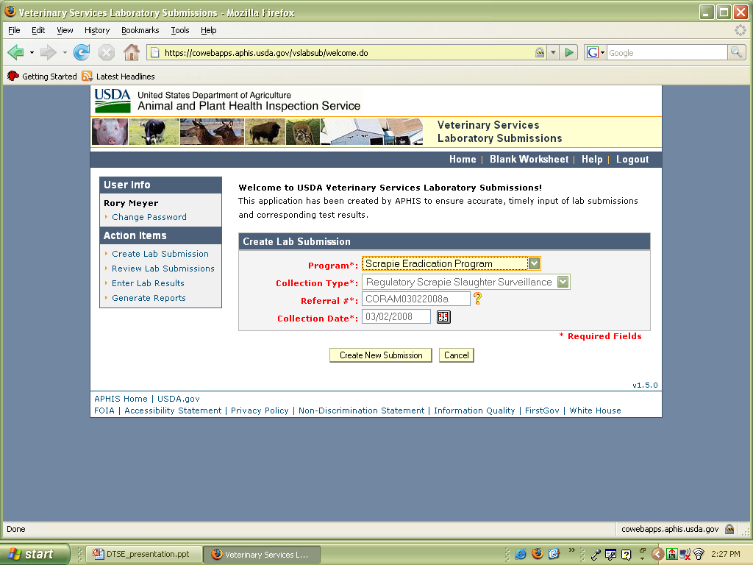

  - Data entry and search form for collection site and collector

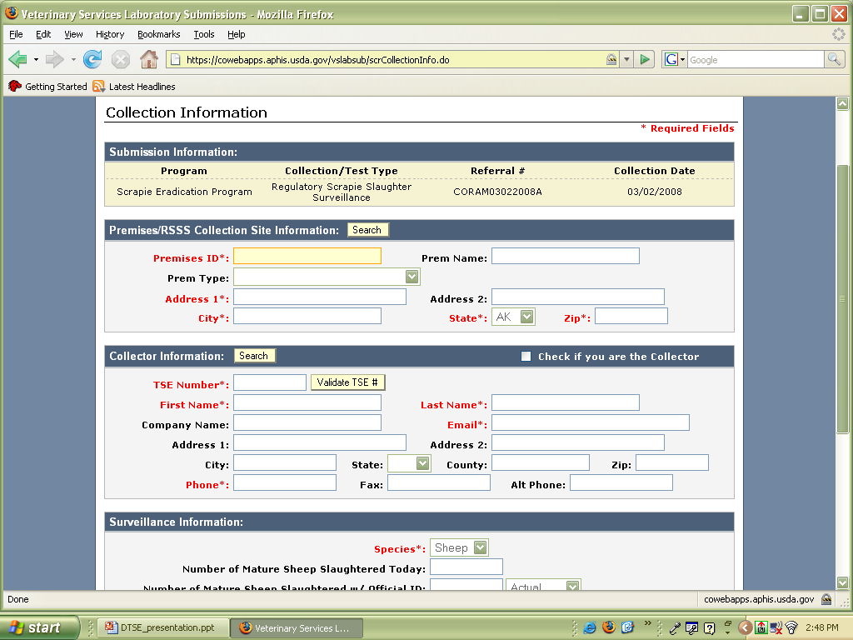

- VSLS Genotyping--Information obtained from VS Forms 5-29 and 5-29A or worksheet. (Appendix B)

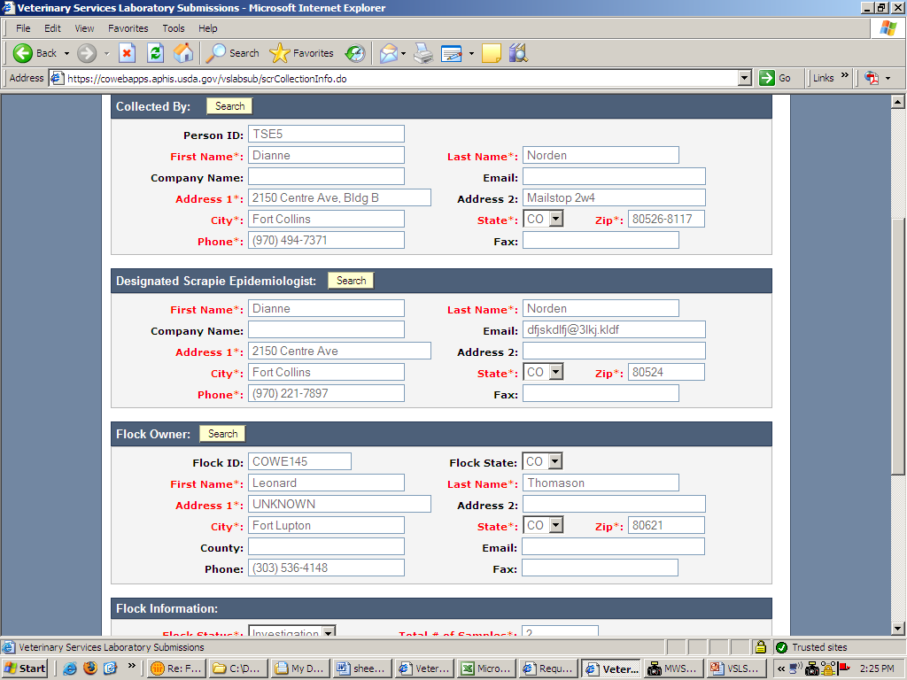

- VSLS On-farm Surveillance—Information obtained from VS Forms 10-4, 5-29 and 5-29A and entered into this module mirrors that of VSLS Genotyping (see previous screenshot)
Appendix E--Animal Identification Management System (AIMS)

- Data entry from used by State and Federal personnel to place tag orders. Program Contact Information is auto-populated from the Scrapie National Generic Database (SNGD). Requests for tags are typically received by phone, email or letter.

- Manufacturers’ forms
  - Order entry screen
    - Manufacturer enters a producer’s flock ID and state, the type of tag ordered (device), and order quantity. All other fields are optional. The flock owner’s address information is pulled from the SNGD and cannot be changed by the manufacturer.
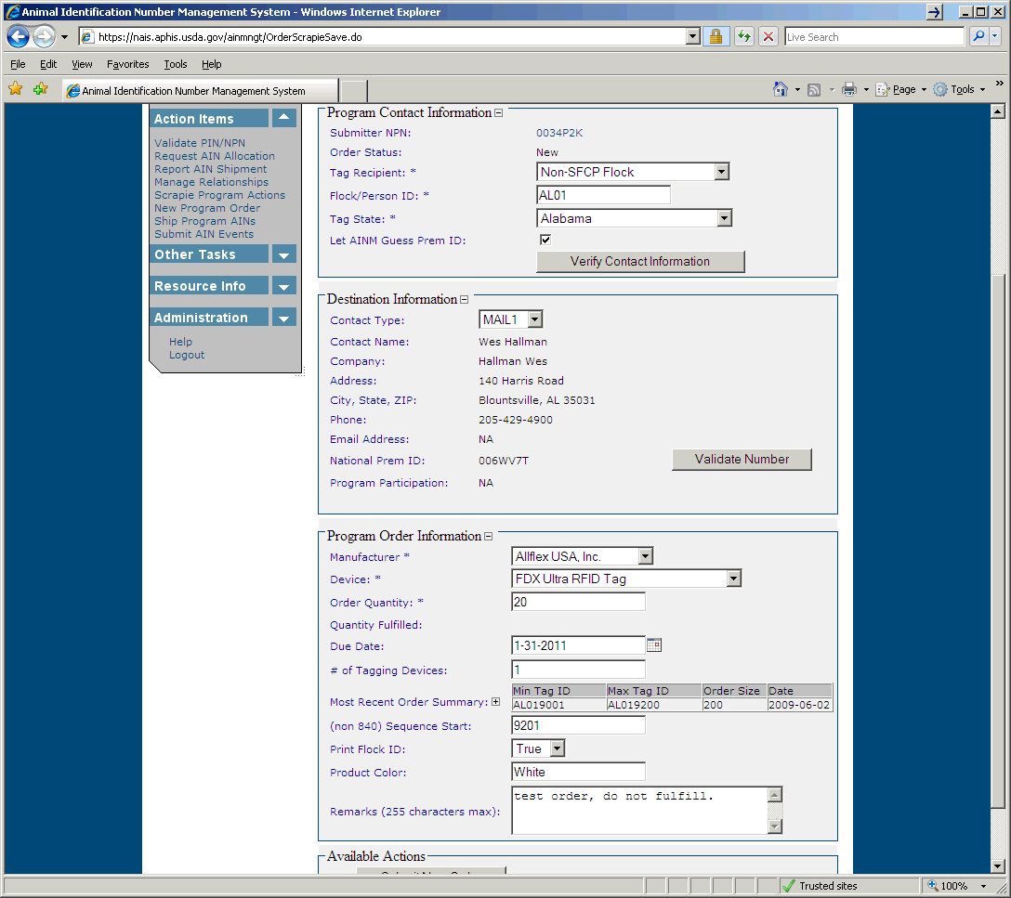
  - Information viewed by tag manufacturer when fulfilling tag orders. Recipient identification number and address are pulled from the SNGD. Specific information for the tag order (tag type, number of tags, starting sequence, color, number of tagging devices, etc.) is provided by the person (State or Federal) placing the order.

