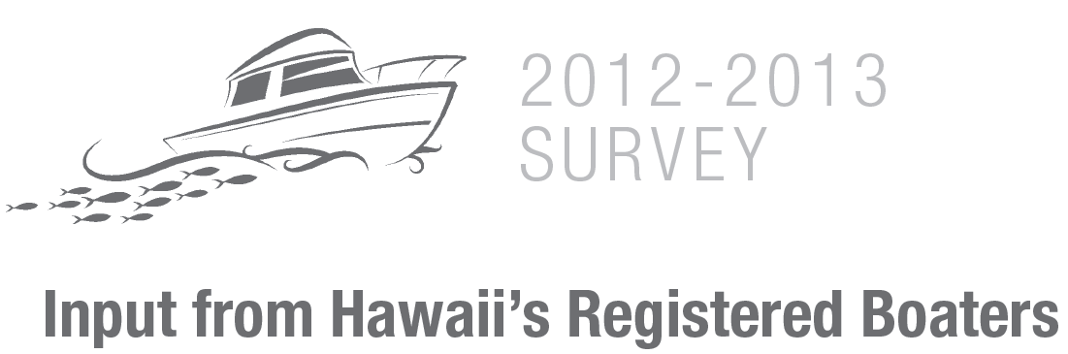

1. Please indicate the type of saltwater fishing you engage in

1. I do not fish in saltwater (please proceed directly to Question 6)
2. Only shore-based fishing (please proceed directly to Question 5)
3. Mostly shore-based fishing, and some boat-based fishing
4. About equal amounts of shore and boat-based fishing
5. Mostly boat-based fishing, and some shore-based fishing
6. Only boat-based fishing
Definitions:
Shore-based fishing means you do not use a boat.
Boat-based fishing means you use a boat or other water-craft while fishing.

2. Have you fished in Hawaii in the past 12 months?
1. Yes
2. No (please proceed directly to Question 19)
3. When I go fishing, I:
1. Always fish from my own boat
2. Sometimes fish from my private boat and sometimes from a friend’s boat
3. Always fish from a friend’s boat
4. Usually hire a charter boat or party fishing boat
5. Other (please specify) _______________________________________
4. When fishing, I would say that:
1. I always fish in State waters (0-3 miles from shore)
2. I usually fish in State waters, but sometimes in Federal waters (more than 3 miles from shore)
3. I fish about equally in State and Federal waters
4. I usually fish in Federal waters, but sometimes in State waters
5. I always fish in Federal waters
5. About how many years of experience do you have…
1. Shore fishing in Hawaii ______ years
2. Boat fishing in Hawaii ______ years

6. What year were you born?
______
7. How long have you lived in Hawaii?
______ years
Paperwork Reduction Act Statement. The information you provide will remain strictly confidential as required by section 402(b) of the Magnuson-Steven Act and NOAA Administrative Order 216-100, Confidentiality of Fisheries Statistics, and will not be released for public use except in aggregate statistical form without identification as to its source. We will combine your responses with information provided by other participants, and report it in summary form so that responses for any individual cannot be identified. Public reporting burden for this collection of information is estimated to average 5 minutes per respondent. Send comments regarding this burden estimate or any other suggestions for reducing this burden to Christopher Hawkins, NOAA Fisheries Service, 1601 Kapiolani Blvd, Suite 1110, Honolulu, HI 96814, 808-944-2291, Christoph.Hawkins@noaa.gov. Notwithstanding any other provisions of the law, no person is required to respond to, nor shall any person be subjected to a penalty for failure to comply with, a collection of information subject to the requirements of the Paperwork Reduction Act, unless that collection of information displays a currently valid OMB Control Number.

