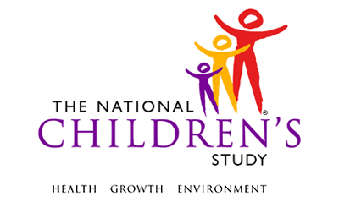

Telephone Medical Records Release Forms Letter: PLSND

Event: | Pregnancy Visit 1, Pregnancy Visit 2,  Birth
Domain: | Questionnaire
Type of Document: | Letter
Recruitment Groups: | PBS
Version: | 1.0
Release: | MDES 3.3

This page intentionally left blank.

Telephone Medical Records Release Forms Letter: PLSND

Dear [Name],

Thank you for speaking with us recently about your loss. As we told you on the phone, we are sending you a packet to complete your participation in the National Children’s Study. This packet should include:

- Two copies of a medical records release form; and,
- A pre-addressed and pre-paid U.S. Postal Service priority mail envelope.

Please review the record release forms that are enclosed. To better understand your loss, we would like to ask your permission to review your medical record related to your most recent pregnancy. If you agree to allow us to access your medical record, please complete the medical records release form entitled Authorization to Obtain Information from Medical Records for the National Children’s Study.

Please return one completed medical record release form in the priority mail envelope within 3 days. The second copy of the form is yours to keep.

After you return the form, you will be mailed $25 to thank you for your participation. As a reminder, your participation is voluntary.

If you have any questions or concerns, you may also contact me on my toll-free number at 1-XXX-XXX-XXXX or by email at XXX@XXXX.xxx.

Best regards,

Name
Full Name
Organization
Phone
Email

