As part of the National Children’s Study, we ask you to collect a sample of your urine.

Instructions

- Wash your hands with soap and water.
- Lay a paper towel on a flat surface. Take the lid off of the collection cup and place it on the paper towel. The inside of the lid should be placed face down on the paper towel. Do not touch the inside of the lid or the collection cup. Do not allow the inside of the collection cup or the inside of the lid to come in contact with any part of your body, clothing, or bathroom surfaces.
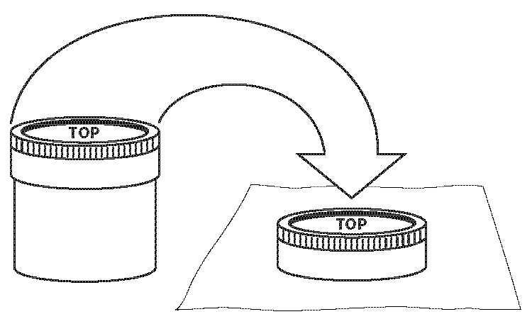
- Start urinating into the toilet, then urinate directly into the collection cup. If possible, fill the cup at least half full. Do not fill to overflowing.
- Put the lid on the collection cup immediately so that the urine is only briefly exposed to the air.
- Use the paper towel to wipe any urine from the outside of the cup.
- Remember to wash your hands with soap and water after collecting the sample.
- Give the collection cup back to the study staff.

If you have any questions please ask study staff. Thank you for providing this sample.

