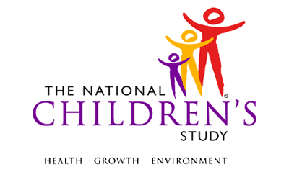

Biospecimen Child Saliva Collection SAQ

Event: | 12- Month
Participant: | Child
Domain: | Biospecimen
Type of Document:  Allowable Mode:  Allowable Method: | Self-Administered Questionnaire  In Person  PAPI
Recruitment Groups:  Version:  Release: | EH, PB, HI  1.0  MDES 3.0

Please complete this form when you collect a sample of your child’s saliva for the National Children’s Study. Thank you for taking the time to provide this information.

- Were you able to collect your child’s saliva sample?
Yes → Go to Question 2
No → Go to Question 6
- What day did you collect your child’s saliva sample? //
- What time did you collect your child’s saliva sample? : → (circle one) AM/PM
- When was the last time your child had anything to eat or drink other than water before you collected your child’s saliva sample? Please enter date (month, day and year) and time.
Date: // Time: : → (circle one) AM/PM
- Who collected your child’s saliva sample?
Mother
Father
Other → (please specify) ______________________________________

- Is there anything you want to tell us about collecting your child’s saliva sample? If you could not collect the saliva sample, please tell us why.

Thank you for participating in the National Children’s Study and for taking the time to complete this information.

Please call the local Study Center number on the last page, if you have any questions.

For Office Use Only:

Sample ID Label

Subject ID Label

Insert local contact information here

