Attachment 5: NIH Privacy Act Officer’s Letter

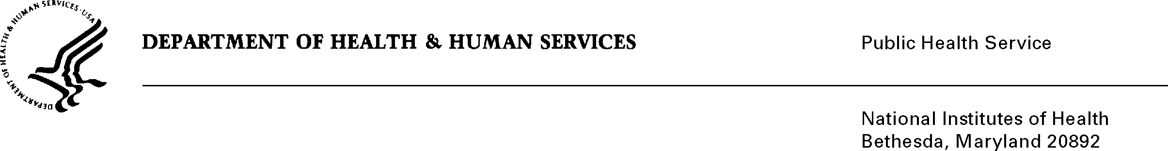
DATE: June 14, 2012

TO: Amanda Greene, Ph.D., M.P.H., R.N., Science Evaluation Officer and PRA Liaison
National Institute for Nursing Research

FROM: NIH Privacy Act Officer

SUBJECT: Applicability of the Privacy Act: “NINR Summer Genetics Institute Alumni Survey”

I have reviewed the NINR submission to OMB requesting approval for the “Summer Genetics Institute (SGI) Alumni Survey”. The purpose of the online survey is to collect prospective data from alumni on the long-term outcomes of the SGI training program in order to refine it so career objectives related to genetics research and education can be met.

An introductory e-mail notification letter will be sent to notify the SGI alumni of the upcoming NINR sponsored survey. An e-mail invitation letter will be sent to inform the alumni about the survey and how they may participate. The invitation will include a URL link to a secure, web-based questionnaire where the respondent will be assigned an ID number and can provide their responses. One week after the initial e-mail announcement, a reminder e-mail will be sent to non-respondents to inform them of the importance of their participation in the evaluation.

I have determined the Privacy Act will apply to this data collection. Although the personal identity of the respondents will be protected by the assignment of an ID number, and personally identifiable information will be stored separately from responses, personal contact information about the respondents will be used by NINR researchers and the contractor for subsequent follow-up.

The online administration of the questionnaire will allow respondents to enter data directly into an electronic database that can be analyzed using statistical software. Data files will be kept in a secure environment and no one outside the study will have access to them. All collected survey information will be analyzed and presentation of data in reports will be in aggregate form, with no links to individuals preserved.

The data collection is covered by NIH Privacy Act Systems of Record 09-25-0156, “Records of Participants in Programs and Respondents in Surveys Used to Evaluate Programs of the Public Health Service, HHS/PHS/NIH/OD”.

If you have any questions, please contact my office at (301) 402-6201.

Karen M. Plá
Enclosure

