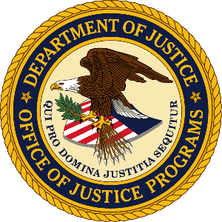

U.S. Department of Justice

Office of Justice Programs

Bureau of Justice Statistics

Washington, D.C. 20531

MEMORANDUM TO: Lynn Murray
DOJ Clearance Officer
Justice Management Division

THROUGH: James P. Lynch
Director

FROM: Devon B. Adams
Chief, Criminal Justice Data Improvement Program

SUBJECT: Submission of changes to the Survey of State Criminal History Information Systems (OMB No. 1121-0312)

This memo is to provide the 2012 version of the Survey of State Criminal History Information Systems. A document is also provided outlining the differences between the 2012 and 2010 versions. The changes from the 2010 version reflect comments/suggestions received from several states, BJS, FBI CJIS, and the National Center for State Courts. There are both layout changes and the addition and deletion of questions. Several questions have also been clarified based on the comments received.

The 2012 survey now has 5 Sections rather than the 8 that comprised 2010:
- Merged Section VI Repository Administration into Section I Repository
- Merged Section IV Court Reporting into Section III Dispositions
- Deleted Section VIII Indian Country Information
If there are any questions concerning this request, please contact Devon Adams at (202) 514-9157 or by email at Devon.Adams@usdoj.gov.

