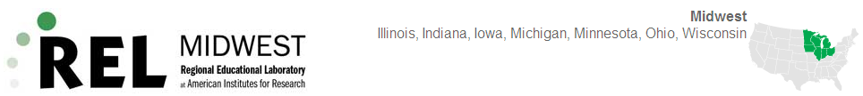

Dear _______________,
You have been selected as one of a small number of [teachers/principals/school board members/district administrators] in your state to provide feedback to REL Midwest, which is one of ten Regional Educational Laboratories funded by the U.S. Department of Education. Each REL serves a designated region of the country and focuses on the national priority of helping states and districts use data and analysis to address relevant and timely education policy and practice issues with the goal of improving student outcomes. Your feedback is critical because it will help REL Midwest refine its understanding of regional needs and inform its future research, technical assistance, and dissemination work.
The survey is being conducted by NORC at the University of Chicago and is expected to take approximately 20 minutes to complete. You may access the survey by typing the following URL into your Web browser: https://aaa.bbbbbb.org. You will then need to enter your credentials to begin:
Username:
Password:
Per the policies and procedures required by the Education Sciences Reform Act of 2002, Title I, Part E, Section 183, responses to this data collection will be used only for statistical purposes. The reports prepared for this study will summarize findings across the sample and will not associate responses with a specific district or individual. We will not provide information that identifies you or your district to anyone outside the study team, except as required by law. Any willful disclosure of such information for nonstatistical purposes, without the informed consent of the respondent, is a class E felony. Please contact a NORC representative at XXX-XXX-XXXX if you wish to decline to participate, and we will remove you from our contact list so that you do not receive reminders to complete the survey.
Thank you,
Kathleen Parks
Senior Vice President
NORC at the University of Chicago
P.S. You can learn more about REL Midwest and the services it provides to educators in your state by visiting the website at http://www.relmidwest.org/ or by calling the REL Midwest hotline at 866-730-6735.

