Dear _______________,
We are contacting you again to encourage your participation in a survey being conducted by NORC at the University of Chicago on behalf of REL Midwest. Your feedback is critical because it will help REL Midwest refine its understanding of regional needs and inform its future research, technical assistance, and dissemination work. You may access the survey by clicking on: http://aaa.bbbbbb.org. You will then need to enter your credentials to begin:
Username:
Password:
IMPORTANT: YOUR PASSWORD is CASE SENSITIVE and will not let you login without proper UPPER and LOWER CASE for the LETTERS in the PASSWORD.
The survey is expected to take approximately 20 minutes to complete. Per the policies and procedures required by the Education Sciences Reform Act of 2002, Title I, Part E, Section 183, responses to this data collection will be used only for statistical purposes. The reports prepared for this study will summarize findings across the sample and will not associate responses with a specific district or individual. We will not provide information that identifies you or your district to anyone outside the study team, except as required by law. Any willful disclosure of such information for nonstatistical purposes, without the informed consent of the respondent, is a class E felony.
We hope you will take some time in the coming week to help REL Midwest understand the needs of educators in the Midwest region. You can learn more about REL Midwest and the services it provides to educators in your state by visiting their website at http://www.relmidwest.org/ or by calling the REL Midwest hotline at 866-730-6735.

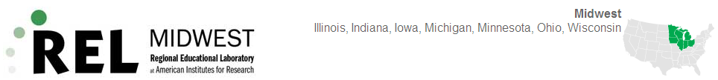
THANK YOU!

